Oregon Address Point
Data Standard
Version 0.2
November 2024

Revision History:
Original 0.1 Draft Written by: Tom Elder
Version 0.2 revised based on the Address Point Data Standard workgroup
Version x.x revised based on GIS community comment
Version x.x revised based on Advisory Group comment
Endorsed by the Oregon Geographic Information Council [Month] [Year]

For questions about this data standard, contact:
Name: Tom Elder
Email: tom.elder@das.oregon.gov

Table of Contents

- Introduction
1.1 Mission and Goals of the Standard
1.2 Relationship to Existing Standards
1.3 Description of the Standard
1.4 Applicability and Intended Use of the Standard
1.5 Standard Development Procedures
1.5.1 Participants
1.5.2 Comment Opportunities and Reviews
1.6 Maintenance of the Standard
2.0 Body of the Standard
2.1 Scope and Content of the Standard
2.2 Need for the Standard
2.3 Participation in the Standard Development
2.4 Integration with Other Standards
2.5 Technical and Operational Context
2.5.1 Data Environment
2.5.2 Reference System
2.5.3 Integration of Themes
2.5.4 Encoding
2.5.5 Resolution
2.5.6 Accuracy
2.5.7 Edge Matching
2.5.8 Feature Identifier
2.5.9 Attributes
2.5.10 Transactional Updating
2.5.11 Records Management
2.5.12 Metadata
3.0 Data Characteristics
3.1 Spatial Data Elements
3.1.1 Address Point
3.2 Minimum Attribute or Non-Graphic Data Elements
3.2.1 Point
3.3 Other Graphic Data Elements
3.3.1 Point
3.4 Optional Attribute of Non-Graphic Data Elements
3.4.1 Point

References
Appendices
A. Terms and Acronyms
B. Workgroup Participants
C. Implementation

1.0 Introduction

Under the direction of the Oregon Geographic Information Council (OGIC) and the guidance of the Oregon Framework Program, the Framework Implementation Team (FIT) was convened to create a statewide data standard for address points. This document is the result of collaboration and cooperation between many address point data providers (local jurisdictions and 9-1-1 Public Safety Answering Points), major address data consumers, and other stakeholders. Their goal was to define a standard to help facilitate the gathering, combining, and distributing of address point data for the entire state that is reliable, accurate, complete, and timely.

There are approximately two million address points across Oregon. An address point refers to the location of a building, apartment, or other structure, typically described using street names, house or apartment numbers, and other identifiers. Address points show the geographic location of individual houses, apartments, condominiums, mobile homes, offices, shops, schools, factories, farms, and other places where people live, work, and gather. Address point locations are indispensable for the efficient delivery of government services and the equitable allocation of public resources, helping to ensure representation and fairness and a better understanding of Oregon’s population at the highest level of spatial detail.

1.1 Mission and Goals of the Standard

Establishing an Oregon Address Point Data Standard is the first step to building and distributing a seamless statewide address point dataset. Address points originate from, and are maintained by, local governments for many different purposes and in many different data formats. The Oregon Address Point Data Standard is designed to accommodate and align different formats in order to assemble a complete, accurate, and comprehensive dataset of all address points for the State of Oregon.
The primary goals of the Address Points Standard are -

- To ensure consistency and compatibility between address point data maintained by different jurisdictions for multiple uses within the state by providing common definitions and value ranges for address information to enhance data sharing.
- To ensure that all address points in the state can be accommodated down to the unit level of detail.
- To ensure that each address point is unique and not duplicated or confused with another address.
- To ensure that each address point is complete and includes all address elements that make each one unique.
- To support the broadest range of stakeholders and use cases.

The Oregon Address Point Data Standard is not intended to replace any jurisdiction’s local schema, internal data workflow, or storage specifications required for their operational needs.

The Oregon Address Point Standard establishes a unified set of attributes and domains for creating and maintaining an enterprise-level statewide address dataset. These attributes promote consistency in locally maintained address data and compatibility between local and statewide address data.

1.2 Relationship to Existing Standards

1.2.1 Existing National Address Standards
Four major national address standards were reviewed during the development of Oregon’s Address Points standard.

- FGDC Federal Geospatial Data Committee, Numbered Thoroughfare address classification.
- NENA National Emergency Number Association, NG9-1-1 GIS Data Model.
- NAD National Address Database.
- USPS United States Postal Service.

FGDC was the former Oregon standard adopted by the Oregon Geographic Information Council in 2014. However, it was never implemented and after review by the Oregon Address Point Workgroup determined to no longer be the best fit for Oregon.

The NENA standard was selected as the core of the Oregon Address Point Data Standard for the following reasons:

- NENA aligns with existing FGDC and NAD standards.
- NENA is simpler to implement than FGDC.
- Many other states already use NENA.
- Most address point data is already available from OEM in NENA format.
- Coordination with the ongoing NG9-1-1 Technical Advisory Committee would reduce redundancies.
- NENA, although intended for public safety use cases, could accommodate other use cases and business requirements with supplemental fields.

The Oregon Address Points Data Standard closely follows the NENA Standard. PSAPs are currently providing address points to the Oregon Department of Emergency Management (OEM) in the NENA standard for public safety purposes. The Oregon Address Point workgroup determined modifications to the NENA standard could transform a single-use data set into an enterprise address point database that could support a variety of use-cases. The Oregon Address Point workgroup has determined that with a few modifications, the nationally recognized and locally adopted NENA NG9-1-1 Data Model Standard can not only support a variety of use cases but also expedite the creation of an enterprise address dataset.

1.2.2 Existing Oregon Framework Standards

Address points are mostly man-made structures and will generally be located within existing parcel and building footprint polygons. The attributes for these polygons (parcel identifier and building footprint identifier) can be added to each address point which helps tie the three themes together. A parcel can have one or more building footprints and each building footprint can have one or more address points.

The Oregon Address Point Standard is closely related to the Cadastral Data Exchange Standard and the Statewide Buildings Footprint Standard. The Statewide Buildings Footprint Data Standard is currently in development and expected to be endorsed in 2025. The Cadastral Data Exchange Standards, Building Footprint Standard, and Oregon Address Point Standard will require coordination through development and future updates as they will result in overlapping datasets with closely related attributes.

1.3 Description of the Standard

The intent of the Oregon Address Point Data Standard is to support data sharing and streamline the aggregation of data created and maintained by local jurisdictions into an enterprise Address Point dataset for the benefit of all Oregonians.

This Address Point Data Standard requires every address point in the state is
- complete
- consistent
- unique

Complete

Every complete street address point can have up to 12 basic elements (shown in Table 1 below). Some of the basic elements are further parsed into sub-elements in the FGDC, NENA, and NAD standards. This standard accommodates the possible elements and sub-elements to ensure that any address in Oregon has the fields to make it complete. A complete address is vital to making each address unique. Missing elements may create duplicate addresses.

Table 1 – Address Point Basic Elements

 | ELEMENT GROUP | BASIC ELEMENT | FGDC/NENA/NAD SUB-ELEMENT | EXAMPLE
1 | Street Number | Address Number | Address Number Prefix | 123
1 | Street Number | Address Number | Address Number | 123
1 | Street Number | Address Number | Address Number Suffix | 123
2 | Street Name | Street Name Pre Direction
3 | Street Name | Street Name | Street Name Pre Modifier | Maple
3 | Street Name | Street Name | Street Name Pre Type | Maple
3 | Street Name | Street Name | Street Name Pre Separator | Maple
3 | Street Name | Street Name | Street Name | Maple
3 | Street Name | Street Name | Street Name Post Modifier | Maple
4 | Street Name | Street Name Post Type |  | Street
5 | Street Name | Street Name Post Direction |  | Northeast
6 | Subaddress | Unit Type | Unit or  Floor or  Room or  Seat | Apartment 101
7 | Subaddress | Unit Number | Unit or  Floor or  Room or  Seat | Apartment 101
8 | Locality | City Name |  | Salem
9 | Locality | State |  | OR
10 | Locality | ZIP Code |  | 97301
11 | Location | Longitude |  | -123.005432
12 | Location | Latitude |  | 45.809563

Consistent

The values used in the address elements should be unambiguous and consistent from any source. Fully spelled street names, with no abbreviations, are used as well as fully spelled street directions and street types. Domains are used to reinforce consistency by providing a complete set of acceptable values for most of the street elements.

Unique

In order for an address to be unique every address must include all of the address elements that apply, have a ZIP Code or city name, and the unit number must be included for addresses that have units. One of the cornerstones of this standard is that every address is unique within a ZIP Code or city. The same address may be found in different ZIP Codes or cities but will never be duplicated within a ZIP Code or city. The combination of the full address including the primary street address plus any secondary unit address if present plus the correct ZIP Code or city is unique and can be used as an intrinsic primary key in a dataset of all addresses. Having the correct ZIP Code or city name be assigned to each address is imperative to prevent duplicates or confusing one address for another.

1.4 Applicability and Intended Use of the Standard

The Address Point Standard is intended to support a broad range of important uses. Table 2 describes a variety of use cases the Oregon Address Point Data Standard is intended to support.

Table 2- Identified use cases for the Oregon Address Point Data Standard.
Category | Use-Case
Census | Redistricting  Voter Registration  Elections
Public Safety | Next Generation 9-1-1:  Location Verification (LVF) , Call Routing (ECRF)  9-1-1 Dispatchable Locations
Emergency Management | Risk Assessment  Event Notification  Evacuation  Shelter
Disaster Response | Damage Assessment  Search and Rescue
Property | Building Permitting  Tax Assessment
Utilities | Broadband  Mail
Service Delivery | Application Verification and Qualification  Billing  Record Keeping and Compliance
Planning and Development | Transportation  Housing  Public Health  Business and Economic Development

1.5 Standard Development Procedures

1.5.1 Participants

The Oregon Address Point Workgroup was led by Oregon Geospatial Enterprise Operations in close cooperation with the Oregon Department of Emergency Management, Next Generation 911 Technical Advisory Committee (NGTAC), and the Oregon Framework Coordinator. The workgroup also consisted of participants from private sector, local jurisdictions, state agency and federal government. The Oregon Address Point Workgroup participants included data providers, data consumers, and other stakeholders with national experience. A full list of participants is provided in Appendix B.

1.5.2 Comment Opportunities and Reviews

The Oregon Address Point Data Standard was circulated throughout Oregon’s GIS Community for review and comment. Table 3 describes the review period and refinement throughout the development process.

Date | Review | Result
Spring/Summer 2024 | Workgroup Development | Draft Standard
October 29, 2024 | Proto Standard Presentation | Presentation to GIS Community at Framework Forum.
November 2024 | Public Review Period | Proto Standard published on GEO Website and circulated through Listservs (FIT, Address & Buildings FIT, Cadastral FIT, GPL, TAC, OGIC, etc.)
Winter 2024 – 2025 | Formal Peer Review | Draft Standard underwent formal peer review by Advisory Group comprised of active Framework members from multiple themes.
Spring 2025 | Technical Review of Preliminary Final Draft | Technical Review by members of OGIC TAC. Recommendations provided for OGIC’s Review.
Spring 2025 | OGIC Request for Endorsement | Presentation to OGIC of Final Draft. Request for Endorsement.
Spring 2025 | Endorsement & Promulgation | Published to OGIC’s Hub site and communicated through listservs and upcoming forum

1.6 Maintenance of the Standard

The Oregon Address Point Data Standard will be reviewed regularly or as needed. As time progresses, unforeseen needs or requirements may arise, necessitating ongoing improvements to the standard. The Framework Implementation Team (FIT) plans to conduct reviews annually.

2.0 Body of the Standard

2.1 Scope and Content of the Standard

This standard is primarily intended to be used for the most commonly found type of Address Points which are –

- Physical address locations that can be seen on the ground or on aerial photography and mapped. They are usually manmade sites or structures where people live, work, or gather.
- Street addresses that have both a street number and street name that fall within the address range of a street segment.
- Any kind of residential or non-residential address whether they are a private, commercial or public place. Group quarters, such as nursing homes, are also included.

In Scope:
2.1.1 Address Points within the Scope

The scope of this standard includes every numbered street address point in the state of Oregon including residential, non-residential, group quarters. Landmarks, building names and business names associated with street address location can also be included. Table 4 further describes types of address points to be expected in a statewide address point dataset.

Table 4. Types of Oregon Street Address Points
Address Point or Attributes | Description of Address Point or Attributes
Residential | Single Family, Multi Family
Non-Residential | Private (commercial) or public (government), including building and business names.
Group Quarters | Non-Residential addresses that have residents including institutions like nursing homes, hospitals, dormitories, jails, other facilities
Landmarks | Landmark names and locations

2.1.2 Address Points (or Attributes) Outside of Scope
The Oregon Address Point Data Standard will not include personal information attributes or points for critical infrastructure locations.

Table 5. Oregon Address Points or Attributes that are not considered within the scope of the Oregon Address Point Data Standard
Address Point or Attributes | Description of Address Point or Attributes
Personal information | Names of any individual occupants, residents, or tenants of residential addresses, as well as, telephone numbers, email addresses, web addresses or any other personal information associated with residential addresses will not be included in statewide address point data set.
Critical infrastructure | Critical infrastructure as defined in ORS 276A.509. This excludes sites and structures that are mostly industrial machinery and where people do not typically reside or work regularly except for temporary maintenance. Electric power substations, water well sites, sewage lift stations, telecommunications switch stations, natural gas compression plants, fuel storage sites, and other automated or unmanned mechanical facilities will not be included in a statewide address point data set.

2.2 Need for the Standard

As of 2024 there is no comprehensive statewide seamless address point dataset available for Oregon. All address points originate with local governments (cities, counties, tribal, regional) where the address authorities are usually found in the planning, development, or building permit departments of each jurisdiction. There are 241 incorporated cities, 36 counties, 9 tribes, and 6 regional councils of governments in Oregon and each maintains their own list of addresses and locations. Local jurisdictions provide the address points to other local government agencies, public utility companies, telecommunications companies, law enforcement, and the US Postal Service. The US Postal Service does not create addresses.

Generally, each jurisdiction has its own format and method for storing and distributing address information. Because the format of each jurisdiction may be different from another, a single comprehensive standard is needed to combine addresses into a seamless statewide dataset. Assembling combined address databases from multiple sources on an ad-hoc basis is extremely inefficient, time-consuming, and costly and a statewide standard will help avoid this uncoordinated duplication of effort.

2.3 Participation in the Standard Development

The Oregon Address Points Workgroup was comprised of local jurisdictions, state agencies, and federal partners. Participation in the workgroup was open to all entities interested in the production, use and exchange of address points. The workgroup was intentionally composed to include participation throughout various levels of stakeholder interest including data originators, data aggregators, and data consumers. Table 3 lists all member affiliations as well as their stakeholder interest.

Table 3 – Work group member affiliations and level stakeholder interest
Data Originators | Collectors and Aggregators | Consumers
Local Jurisdictions:  - City of Portland  - City of Salem | Local Jurisdictions:  - Baker County  - Lane County Council of Governments  - Yamhill Count  State Agencies:  - Oregon Department of Emergency Management  National Partners:  - National Address Database, US Department of Transportation  - GEOComm | State Agencies:  - Department of Geology and Mineral Industries  - Department of Land Conservation and Development  - Geospatial Enterprise Operations  - Secretary of State’s Office  - Oregon Department of Forestry  - Business Oregon  - Portland State University, Population Research Center

2.4 Integration with Other Standards

The Oregon Address Points Data Standard will coordinate closely with the Cadastral Data Exchange Standard, Road Centerline Data Standard, and Statewide Building Footprints Data Standard.

Cadastral Data Exchange Standard: Address points generally are located within parcel polygons and a parcel identifier can be added to the address point to group them by parcel.

Road Centerline Data Standard: Address points are located along road centerlines and will contain similar attributes.

Statewide Buildings Footprint Data Standard: The Statewide Buildings Footprint Data Standard is currently in development and the Oregon Address Point Standards workgroup will coordinate closely with the Statewide Buildings Footprint workgroup. Address points generally are located within building footprint polygons and a building identifier can be added to the address point to group them by building.

2.5 Technical and Operational Context

This standard can be implemented in several ways.

- Basic – As a single text file format including CSV, JSON, XML without domains.
- Intermediate – As a file geodatabase with domains.
- Advanced – As a full relational database model with several lookup tables.

2.5.1 Data Environment

The spatial data environment for the address standard is a vector model comprised exclusively of point geometry and associated attribute tables.

2.5.2 Reference System

Longitude (X) and latitude (Y) stored as decimal degrees in WGS84 as specified in the NENA standard.

2.5.3 Integration of Themes

Addresses and Buildings Theme

The address points are very closely related to building footprints. Address points will usually fall within a building footprint and, in the case of multi-family or multi-business addresses, there could be multiple address points within one building footprint. Each address point will typically have a building footprint identifier as an attribute based on the location. Exceptions can occur where the address point was created before the actual building has been constructed (future/planned status) or where building has been demolished (past/historical status).

Cadastral Framework Theme

Address points and building footprints are usually found within parcel boundaries. Each address point will typically have a parcel identifier as an attribute. There can be one or more address points within a building footprint, and one or more building footprints within a parcel. For example, a parcel may have an apartment complex with several buildings and each building could have several address points for the units.

Transportation Framework Theme

Address points are more loosely related to street centerlines. The full street name (including street type and direction) should have a corresponding street segment in the road centerlines. Likewise, the street number of an address point should be within range of street numbers for the correct street segment and on the correct side (right or left) of the street segment.

Preparedness Framework Theme

Subsets of address points are used for elements in the Preparedness theme such as hospitals, schools, police stations, fire stations, and many others. These often contain additional detail fields that are not included in the Oregon Address Point Standard to provide much more information about each subset. Each address point found in a Preparedness element should also have a corresponding address point in the Address Point theme.

2.5.4 Encoding

Proper encoding greatly improves data consistency and cuts down on data cleanup. This is very important when sorting and comparing addresses to identify duplicates.

All address text attribute data will be stored using only upper case letters (A-Z), lower case letters (a-z), numbers (0-9), and spaces in ASCII 8-bit characters in ranges 32, 47–57, 65-90, 97-122. Do not use other special characters except those noted below, non-printing ASCII characters (in range 0 – 31), or extended ASCII characters (in range 128 – 255). No extended ASCII characters are stored for diacritical symbols in foreign language spellings in a street address. Unicode data types (NVARCHAR) are not used are not necessary. Invalid characters (most special characters, non-printing or extended characters) found embedded in the source data should be converted to standard ASCII characters or removed.

Only single spaces between words are stored. Multiple spaces between words should be converted to single spaces. Leading and trailing spaces should be removed.

All text values are stored using Title Case where all principal words are capitalized and others are not capitalized, like articles (a, an, the, others), prepositions (on, in, of, de, de la, others) and a few others (as, to, and). This includes any foreign language (Spanish, others) words as well as English words. All words are fully spelled and no abbreviations are used except as noted below.

Examples: 7700 Avenue of the Sun, White City, OR, 97503
15980 Camino de Oro, La Pine, OR, 97739

Full Spelling Exceptions:

Numbered streets are not fully spelled (1st, 2nd, 3rd, 4th, 5th, etc.). Also State (OR) and Country (US) are always abbreviated.

Examples: 2500 Southeast 157th Avenue Apartment 19, Portland, OR, 97236

Special Character Exceptions

A hyphen (-) may be found in sub-address numbers.

Examples: 3407 S Hemlock Street Unit C-2, Cannon Beach, OR, 97110

A forward slash (/) is used to store half-addresses in the street number suffix field. One half is stored as one-forward slash-two “1/2” and not ½ (extended ASCII 189).

Examples: 1210 1/2 River Road, Eugene, OR, 97404

A pound sign (#) in the Unit field may be used to separate a sub-address (unit) number from the street address where the unit type is not otherwise indicated. This is especially important for numbered highway addresses that have sub-addresses to avoid having the sub-address number confused with the highway number.

Examples: 21255 Highway 20 # 20, Bend, OR, 97701 (21255 Highway 20 Apartment 20)

2.5.5 Resolution

The resolution of the data will be determined by the local jurisdictions creating and maintaining address point data.

2.5.6 Accuracy

There are two definitions of accuracy for address data in this standard.
- Address Attribute Accuracy – The completeness and correctness of all address elements.
- Address Location Accuracy – The positional accuracy of the location coordinates of the address.

Address Attribute Accuracy

Each address must include all its components, such as directionals, street type, unit numbers, and any other essential elements; none of these can be missing or excluded if they are part of the address.

One way to check the accuracy of the address is to use the free USPS ZIP Code Lookup tool.
Enter an incomplete or suspect address along with the city and state. The tool will complete the address by filling in the missing elements (street type and post-direction in this example) and provide the correct ZIP Code. US Postal Service CASS-certified software and services can do the same thing, and add more information, for large address lists but are not free. The only limitation with these tools is that they work best for addresses that receive mail (which most do).

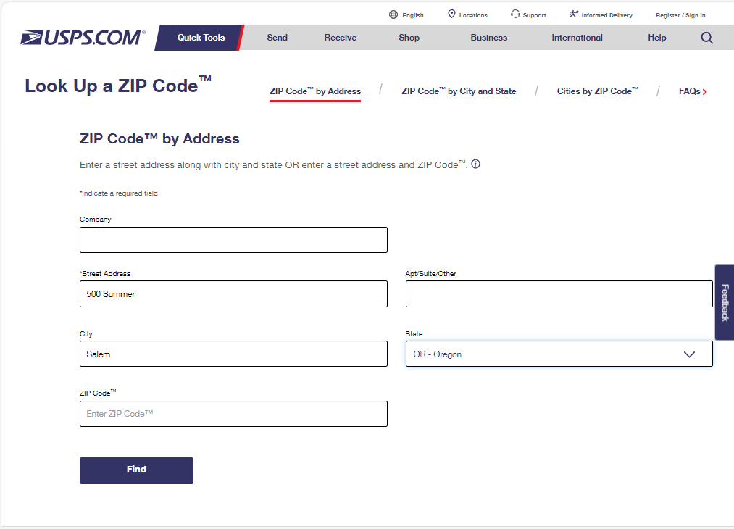

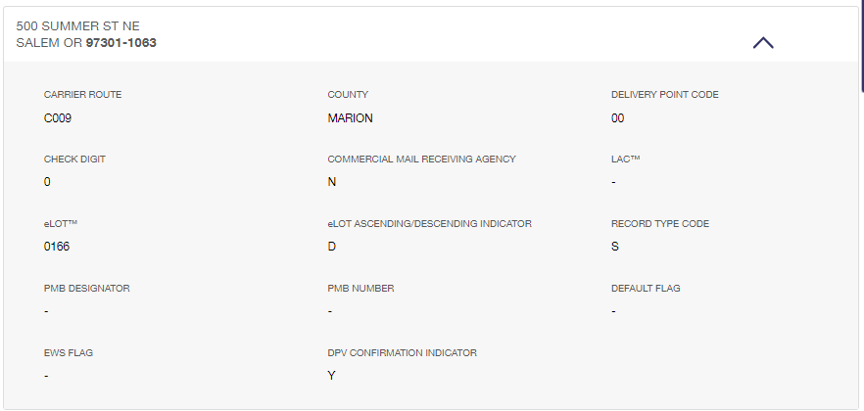

Address Location Accuracy

The position of an address point is relative, not absolute, because an address point generally represents large features on the ground, such as a house, not a precise point, such as a survey monument. Address points are typically placed manually based on the interpretation of one or a combination of the following: maps, site diagrams, aerial photographs, street view photos, and/or other reference data. Various levels of accuracy will be defined for the location including unit level (best), rooftop or building level (good), parcel level (fair) or street level (estimated).

At a minimum, the address point(s) should be located within the building footprint if a structure exists on the property. If no structure exists, the address points(s) must be located within the taxlot for the property. Address points that are estimated along a street centerline should be repositioned to either the correct taxlot or building footprint.

2.5.7 Edge Matching

2.5.8 Feature Identifier
By nature, address points are a unique index. Complete and accurate data provided from local jurisdictions will serve as a unique address ID.

2.5.9 Attributes

The Oregon Address Points Data start has divided attributes into two categories, NENA Core Attributes, and supplemental attributes.

2.5.10 Transactional Updating

Address point data is created and maintained by local jurisdictions then aggregated into a statewide dataset. Transactional updates to the aggregated dataset relies on maintaining a unique primary key to ensure the same address is comparable in both the old and new updates. While most address points will have no change in each update some may have changes including -

New address (added)
Changed address or location (modified)
Old address (deleted)

2.5.11 Records Management

The Oregon Address Points Data Standard will be available to the public on OGIC’s Hub site of all Oregon Framework standards. The geospatial data created using this standard will be made available to the public through standard means such as online data services or data downloads through GEOHub.

2.5.12 Metadata

The standard follows the Oregon Framework Metadata Standard for geospatial data, which is integrated with the Federal Geographic Data Committee, Content Standard for Digital Geospatial Metadata.

3.0 Data Characteristics

3.1 Minimum Graphic Data Elements

The Oregon Address Point Data Standard only includes point features.

Table 3 – Address Point Data Schema

IMPORTANT: The core of the Oregon Address Point Standard is the NENA Site Structure Address Point (SSAP) schema. Refer to the NENA Standard for NG9-1-1 GIS Data Model document on pages 31 – 33 with detailed descriptions of each field starting on page 51.

Required – Red indicates a change in the Oregon standard from the national standard.

"Y" = The data element is required to be present in all addresses.
"N" = The data field is optional in an address.
"C" = The data field is conditionally required if a value is present in a complete address.

Used – Indicates how often a field is used.

"1" = Always used
"2" = Commonly used
"3" = Occasionally used
"4" = Rarely used

Values –

"Y" - Domain or lookup table of acceptable values is available for the field.

Source – Indicates if the field comes from the NENA core or has been added for the Oregon standard.

"NENA" = Core fields (45 fields)
"ADDED" = Supplemental fields added to the Oregon standard (14 fields)

GROUP | SUBGROUP | FIELD NAME | FIELD DESCRIPTION | DATA TYPE | WIDTH | REQUIRED | USED | VALUES | SOURCE
ADDRESS |  | ADDRESS_ID | Unique Address Identifier | TEXT | 36 | Y | 1 |  | ADDED
ADDRESS |  | ADDRESS_FULL | Complete Street Address | TEXT | 100 | Y | 1 |  | ADDED
ADDRESS | STREET NUMBER | STREET_NUMBER_FULL | Complete Street Number | TEXT | 10 | Y | 1 |  | ADDED
ADDRESS | STREET NUMBER | Add_Number | Address Number | INTEGER | 6 | Y | 1 |  | NENA
ADDRESS | STREET NUMBER | AddNum_Pre | Address Number Prefix | TEXT | 15 | C | 4 |  | NENA
ADDRESS | STREET NUMBER | AddNum_Suf | Address Number Suffix | TEXT | 15 | C | 2 |  | NENA
ADDRESS | STREET NAME | STREET_NAME_FULL | Complete Street Name | TEXT | 254 | Y | 1 |  | ADDED
ADDRESS | STREET NAME | St_PosTyp | Street Name Post Type | TEXT | 50 | C | 2 | Y | NENA
ADDRESS | STREET NAME | St_PreDir | Street Name Pre Directional | TEXT | 10 | C | 2 | Y | NENA
ADDRESS | STREET NAME | St_PosDir | Street Name Post Directional | TEXT | 10 | C | 2 | Y | NENA
ADDRESS | STREET NAME | St_Name | Street Name | TEXT | 254 | Y | 1 | Y | NENA
ADDRESS | STREET NAME | St_PreTyp | Street Name Pre Type | TEXT | 50 | C | 3 | Y | NENA
ADDRESS | STREET NAME | St_PreSep | Street Name Pre Type Separator | TEXT | 20 | C | 4 | Y | NENA
ADDRESS | STREET NAME | St_PreMod | Street Name Pre Modifier | TEXT | 15 | C | 4 |  | NENA
ADDRESS | STREET NAME | St_PosMod | Street Name Post Modifier | TEXT | 25 | C | 4 |  | NENA
ADDRESS | SUBADDRESS | SUBADDRESS_FULL | Complete Unit Address | TEXT | 100 | C | 2 |  | ADDED
ADDRESS | SUBADDRESS | SUBADDRESS_TYPE | Unit Type | TEXT | 20 | C | 2 | Y | ADDED
ADDRESS | SUBADDRESS | SUBADDRESS_NUMBER | Unit Number | TEXT | 10 | C | 2 |  | ADDED
ADDRESS | SUBADDRESS | Unit | Unit | TEXT | 75 | C | 2 |  | NENA
ADDRESS | SUBADDRESS | Building | Building | TEXT | 75 | N | 3 |  | NENA
ADDRESS | SUBADDRESS | Floor | Floor | TEXT | 75 | N | 3 |  | NENA
ADDRESS | SUBADDRESS | Room | Room | TEXT | 75 | N | 3 |  | NENA
ADDRESS | SUBADDRESS | Seat | Seat | TEXT | 75 | N | 4 |  | NENA
ADDRESS | SUBADDRESS | Addtl_Loc | Additional Location Information | TEXT | 225 | N | 4 |  | NENA
LOCALITY | PROPERTY | BUILDING_ID | Building Footprint Identifier | TEXT | 20 | N | 2 |  | ADDED
LOCALITY | PROPERTY | PARCEL_ID | Parcel Identifier | TEXT | 20 | N | 2 |  | ADDED
LOCALITY | COMMUNITY | Post_Comm | Postal Community Name | TEXT | 40 | Y | 1 | Y | NENA
LOCALITY | COMMUNITY | Post_Code | Postal Code | TEXT | 7 | Y | 1 | Y | NENA
LOCALITY | COMMUNITY | PostCodeEx | Postal Code Extension | TEXT | 4 | N | 2 |  | NENA
LOCALITY | COMMUNITY | Inc_Muni | Incorporated Municipality (A3) | TEXT | 100 | Y | 1 | Y | NENA
LOCALITY | COMMUNITY | Uninc_Comm | Unincorporated Community (A4) | TEXT | 100 | N | 3 | Y | NENA
GROUP | SUBGROUP | FIELD NAME | FIELD DESCRIPTION | DATA TYPE | WIDTH | REQUIRED | USED | VALUES | SOURCE
LOCALITY | COMMUNITY | Nbrhd_Comm | Neighborhood Community (A5) | TEXT | 100 | N | 4 |  | NENA
LOCALITY | REGION | County | County or Equivalent (A2) | TEXT | 100 | Y | 1 | Y | NENA
LOCALITY | REGION | State | State or Equivalent (A1) | TEXT | 2 | Y | 1 | Y | NENA
LOCALITY | REGION | Country | Country | TEXT | 2 | Y | 1 | Y | NENA
LOCATION |  | SHAPE | SHAPE | GEOMETRY |  | Y | 1 |  | ADDED
LOCATION |  | OBJECTID | ArcGIS Record Identifier | INTEGER |  | Y | 1 |  | ADDED
LOCATION |  | Longitude | Longitude (X) | DECIMAL |  | Y | 1 |  | NENA
LOCATION |  | Latitude | Latitude (Y) | DECIMAL |  | Y | 1 |  | NENA
LOCATION |  | Elevation | Elevation (Z) | INTEGER | 6 | N | 4 |  | NENA
LOCATION |  | Placement | Placement Method | TEXT | 25 | N | 2 | Y | NENA
EXTRA | CASS | MAIL | USPS Delivery Point Validation | TEXT | 20 | N | 2 | Y | ADDED
EXTRA | CASS | RESIDENTIAL | USPS Residential Delivery Indicator | TEXT | 20 | N | 2 | Y | ADDED
EXTRA | TIME | STAGE | Address Lifecycle Stage | TEXT | 20 | N | 2 | Y | ADDED
EXTRA |  | Place_Type | Place Type | TEXT | 50 | N | 3 | Y | NENA
EXTRA |  | LandmkName | Complete Landmark Name | TEXT | 150 | C | 3 |  | NENA
EXTRA |  | AddDataURI | Additional Data URI | TEXT | 254 | C | 3 |  | NENA
METADATA | TIME | DateUpdate | Date Updated | DATE |  | Y | 1 |  | NENA
METADATA | TIME | Effective | Effective Date | DATE |  | N | 3 |  | NENA
METADATA | TIME | Expire | Expiration Date | DATE |  | N | 3 |  | NENA
911 | 911 IDENTIFIER | DiscrpAgID | Discrepancy Agency ID | TEXT | 100 | Y | 1 |  | NENA
911 | 911 IDENTIFIER | NGUID | NENA Globally Unique ID | TEXT | 254 | Y | 1 |  | NENA
911 | 911 LEGACY ADDRESS | LSt_PreDir | Legacy Street Name Pre Directional | TEXT | 2 | C | 4 | Y | NENA
911 | 911 LEGACY ADDRESS | LSt_Name | Legacy Street Name | TEXT | 75 | C | 4 |  | NENA
911 | 911 LEGACY ADDRESS | LSt_Typ | Legacy Street Name Type | TEXT | 4 | C | 4 | Y | NENA
911 | 911 LEGACY ADDRESS | LSt_PosDir | Legacy Street Name Post Directional | TEXT | 2 | C | 4 | Y | NENA
911 | 911 REGION | MSAGComm | Master Street Address Guide Community Name | TEXT | 30 | C | 4 | Y | NENA
911 | 911 REGION | ESN | Emergency Service Number | TEXT | 5 | C | 4 | Y | NENA
911 | 911 OTHER | Milepost | Milepost | TEXT | 150 | C | 4 |  | NENA

Address Point Data Dictionary – Alphabetical by Field Name

Format

Field Name | Field Description | NENA Core or Oregon Added
5.n - NENA standard section and description.
Oregon additional description, notes, tips, and examples.

AddDataURI | Additional Data URI | NENA Core
5.4 - Uniform Resource Identifier(s) for additional data associated with the address point. This attribute is contained in the Site Structure Address Point layer and will define the Service URI of additional information about a location, including building information (blueprints, contact info, floor plans, etc.).
A web link that adds context to, or additional specific information about, a street address.

Examples: 1705 Main Street, Baker City, OR 97814 https://www.bakertower.com

Addtl_Loc | Additional Location Information | NENA Core
5.5 - A part of a sub-address that is not a Building, Floor, Unit, Room, or Seat.

Add_Number | Address Number | NENA Core
5.6 - The numeric identifier of a location along a thoroughfare or within a defined community.
The street number, occurring within the range of block numbers along a street segment, that is usually assigned to each house or separate structure. The street number is the integer-only portion and does not include any leading zeros or trailing characters. Even and odd numbers are usually found on opposite sides of the street.

AddNum_Pre | Address Number Prefix | NENA Core
5.7 - An extension of the address number that precedes it and further identifies a location along a thoroughfare or within a defined area.
There are no known addresses in Oregon with an address number prefix.

AddNum_Suf | Address Number Suffix | NENA Core
5.8 - An extension of the address number that follows it and further identifies a location along a thoroughfare or within a defined area.
The vast majority of Oregon street numbers are numeric only. However, a few street numbers also contain trailing characters with the most common being half addresses (1/2) separated from the street number by a space.

Examples: 510 1/2 East 12th Avenue Apartment B, Eugene, OR 97401

Much less common are single letters (usually A, B, C, D) sometimes used in mailing addresses for units in duplexes, triplexes, or Auxiliary Dwelling Units (ADU). These characters are usually not separated from the street number by a space. For added confusion, these letters could also be in the Unit field instead.

Examples: 2560A Columbia Boulevard, Saint Helens, OR 97051
2560B Columbia Boulevard, Saint Helens, OR 97051
2560C Columbia Boulevard, Saint Helens, OR 97051
2560D Columbia Boulevard, Saint Helens, OR 97051

ADDRESS_FULL | Complete Street Address | Oregon Added
none
The complete address concatenated from all the address elements present for an address including the full street number, full street name, and full subaddress. Can be part of a composite intrinsic primary key along with the ZIP Code.

ADDRESS_ID | Address Identifier | Oregon Added
none
Unique extrinsic address primary key.

Building | Building | NENA Core
5.19 - One among a group of buildings that have the same address number and complete street name.
The name, number, or letter identifying a single building among a group of buildings associated with the same street address. Buildings are often identified in apartment complexes, university campuses, business parks, and other multi-building areas.

Examples: 415 Toliver Road Building F1, Molalla, OR 97038
415 Toliver Road Building F2, Molalla, OR 97038

Tip – Sometimes the building is part of the unit number.

Examples: 1605 Oak Street Southeast Apartment A101, Albany, OR 97322
(Building A, Unit 101)
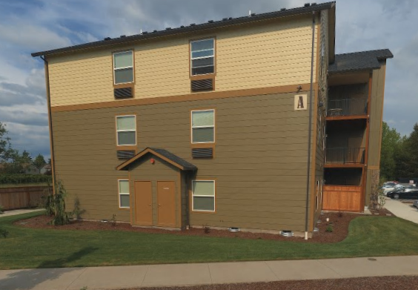

BUILDING_ID | Building Footprint Identifier | Oregon Added
none
Placeholder for a building footprint identifier that the address point is located within. Still to be determined from a future building footprint data standard.

Country | Country | NENA Core
5.24 - The name of a country represented by its two-letter ISO 3166-1 English country alpha-2 code elements in UPPER CASE letters.
“US” only. No blanks or nulls.

County | County or Equivalent (A2) | NENA Core
5.27 - The name of a County or County-equivalent where the address is located. A county (or its equivalent) is the primary legal division of a state or territory.
Values are the county names for the 36 counties in Oregon listed in a domain. No blanks or nulls.

DateUpdate | Date Updated | NENA Core
5.30 - The date and time that the record was created or last modified. This value MUST be populated upon modifications to attributes, geometry, or both.

DiscrpAgID | Discrepancy Agency Identifier | NENA Core
5.31 - Agency that receives a Discrepancy Report (DR), should a discrepancy be discovered, and will take responsibility for ensuring discrepancy resolution. This may or may not be the same as the 9-1-1 Authority.

Effective | Date Effective | NENA Core
5.33 - The date and time that the record is scheduled to take effect.

Elevation | Elevation | NENA Core
5.34 - The elevation, given in meters above a reference surface defined by the coordinate system, associated with the site/structure address.

ESN | Emergency Service Number | NENA Core
5.35 - A 3-5 character numeric string that represents one or more 9-1-1 Emergency Service Zones (ESZ).

Expire | Date Expired | NENA Core
5.39 - The date and time when the information in the record is no longer considered valid.

Floor | Floor | NENA Core
5.40 - A floor, story, or level within a building.
Examples: 1300 Southwest 5th Avenue Floor 10, Portland, OR 97201
1300 Southwest 5th Avenue Floor 11, Portland, OR 97201
1300 Southwest 5th Avenue Floor 12, Portland, OR 97201

Tip – Sometimes the floor is part of the unit number.

Examples: 1605 Oak Street Southeast Apartment A101, Albany, OR 97322
(Building A, Floor 1, Unit 101)
1605 Oak Street Southeast Apartment A201, Albany, OR 97322
(Building A, Floor 2, Unit 201)

Inc_Muni | Incorporated Municipality | NENA Core
5.45 - The name of the Incorporated Municipality or other general-purpose local governmental unit (if any) where the address is located. Use "Unincorporated" if the address is not within an incorporated local government.
The name of the actual incorporated jurisdiction the address point is in. Values of all 241 incorporated city names in Oregon are listed in a domain.

IMPORTANT – The postal city name may not match the incorporated city name of the actual jurisdiction the address point is located in because ZIP Codes frequently do not follow incorporated city limits.

LandmkName | Complete Landmark Name | NENA Core
5.21 - The name by which a prominent site/structure is publicly known. Landmarks may or may not be associated with a civic address.
The landmark name can be used to attach a familiar, prominent, or famous place name to a street address.

Examples: 900 Court Street Northeast, Salem, OR 97301
Landmark Name: Oregon State Capitol

Latitude | Latitude (Y) | NENA Core
5.51 - The angular distance of a location north or south of the equator as defined by the coordinate system, expressed in decimal degrees.
In Oregon the latitude (Y) coordinate is north of the Equator in positive decimal degrees between 42.0 and 46.25. Accuracy to six decimal places is required.

Longitude | Longitude (X) | NENA Core
5.65 - The angular distance of a location east or west of the prime meridian of the coordinate system, expressed in decimal degrees.
In Oregon the longitude (X) coordinate is west of the Prime Meridian in negative decimal degrees from -116.5 to -124.5. Accuracy to six decimal places is required.

LSt_Name | Legacy Street Name | NENA Core
5.55 - The street name as it currently exists in the MSAG. Ideally this is the name as assigned by the local addressing authority.

LSt_PosDir | Legacy Street Post Direction | NENA Core
5.56 - The street name as it currently exists in the MSAG. Ideally this is the name as assigned by the local addressing authority.

LSt_PreDir | Legacy Street Pre Direction | NENA Core
5.57 - The leading street direction prefix as it currently exists in the MSAG. Ideally this is the street name pre directional as assigned by the local addressing authority.

LSt_Typ | Legacy Street Type | NENA Core
5.58 - The valid street abbreviation as it currently exists in the MSAG. Ideally this is the street name type as assigned by the local addressing authority.

MAIL | USPS Delivery Point Validation | Oregon Added
none
DPV indicates that the street and unit addresses matches the US Postal Service Delivery Point File (DPF) and receives mail. The USPS ZIP Code Lookup tool will provide the DPV for an individual address. CASS tools will also return the DPV for address lists.

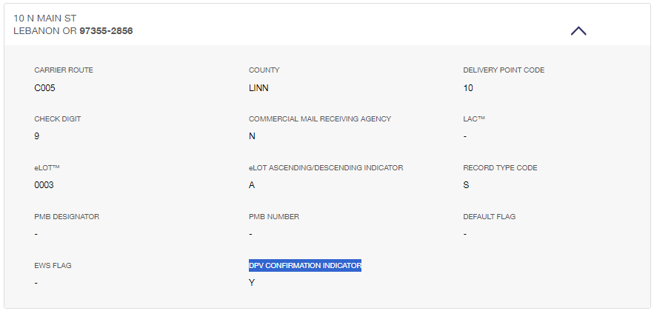

Y = Matches both street and unit address (if present). Receives mail.
N = Does not match a street number for the street address range. Does not receive mail.
D = Matches street address but a unit address is missing. Does not receive mail.
S = Matches street address but the unit address is incorrect. Does not receive mail.
Null = No match found in the DPF. Does not receive mail.

NOTE – Many addresses actually exist on the ground that do not receive mail. These addresses may have a Post Office box for a mailing address. For example, addresses in Sunriver do not receive mail.

Milepost | Milepost | NENA Core
5.67 - A distance travelled along a route such as a road or highway, typically indicated by a milepost sign. There is typically a post or other marker indicating the distance in miles/kilometers from or to a given point.
Not required for Oregon street addresses.

MSAGComm | Master Street Address Guide Community | NENA Core
5.68 - The Community name associated with an address as given in the MSAG and may or may not be the same as the Community Name used by the postal service.

Nbrhd_Comm | Neighborhood Community | NENA Core
5.71 - The name of an unincorporated neighborhood, subdivision, or area, either within an incorporated municipality or in an unincorporated portion of a county or both, where the address is located.

NGUID | NENA Globally Unique Identifier | NENA Core
5.74 - The NENA Globally Unique ID (Primary Key) for each record in a GIS data layer. Each record in the GIS data layer MUST have a globally unique ID.

OBJECTID | ArcGIS Record Identifier | Oregon Added
none
The OBJECTID is a unique, sequential, auto-incrementing row number for each geometry feature that is used and maintained exclusively by ArcGIS software. It is not used as an address primary key because it may change unexpectedly at any time.

PARCEL_ID | Parcel Identifier | Oregon Added
none
Placeholder for the parcel or taxlot that the address point is located within. Conforms to the MapTaxlot field in the Oregon Cadastral Exchange Standard.

Place_Type | Place Type | NENA Core
5.78 - The type of feature identified by the address. See the Location Types Registry.

Placement | Placement Method | NENA Core
5.79 - The methodology used for placement of the address point. See the Placement Method Registry.

Post_Code | Postal Code | NENA Core
5.80 - A system of 5-digit (US) codes that identify the individual USPS Post Office or metropolitan area delivery station associated with an address.
The US Postal Service assigned five-digit Zone Improvement Plan (ZIP) Code for the address. This address element can be used to make identical addresses found in different cities unique. There are 479 ZIP Codes in Oregon all beginning with “97” and all values are listed in a domain. The USPS ZIP Code Lookup tool can be used to find the correct ZIP Code for individual street addresses. USPS CASS certified software or services can be also used to find the correct ZIP Code for address lists. ZIP Codes are always stored as text, not integers, because they can have leading zeros. The first character of a ZIP Code is for the general geographic area within the US from 0 on the east coast to 9 on the west coast. The second and third characters are for regions within Oregon. The last two characters are for specific Post Offices.

Examples: 10 North Main Street, Lebanon, OR, 97355
10 North Main Street, Falls City, OR, 97344

Post_Comm | Postal Community | NENA Core
5.84 - A city name for the Postal Code of an address.
The USPS preferred city name associated with the ZIP Code. ZIP Codes do not necessarily follow city limits so the postal city name may not match the actual city jurisdiction the address is located in. The US Postal Service exclusively manages ZIP Codes and the preferred city names. Some ZIP Codes have other acceptable postal city names that can be used for mail instead of the preferred city name. Refer to the ZIP Codes in Oregon to see the preferred, acceptable, and city names to avoid for each ZIP Code.

PostCodeEx | Postal Code Extension | NENA Core
5.81 - The addition of the Postal Code Extension refines the mail delivery point down to a specific block or building, and may prove useful to validate locations. Postal Code Extensions change more often than US Postal Codes, and this additional data field should make maintaining these optional codes easier
The four-digit ZIP Code+4 add-on. The USPS ZIP Code Lookup tool can be used to find the correct ZIP Code add-on for any individual address. CASS certified software or services can also be used to find the correct ZIP Code add-on for address lists. The ZIP Code add-on is not used to make an address unique because the five-digit ZIP Code is sufficient to make sure there are no duplicate addresses. Even though they are numerals the ZIP+4 add-on is always stored as text, not integers, because it can have leading zeros.

RESIDENTIAL | USPS Residential Delivery Indicator | Oregon Added
none
The US Postal Service Residential Delivery Indicator (RDI) can be used to distinguish a residential address from a non-residential address. CASS software can provide the RDI.

Room | Room | NENA Core
5.97 - A single room within a building.

Seat | Seat | NENA Core
5.98 - A place where a person might sit within a building.

SHAPE | SHAPE | Oregon Added
none
The SHAPE field stores the spatial location of the address point as a binary geometry object. This object is constructed from -

1. The geometry type – single POINT for every address. There will be no multi-point features for address points.
2. The negative longitude (X) coordinate for the east-west direction to six decimal places.
3. The positive latitude (Y) coordinate for the north-south direction to six decimal places.
4. The spatial reference well-known identifier. 4326 = WGS84 (World Geodetic System 1984).

Examples: POINT(-123.123456 45.123456),4326

NOTE: The SHAPE field will also have a spatial index that greatly speeds up spatial operations.

St_Name | Street Name | NENA Core
5.110 - The official name of the road, usually defined by the lowest jurisdictional authority (e.g., city). The street name does not include any street types, directionals, or modifiers.
The street name may consist of letters or numbers, single or multiple words separated by single spaces.

Examples: 124th Avenue
Avenue A
Highway 101
Summer Street

St_PosDir | Street Name Post Direction | NENA Core
5.111 - A word following the Street Name element that indicates the direction taken by the road from an arbitrary starting point or line, or the sector where it is located.
A street may or may not have a post-direction. This usually depends on the jurisdiction. Generally, if a street has a pre-direction it will not have a post-direction. Many streets have neither and may be blank or null. The pre-direction and post-direction values are the same – North, South, East, West, Northeast, Northwest, Southeast, Southwest.

Examples: 500 Summer Street Northeast, Salem, OR 97301

St_PosMod | Street Name Post Modifier | NENA Core
5.112 - A word or phrase that follows and modifies the Street Name element, but is separated from it by a Street Name Post Type or a Street Name Post Directional or both.
Very few addresses in Oregon have a street name post-modifier.

Examples: Highway 95 Spur
Highway 101 Business

St_PosTyp | Street Name Post Type | NENA Core
5.113 - A word or phrase that follows the Street Name element and identifies a type of thoroughfare in a complete street name.
The fully spelled street suffix or street type following the street name (Avenue, Boulevard, Road, Street, many others), that identifies a type of thoroughfare in a complete street name. The vast majority of streets will have a street type but this field may be null for the relatively few addresses that do not have a street type (mostly numbered Highway addresses). A list of all street type values are listed in a domain.

St_PreDir | Street Name Pre Direction | NENA Core
5.114 - A word preceding the Street Name element that indicates the direction taken by the road from an arbitrary starting point or line, or the sector where it is located.
A street may or may not have a pre-direction. This usually depends on the jurisdiction. Generally, if a street has a post-direction it will not have a pre-direction. Many streets have neither and may be blank or null.

The pre-direction and post-direction values are the same – North, South, East, West, Northeast, Northwest, Southeast, Southwest.

Examples: 800 Northeast Oregon Street, Portland, OR 97232

St_PreMod | Street Name Pre Modifier | NENA Core
5.115 - A word or phrase that precedes and modifies the Street Name element but is separated from it by a Street Name Pre Type or a Street Name Pre Directional or both.
There are very few addresses in Oregon that have a pre-modifier.

Examples: Old Highway 99

St_PreSep | Street Name Pre Separator | NENA Core
5.117 - A preposition or prepositional phrase between the Street Name Pre Type and the Street Name. See Street Name Pre Type Separators.
Very few street names in Oregon have pre separators which are found between the street pre-type and street name for certain addresses. These can have foreign language spellings (Spanish, Italian, French, Portuguese) as well as English spellings and will also have street pre types.

Examples: 7700 Avenue of the Sun, White City, OR 97503
15820 Camino de Oro, La Pine, OR 97739

St_PreTyp | Street Name Pre Type | NENA Core
5.116 - A word or phrase that precedes the Street Name element and identifies a type of thoroughfare in a complete street name. See Street Name Pre and Post Types.
The street type appears before the street name for certain addresses. The street pre-type uses the same values as the street type domain. Generally, there will be no street type if there is a street name pre-type. By far, the most common street pre-type in Oregon is for numbered Highway addresses.

Examples: 2701 Northwest Highway 101, Lincoln City, OR 97367
1125 Avenue A, Seaside, OR 97138

STAGE | Address Lifecycle Stage | Oregon Added
none
Indicates which stage the address is in its lifecycle, especially if there is no structure associated with it.

Future - Planned, platted, or pending address that has not been constructed yet.
Current - Address is active, constructed, occupied
Past - Historical address that has been demolished.

State | State or Equivalent (A1) | NENA Core
5.107 - The name of a state or state equivalent, represented by the two-letter UPPER CASE abbreviation given in USPS Publication 28, Appendix B. A state is a primary governmental division of the United States. See the Census State List.
This field has only one value - OR for Oregon. No blanks or nulls are allowed.

STREET_NAME_FULL | Complete Street Name | Oregon Added
none
Complete street name concatenated from these separate street name elements separated by blank spaces:

Street Name Pre Modifier
Street Name Pre Type
Street Name Pre Separator
Street Name
Street Name Post Modifier

It does not include these elements:

Street Name Pre Direction
Street Name Post Type
Street Name Post Direction

STREET_NUMBER_FULL | Complete Street Number | Oregon Added
none
Complete street number concatenated from these separate address number elements:

AddNum_Pre
Add_Number
AddNum_Suf

SUBADDRESS_FULL | Complete Subaddress | Oregon Added
none
Complete subaddress concatenated from these separate subaddress elements separated by a blank space:

SUBADDRESS_TYPE
SUBADDRESS_NUMBER

SUBADDRESS_NUMBER | Subaddress Number | Oregon Added
none
The FGDC, NENA, and NAD standards typically concatenate both the unit type and unit number into one field. The USPS standard has separate unit type and unit number fields.

SUBADDRESS_TYPE | Subaddress Type | Oregon Added
none
The FGDC, NENA, and NAD standards typically concatenate both the unit type and unit number into one field. The USPS standard has separate unit type and unit number fields. The unit type has specific values listed in a domain (apartment, space, suite, unit, etc.). A pound sign (#) can also be used if the unit type is not known.

Uninc_Comm | Unincorporated Community | NENA Core
5.120 - The name of an Unincorporated Community, either within an incorporated municipality or in an unincorporated portion of a county, or both, where the address is located.
This may not be the same as the preferred city name for the ZIP Code but might be an acceptable alternate mailing city name. Could also be a Census Designated Place (CDP).

Examples: Aloha, OR 97078
Damascus, OR 97009

Unit | Unit | NENA Core
5.123 - A group or suite of rooms within a building that are under common ownership or tenancy, typically having a common primary entrance.
The unit number can be any combination of letters and/or numbers. Examples – Apartment 101, Apartment B-201, Space 18, Suite 3, Unit A. By far, the most common unit numbers are either single numbers or single letters. Various other letter/number patterns are less common.

IMPORTANT – If an address has units then they must be included as part of a complete unique address point. Because it is needed to make an address unique, the Oregon standard makes the unit field conditionally required (instead of not required in the national NENA standard). If the unit numbers are omitted from address points that should have them, duplicate street addresses could result.

IMPORTANT – To make sure all unit numbers are included for an address use the USPS ZIP Code Lookup tool to get all the unit ranges for an address. Enter just the street address and, if the address has units, the unit ranges will be listed in the results.

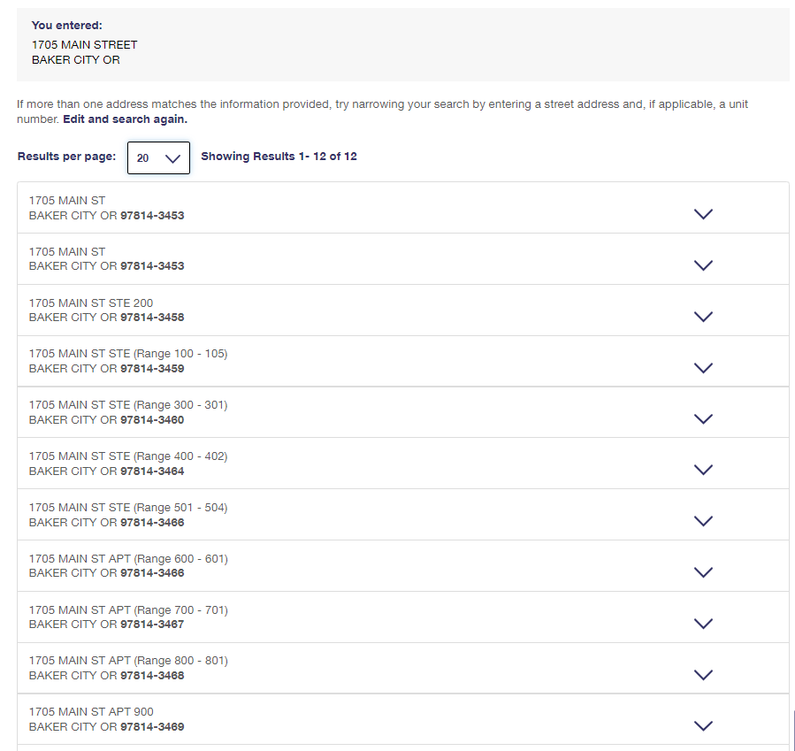

NOTE – Some mixed-use buildings have both non-residential offices (suites) and residential apartments, usually on different floors.

Examples: 1705 Main Street Suite 101, Baker City, OR 97814
1705 Main Street Suite 102, Baker City, OR 97814
1705 Main Street Suite 103, Baker City, OR 97814
1705 Main Street Suite 104, Baker City, OR 97814
1705 Main Street Suite 105, Baker City, OR 97814
1705 Main Street Suite 200, Baker City, OR 97814
1705 Main Street Suite 300, Baker City, OR 97814
1705 Main Street Suite 301, Baker City, OR 97814
1705 Main Street Suite 400, Baker City, OR 97814
1705 Main Street Suite 401, Baker City, OR 97814
1705 Main Street Suite 402, Baker City, OR 97814
1705 Main Street Suite 501, Baker City, OR 97814
1705 Main Street Suite 503, Baker City, OR 97814
1705 Main Street Apartment 600, Baker City, OR 97814
1705 Main Street Apartment 700, Baker City, OR 97814
1705 Main Street Apartment 701, Baker City, OR 97814
1705 Main Street Apartment 800, Baker City, OR 97814
1705 Main Street Apartment 801, Baker City, OR 97814
1705 Main Street Apartment 900, Baker City, OR 97814

NOTE – Some apartments do not have unit numbers but have individual street numbers instead. The Winter Garden Apartments in Salem has twelve units in two buildings, all with individual street numbers instead of unit numbers.

References

Link
Idaho Site Structure Address Point Standard
Minnesota Geospatial Advisory Council Address Point Data Standard
NENA Next Generation 9-1-1 United States Civic Location Data Exchange Format Standard
NENA Standards for the Provisioning and Maintenance of GIS data to ECRFs and LVFs
NENA Standard for NG9-1-1 GIS Data Model
NENA GIS Data Transition Information Document
NENA Information Document for Development of Site/Structure Address Point GIS Data for 9-1-1
NENA Information Document for GIS Data Stewardship for Next Generation 9-1-1
Address Point Standard for Minnesota

Appendices

Appendix A - Acronyms

Acronym | Description
ADU | Auxiliary Dwelling Unit
ALI | 9-1-1 Automatic Location Identification
CAD | 9-1-1 Computer Aided Dispatch
CASS | US Postal Service Coding Accuracy Support System
CDP | Census Designated Place
DAS | Oregon Department of Administrative Services
DPF | US Postal Service Delivery Point File
DPV | US Postal Service Delivery Point Validation
ESN | 9-1-1 Emergency Service Number
FGDC | Federal Geographic Data Committee
FIT | Framework Implementation Team
GEO | Geospatial Enterprise Operations
LACS | US Postal Service Locatable Address Conversion System
LUCA | Local Update of Census Addresses
MSAG | 9-1-1 Master Street Address Guide
NG9-1-1 | Next Generation 9-1-1
NAD | National Address Database
NENA | National Emergency Number Association
OEM | Oregon Department of Emergency Management
OGIC | Oregon Geographic Information Council
PSAP | 9-1-1 Public Safety Answering Point
RDI | US Postal Service Residential Delivery Indicator
SSAP | NENA Site Structure Address Point layer
URI | Uniform Resource Identifier
USPS | United States Postal Service
WGS84 | World Geodetic System of 1984
ZIP | US Postal Service Zone Improvement Plan
ZCTA | Census ZIP Code Tabulation Area

Appendix B - Workgroup Participants

Participant | Organization
Alex Petzold | Oregon Department of Emergency Management
Alicia Wood | Oregon Metro
Christina Barrows | Lane Council of Governments
Erik Larson | Oregon Department of Forestry
Ethan Sharygin | Portland State University, Population Research Center
Hilary Leavell | City of Salem, Willamette Valley Communications
Jason Ford | National Address Database, US Department of Transportation
Jessica Beierman | GeoComm
Juliana Wold | Oregon Department of Emergency Management
Kurt Abe | City of Portland, Bureau of Development Services
Matt Williams | FIT Co-lead, Oregon Department of Geology and Mineral Industries
Melissa Foltz | Framework Coordinator, Oregon Department of Administrative Services
Paul Cone | City of Portland
Tim Esau | Oregon Secretary of State Elections
Tim Smothers | Baker County Planning Department
Tim VanDeWalle | Yamhill Communications Agency
Tom Elder | FIT Co-lead, Oregon Department of Administrative Services

Appendix C - Implementation

Sample code for implementing the standard.

