
Oregon Reference Summit Presents...

Oregon Reference Summit Presents…is a series of virtual professional development sessions with reference-focused content appropriate for all skill levels, library types, and experiences.

Interested in Presenting?
Programs should be designed to run for either 60 minutes or 20-30 minutes including Q&A. The Summit Planning Team will provide the presentation platform (Zoom), manage advertising and registration, and assist and support presenters.

Interested in Attending?
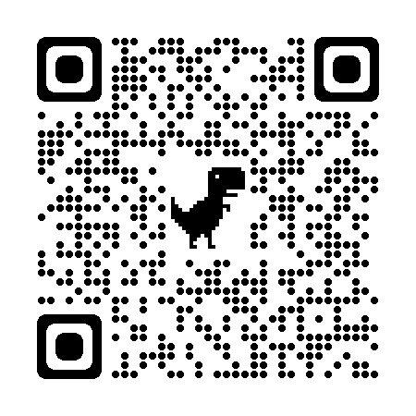
We offer session opportunities throughout the year. Our goal is to share reference-focused content appropriate for all skill levels, library types, and experiences.
For more information, or to view recordings of past sessions, scan this QR code!

Oregon Reference Summit Presents...

Oregon Reference Summit Presents…is a series of virtual professional development sessions with reference-focused content appropriate for all skill levels, library types, and experiences.

Interested in Presenting?
Programs should be designed to run for either 60 minutes or 20-30 minutes including Q&A. The Summit Planning Team will provide the presentation platform (Zoom), manage advertising and registration, and assist and support presenters.

Interested in Attending?
We offer session opportunities throughout the year. Our goal is to share reference-focused content appropriate for all skill levels, library types, and experiences.
For more information, or to view recordings of past sessions, visit the URL below or scan this QR code!

