Publicalerts.org
Lists all the alert systems for Oregon counties. Page can be translated in Spanish using the upper-left hand corner menu.
https://www.publicalerts.org/signup

METCOM 911 Alerts (Text Message/ Mensaje de texto)
Alerts Marion County and portions of Linn and Clackamas County. Alertas para el condado de Marion, y porciones de los condados de Linn y Clackamas.
- Text your zip code to 888777 / Mande un mensaje de texto con su código postal a 888777
- Wait for confirmation / Espera confirmación
- Reply ESP to get Spanish notifications (if available) / Responde con las letras ESP para recibir notificaciones en español (si disponible)

Air Quality / Calidad de Aire – Has Smoke Outlooks for North and Central Oregon (pronósticos de humo en español para las áreas central y norte de Oregon - actualizados diariamente)
http://oregonsmoke.blogspot.com/

Real-time Assessment and Planning Tool for Oregon (RAPTOR)
Where are all the wildfires in Oregon and what are the levels of evacuation? ¿Dónde están localizados los incendios forestales en Oregon y cuales son los niveles de evacuación?
https://www.oregon.gov/oem/emops/Pages/RAPTOR.aspx
Use the search bar to search by zip code or address to give an accurate answer on evacuation levels (see screen shot below). It takes awhile to load because of all the information on the map.

Bilingual Explanation of Levels of Evacuation from Marion County
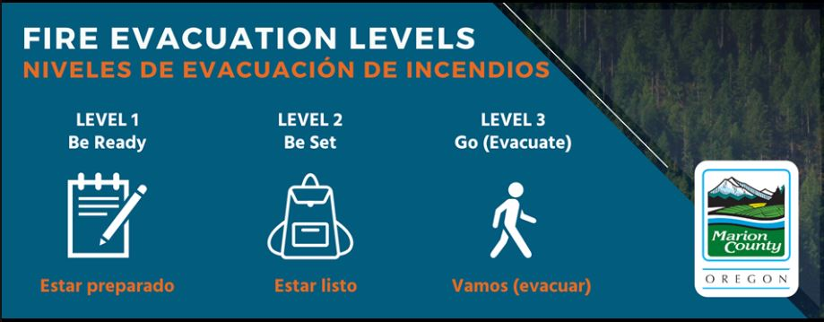

Report price gouging in Oregon
Website can be translated into various languages using the upper-right corner language menu.
https://www.doj.state.or.us/consumer-protection/

Oregon Wildfire Page – uses Google translate
https://wildfire.oregon.gov/

