1) Select the Tickets & FAQs drop down menu in the gold tool bar at the top of the page and click on the FAQ Knowledge Base menu item
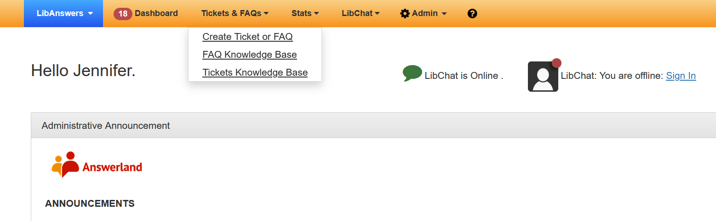

2) On the following page under the Group(1) drop down menu, select your institution from the list and click the blue Filter(2) button in the center of the page
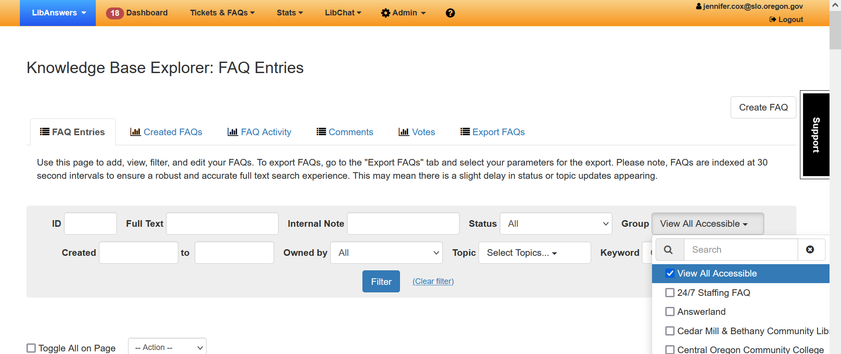
2
1
3) Look at the Updated column to see when the content was last viewed by your staff. Then click on the title of the FAQ that you wish to update/edit.
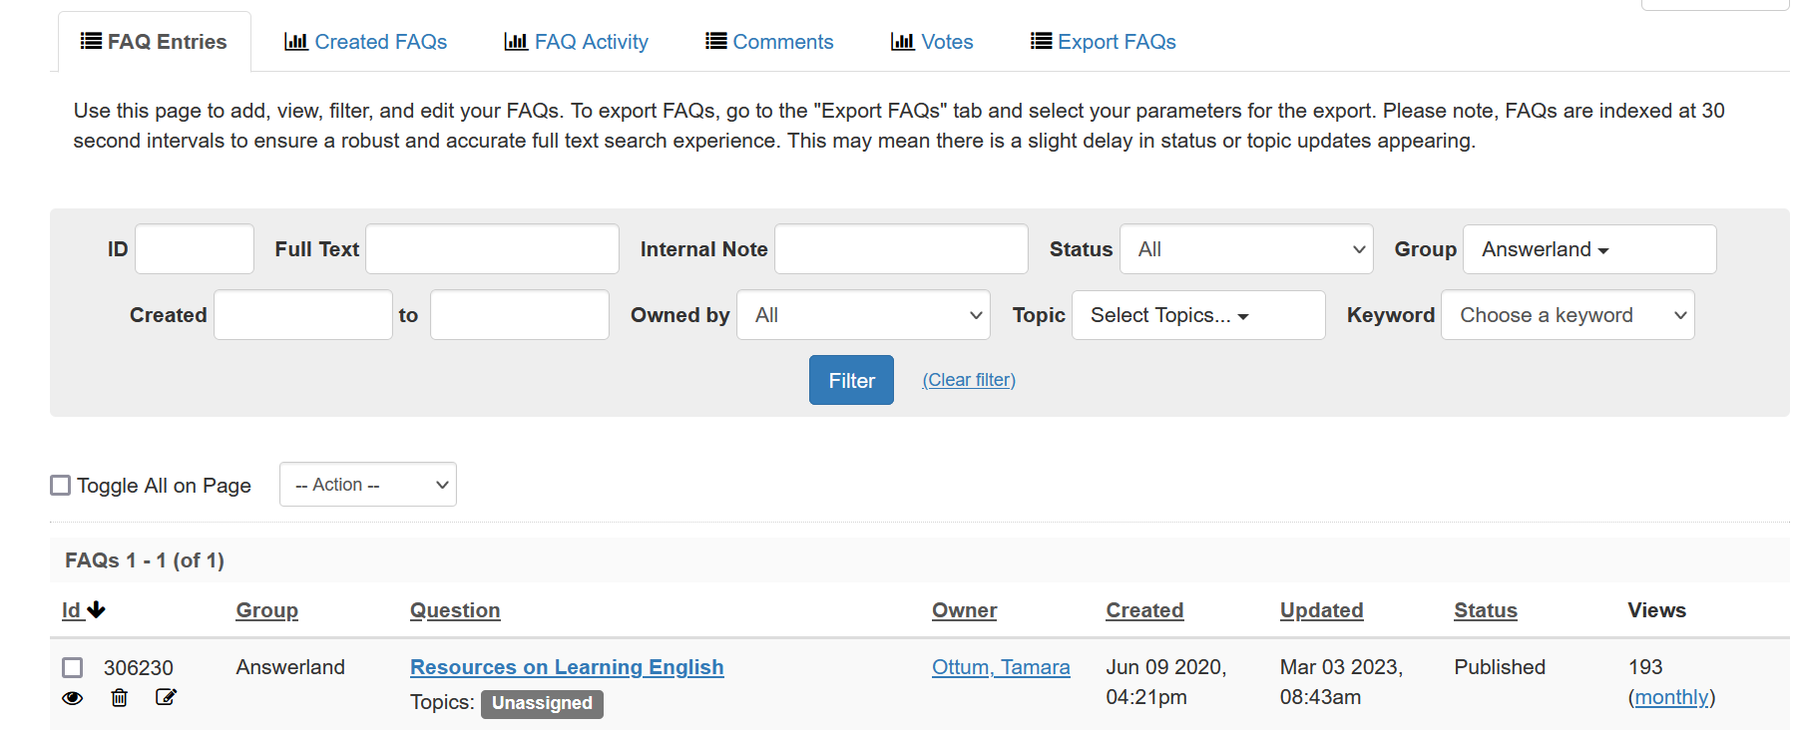
4) On the following page, click the Edit button in the middle of the page. 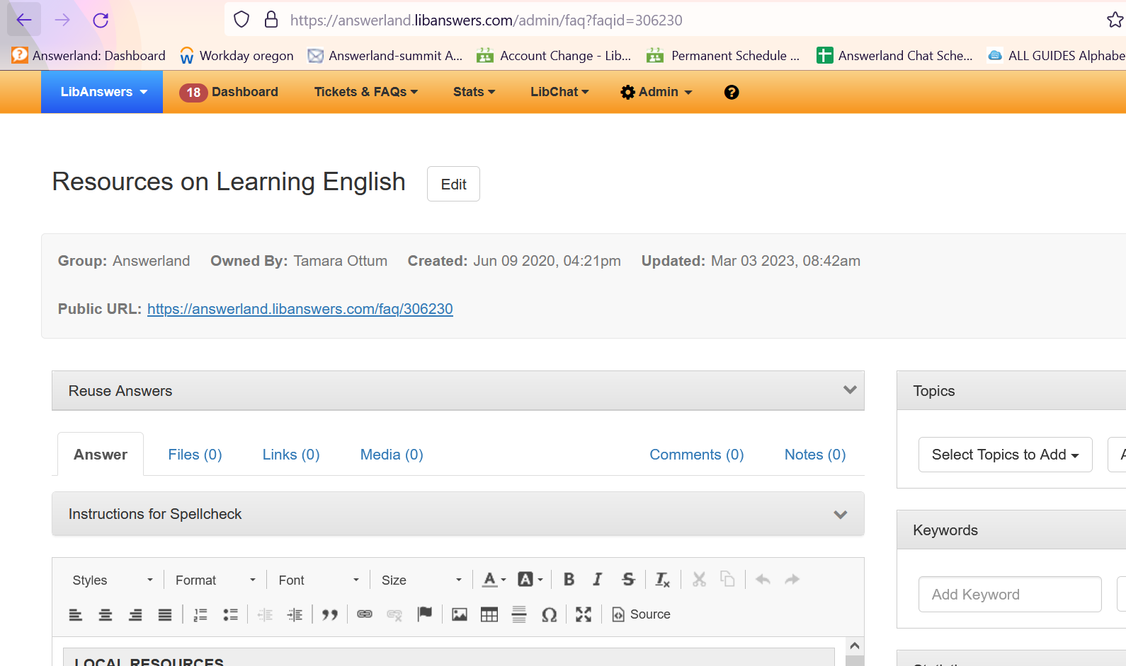

5) Review the information and links in plain text or html, then click Save Answer Text. Next you can Preview the FAQ or select its status to published or unpublished (if you feel like changes make take longer then you have the ability to make in this session).
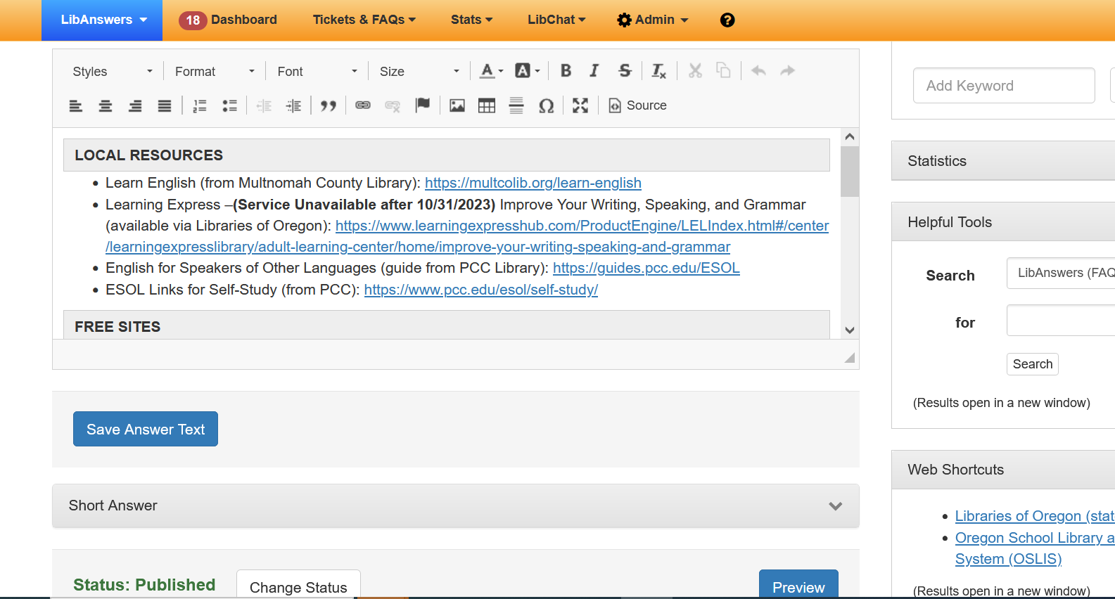
References
Springshare’s FAQs: Create, edit, and publish an FAQ entry

