PUBLIC HEALTH DIVISION  Injury Prevention and Epidemiology | 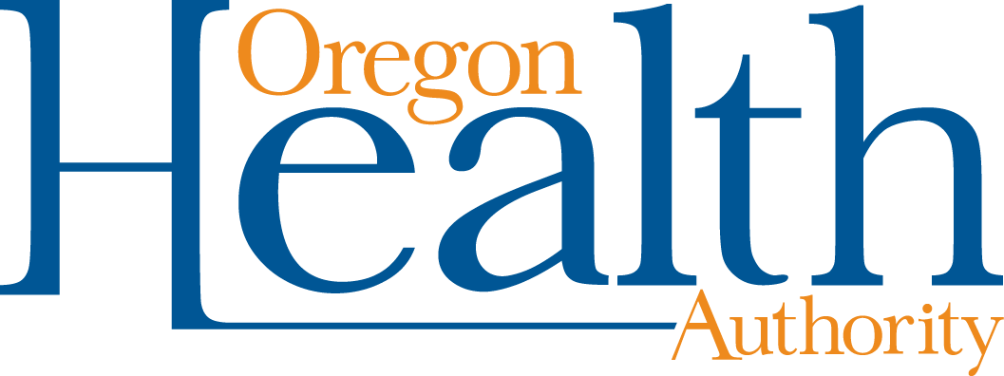

800 NE Oregon Street, Suite 772
Portland OR 97232
Phone: 971-673-1023
FAX: 971-673-0990

July 30, 2026

Dear Oregon ASIST Trainers,

Good news! I received approval from the Oregon chapter of NASW to offer 12.0 CE credits for social workers who complete the ASIST training from "approved" trainers (everyone who sent me a bio).

You may begin to offer the 12.0 CE credits right away for those who complete the training. Here is the process:
- Participants who want credits sign a roster.
- They complete a separate evaluation form for NASW.
- You give each of the participants who are getting credits an NASW certificate - you fill in their names and the training completion date.
- You send the completed rosters and evaluations to me (address on the forms).

Send the forms to me because the Public Health Division is "sponsoring" the trainings as far as CEs are concerned. That might seem a little strange because you/your organizations are sponsoring your trainings, but CE approval is through our application. Oregon NASW wants to receive the rosters and evaluations only 2-3 times a year (not after each training), so I will send many in at the same time.

Please contact me for the blank certificates, roster, and evaluation forms that you'll need. I'll send them electronically.

If you want your trainings listed on the Oregon NASW training website and in their quarterly newsletter, you'll have to let me know by August 31, November 30, February 29, and May 31 for the following quarter. Send me the dates, address, sponsor, cost, and contact information (phone, email, or web address).

If you didn't send me a brief bio, it's not too late. Please send it now - it does have to go through their approval process, but I can add names. I'll attach the list of ASIST trainers approved to offer NASW CE credits. If you or your training partners aren't listed, I didn't receive a bio.

I understand that NASW CEs also are accepted for LPCs and also for addictions counselors and prevention specialists through ACCBO (the Addiction Counselor Certification Board). Now we can advertise that we offer NASW CE credits in our promotional materials.

Please let me know if you have any questions.

Kind regards,
Donna
Donna G. Noonan

