 | April 26thand 27th, 2012  9:00 am – 5:00 pm (both days) in EUGENE

This ASIST Training is sponsored by ColumbiaCare and The Lane County Prevention Program | 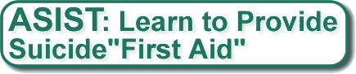  Applied ... Suicide... Intervention... Skills... Training...  ASIST is a two-day interactive workshop that trains professionals and other community providers in suicide "first-aid". Participants are trained how to recognize and assess the potential risk of suicide. This workshop also equips the participant with the intervention skills to keep the person safe until the appropriate level of ongoing help can be accessed.  World Class Training  ASIST is the most widely used, acclaimed, and researched suicide intervention training in the world. Over 1500 Oregonians have taken ASIST in recent years. In addition to learning the knowledge and skills of suicide intervention, participants report improved comfort, confidence, and competence doing interventions. ASIST is not therapy. It is "first-aid" designed to keep a person safe until they can receive further intervention.  Participants will be able to:  - Recognize attitudes about suicide  - Identify suicide factors and estimate risk  - Intervene with a person at risk to make them safe  - List resources available to a person at risk  - Commit to help coordinate social support for a person at risk  Registration  Cost: $125.00. Cost includes registration, and all materials for the class. Lunch will be on your own.  Please note: Space is limited to 30 per class.  To Register Online: Click Here  Please note that your payment must be received 10 days prior to training.  Materials must be ordered from Canada. Payments will not be refundable after April 16th.  Questions about the training? Please contact Jill Hollingsworth at (541) 337.9001.

Who should take this training?  This training is for any person in a position of trust. This includes:  - School Nurses  - Teachers  - Counselors  - Mental Health Professionals  - Physicians  - Police and Corrections staff  - Juvenile and Adult Court staff  - School support staff  - Youth workers  - Coaches  - Community volunteers | Your Presenters:  Jill Hollingsworth, M.A., is an ASIST Consulting Level Trainer with LivingWorks Education. She is the Program Supervisor for ColumbiaCare’s Center for Suicide Prevention and author of several national suicide prevention programs including Response and Shield of Care.  Brain Leavitt is an ASIST Master Level Trainer with LivingWorks Education who volunteers as a First Responder, Chaplain and Firefighter for the Alsea Fire Department A retired federal law enforcement officer, Brian facilitates trainings for a variety of audiences.  Location  Oregon Community Credit Union Corporate Office 2880 Chad Dr. (by Costco) Eugene, OR 97402  Credit  12.0 NASW CEs for social workers, licensed professional counselors (LPCs). ACCBO also accepts NASW credits for alcohol, drug prevention and treatment providers.

Registration
Cost: $125
Please note: Space is limited to 30 per class.
To Register Online: Click Here

Please note that your payment must be received 10 days prior to training.

Materials must be ordered from Canada. Payments will not be refundable after April 16th.

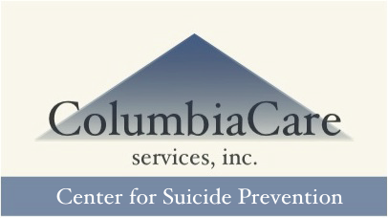
Questions about the ASIST or the training?
For more information about ASIST, visit http://www.livingworks.net
For information about the training, please contact Jill at (541) 337.9001.

Co-sponsored by the Lane County Prevention Program, www.preventionlane.org

