CONTINUING EDUCATION PROVIDER  BOARD OF BEHAVIORAL SCIENCES  STATE OF CALIFORNIA – No. PCE 624 |  |  | 19-12-152
 | NASW

Certificate of Attendance
NASW Continuing Education Program
The Oregon Chapter, National Association of Social Workers Certifies that:
Is conferred 12.75 hours of continuing Education Credit for attendance at:
Applied Suicide Intervention Skills Training (ASIST)
Completion Date |  | Oregon Public Health Division  Instructor/Conference Sponsor
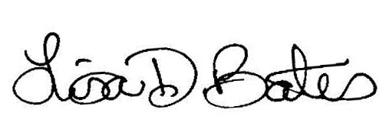  Oregon Chapter President, NASW |  | 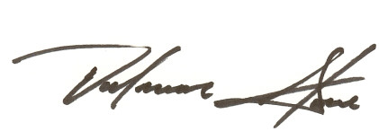  Executive Director, Oregon Chapter NASW

