9
CONTINUING EDUCATION PROVIDER  BOARD OF BEHAVIORAL SCIENCES  STATE OF CALIFORNIA – No. PCE 624 |  |  | ___19-13-129______________
 | NASW

Certificate of Attendance
NASW Continuing Education Program
The Oregon Chapter, National Association of Social Workers Certifies that:
Is conferred 12.5 hours of continuing Education Credit (clinical) for attendance

Applied Suicide Intervention Skills Training (ASIST)
Completion Date |  | Oregon Public Health Division  Instructor/Conference Sponsor
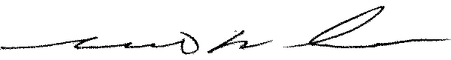  _______________________________________________________________________________________________________________________________________________________  R. Marc Andrews  Oregon Chapter President, NASW |  | 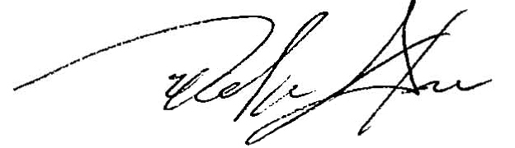  Delmar Stone  Executive Director, NASW Oregon Chapter

