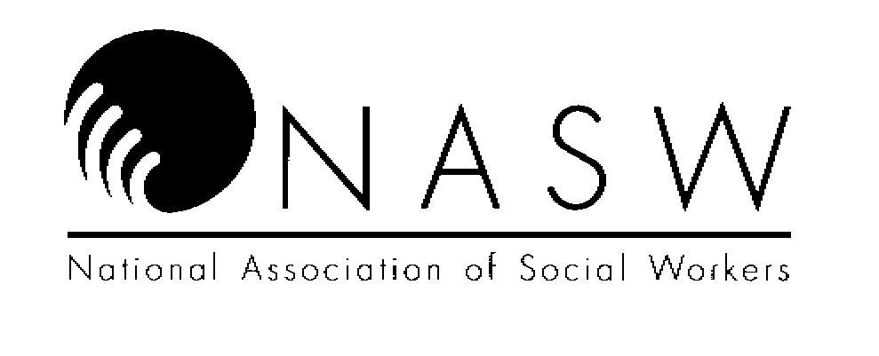
Conference Number 19-19-179

OREGON CHAPTER
National Association of Social Workers

CONFERENCE EVALUATION FORM

CONFERENCE TITLE: Applied Suicide Intervention Skills Training

CONFERENCE SPONSOR: Oregon Public Health Division CONFERENCE DATE: FILL IN

Conference attendees requesting NASW Continuing Education Credit should complete the following questions
regarding the conference. This form is to be completed following the conference and submitted to the conference
sponsor (or their designee). Completed evaluation forms are required for CE credit.

Poor Average Superior
Quality of instruction: 1 2 3 4 5

Knowledge and expertise of instructor: 1 2 3 4 5

Usefulness of program content: 1 2 3 4 5

Presentation was clearly organized: 1 2 3 4 5

Presentation met the goals/objectives
of the conference: 1 2 3 4 5

Conference contributed new, pertinent
data to my understanding of the topic: 1 2 3 4 5

Facilities (size, temp. sound level etc.)
were adequate for the conference: 1 2 3 4 5

Presenter was responsive to
audience participation/questions: 1 2 3 4 5

Overall, this conference was: 1 2 3 4 5

What level of social work practice did this conference address? ____ all levels
__ entry level (0-2 years) __ intermediate level (2-10 years) __ advanced level (over 10 years)

What other topics and/or speakers would you like to see NASW Oregon Chapter sponsor?

