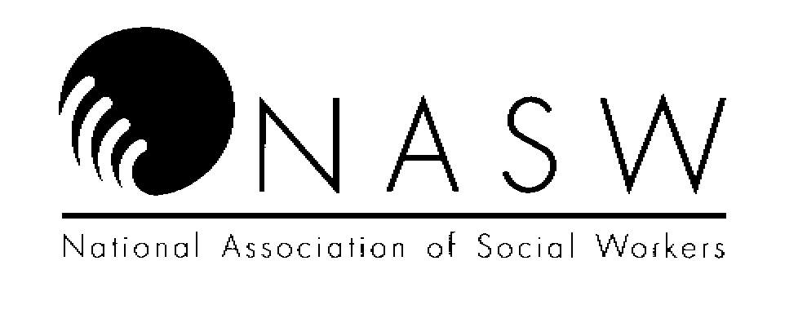 Conference Number 19-20-174

OREGON CHAPTER

National Association of Social Workers

## CONFERENCE EVALUATION FORM

CONFERENCE TITLE: Applied Suicide Intervention Skills Training (ASIST)

CONFERENCE SPONSOR: Oregon Public Health Division CONFERENCE DATE: TRAINER TO FILL IN

Conference attendees requesting NASW Continuing Education Credit should complete the following questions

regarding the conference. This form is to be completed following the conference and submitted to the conference

sponsor (or their designee). **Completed evaluation forms are required for CE credit.**

Poor Average Superior

Quality of instruction: 1 2 3 4 5

Knowledge and expertise of instructor: 1 2 3 4 5

Usefulness of program content: 1 2 3 4 5

Presentation was clearly organized: 1 2 3 4 5

Presentation met the goals/objectives

of the conference: 1 2 3 4 5

Conference contributed new, pertinent

data to my understanding of the topic: 1 2 3 4 5

Facilities (size, temp. sound level etc.)

were adequate for the conference: 1 2 3 4 5

Presenter was responsive to

audience participation/questions: 1 2 3 4 5

Overall, this conference was: 1 2 3 4 5

What level of social work practice did this conference address? ____ all levels

__ entry level (0-2 years) __ intermediate level (2-10 years) __ advanced level (over 10 years)

**What other topics and/or speakers would you like to see NASW Oregon Chapter sponsor?**

**Return Completed Form to: Tim Glascock,** [**tglascock@aocmhp.org**](mailto:tglascock@aocmhp.org)