9
 |  |  | ___19-20-174_____________
 | NASW

Certificate of Attendance
NASW Continuing Education Program
The Oregon Chapter, National Association of Social Workers Certifies that:
Is conferred 12.5 hours of Continuing Education Credit (clinical) for attendance at:

Applied Suicide Intervention Skills Training (ASIST)
DATES  Completion Date |  | Oregon Public Health Division  Instructor/Conference Sponsor
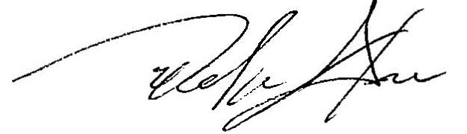

Delmar Stone, LMSW
Executive Director, NASW Oregon Chapter

