Starting in 2015-16, ODE has the opportunity to transition to AIR’s Data Entry Interface (DEI) of the OAKS Portal for the submission of Kindergarten Assessment (KA) data and expansion of OAKS Online Reporting to provide informal KA reports. The DEI is a streamlined user interface hosted through the same OAKS Portal used for Oregon’s online assessments that would be accessible to authorized school or district staff (including test administrators) via tablet, laptop, or desktop. Transition to AIR’s DEI would include the following processes:
- ODE’s Consolidated Collections to AIR’s Assessment Student Records
- Data entry of student responses into Student-Level Data Collections to real-time data entry using DEI (with optional asynchronous entry for the 2015-2016 school year).
- Delayed official paper KA reports to nearly real-time preliminary online electronic KA reports.

This Frequently Asked Questions (FAQ) document addresses the most common questions asked by the Assessment Advisory Committee in consideration of a new Kindergarten Assessment Data Entry Interface.

The FAQ is organized according to the following topics:
- Background
- Administration
- Reporting
- Training
- Funding

Background

Who was the originator of DEI? Which technical groups have seen this and deemed it to be viable?
- American Institutes for Research (AIR) developed the DEI and it is currently in operational use in several states for alternate assessment.

Has the DEI been piloted in any schools this year, if so what were the results?
- The DEI has not yet been piloted in any Oregon schools this year, but it is already in operational use in several states for alternate assessment.
- If feedback is positive, ODE would like to recruit for a very small-scale pilot.

Administration

Can a Test Administrator (TA) access DEI with any mobile or immobile device, except smart phones?
- Correct, TAs may use any platform (tablet, desktop or laptop) to submit student responses, but smart phones are not allowed.

The form and function of the input interface is crucial, can you send the committee mockups of them, please?
- We are asking for initial input on whether ODE should explore providing this opportunity to districts. (See document for a Quick Guide to the Data Entry Interface, Draft for Review Only, found on last two pages of FAQ).

Reporting

What will the output reports look like? And what audiences will be addressed by the various report formats?
- The output reports will have a similar look and feel to the preliminary OAKS online reports currently available to districts, but will be tailored to the Kindergarten Assessment data with similar formats for TA’s, school-level, district level, and possibly Hub level.

If we can't see the interfaces & reports, we can't make credible estimates of training needs, device needs, actual functionality, etc.
- We are asking for initial input on whether ODE should explore providing this opportunity to districts. (See attached document for a Quick Guide to the Data Entry Interface, Draft for Review Only, found on last two pages of FAQ).

Training

What training options would be available and when? Will this be added to the existing Kindergarten Initial Skills Survey training or be another training? If the latter, when would it be provided?
- We are asking for initial input on whether ODE should explore providing this opportunity to districts before we establish the types of trainings we will be providing.
- Here is an initial proposal for Assessment Advisory’s feedback. ODE proposes:
- Adding one additional training module within the existing Kindergarten Assessment Training module on the administration of AIR’s DEI, eliminating the KA Data Collections Training.
- To provide one day, prior to 6/30/2015 when DEI would be available for districts and others to download and explore. This is a model used in Kansas which they call “Break the KTC” day.

Funding
Will funding be provided for schools to purchase tablets, etc. if they do not have a sufficient number of devices already?
- There are no plans at this time to provide schools funding to purchase additional devices. TAs may use any platform (tablet, desktop or laptop) to submit student responses. Keep in mind that the KA window doesn’t conflict with other testing windows.

There is no mention of the origin of the concept or the supporting funding & authorization.
- The DEI is within scope of ODE’s current assessment contract with AIR.

Quick Guide to the Data Entry Interface
The Data Entry Interface (DEI) allows authorized users to enter responses for students who have tested using the Oregon Kindergarten Assessment. The DEI looks similar to the student interface of the OAKS and Smarter Balanced’ Online Testing System.

 | All accommodation codes must be set in the Test Information Distribution Engine (TIDE) or in Test by the District or School Assessment Coordinator before students’ responses or score data are entered.

Logging In  Authorized users must log in to the Data Entry Interface in order to enter students’ responses from the Early Literacy, Early Math, and Approaches to Learning segments.  - Access oaksportal.org through Firefox.  - Click the [Test Administrator or Test Coordinator] icon.  - Click the [Data Entry Interface] icon.  - Log in with your username and password.  - On the Enter Student Information page, enter the student’s first name as it appears in TIDE and SSID number, and then click [Sign In].  - Verify the student’s information and assessment:  - Is This the Student? – Verify the student’s demographic information (date of birth, school, SSID number, and grade). Click [Yes] to continue.  - Tests For This Student – Select the test for which you will start or resume data entry. (Responses do not need to be entered in one sitting; they can be entered across multiple sessions.) |  | Login – Enter Student Information  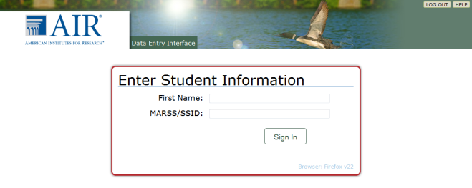  Note: A supported version of Firefox must be  used to access the Data Entry Interface.  Login Process  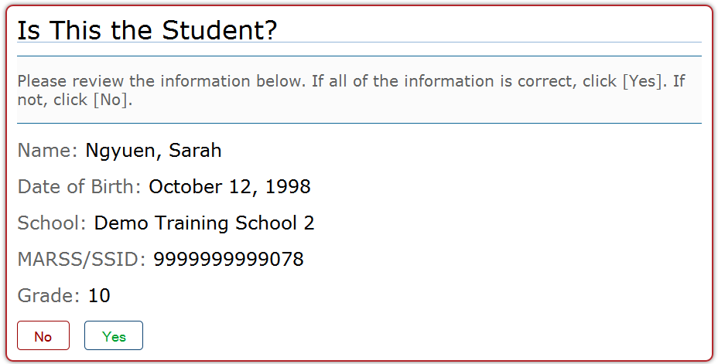  K  October 12, 2010  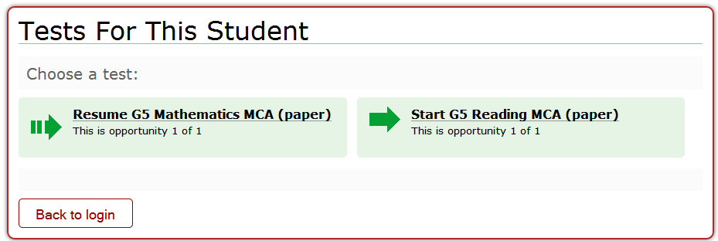  Start Early Spanish Literacy (Paper)  Start Early Mathematics (Paper)  Start Approaches to Learning  Start Early English Literacy (Paper)
- Is This the Right Test? – Verify the selected assessment and select the correct test form.  - For most tests, only one form will be listed.  - If multiple forms are available, the selected test form must match the form indicated on the accommodated test materials.  - Select [Yes, Enter Data] to begin or resume data entry. | 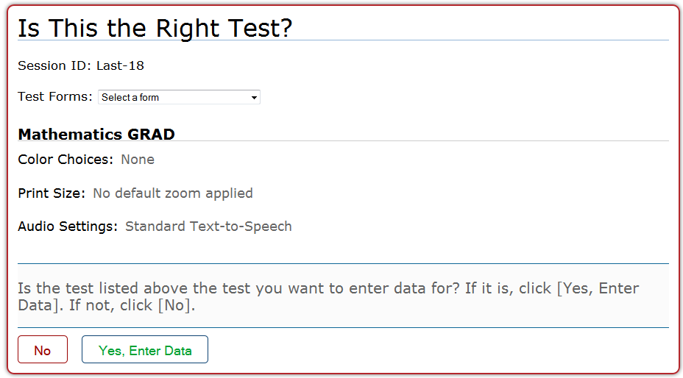  Early English Literacy
- Test Instructions and Help – Select [Begin Test Now]. | 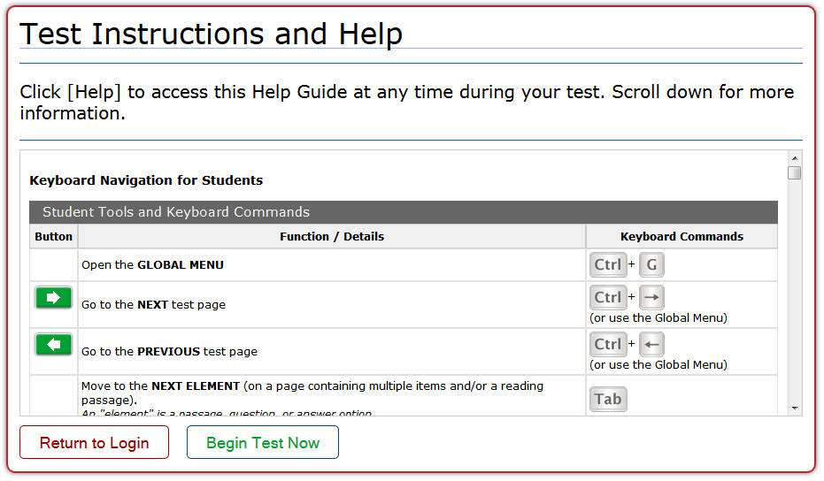
Basic Navigation Rules
- You are permitted to skip a test item only if a student did not provide a response for that item or if a measure was not administered. Do not enter an answer if the student did not select one or if there is no score indicated on the Data Collection Form. Note: Refer to the Task Administration Manual for scoring information where a student did not respond to a measure.
- You can “clear” an item answer or measure score that was accidentally selected.
- You may mark items for review and review them before pausing or submitting the test.
- You may review past items and change the answers only if the test has not yet been submitted for scoring.
- No pause rule is in effect for data entry for any assessment. You will be permitted to pause for as long as necessary and you can return to review items until you submit the test for scoring.
Reaching the End of the Test and Reviewing Entered Data (Responses)
After you have entered all of the student’s responses, click the [Data Entry Complete] button in the bottom-right corner of the screen. You will need to select [Yes] to continue or select [No] to keep working on the test. If you select [Yes], the End Test screen will appear.
- To review the entered responses and go back to the test:
  - Select an item or item page from the list and then click [Review Entered Data]. While reviewing the student’s responses, the [Data Entry Complete] button will remain on the screen.
  - To return at any time to the End Test screen and submit the test for scoring, click the [Data Entry Complete] button again.
- To complete the testing process, click [Submit Test for Scoring]. The Test Successfully Submitted screen will appear.
- To enter data for another student’s test, click [Enter More Data]. You will be directed to the Enter Student Information login screen.
- To enter data for another test for the same student, click [Enter More Data for this Student]. You will be directed to the Tests For This Student screen.

