2015-16 Group Interpretive Guidance Overview for the Kindergarten Assessment
The 2015-16 school year marks the third operational year of Oregon’s Kindergarten Assessment.
The Kindergarten Assessment provides:
- Local and statewide information for state-level policy makers, communities, schools, and families about the interpersonal, math, and literacy skills of incoming kindergartners;
- Information about the strengths and identification of opportunity gaps in the development and academic skills of Oregon’s youngest students and early learning/K-12 systems about the allocation of resources, professional development, and other support to students with the greatest needs; and
- A consistent, statewide tool that will provide a snapshot about the identification of systemic opportunity gaps and will measure Oregon’s progress over time.

Oregon’s incoming kindergartners are assessed during the first six weeks of school in the areas of Early Literacy, Early Math, and Approaches to Learning. The data collected from the assessment allows the Oregon Department of Education and the Early Learning Division to more effectively target resources where they are most needed within Oregon’s Early Learning system. The data also helps kindergarten teachers establish a baseline for children’s learning and development at the onset of each kindergarten year.

Cautions in interpreting the Results of the Kindergarten Assessment:
Although the results of the Kindergarten Assessment are useful for learning about specified knowledge and skills of incoming kindergartners, it also has limitations. First and foremost, students cannot pass or fail the Kindergarten Assessment. The Kindergarten Assessment provides a snapshot of a few important areas of children’s learning and development at a particular moment in time. It is not intended to be a comprehensive assessment of children’s readiness for school and is not used to exclude or prevent children from starting kindergarten. Students enter kindergarten with a wide range of skills that teachers build upon to ensure growth throughout the year and beyond, and the Kindergarten Assessment provides one part of a larger picture of students’ strengths and areas in need of improvement. The results of the Kindergarten Assessment, alone, should not be used for student placement purposes and are not intended to be used as individual student reports to be shared with parents. However, teachers may choose to share students’ Kindergarten Assessment results with parents in the context of a parent-teacher conference as part of the conversation around their child’s growth and development throughout the school year.

The following information can guide interpretation of data gathered from the Approaches to Learning, Early Literacy, and Early math measures during the 2015-16 administration.

Approaches to Learning:
The Approaches to Learning measure is administered within the first six weeks of school. Classroom teachers observe the students during regular activities and routines to complete the fifteen-item Child Behavior Rating Scale (CBRS), which measures teacher perceptions of students’ self-regulation behaviors and interpersonal skills. This measure has been used around the world and has been found to predict academic achievement (Cameron Ponitz et al., 2009; McClelland et al., 2007; Matthews et al., 2009; von Suchodoletz et al., 2013; Wanless, McClelland et al., 2011, 2013).

Self-Regulation:
The Self-Regulation portion looks at how often students exhibit behaviors such as persisting at difficult tasks and using organizational tools. The Self-Regulation score for each student is the average of the teacher’s ratings for that student on the ten Self-Regulation items included in the CBRS.
Average scores range from 1.0 to 5.0. Items for which behaviors are not observed are excluded from the average.

Interpersonal Skills:
The Interpersonal Skills portion looks at how often students exhibit skills such as sharing with their fellow students and following adult directions. The Interpersonal Skills score for each student is the average of teachers’ ratings for that student on the five Interpersonal Skill items included in the CBRS. Average scores range from 1.0 to 5.0. Items for which behaviors are not observed are excluded from the average.

For each Approaches to Learning item, students are rated on the following scale:

1 = the child never exhibits the behavior described by the item
2 = the child rarely exhibits the behavior described by the item
3= the child sometimes exhibits the behavior described by the item
4 = the child frequently/usually exhibits the behavior described by the item
5 = the child always exhibits the behavior described by the item

Total Approaches to Learning scores range from 1.0 to 5.0, which is an average of the teacher’s ratings across all fifteen items of the CBRS, including both Self-Regulation and Interpersonal Skills.

There is a large body of evidence that supports our understanding that a student’s ability to self-regulate and provide sustained attention to a task are predictive of academic success (Howse, Lange et al., 2003). Results from these studies suggest that there are specific benchmark goals that are more predictive of later outcomes. The Oregon Department of Education, in conjunction with stakeholder feedback, synthesized the results from these studies to provide guidance for Approaches to Learning.

Scores from the Approaches to Learning measure are depicted along a developmental continuum that describes the skills that typical students should be able to demonstrate upon entry into kindergarten. This continuum is illustrated across the top of the table below. Benchmark level expectations are assigned based upon a range of scores and will help provide a baseline for student growth in subsequent years, as well as enable teachers to identify targeted areas for supporting the social-emotional and interpersonal development of groups of children.

The benchmark levels for the Approaches to Learning measure are as follows:
- Developing (An average score of 1.0-2.90 )
- Approaching (An average score of 2.91-3.99)
- Demonstrating and Above (An average score of 4.0-5.0) 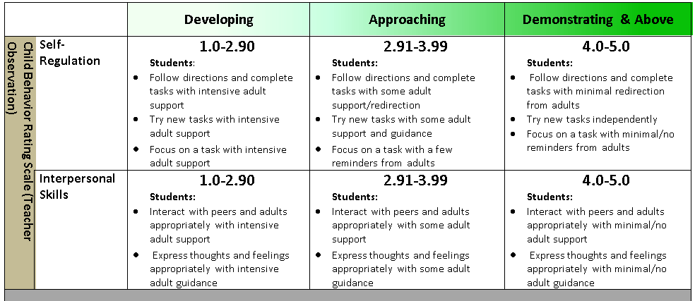

These benchmark levels provide a description of the key behaviors that students exhibit at each level along the continuum from Developing through Demonstrating and Above. The scores serve as a baseline for student growth in subsequent years, and enable teachers to provide targeted instruction for groups of students. Students may demonstrate behaviors in all three levels, and professional judgment should be used when determining benchmark levels. Student scores falling in the lower end of the Approaching range and in the Developing range of the continuum may signal the need for further exploration. Scores in the lower range do not indicate that students are not “ready” to start kindergarten. Students in these ranges greatly benefit from teachers and students modeling and scaffolding the desired behaviors during regular classroom activity. Additional scaffolding and modeling may also be needed by the teacher to engage and support students who have a different racial, ethnic, linguistic, or cultural background. Analysis from Oregon State University demonstrate that self-regulation is strongly related to academic outcomes. (Duncan & McClelleand, 2014). Average scores of 4.0 in Self-Regulation and Approaches to Learning can contribute to later academic success.

Early Literacy and Early Math
Specific interpretive guidance around the Early Literacy and Early Math measures cannot be provided at this time, in part, because the measures were developed before the adoption of the new Head Start Early Learning Outcomes Framework and the kindergarten Common Core State Standards. A work group has been engaged in aligning both sets of standards to represent a continuum of development and learning from age three to the end of kindergarten that will be available later this year. This work will result in a document that provides a foundation for establishing benchmark levels in the areas of early literacy and math for entering kindergarteners. Also, as 2015-16 marks only the third year of administering these measures, the Oregon Department of Education does not yet have longitudinal data to link the results from these measures to future outcomes. As student cohorts who participated in these measures enter 3rd grade and participate in Oregon’s statewide assessments in English language arts and math, ODE anticipates conducting further analysis evaluating the correlation between results on the Kindergarten Assessment and future outcomes.

In order to support alignment with our new standards, the Oregon Department of Education will remove the timing component to the Early Literacy measures for the 2016-17 Kindergarten Assessment. The new untimed measures will examine letter and sound recognition instead of fluency. In addition, extensive research is being conducted as to the best practices in assessing early Spanish Literacy. The Oregon Department of Education’s future plans also include refining and replacing current math items to increase alignment with the standards.

Early Literacy:
The Early Literacy measure of the Kindergarten Assessment is administered within the first three weeks of school. This measure, adapted from EasyCBM, is a timed fluency measure that provides information about how quickly and accurately entering kindergartners can produce letter names and letter sounds.

English Letter Names:
The Letter Names assessment measures how quickly and accurately students name upper and lower case letters while looking at a chart. Letter name scores represent the total number of letters a student is able to correctly identify in one minute.

English Letter Sounds:
The Letter Sounds Assessment measures how quickly and accurately students produce the sounds of upper and lowercase letters and some letter blends while looking at a chart. Letter Sound scores represent the number of English Letter sounds a student is able to correctly identify in one minute.

Spanish Letter Sounds:
The Spanish Letter Sounds assessment is for students who are officially identified as Spanish-speaking English Learners. The Spanish Letter Sounds assessment measures how quickly and accurately a student is able to identify Spanish letter sounds while looking at a chart. Spanish Letter Sound scores represent the number of Spanish letter sounds a student is able to correctly identify in one minute. Students who are bilingual or trilingual may require additional time to process and adjust to being asked to produce sounds in their native language in an environment where English is the dominate language.

Early Mathematics:
The Early Mathematics measure, adapted from EasyCBM, is administered within the first three weeks of school. The Early Mathematics segment is an untimed direct assessment in numbers and operations including counting, simple addition, simple subtraction, and recognizing number patterns. Students are given oral directions and are asked to respond to sixteen multiple choice items by either pointing to or verbalizing the correct answer. Students who have been officially identified as Spanish-speaking English Learners are given the choice to receive oral directions in either English or Spanish and may respond in either English or Spanish. Early Mathematics scores range from zero to sixteen and represent the number of items the student answers correctly.

Kindergarten Assessment Reports:
The following table shows the levels of Kindergarten Assessment reports and the appropriate uses of the results at each level. At all levels, the results of the Kindergarten Assessment can be used for early identification of opportunity gaps; to determine how to equitably allocate resources in early childhood through third grade; and to communicate with policymakers, families, and communities about the importance of high-quality education from early childhood through grade three.
Statewide reports are posted on the Kindergarten Assessment Resources webpage. These results display the average scores of students statewide and in each district and school, overall, and by student group.

School District and school level results are sent to school districts and Early Learning Hubs, and displayed in the publicly available statewide report. District and school-level results display the average scores of students in each school, overall and by student subgroup.

Student-level results display individual students’ scores for each segment of the Kindergarten Assessment. In order to protect student confidentiality, student-level results are included in the district and school level results of the students’ attending districts and schools, but are not released to the public in the statewide reports.

Hub-level results are sent to Early Learning Hubs and display the average scores of students in the districts and schools within each hub, overall and by student subgroup.

Reporting Level | Uses of the Results
Statewide  Statewide reports are posted on the Kindergarten Assessment Resources webpage. These results display the average scores of students statewide and in each district and school, overall and by student subgroup. | Statewide results are used to identify opportunity gaps in order to inform decision- making in allocating resources to the communities with the greatest need and to measure statewide progress in the years to come.
District and School  School District and school level results are sent to school districts and hubs, and displayed in the publicly available statewide report. District and school-level results display the average scores of students in each school, overall and by student subgroup.  Student-level results display individual students’ scores for each segment of the Kindergarten Assessment. In order to protect student confidentiality, student-level results are included in the district and school level results of the students’ attending districts and schools, but are not released to the public in the statewide reports. | District and school level results help districts and schools, in partnership with local providers of early learning services, better understand the strengths and gaps in selected domains of development for Oregon’s entering kindergarteners overall and by student subgroups. These results can be used to monitor patterns in district- and school-level data over time and identify opportunity gaps among student subgroups. This information can inform instructional strategies in the classroom and be used to target professional development, resources, and supports on the areas of greatest need.  Student-level results provide a snapshot of the skills in early literacy, early math, and approaches to learning each entering kindergartener can demonstrate on the Kindergarten Assessment. These results can be used to initiate outreach to families and, when used in conjunction with other sources of information, inform instructional decisions.
Early Learning Hub  Hub-level results are sent to Hubs and display the average scores of students in the districts and schools within each hub, overall and by student subgroup. | The Early Learning Hub results help Hubs better understand the strengths and opportunity gaps in selected domains of development of the population of children in the Hub’s service area. These results can be used to help Hubs target resources supports, and cross-sector community-based strategies that support early learning.

