Buildings Collection

USER Manual

For the 2016-17 School Year

Oregon Department of Education

Salem, Oregon



Salam Noor, Deputy Superintendent of Public Instruction

X:\Library\Logos and Brands\ODE Labels\Finance-Administration\lbl_FinAdmin.png

It is a policy of the State Board of Education and a priority of the Oregon Department of Education that there will be no discrimination or harassment on the grounds of race, color, sex, marital status, religion, national origin, age, sexual orientation, or disability in any educational programs, activities or employment. Persons having questions about equal opportunity and nondiscrimination should contact the Deputy Superintendent of Public Instruction at the Oregon Department of Education.

The Secretary of State publishes the officially codified and compiled Administrative rules and portions of that published compilation have copyright status. The Oregon Administrative Rules presented on these pages are not the official version of the rules published by the Secretary of State.

Please share this document with your colleagues!

All or any part of it may be photocopied for educational purposes

without permission from the Oregon Department of Education.

|  |  |
| --- | --- |
| Creation Date: | 6/20/2016 |
| Last Updated: | 12/13/2016 |
| Version: | 1.0 |

Table of Contents

[General Information 5](#_Toc468193725)

[Buildings Collection 5](#_Toc468193726)

[History 5](#_Toc468193727)

[Other sources of the data 6](#_Toc468193728)

[Data Definition 6](#_Toc468193729)

[Looking Forward 6](#_Toc468193730)

[Staff Responsibilities and Contact List 7](#_Toc468193731)

[ODE Staff 7](#_Toc468193732)

[Important Dates 8](#_Toc468193733)

[Important Links 9](#_Toc468193734)

[General Information 9](#_Toc468193735)

[Laws and Rules 9](#_Toc468193736)

[Buildings Collection Data Elements 10](#_Toc468193737)

[Look-Up Tables 21](#_Toc468193738)

[Step-by-Step Reporting 23](#_Toc468193739)

[Web Submission 23](#_Toc468193740)

[File Upload 25](#_Toc468193741)

Revision History

VERSION LOG

|  |  |  |  |
| --- | --- | --- | --- |
| **Version** | **Description** | **Author** | **Date** |
| 1.0 | 2016-17 District Buildings Collection | Michael Kelly | 12/13/2016 |
|  |  |  |  |

General Information

# Buildings Collection

## History

In 2013, the state legislation passed SB 540, which created the School Facilities Data Collection (Buildings Collection). This bill created the Task Force on School Facilities and required ODE to create a database on school facilities. Currently, ODE does not have any state-wide data set that is a true and accurate inventory of school buildings and their conditions. This database will gather information about the current state of school facilities. The long-term goal of this database is to be able to inventory school facilities and the needs of those facilities across the state.

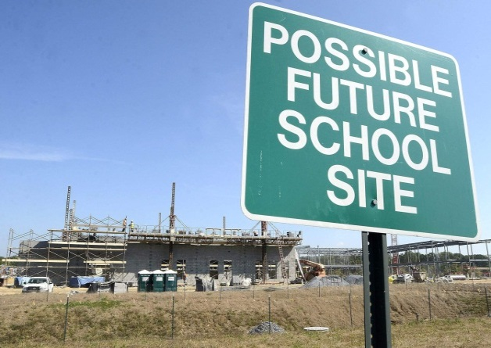To build this database we are asking districts for information about their school facilities. As a brand new collection, the heavy lifting for this collection will occur in the first year. Districts will need to identify their buildings and provide a lot of building information. The good news is that after this first year, much of this information will roll over to the new data collection. Square footage, for example, is not likely to change for a given building. The information will move forward and only need updating, if an addition to the building occurred. This will be the case for many of the fields in the database. They will roll forward to future years of the database.

There is also another collection tied to SB 540. This collection gathers district-wide information regarding bond sales and elections. The collection will be asking about bonds passed, outstanding indebtedness, and other items.

## 

## Other sources of the data

We know that other state agencies have recently collected information on school facilities and may have this information available. Thus, if districts are having a difficult time gathering this information from their own records, they may be able to reach out to Department of Geology and Mineral Industries (DOGAMI) or the Department of Energy (ODOE) for some of this information. Additionally, districts may be able to access local resources such as county building offices of other third parties that have gathered and stored building information.

## Data Definition

A major issue for this collection is the definition of a building. ODE is defining a building to be anything that is tied to a foundation and has an energy source. For example, football grandstands that have lights, a field, and a foundation would be a building. A mobile concession stand would not. A shed used to store athletic equipment that does not have an energy source is also not a building. Bus barns, garages, and other support facilities are a building. The goal is to gather information on those buildings that need regular maintenance throughout the life of the building.

## Looking Forward

The database will be changing in the years to come. This current data collection is the starting point. As more information becomes available to the Office of School Facilities through technical assistance grants or funding capital construction through the Oregon School Capital Improvement Matching Program, the database will change to capture that information. The goal will be to minimize the impact on districts and gather data from other sources already submitted by districts. However, the ultimate goal of the database is to assist districts with analyzing, planning and prioritizing school capital improvement needs.

Staff Responsibilities and Contact List

# ODE Staff

|  |  |  |  |
| --- | --- | --- | --- |
| **Type of Help** | **Contact Name** | **E-mail** | **Phone Number** |
| Office of School Facilities General Assistance | Michael Elliott | [michael.s.elliott@ode.state.or.us](mailto:michael.s.elliott@ode.state.or.us) | (503) 947-5627 |
| Office of School Facilities General Assistance | Michael Kelly | [michael.t.kelly@ode.state.or.us](mailto:michael.t.kelly@ode.state.or.us) | (503) 947-5859 |
| Office of School Facilities Technical Help | ODE Helpdesk | [Ode.Helpdesk@state.or.us](mailto:Ode.Helpdesk@state.or.us) | (503) 947-5715 |

Important Dates

|  |  |  |  |
| --- | --- | --- | --- |
| **Open Date** | **Close Date** | **Eligible Use Date** | **Training Date** |
| 12-8-2016 | 1-30-2016 | [4-1-2016](mailto:michael.s.elliott@ode.state.or.us) | TBD |

Important Links

# General Information

|  |  |
| --- | --- |
| **Description** | **URL Address** |
| Office of School Facilities website | <http://www.ode.state.or.us/search/results/?id=398> |

# Laws and Rules

|  |  |
| --- | --- |
| **Description** | **URL Address** |
| Senate Bill 540 | <https://olis.leg.state.or.us/liz/2013R1/Downloads/MeasureDocument/SB540/Enrolled> |
| Senate Bill 447 | <https://olis.leg.state.or.us/liz/2015R1/Downloads/MeasureDocument/SB447/Enrolled> |
| Office Of School Facilities  ORS 326.125 | <https://www.oregonlegislature.gov/bills_laws/ors/ors326.html> |
| Division 27: School Construction Matching Program OAR 581-027-0005 through 581-027-0050 | <http://www.ode.state.or.us/wma/sf/office-of-school-facilities-oars.pdf> |
| School Capital Matching Bonds ORS 286A.796 to 286A.806 | <https://www.oregonlegislature.gov/bills_laws/ors/ors286A.html> |

Buildings Collection Data Elements

The information in this section contains the field names for the data submission and the data description. Special Help is given to assist the data submitter in reporting the data.

There is an expectation that all data be submitted correctly. ODE may include data from any period in Federal or State reports, as well as in media requests and other requests submitted under the Freedom of Information Act.

|  |  |
| --- | --- |
| Field Name | DistInstID – Required |
| ***Data Element Name*** | District Institution Identifier |
| ***Description*** | ODE Institution Identification number for the ESD or District the Building belongs to. Institution ID numbers can be found at: <http://www.ode.state.or.us/instid/> |
| ***Special Help*** | No long description |

|  |  |
| --- | --- |
| Field Name | SchlIinstID – Required |
| ***Data Element Name*** | School Institution Identifier |
| ***Description*** | ODE Institution Identifier for the school (if not a school the District ID) where the Building is located. Institution ID numbers can be found at: <http://www.ode.state.or.us/instid/> |
| ***Special Help*** | No long description |

|  |  |
| --- | --- |
| Field Name | BldgID – Required |
| ***Data Element Name*** | Building Identifier |
| ***Description*** | Unique identifier for this Building at this institution |
| ***Special Help*** | "This is a unique ID (can be number and alphabet, or both) that is used for each individual structure. A structure is a building tied to a foundation and has an energy source. (non structure, non-lighted equipment sheds, mobile concession stands)"  The format for this data element is as follows: District ID followed by district supplied building ID. For example: 1234001 means building number 001 in district ID 1234. The building IDs must be consistent across the district. |

|  |  |
| --- | --- |
| Field Name | Nm – Required |
| ***Data Element Name*** | Name |
| ***Description*** | The name of the Building at the institution. The identifier can be any convention used by the institution. For example big gym, main Building, portable 1 (50 character max) |
| ***Special Help*** | The name of the building/structure should be consistent across a district. For example Big Gym or Big Gymnasium / Portable 1 vs. Portable A.  Please use the following terms to describe common buildings:  Gym: gymnasiums  Portable: portables  High School: All high schools or senior high schools  Junior High School: All junior high schools  Jr. High/High School: All combined junior and senior high schools  Middle School: All middle schools  Elementary School: All elementary schools  Administration: all administration or district central offices  Stadium: All fields that have a building that meets the above definition.  For other types of buildings please use a consistent term across the district. |

|  |  |
| --- | --- |
| Field Name | Str – Not Required |
| ***Data Element Name*** | Street Address |
| ***Description*** | The physical street address assigned to the building |
| ***Special Help*** | Should be the same street address on file with ODE. If a separate building on the same campus, please use the campus address, unless the building has a separate address. |

|  |  |
| --- | --- |
| Field Name | City – Not Required |
| ***Data Element Name*** | City |
| ***Description*** | The city where the building is located |
| ***Special Help*** | No long description |

|  |  |
| --- | --- |
| Field Name | St – Not Required |
| ***Data Element Name*** | State |
| ***Description*** | The state where the building is located |
| ***Special Help*** | No long description |

|  |  |
| --- | --- |
| Field Name | Zip – Not Required |
| ***Data Element Name*** | Zip Code |
| ***Description*** | The zip code assigned to the building |
| ***Special Help*** | No long description |

|  |  |
| --- | --- |
| Field Name | YrOfCmpltn – Required |
| ***Data Element Name*** | Year of Completion |
| ***Description*** | Year Building was completed and available for use. |
| ***Special Help*** | The year the building was opened for use. |

|  |  |
| --- | --- |
| Field Name | YrNoLongInUse – Not Required |
| ***Data Element Name*** | Year No Longer In Use |
| ***Description*** | Year building was no longer in use |
| ***Special Help*** | If the building is no longer used, what was the first full year it was not in use. Even if the district still owns but does not use. For example if the school closes June 2016, then this field would report 2017 as the first full year the building was not in use. |

|  |  |
| --- | --- |
| Field Name | RsnNoLongInUse – Not Required |
| ***Data Element Name*** | Reason No Longer In Use |
| ***Description*** | Reason building no longer in use |
| ***Special Help*** | For example, was the building condemned, consolidated to another building due to declining enrollment, etc. |

|  |  |
| --- | --- |
| Field Name | UseCd – Required |
| ***Data Element Name*** | Usage Code |
| ***Description*** | Code indicating how the Building is being used. |
| ***Special Help*** | No long description |

|  |  |
| --- | --- |
| Field Name | Ft2 – Required |
| ***Data Element Name*** | Square Footage |
| ***Description*** | Current year square footage for Building |
| ***Special Help*** | This should be the gross square footage, referring to the outer structure measurements. |

|  |  |
| --- | --- |
| Field Name | Stry – Required |
| ***Data Element Name*** | Stories |
| ***Description*** | Number of stories including basement as a level |
| ***Special Help*** | How many floors does the building have. |

|  |  |
| --- | --- |
| Field Name | PrimStrctrTyp – Required |
| ***Data Element Name*** | Primary Structure Type |
| ***Description*** | Primary type of structure (selected from a list) |
| ***Special Help*** | No long description |

|  |  |
| --- | --- |
| Field Name | ScndryStrctrTyp – Not Required |
| ***Data Element Name*** | Secondary Structure Type |
| ***Description*** | Secondary type of structure (selected from a list) |
| ***Special Help*** | No long description |

|  |  |
| --- | --- |
| Field Name | StdntCap – Required |
| ***Data Element Name*** | Student Capacity |
| ***Description*** | Number of students building is intended to serve as of original build date or most recent renovation. |
| ***Special Help*** | No long description |

|  |  |
| --- | --- |
| Field Name | MtrdFg – Required |
| ***Data Element Name*** | Metered |
| ***Description*** | Does this building have a separate energy meter? |
| ***Special Help*** | This means that this building does not have its own meter and therefore is tied to the energy usage of another building. |

|  |  |
| --- | --- |
| Field Name | Elctrcty – Not Required |
| ***Data Element Name*** | Electricity Usage |
| ***Description*** | Annual Electricity usage of the Building (kilowatt hours) |
| ***Special Help*** | If building does not have a separate meter then prorate the amount of energy this building uses on a square foot basis. |

|  |  |
| --- | --- |
| Field Name | NtGs – Not Required |
| ***Data Element Name*** | Natural Gas Usage |
| ***Description*** | Annual Natural gas usage of the Building (cubic feet) |
| ***Special Help*** | If building does not have a separate meter then prorate the amount of energy this building uses on a square foot basis. |

|  |  |
| --- | --- |
| Field Name | HtngOl – Not Required |
| ***Data Element Name*** | Heating Oil Usage |
| ***Description*** | Annual Heating Oil usage of the Building (gallons) |
| ***Special Help*** | If building does not have a separate meter then prorate the amount of energy this building uses on a square foot basis. |

|  |  |
| --- | --- |
| Field Name | OthrEnrgy – Not Required |
| ***Data Element Name*** | Other Energy Usage |
| ***Description*** | Description of other types of annual energy usage and amount for the Building |
| ***Special Help*** | Other types of energy usage could be natural gas, diesel, propane, etc. |

|  |  |
| --- | --- |
| Field Name | SmctyZnCd – Not Required |
| ***Data Element Name*** | Seismicity Zone Code |
| ***Description*** | Building seismicity zone code |
| ***Special Help*** | This code can be found on the DOGAMI website URL: <http://www.oregongeology.org/sub/projects/rvs/county/county-sites.htm>  Seismic zones (low, moderate, high) defined by FEMA 154 and very high defined as 60% g on the 1.0 second spectral acceleration 2% probability. |

|  |  |
| --- | --- |
| Field Name | IntrntFg – Required |
| ***Data Element Name*** | Internet Connection |
| ***Description*** | Y(es) or N(o) - Does Building have internet connectivity? |
| ***Special Help*** | No long description |

|  |  |
| --- | --- |
| Field Name | IntrntTyp – Not Required |
| ***Data Element Name*** | Internet Connection Type |
| ***Description*** | What type of internet connection for Building? Wired, wireless, both, other? |
| ***Special Help*** | WD: Wired  WDL: Both wired and wireless  WL: Wireless |

|  |  |
| --- | --- |
| Field Name | IntrntUpldSpd – Not Required |
| ***Data Element Name*** | Internet Upload Speed |
| ***Description*** | Maximum Internet upload speed (Mbps). You can find this value at <http://www.speedtest.net/> |
| ***Special Help*** | No long description |

|  |  |
| --- | --- |
| Field Name | IntrntDnldSpd – Not Required |
| ***Data Element Name*** | Internet Download Speed |
| ***Description*** | Maximum Internet download speed (Mbps). You can find this value at <http://www.speedtest.net/> |
| ***Special Help*** | No long description |

|  |  |
| --- | --- |
| Field Name | Reno1Cd – Not Required |
| ***Data Element Name*** | Major Renovation Code |
| ***Description*** | Code indicating the type of renovation completed |
| ***Special Help*** | No long description |

|  |  |
| --- | --- |
| Field Name | Reno1Yr – Not Required |
| ***Data Element Name*** | Major Renovation Year |
| ***Description*** | Year renovation was completed and Building was available for new purpose |
| ***Special Help*** | No long description |

|  |  |
| --- | --- |
| Field Name | Reno2Cd – Not Required |
| ***Data Element Name*** | Major Renovation Code |
| ***Description*** | Code indicating the type of renovation completed |
| ***Special Help*** | No long description |

|  |  |
| --- | --- |
| Field Name | Reno2Yr – Not Required |
| ***Data Element Name*** | Major Renovation Year |
| ***Description*** | Year renovation was completed and Building was available for new purpose |
| ***Special Help*** | No long description |

|  |  |
| --- | --- |
| Field Name | Reno3Cd – Not Required |
| ***Data Element Name*** | Major Renovation Code |
| ***Description*** | Code indicating the type of renovation completed |
| ***Special Help*** | No long description |

|  |  |
| --- | --- |
| Field Name | Reno3Yr – Not Required |
| ***Data Element Name*** | Major Renovation Year |
| ***Description*** | Year renovation was completed and Building was available for new purpose |
| ***Special Help*** | No long description |

|  |  |
| --- | --- |
| Field Name | Reno4Cd – Not Required |
| ***Data Element Name*** | Major Renovation Code |
| ***Description*** | Code indicating the type of renovation completed |
| ***Special Help*** | No long description |

|  |  |
| --- | --- |
| Field Name | Reno4Yr – Not Required |
| ***Data Element Name*** | Major Renovation Year |
| ***Description*** | Year renovation was completed and Building was available for new purpose |
| ***Special Help*** | No long description |

|  |  |
| --- | --- |
| Field Name | Reno5Cd – Not Required |
| ***Data Element Name*** | Major Renovation Code |
| ***Description*** | Code indicating the type of renovation completed |
| ***Special Help*** | No long description |

|  |  |
| --- | --- |
| Field Name | Reno5Yr – Not Required |
| ***Data Element Name*** | Major Renovation Year |
| ***Description*** | Year renovation was completed and Building was available for new purpose |
| ***Special Help*** | No long description |

|  |  |
| --- | --- |
| Field Name | AsbstFg – Required |
| ***Data Element Name*** | Presence of Asbestos |
| ***Description*** | Presence of asbestos in building |
| ***Special Help*** | No long description |

|  |  |
| --- | --- |
| Field Name | LeadFg – Required |
| ***Data Element Name*** | Presence of Lead paint |
| ***Description*** | Presence of lead paint in building |
| ***Special Help*** | No long description |

|  |  |
| --- | --- |
| Field Name | TotYrMaintCst – Required |
| ***Data Element Name*** | Tot Yearly Maintenance Cost |
| ***Description*** | Total yearly maintenance cost of building as reported under PBAM code 2540 |
| ***Special Help*** | Include all costs associated with maintaining the building rather than just the in-house costs. For examplem if a district contracts out for maintenance services, then those costs should be reported in this field as well. |

|  |  |
| --- | --- |
| Field Name | BldgFill – Not Required |
| ***Data Element Name*** | Building Fill Field |
| ***Description*** | Reserved for Future Use |
| ***Special Help*** | No long description |

Look-Up Tables

|  |  |  |
| --- | --- | --- |
| **Building Internet Connection Type Lookup Table** | | |
| **Code** | **Name** | **Description** |
| WD | WD | Internet access available through hard wired connection only |
| WL | WL | Internet access available through wireless connection only |
| WDL | WDL | Internet access available through both wired and wireless connection |
| **Building Major Renovation Code Lookup Table** | | |
| **Code** | **Name** | **Description** |
| RFCOM | Roof - Complete | Roof Replacement -- Complete |
| RFPAR | Roof - Partial | Roof Replacement -- Partial |
| HVRPL | HVAC - Replacement | HVAC System Replacement |
| HVRPR | HVAC - Repair | HVAC System Major Repair |
| WINCM | Window - Complete | Window Replacement -- Complete |
| WINPR | Window - Partial | Window Replacement -- Partial |
| EN | Energy | Energy Efficiency Upgrade |
| PLCOM | Plumbing - Complete | Plumbing Replacement -- Complete |
| PLRPR | Plumbing - Partial | Plumbing Major Renovation/Repair |
| SM | Seismic | Seismic Upgrade |
| ST | Structural | Structural Repair (non-Seismic) |
| CR | Classroom | Classroom Upgrade |
| LAP | Lab | Science Lap Upgrade |
| KIT | Kitchen | Kitchen Upgrade/Repair |
| BATH | Bathroom | Bathroom Upgrade/Repair |
| ELEC | Electrical | Electrical Upgrade/Repair |
| OTH | Other | Other Upgrade/Repair |
| TECH | Tech | Technology Upgrade |
| ASB | Asbestos | Asbestos Removal |
| ADDCR | Addition - Classroom | Major Addition -- Classroom |
| ADDOT | Addition - Other | Major Addition -- Other |
| **Building Seismicity Zone Code Lookup Table** | | |
| **Code** | **Name** | **Description** |
| H | High | High |
| M | Moderate | Moderate |
| L | Low | Low |
|  |  |  |
| **Building Structure Type Lookup Table** | | |
| **Code** | **Name** | **Description** |
| W1 | WoodL | Wood, Light Frame |
| W2 | WoodI | Wood, Commercial and Industrial |
| C1 | ConcrFr | Concrete Moment Resisting Frame |
| C2 | ConcrSW | Concrete Shear Walls |
| C3 | ConcrInfill | Concrete Frame with Unreinforced Masonry Infill Walls |
| RM1 | ReinMasWM | Reinforced Masonry Bearing Walls With Wood or Metal Deck Diaphragm |
| RM2 | ReinMasConcr | Reinforced Masonry Bearing Walls With Precast Concrete Diaphragm |
| URM | UnReinMas | Unreinforced Masonry Bearing Walls |
| S1 | SteelMFr | Steel Moment Frame |
| S2 | SteelBFr | Steel Braced Frame |
| S3 | SteelLFr | Steel Light Frame |
| S4 | SteelConcr | Steel Frame with Case-In-Place Concrete Shear Walls |
| S5 | SteelMas | Steel Frame with Unreinforced Masonry Infill Walls |
| MH | MobileHm | Mobile Home |
| OTH | Other | Other |
| **Building Usage Code Lookup Table** | | |
| **Code** | **Name** | **Description** |
| ADMIN | Administrative | Administrative |
| CTE | Career and Technical Facility | Career and Technical Facility |
| ESCHL | Elementary School | Elementary School |
| MSCHL | Middle School | Middle School |
| HSCHL | High School | High School |
| PORT | Portable Class | Portable Class |
| GYM | Gymnasium | Gymnasium (separate building) |
| INSTR | Instructional | Other instructional building that is not part of the school |
| PLAY | Playground Cover | Playground Cover |
| SHOP1 | Shop - Instructional | Shop - Instructional |
| SHOP2 | Shop - Maintenance | Shop - Maintenance |
| SHOP3 | Shop - Transportation | Shop - Transportation |
| STOR1 | Storage - Transportation | Storage - Transportation |
| STOR2 | Storage - Other | Storage - Other |
| **Decision Lookup Table** | | |
| **Code** | **Name** | **Description** |
| N | No | No |
| Y | Yes | Yes |

### 

Step-by-Step Reporting

# Web Submission

1. Under Institution Collections, Buildings 16-17, select **Submission/Maintenance** as shown below.

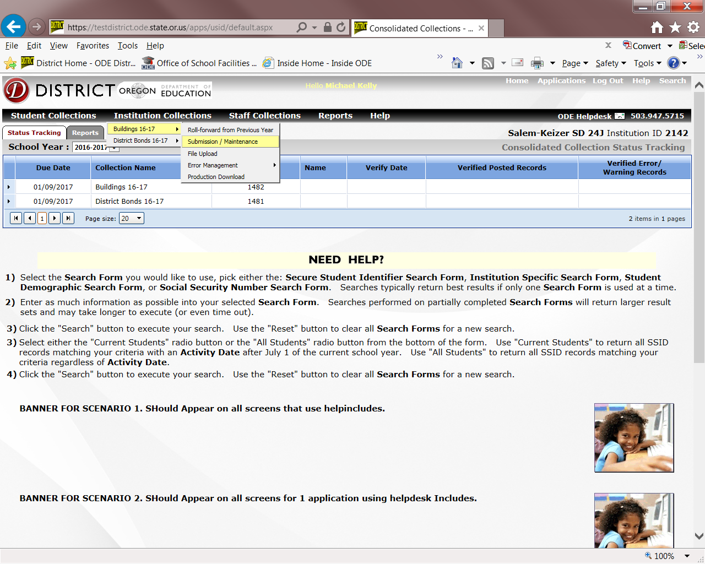

1. Select **“Insert New Record”** as shown below.

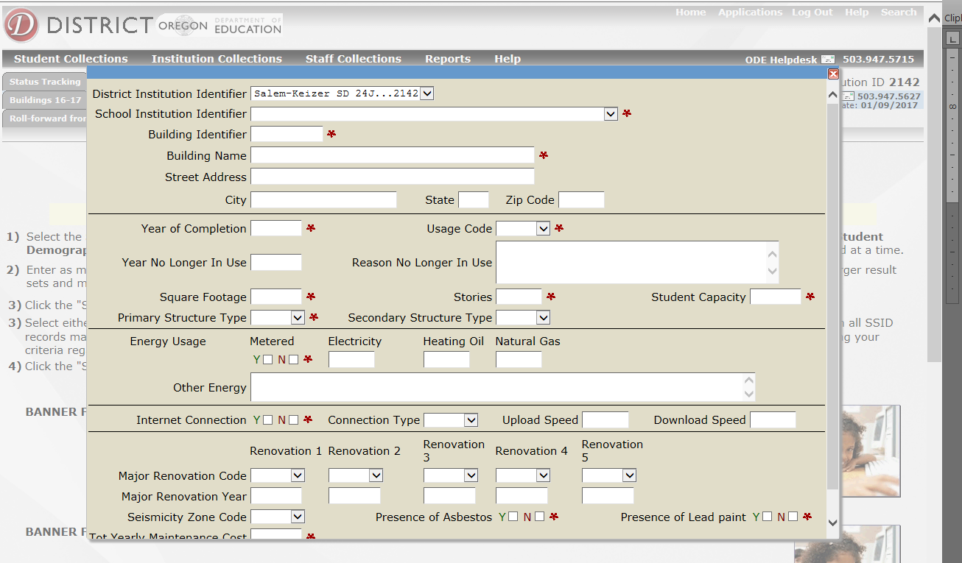

1. Enter Data
   1. For specific questions concerning data elements please refer to the “Buildings Collection Data Elements” section
2. **“SAVE”** and submit your data
   1. After you have entered your data, click the **SAVE** button at the bottom of the page and your estimates will be uploaded to ODE.

# File Upload

1. Navigate to this screen:

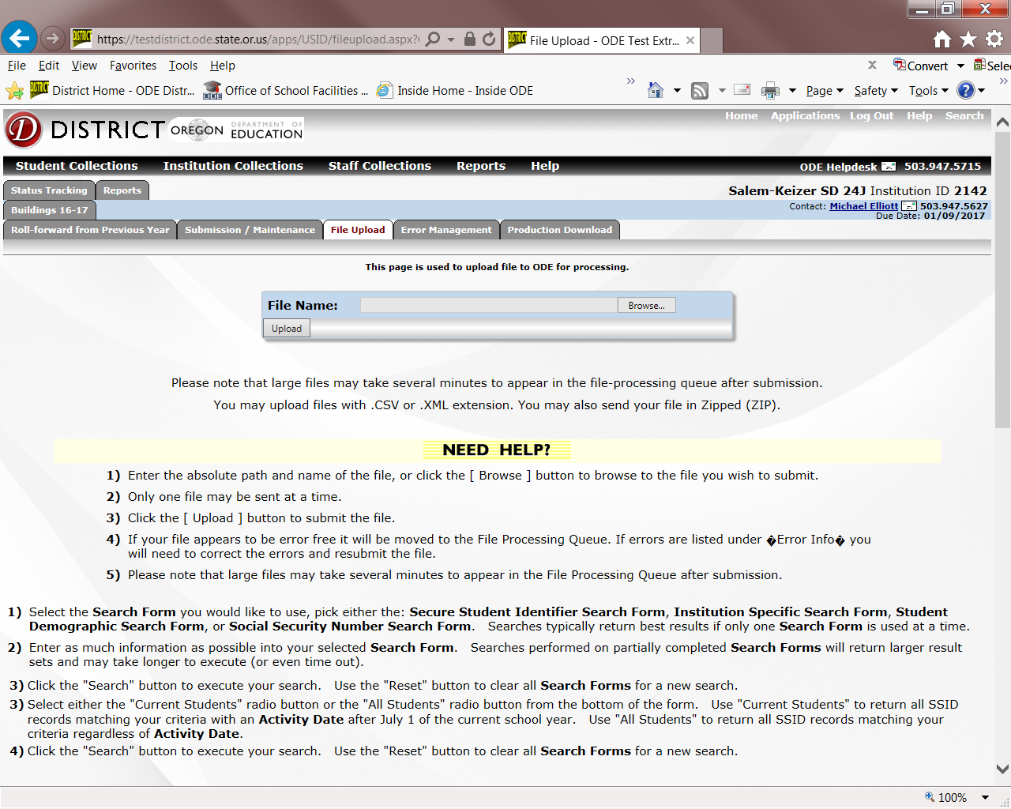

1. Enter the absolute path and name of the file, or click the **“Browse...,”** button to browse to the file you wish to submit.
2. Only one file may be sent at a time.
3. Click the **“Upload”** button to submit the file.
4. ODE will send a confirmation email
5. If the file has errors review under the “**Error Management” tab**