District Bonds Collection

USER Manual

For the 2016-17 School Year

Oregon Department of Education

Salem, Oregon



Salam Noor, Deputy Superintendent of Public Instruction

X:\Library\Logos and Brands\ODE Labels\Finance-Administration\lbl_FinAdmin.png

It is a policy of the State Board of Education and a priority of the Oregon Department of Education that there will be no discrimination or harassment on the grounds of race, color, sex, marital status, religion, national origin, age, sexual orientation, or disability in any educational programs, activities or employment. Persons having questions about equal opportunity and nondiscrimination should contact the Deputy Superintendent of Public Instruction at the Oregon Department of Education.

The Secretary of State publishes the officially codified and compiled Administrative rules and portions of that published compilation have copyright status. The Oregon Administrative Rules presented on these pages are not the official version of the rules published by the Secretary of State.

Please share this document with your colleagues!

All or any part of it may be photocopied for educational purposes

without permission from the Oregon Department of Education.

|  |  |
| --- | --- |
| Creation Date: | 6/20/2016 |
| Last Updated: | 12/1/2016 |
| Version: | 1.0 |

Table of Contents

[General Information 5](#_Toc468199902)

[District Bonds 5](#_Toc468199903)

[History 5](#_Toc468199904)

[Looking Forward 5](#_Toc468199905)

[Staff Responsibilities and Contact List 6](#_Toc468199906)

[ODE Staff 6](#_Toc468199907)

[Important Dates 7](#_Toc468199908)

[Important Links 8](#_Toc468199909)

[General Information 8](#_Toc468199910)

[Laws and Rules 8](#_Toc468199911)

[District Bonds Collection Data Elements 9](#_Toc468199912)

[Look-Up Tables 11](#_Toc468199913)

[Step-by-Step Reporting 12](#_Toc468199914)

[Web Submission 12](#_Toc468199915)

Revision History

VERSION LOG

|  |  |  |  |
| --- | --- | --- | --- |
| **Version** | **Description** | **Author** | **Date** |
| 1.0 | 2016-17 Bonds Collection | Michael Kelly | 12/13/2016 |
|  |  |  |  |

General Information

# District Bonds

## History

In 2013, SB 540 created the School Facilities Data Collection. In 2015 SB 447 was passed to provide incentives to local communities to pass invest in their local school district. If a community passed a local school district general obligation (GO) bonds, they community became eligible for a match from the State of Oregon. In addition to this matching program, SB 447 requires ODE to maintain the database established in SB 540. Part of that database is tracking bonds passed by local districts.

The District Bonds collection gathers district information on bond sales and elections to provide state-wide information on the status of local school district bonds. The collection asks districts to provide information about bonds passed, outstanding indebtedness, and other items.

## Looking Forward

The database will be changing in the years to come. These first years are to provide basic information about district bonds. As the Office of School Facilities and the Oregon School Capital Improvement Matching Program develop, additional information will be added to the collection. The goal will be to minimize the impact on districts and gather data from other sources already submitted by districts. However, the ultimate goal is provide consistent and accurate data that tells the story of our aging school facilities and insight into what resources a district will need to address a situation.

Staff Responsibilities and Contact List

# ODE Staff

|  |  |  |  |
| --- | --- | --- | --- |
| **Type of Help** | **Contact Name** | **E-mail** | **Phone Number** |
| Office of School Facilities General Assistance | Michael Elliott | [michael.s.elliott@ode.state.or.us](mailto:michael.s.elliott@ode.state.or.us) | (503) 947-5627 |
| Office of School Facilities General Assistance | Michael Kelly | [michael.t.kelly@ode.state.or.us](mailto:michael.t.kelly@ode.state.or.us) | (503) 947-5859 |
| Data Collection Technical Help | ODE Helpdesk | [Ode.Helpdesk@state.or.us](mailto:Ode.Helpdesk@state.or.us) | (503) 947-5715 |

Important Dates

|  |  |  |  |
| --- | --- | --- | --- |
| **Open Date** | **Close Date** | **Eligible Use Date** | **Training Date** |
| 12-8-2016 | 1-30-2016 | [4-1-2016](mailto:michael.s.elliott@ode.state.or.us) | TBD |

Important Links

# General Information

|  |  |
| --- | --- |
| **Description** | **URL Address** |
| Office of School Facilities website | <http://www.ode.state.or.us/search/results/?id=398> |
|  |  |
|  |  |
|  |  |

# Laws and Rules

|  |  |
| --- | --- |
| **Description** | **URL Address** |
| Senate Bill 540 | <https://olis.leg.state.or.us/liz/2013R1/Downloads/MeasureDocument/SB540/Enrolled> |
| Senate Bill 447 | <https://olis.leg.state.or.us/liz/2015R1/Downloads/MeasureDocument/SB447/Enrolled> |
| Office Of School Facilities  ORS 326.125 | <https://www.oregonlegislature.gov/bills_laws/ors/ors326.html> |
| Division 27: School Construction Matching Program OAR 581-027-0005 through 581-027-0050 | <http://www.ode.state.or.us/wma/sf/office-of-school-facilities-oars.pdf> |
| School Capital Matching Bonds ORS 286A.796 to 286A.806 | <https://www.oregonlegislature.gov/bills_laws/ors/ors286A.html> |

District Bonds Collection Data Elements

The information in this section contains the field names for the data submission and the data description. Special Help is given to assist the data submitter in reporting the data.

There is an expectation that all data be submitted correctly. ODE may include data from any period in Federal or State reports, as well as in media requests and other requests submitted under the Freedom of Information Act.

|  |  |
| --- | --- |
| Field Name | DistInstID – Required |
| ***Data Element Name*** | Institution Identifier |
| ***Description*** | ODE Institution Identification number for the ESD or District the Building belongs to. Institution ID numbers can be found at: <http://www.ode.state.or.us/instid/> |
| ***Special Help*** | No long description |

|  |  |
| --- | --- |
| Field Name | EvrBndFg – Required |
| ***Data Element Name*** | Ever Bonded |
| ***Description*** | Have you ever passed a bond |
| ***Special Help*** | No long description |

|  |  |
| --- | --- |
| Field Name | BndIndAmt – Not Required |
| ***Data Element Name*** | Bonded Indebtedness |
| ***Description*** | Total outstanding general obligation bond indebtedness of school district |
| ***Special Help*** | No long description |

|  |  |
| --- | --- |
| Field Name | BndFreeDt – Not Required |
| ***Data Element Name*** | Retire Date of Bonds |
| ***Description*** | The date the district will be free of all general obligation bond indebtedness |
| ***Special Help*** | No long description |

|  |  |
| --- | --- |
| Field Name | LstBndAmt – Not Required |
| ***Data Element Name*** | Amount of Last Bond Request |
| ***Description*** | Dollar amount of last general obligation bond request |
| ***Special Help*** | No long description |

|  |  |
| --- | --- |
| Field Name | LstBndPurp – Not Required |
| ***Data Element Name*** | Last Bond Request Funding Purpose |
| ***Description*** | Funding purpose identified for last general obligation bond request |
| ***Special Help*** | Short description of projects to be funded with bond. For example: construct new school; seismic upgrades at three schools; systems upgrades at all schools in district; etc. |

|  |  |
| --- | --- |
| Field Name | LstBndApprvd – Required |
| ***Data Element Name*** | Last Bond Request Status |
| ***Description*** | Y(es) or N(o) - Was last general obligation bond request approved |
| ***Special Help*** | No long description |

Look-Up Tables

|  |  |  |
| --- | --- | --- |
| **Decision Lookup Table** | | |
| **Code** | **Name** | **Description** |
| N | No | No |
| Y | Yes | Yes |

### 

Step-by-Step Reporting

# Web Submission

1. Under Institution Collections, District Bonds16-17, select **Submission/Maintenance** as shown below.

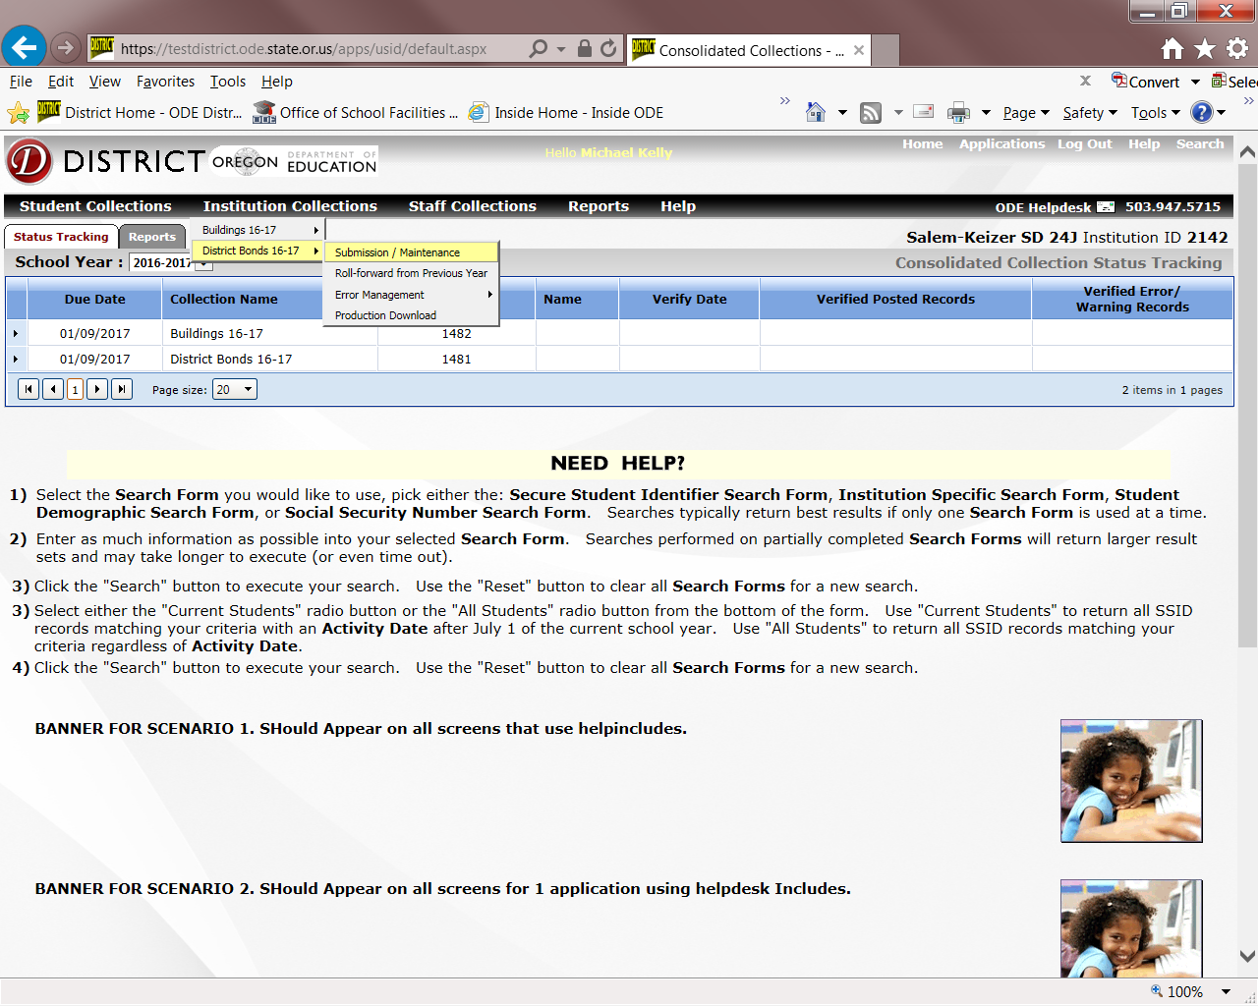

1. Select **“Insert New Record”** as shown below.

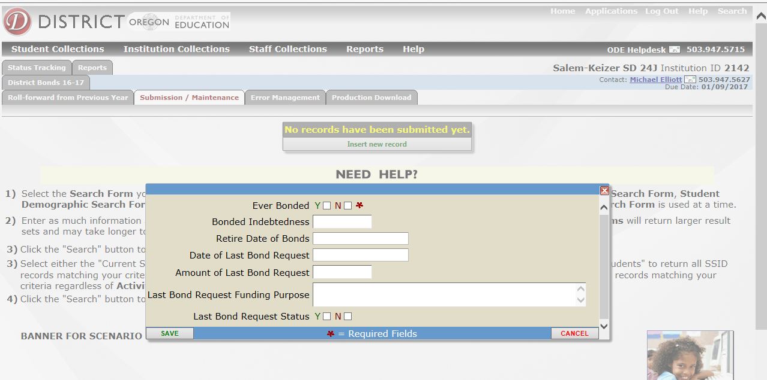

1. Enter Data
   1. For specific questions concerning data elements please refer to the “District Bonds Collection Data Elements” section
2. **“SAVE”** and submit your data
   1. After you have entered your data, click the **SAVE** button at the bottom of the page and your information will be uploaded to ODE.