
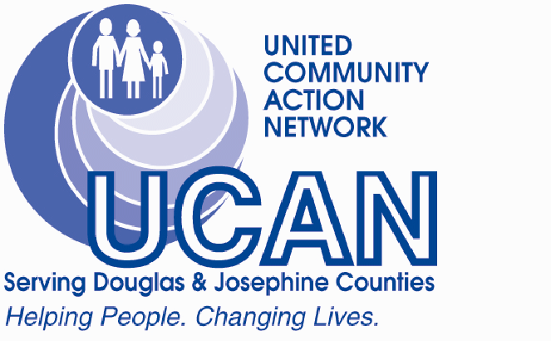

Medicare 101
Tuesday, Nov. 19th, 2:00 PM
Come to our introductory seminar and learn all you need to know about Medicare, but were afraid to ask!
- Are you NEW to Medicare in December through February?
- Are you confused by Medicare?
- Do you want help selecting an insurance plan?
- Need an explanation of your Part “D” choices?

Class is free but seating is limited,
Call to register 541-956-4050

UCAN RSVP, Conference Room
201 N.E. 8th Street, Grants Pass OR 97526

