  
    - EIS Cyber SEcurity Webinar
  Supply Chain Risks
  Please join us on Thursday, February 16th at 1pm for our next Enterprise Information Services (EIS) web series event “Supply Chain Risks”.
  As the details of the well-documented SolarWinds, Log4j, Kayesa, and other breaches are published, some unnerving cybersecurity concerns about software security are being exposed. The nature of software makes it difficult to determine if any particular application is secure or not, and many people and organizations feel helpless. After all, if federal defense agencies and fortune 500 corporations can’t defend themselves against software supply chain attacks, how is a small agency supposed to vet their software vendors?
  Join our Cyber Webinar as we provide a not-too-technical introduction to what makes the software vendor supply chain breaches so concerning. We’ll also point out some concerns about IT hardware supply chains. Then we’ll provide actionable advice on how organizations of all sizes can help defend themselves from the specter of software vendor cybersecurity concerns and have an open discussion between attendees and a panel of experts.
  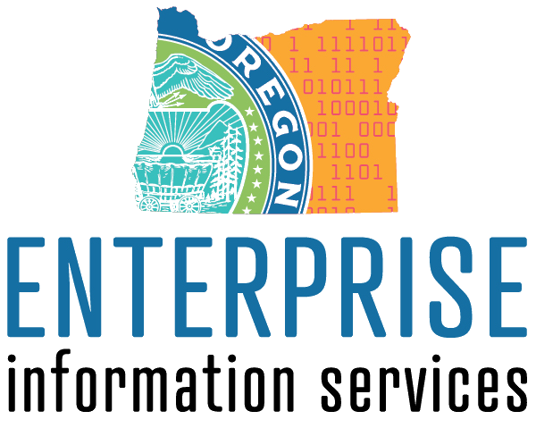
  Visit the EIS Cyber Security Webinar webpage at: https://www.oregon.gov/das/OSCIO/Pages/eis-security-webinars.aspx
  Feruary 16, 2023
  1:00Am – 2:30pm
  Click here to join the meeting
  Who should attend:
  Business Decision makers, cyber SECURITY and IT personnel
  FUTURE WEBINARS INCLUDE
  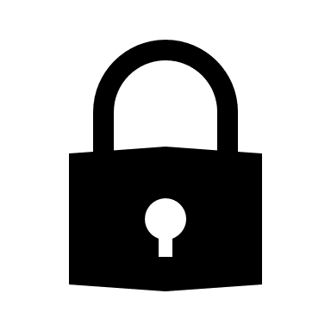
  Cloud Security
  April 13th – 1pm
  Security Roadmaps
  June 15th – 1pm
  Data Privacy
  August 17th – 1pm
  Approach to Social
  Engineering
  October 19th – 1pm

