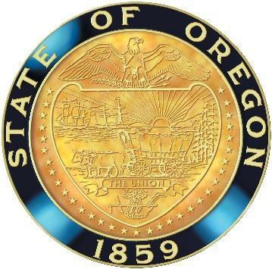
Oregon State Board of Nursing Listening Session

Oregon State Board of Nursing

Listening Session: Possible consolidation of CNA1 and CNA2
The Oregon State Board of Nursing (OSBN) is seeking community feedback on the topic of possible consolidation of CNA1 and CNA2 certifications into one CNA certification. A virtual meeting is scheduled for Tuesday, May 30, 2023, from 10 am - 11 am, to collect this information.

Note: This Listening Session is being conducted at the request of OSBN Board Members. This Listening Session is for information collection only.

This public listening session is open to any member of the public interested in either listening or contributing to the session. Comments will be limited to 5 minutes for everyone. If there are several representatives from a specific group or organization, please have one individual comment for the group.

Participants may access the Listening Session using the link below:
Microsoft Teams meeting
Join on your computer, mobile app or room device
Click here to join the meeting

Meeting ID: 232 295 797 736
Passcode: UgvjmG
Download Teams | Join on the web

Or call in (audio only)
+1 503-446-4951,,806527816# United States, Portland
Phone Conference ID: 806 527 816#

