Save the Date NAVRC 2021

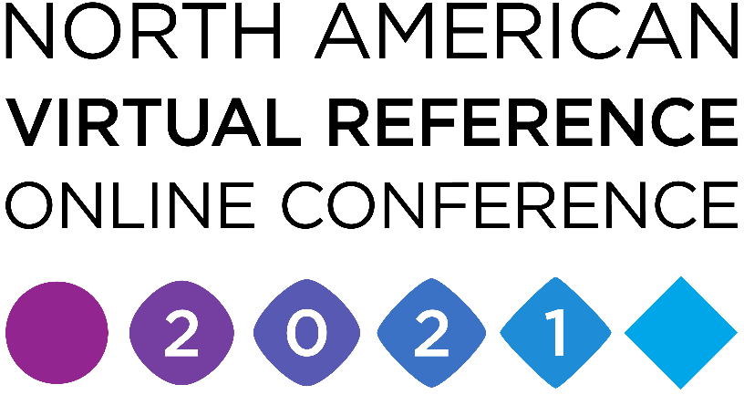

February 23-25, 2021

Adaptability: Thriving in Uncertain Times

The pandemic has created an environment of ambiguity and changeability, and through it all librarians are finding new ways to reach and serve their communities. Join us as library professionals from around the continent discuss how they are using virtual reference services to increase access, forge partnerships, drive equity, and foster engagement -- all when planning for more than a week ahead can sometimes feel like an impossible task.

[https://www.navronline.org/home](https://nam02.safelinks.protection.outlook.com/?url=https%3A%2F%2Fwww.navronline.org%2Fhome&data=04%7C01%7Cmccarthy%40wccnet.edu%7Cd15158aca851487258f708d87b5b709d%7Cec4c99b641114ea0bd5a735a0ae10394%7C0%7C0%7C637394979964847438%7CUnknown%7CTWFpbGZsb3d8eyJWIjoiMC4wLjAwMDAiLCJQIjoiV2luMzIiLCJBTiI6Ik1haWwiLCJXVCI6Mn0%3D%7C1000&sdata=nBtmkv2mr%2FCCDxHD3K4dUe3FoFfhAVut%2FHUEiDnXD0A%3D&reserved=0)

Please direct your questions to Tamara Ottum at [tamara.ottum@state.or.us](mailto:tamara.ottum@state.or.us)