Date | Photo Copy | Post Copy | Post image or video still
Wednesday 1/3 | New Year, new you. | The past doesn't define who you are. Decide who you want to be today. #staytrueoregon | 
Friday 1/5 | Why risk your full potential? | Brain development continues into your mid-twenties. #staytrueoregon | 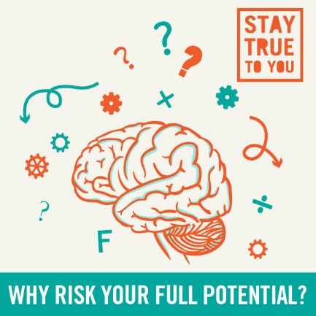
Monday 1/8 | Harry Potter's got a point. | "Don't try too hard to be something you're not." — Daniel Radcliffe #staytrueoregon | 
Friday 1/12 | First of all, that's my child. | When someone tells you it's just a dog. #staytrueoregon | 
Monday 1/15 | Happy Martin Luther King Day! | "The time is always right to do what is right." — Martin Luther King, Jr. #staytrueoregon | 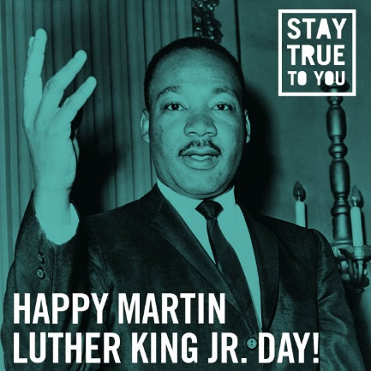
Thursday 1/18 | You wouldn’t get high when you’re responsible for them. | So why would you get high when you’re responsible for you? #staytrueoregon | 
Saturday 1/20 | Forward never backwards. | Your voice is a gift that can change the world. #staytrueoregon | 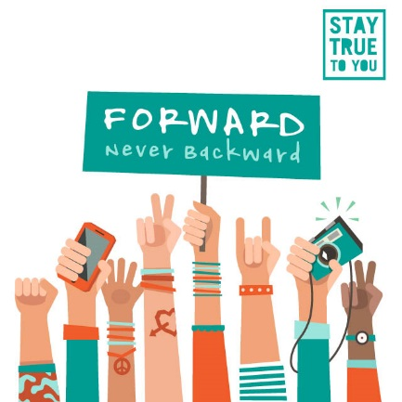
Thursday 1/25 | It's a miracle! | When the weatherman forecasts for snow, and it actually does snow. #staytrueoregon | 
Tuesday 1/30 | Looking at colleges? | They may be looking at you too. Weed is still illegal if you're under 21. #staytrueoregon | 

