Date | Theme Bucket | Post Copy | Link | Visual
Monday 1/1 | Youth | “With Tobacco 21, we will now be able to continue this crucial work, helping to prevent future youth from starting tobacco addiction while promoting good health in every corner of our state.” — Governor Kate Brown #Tobacco21 #BeTheFirst | NA | 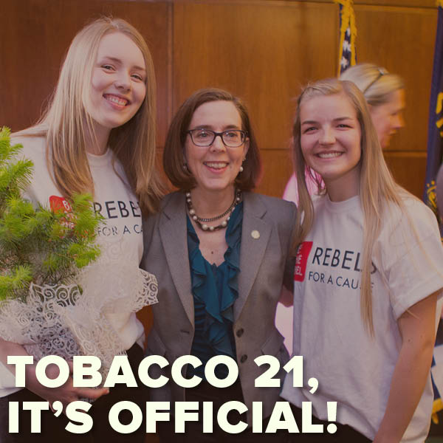
Wednesday 1/3 | Cessation | One of the many quit benefits: it's a money saver! Call 1-800-QUIT-NOW or visit www.quitnow.net/oregon/ | www.quitnow.net/oregon/ | 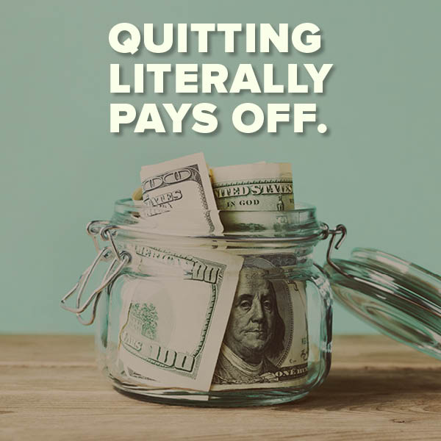
Thursday 1/4 | Youth | Preventing tobacco use among young adults is critical to ending tobacco use in Oregon. | http://wapo.st/2kzVidB | NA
Friday 1/5 | Partner Post | Big Tobacco is finally telling the truth...after millions of lives have been lost. #tobaccoracketeers | http://bit.ly/2AYBoSY | NA
Monday 1/8 | Partner Post/Cessation | "Instead of picking one day a year, use Monday as your day to quit and recommit to your quit every 7 days." Call 1-800-QUIT-NOW or visit www.quitnow.net/oregon/ | http://bit.ly/2ksIMPI | NA
Wednesday 1/10 | Disparities | African American neighborhoods have more tobacco advertisements than other neighborhoods. This is no coincidence. #StopProfiling @truthorange | http://bit.ly/2j0jtV2 | NA
Thursday 1/11 | Tobacco retail environment | Big Tobacco knows that 70 percent of teens shop in convenience stores at least once a week. http://bit.ly/1Lnfcwa | http://bit.ly/1Lnfcwa | 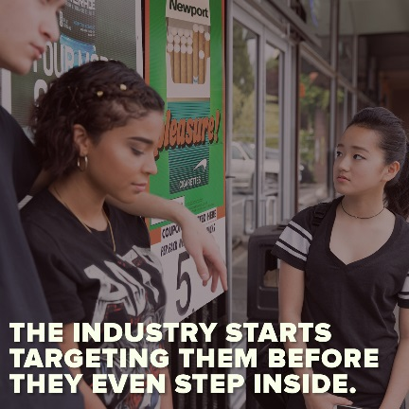
Friday 1/12 | Corrective statements | Way too little, way too late. Tobacco companies are finally admitting the truth, but check out what they've been saying for years. #tobaccoracketeers | NA | NA
Monday 1/15 | Cessation/Events and Key dates | Happy Martin Luther King Jr. Day from Smokefree Oregon! Call 1-800-QUIT-NOW or visit www.quitnow.net/oregon/ | www.quitnow.net/oregon/ | 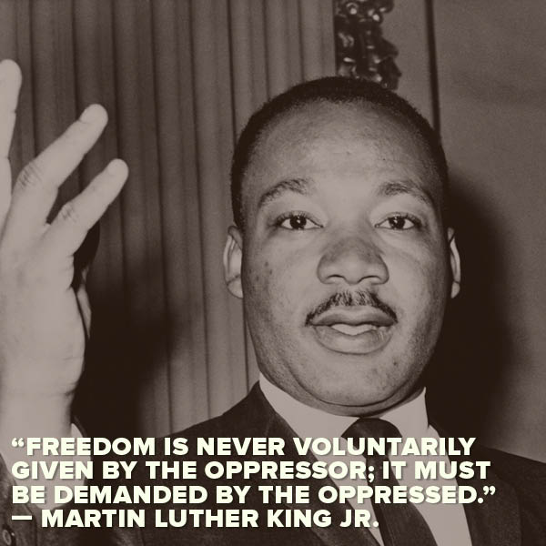
Wednesday 1/17 | Environment | Learn about other smokefree places in your community and how you can get involved: http://bit.ly/1IXrKeS @MtHoodCommunityCollege @MultCoHealth | http://bit.ly/1IXrKeS | 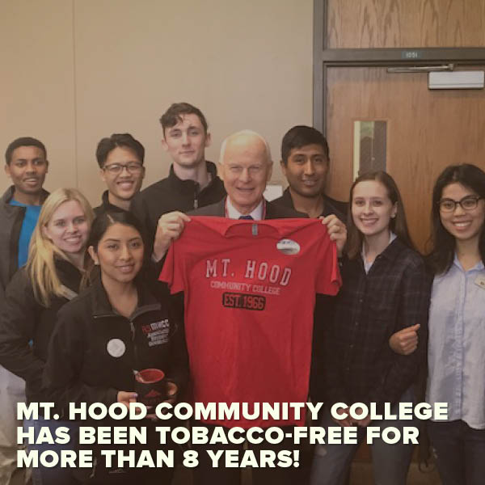
Thursday 1/18 | Join the SF Community | 2.5 years and still going strong. Hear about how Portland City Parks became tobacco-free. #TBT | http://bit.ly/2jkHnHA | NA
Friday 1/19 | Real Cost | Even if you don't smoke, tobacco costs you dearly. It robs life from our communities. http://bit.ly/1mNoXHO | http://bit.ly/1mNoXHO | 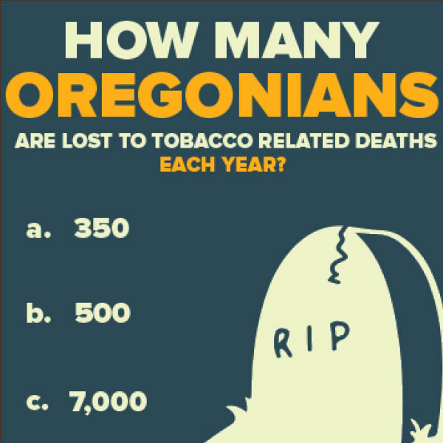
Monday 1/22 | Cessation | "Don't believe that this can't happen to you, because it can." Call 1-800-QUIT-NOW or visit www.quitnow.net/oregon/ | http://bit.ly/2jZsH04 | NA
Wednesday 1/24 | Partner Post | #FinishIT | http://bit.ly/2BRlYNI | NA
Thursday 1/25 | Environment | #DYK: Cigarettes, filters and butts are our most common source of litter. http://bit.ly/10XoZZ4 | http://bit.ly/10XoZZ4 | 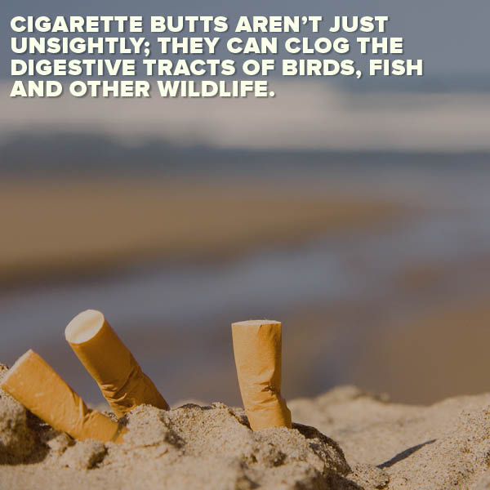
Friday 1/26 | Environment | Congrats to Klamath County on their new tobacco retail license! Learn more about what this will mean for the community. http://bit.ly/2BQG62M @klamathpublichealth | http://bit.ly/2BQG62M | 
Monday 1/29 | Cessation | No judgments. Just help. Call 1-800-QUIT-NOW or visit www.quitnow.net/oregon/ | www.quitnow.net/oregon/ | NA
Wednesday 1/31 | Environment | #DYK: It has been more than 10 years since Oregon passed the Indoor Clean Air Act! http://bit.ly/2kJt1k1 | http://bit.ly/2kJt1k1 | 