**March 20, 2020**

**Purpose**

To establish an SFMA profile for all agencies to use to track COVID-19 costs. By establishing a single profile used by all agencies, DAS will be able to query activity from the SFMA Datamart.

**Process**

Create an SFMA project and phase number for use by all agencies that use SFMA. Unless granted an exception by SARS, each agency shall create the profiles in their agency specific accounting structure. The project and phase numbers may be used in any budgetary fund type, ORBITS cross reference, GAAP fund account, cash account, treasury account, etc.

**Agency responsibility**

**Step 1**. Create a D06 Project Type profile in the agency’s accounting structure using the data referenced in the below screen shot. *Note*: replace agency “XXX” with the actual agency number.

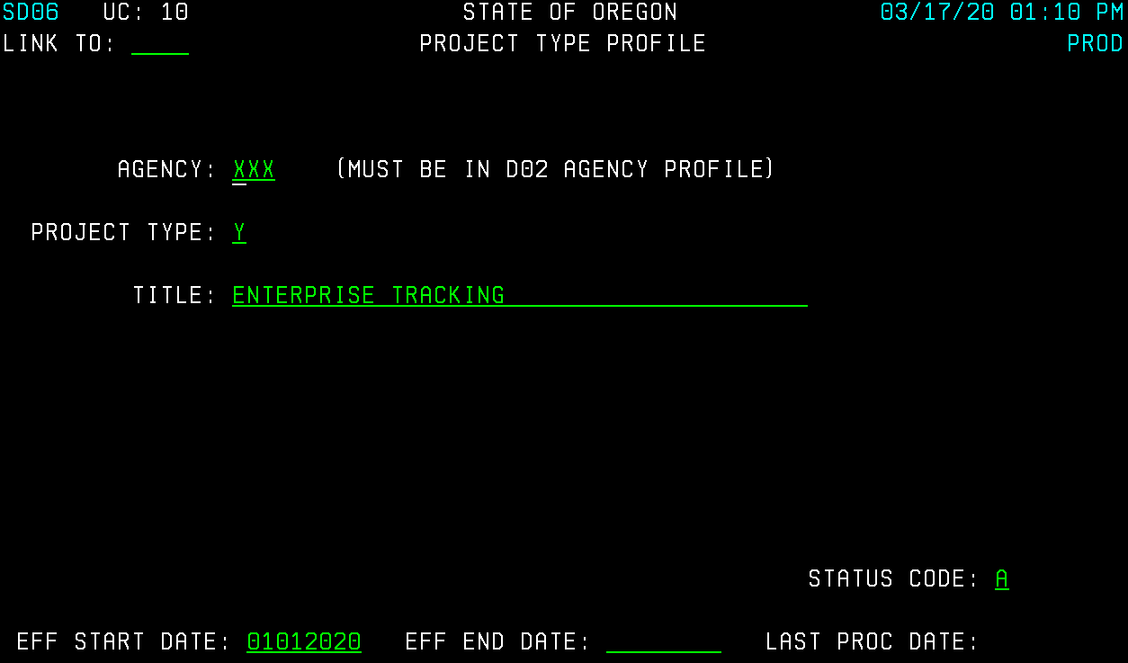

**Step 2**. Create a D42 Project Number profile using the data referenced in the below screenshot. *Note*: replace agency “XXX” with the actual agency number and enter the agency’s contact information (name and phone number).

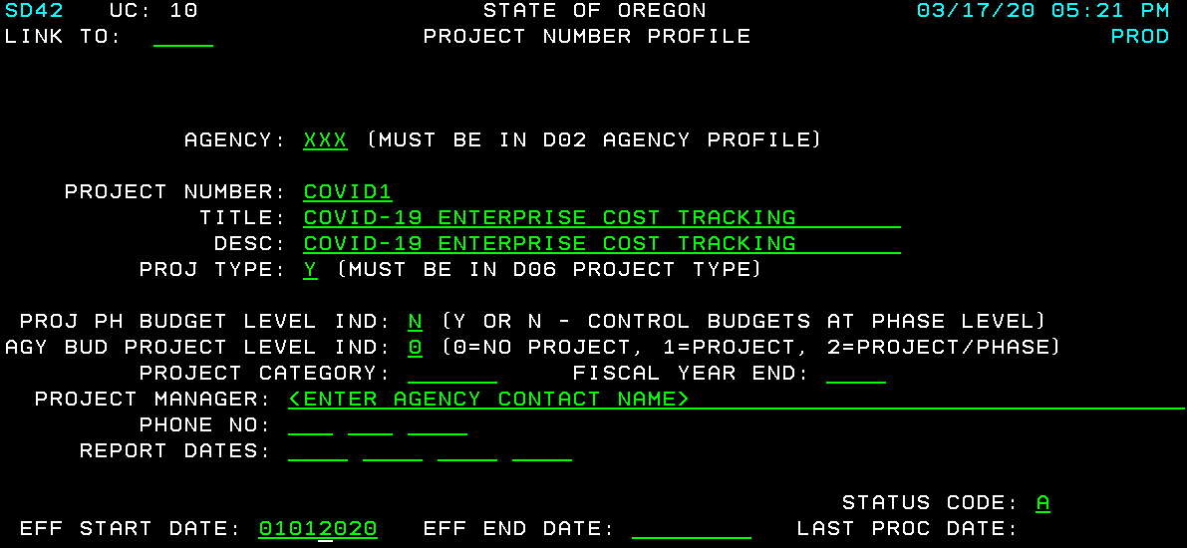

**Step 3**. Create a 27 Project Control profile using the data referenced in the below screenshot. *Note*: replace agency “XXX” with the actual agency number.

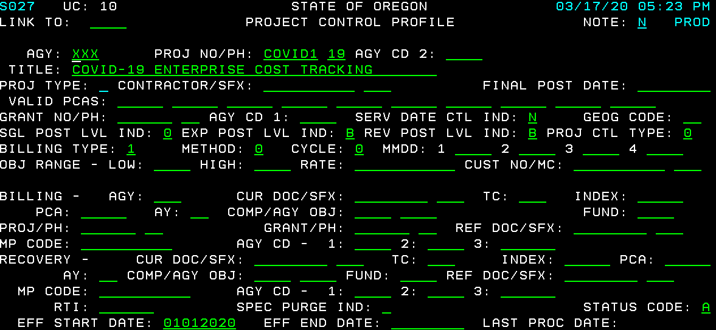

**Step 4**. Use the COVID-19 project and phase number for all financial transactions (including payroll costs) related to the COVID-19 pandemic. If transactions have already posted to SFMA without reference to the COVID-19 project and phase number, agencies must reclassify the transactions to ensure the COVID-19 project and phase number are included.

Payroll costs should be recorded in ePayroll by recording “COVID1” in the Work Charge field for **hours worked**, for this purpose, please do not record “COVID1” in the Work Charge field for any paid/unpaid leave.

