OBIEE User Group Meeting Summary:
Welcome and housekeeping
Reminder: Please continue to send OBIEE (OB1) issues to Datamart support. If you are sending them directly to Aaron, the answers may be delayed if out of the office. There is a great backup team to answer questions if issues are sent to the support inbox.
Thanks to all who participation in the recent short survey. I believe the results will help us plan for future projects with OB1 and the DM.
Resource reminders for OB1 information:
Trainings on Workday: “Datamart: OBIEE”, “Fundamentals of the Datamart” and “OBIEE-Hyperion conversion process” More training on the way, so make sure to check the news list for those updates.
The DM website contains a ton of information, not only on OB1 but the Datamart.
Check out the SARS System Security site (https://www.oregon.gov/das/financial/acctng/pages/syst-security.aspx) if you have any questions about OB1 security. All security setup or alterations are done by System Security. You will start by speaking with your Agency Security Officer (ASO), who then speaks directly with System Security.
The following items are the top issues users face on a regular basis.
- Passwords – They will expire every 90-days, whether you are sync or non-sync for OB1. Make sure to change your PW prior to the 90-day expiration. And do not forget to set a pop-up reminder on your email to help.
- The OSPS Datamart will now allow users to view ‘all’ agencies. Your OSPS security is no longer locked down and this change is not only OB1 but other programs as well. The big key with this change, from now on, is to add an Agency filter to all OSPS queries. If not, you will waste a lot of time by pulling all agencies.
- Users have recently received error messages or a blank screen when trying to access the OB1 production site. If this happens, the first fix suggestion is to ‘clear the cache’ on your internet browser. Go to settings, search for ‘cache’ and clear it. If you need help, please contact your helpdesk.
- Here is one of the main issues users’ run into when building an analysis. They use profile table fields when the field is also on the main financial table. If they are in both places and the profile field is used, it will cause major slowness issues. It can potentially become out-of-control. Make sure to only use the main financial table field.
- “Editing without refresh” - This was a recent hint, sent over the news list.
  - When creating an analysis and viewing the ‘results’ section, you can ‘edit’ the views you have created, such as table & pivots. Once you click on the ‘edit’ mode (the pencil icon), there is always a refresh that occurs. In addition, each time you update something in this mode it will refresh. What you can do is turn off the ‘display results’ option, which will allow you to freely move around edit mode. Complete all the necessary edits and then select ‘done’ when finished. Yes, it will refresh once you click ‘done’ but the entire time you were editing it will not refresh. This should be a huge time savings.
There were a few comments/questions during the training:
- Do we have a cheat sheet type of document that would help us know more about the tables in the Datamart?
  - This can be found on the Datamart website within the SFMA or OSPA Datamart tables sections: https://www.oregon.gov/das/Financial/AcctgSys/Pages/datamart.aspx
- Is there a timeline on the fix for the Excel export issue?
  - Tech support is close; however, there is no timeline.
- How can a user find fields, within the ‘criteria’ section, quickly?
  - There is a search feature that makes it possible to find these fields. Here is an example:
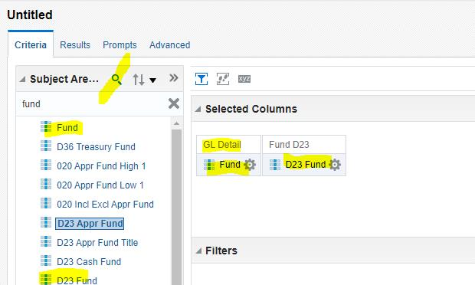
- A user asked if there was way to save a template of the file they created.
  - Other users suggested creating a basic query, save it as their template, and then copy and paste as a new file whenever they need to start a file. This will help save a lot of time.
- Is there a way to format a date like MMDDYY?
  - A user could go to the ‘column properties’ area of a field and update the format.
  - You are also able to alter this format in Excel. Use this formula format: =TEXT(A1,"mmddyy").
- Is there a way to change the ‘All acct Event’ subject area to the ‘Archived All Acct Event’ without recreating the full analysis?
  - There is not a way to complete this task. A user would have to restart the file from scratch.
- Is there a way to have two files open at the same time?
  - Yes, a user could have two internet browser programs open and have two sessions of OB1 going at the same time. You can have multiple (2+) sessions going at the same time, if needed.
- Is there a way to lock headers on the ‘results’ tab, within a table or pivot view, so that when I scroll down to review my data, I do not lose sight of the headers?
  - I confirmed with the contractor, and they say there is no such feature in OBIEE.
- If I accidentally delete a file, can it be saved?
  - Yes, we back up the OB1 server one month, so if a request to Datamart Support is completed a month prior to the ‘date of deletion’, we can retrieve it.
  - It updates nightly, so if you create and delete a file the same day, you will not be able to retrieve it.

What is working well with OB1?
- The following are comments from users:
  - I love not having to sign in every time I switch to a different query.
  - I like the fact that I can use the dashboards.
  - Exporting functions look more professional.
  - I've found it easier to learn and easier to create a query/analysis.
  - OBIEE opens and runs much quicker than Hyperion did in the Citrix environment for us Mac users.
  - I really like the tables are already linked correctly – yay
  - creating queries are much more user friendly in OBIEE than Hyperion.
  - To me, the whole thing is a bit more user friendly and I love it!
  - it's nice that all the files are accessed through OB1 as opposed to Datamart files being potentially saved all over an agency's file folders
  - I like the new DAFR6610 and 6620 repository reports. It’s nice to be able to export them as Excel or as CSV if I need more detailed data.
  - I think OB1 is a big improvement. Seriously!
  - It ignores hidden fields.
  - It was very helpful to use the ‘scheduler’ feature, during year-end close, so that I could have results emailed and ready in my inbox as I arrived at work.
What has not worked well and needs improved.
- Displayed below are the user comments and plans of action for these issues.
  - I cannot use external data.
    - The program does allow for external data usage; however, DAS does not have the resources to make this a reality.
  - Able to change the field size (width wise) when needed.
    - There are various ways to update the width. Datamart support will research what would be a valid option.
    - A user mentioned that they can change the width of each field via the ‘edit’ view and then ‘column properties’ for each specific field.
  - How to "order" filters so they work (‘and’ and ‘or’).
    - This is a very complex topic and will be researched at greater length.
  - Really, I don't need any improvements.
    - Great comment.
  - Our agency bought licenses for a different product in order to merge data.
    - Since, the DAS OBIEE server is not setup to merge data, agency management decided to obtain a different product. This can be done by any agency, if needed.
  - Can't create groupings by selecting and dragging from list.
    - Creating groups is much different than Hyperion. You can review the trainings on Workday to see the details on grouping creation.
  - Want the ability to utilize OBIEE Visual Analyzer (VA).
    - This is a separate license, which the State of Oregon does not currently own. Each agency has the option to purchase the license, if so desired.
  - More training on creating compound layouts and pivot tables.
    - This will be on top of the list for training creation.
  - Hyperion allowed a transaction register of all OSP revenue and expense for entire biennium. OBIEE does not it is far too much even for a month for all OSP. That data is very handy to have all in one place.
    - This issue is being researched.
  - It would be helpful for formulas to reference columns by name rather than column formula. It gets so much more confusing seeing the entire formula and requires extra time editing when a base formula is modified.
    - A formula is very complex, and Oracle has set up their program to show the complete view. It was very nice to have it shortened in Hyperion; however, it looks as though this product will continue to show a full view.
  - I wish the ‘Edit’ Filters had the "Ignore" option like we used to have in Hyperion.
    - This would be a ‘nice to have’ option but currently it is not in the program.
  - Ability to "focus" (like filters) on one pivot without having that apply to the other pivots in the query.
    - This would be a ‘nice to have’ option but currently it is not in the program. I have discussed this with the OBIEE contractor, and they say it is not available at this time.
  - How to subtract results in one column from another.
    - One way to accomplish this task is to create a new criteria field that contains a formula. Creating it at the criteria level is the best option as it will allow the data to flow to all tables/pivots. Within the formula, you can reference other fields to help display the formula quickly; however, even with the reference feature, the code will display in full. As a reminder, the new formula must be set as an aggregation rule of ‘sum’, or the column will not function as a proper dollar type figure.
  - I dislike that the "Measures" section on pivots will only take number data.
    - You can include non-measure fields within a table/pivot; however, the OB1 program will only recognize dollar type figures properly when included in the ‘measure’ section.
  - I wish it was easier to update a title of an analysis, once it is saved it seems like it is locked in. Also wish I could delete it.
    - You can alter a title of a file or delete it within the ‘catalog’ section. You may have been trying to alter the info in the ‘home’ section, which will not allow these alterations. If you go to the ‘catalog’ menu and the ‘more’ option, you will find the ‘rename’ and ‘delete’ options.
  - It seems that if you have too much data you can't run the query, like a full biennium for example.
    - There are specific limitations set in OBIEE to keep up the standards of the server output. The current row and cell limitations are 1 million and 15 million, respectfully. Exceed these limits and you will receive an error.
    - Please alert Datamart support if you have an analysis file that are under the limits but is still having issues because potential fixes are on a case-by-case basis.
  - How do we delete old scheduled queries? I used the query bots during fiscal close. Now I have a long list of old query bots, I keep trying to delete the old ones, it acts like it will delete and then an error message pops up and it won't delete the old 'scheduled' query bot.
    - You can go to the ‘catalog’ menu, find the file, and select the ‘more’ option. Within this option is ‘delete’, which will complete the desired operation. If you continue to have issues, please contact Datamart Support.
  - Calculated fields - such as: budget - minus expenditures, remaining budget % and expenditures minus revenues (reimbursement billings). I would love some sample files so I can tweak or follow how to do it. Would love reports (w/calc fields) on dashboard tutorial.
    - There are a few formula type calculations on the OB1 repository files. I highly recommend checking them out. In addition, Datamart support will look to add more formula info to future trainings.
  - Can we set ‘Results’, so we see all data rather than just first part?
    - There is a limit of 20,000 total rows displayed; however, you must set it to show that amount as the default is very low.
  - Is there an "undo" feature. Like if you want to go back to previous. Do, we "remove all steps" for this also.
    - There is no official ‘undo’ feature in OB1. If you focus on some data, you must use the ‘remove all steps’ function to undo. You are also able to use the ‘’table prompts’ function within a table/pivot edit mode. (See example below)
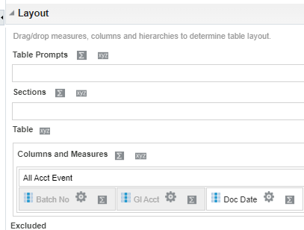
  - Many of these questions will be very helpful if it could be part of the newsletter. Being, in person, at this meeting is great.
    - I am sending the summarized info over the new list for all to enjoy.
  - I have noticed that the criteria bar seems to act as an order of operations of sorts. That columns later referenced in other formulas must be positioned in the criteria to the left of the column that references it. Is this true?
    - We will research this issue and ask the contractor.
- Thank you all for attending.

