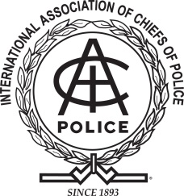



**The International Association of Chiefs of Police**

**in partnership with**

**The Law Enforcement Council of Washington**

**County & The Sherwood Police Department**

**Present:**

***Enhancing Police Response to Violence Against Women***

**When**: **Monday May 7th, 2012 8:00am to 5:00pm**

**Where:** **City of Sherwood Police Department, Community Room**

**20495 SW Borchers Drive**

**Sherwood, OR 97140**

**Cost:** **Free**

**Target Audience:** This training is intended for law enforcement of all ranks, specifically first-line officers and supervisors, but will also highlight information pertinent to command staff. Community partners are also welcome to attend.

**Training Topics:** This training will focus on the realities of violence against women and present promising practices to assist law enforcement in responding to and investigating domestic violence, sexual assault, stalking, and human trafficking.

**Instructors:** Instructors and staff for this training course include:

* **Mr. Mark Wynn**- Mark Wynn is a retired Lieutenant and twenty year member of the Metropolitan Police Department in Nashville, Tennessee.  He currently runs Wynn Consulting, providing prevention, training, and consulting on the topics of domestic violence and sexual violence.
* **Ms. Michael Rizzo**- Michael Rizzo is the Project Manager for the IACP’s National Law Enforcement Leadership Initiative on Violence Against Women. Ms. Rizzo has over 15 years of experience in victim advocacy and community education.
* **Ms. Gina Skinner**- Gina Skinner is a Prosecutor with the Washington County District Attorney’s Office. As a Deputy District Attorney she is assigned to the Felony Unit, where she prosecutes domestic violence cases.

**Registration Information:** To register, please contact Angela Hass, either by phone or email at:

[hassa@sherwoodoregon.gov](mailto:hassa@sherwoodoregon.gov) or (503) 925-7131.

Supported by the Department of Jusitce, office oN violence against women