E-Rate Central News for the Week of May 28, 2018

- Funding Status – FY 2018 and FY 2017
- Updates on USAC’s E-Rate Productivity Center and Legacy System
  - USAC Data Tools Outage
  - “Missing” SPIN Change Module
  - Summer Deferral
- E-Rate Updates and Reminders
  - Upcoming 2018 E-Rate Dates
  - Form 470/471 Public Comment Period
  - Bill supporting Wi-Fi on School Buses
- USAC News Brief Dated May 25 – Special Construction Deadline Reminder

Funding Status – FY 2018 and FY 2017

FY 2018:

Wave 7 for FY 2018 was released Saturday, May 26th for an undetermined amount. See the article below for details about USAC tool outages. Cumulative funding as of Wave 6 is $873 million. The next scheduled wave has not been announced.

FY 2017:

Cumulative national funding through Wave 55 is $2.33 billion. The next scheduled wave has not been announced.

Updates on USAC’s E-Rate Productivity Center and Legacy System

USAC Data Tools Outage

USAC is currently experiencing an unannounced outage of several tools including: the FRN Status Tool (FST), the Search Commitments Tool and USAC’s Open Data tool pertaining to Form 471 datasets. These tools appear to have gone offline as of Wednesday, May 23rd. A “Release Note” found on USAC’s Open Data web page cites “system issues” while the FST and Search Commitments tool state “website maintenance”.

“Missing” SPIN Change Module

The “Landing Page” is typically the point from which any form filing action takes place. It appears that for some users, the SPIN Change button which used to be adjacent to the Service Substitutions button, is missing.

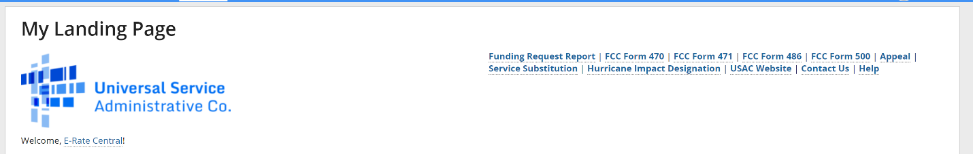

While the hyperlink to the “SPIN Change” module may be missing from your “Landing Page”, you may still be able to access the “SPIN Change” by selecting your entity from the home page.

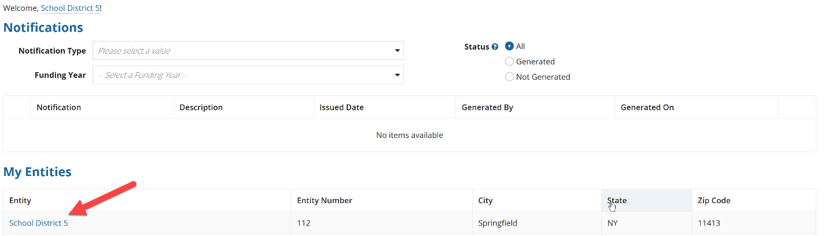

Next, select “Related Actions” to access the complete menu of “Related Actions” which includes the option for filing SPIN changes.

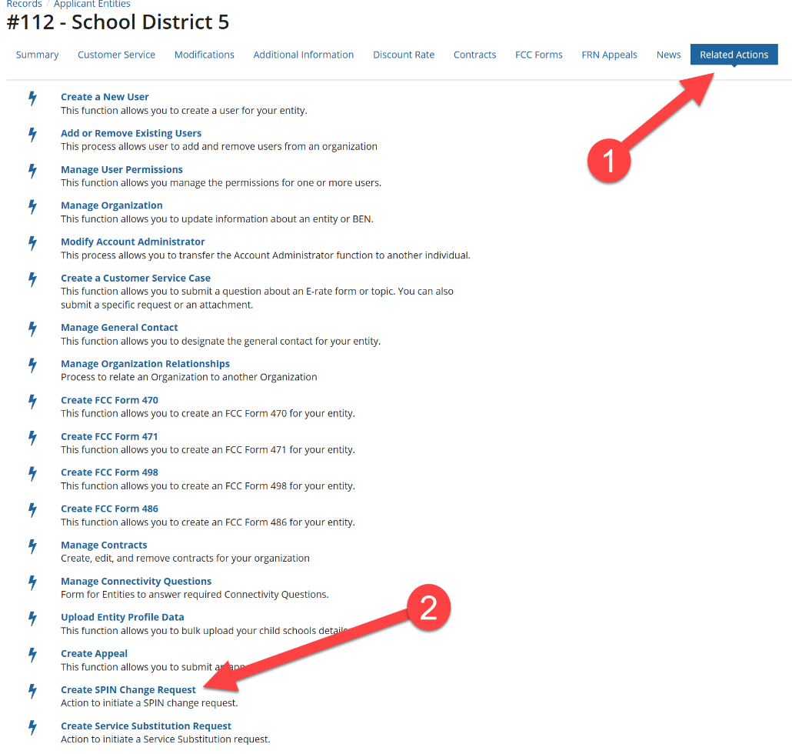

Summer Deferral

This week begins the summer deferral period. Typically, the summer deferral period extends to the last Friday (September 7) after Labor Day. Applicants understaffed during the summer have the option of handling PIA inquiries as they come in or may proactively place the review of their applications on hold during the summer deferral period. To request a summer deferral in EPC after receiving a PIA inquiry, click on the “Apply Summer or Winter Deferral” button. Two ways of accessing the “Apply Summer OR Winter Deferral” option within the specified Form 471 are:

- Within “Review Inquiries”
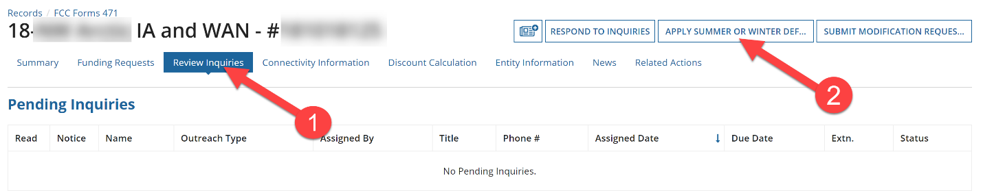

- Within “Related Actions”
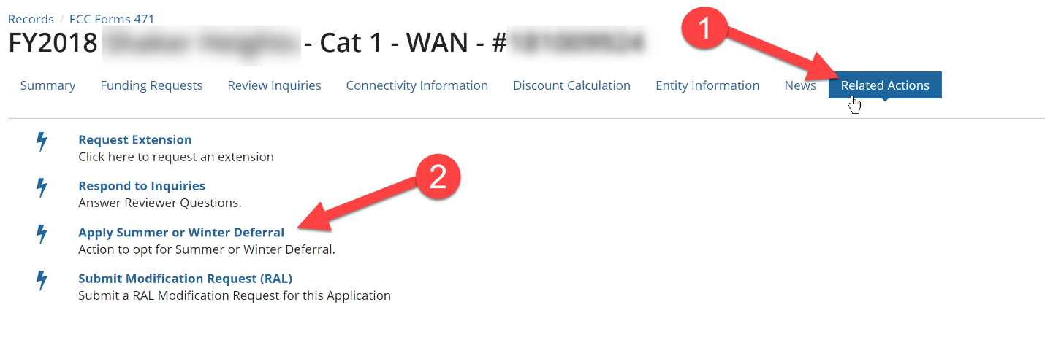

Note: Summer deferrals can only be applied at the Form 471 application level, not at the applicant level. If you need to use this option on all of your applications, be sure to navigate to each Form 471 individually and apply the summer deferral option.

E-Rate Updates and Reminders

Upcoming 2018 E-Rate Dates:

May 21 FY 2017 Form 486 deadline for funding committed in Wave 36. Other upcoming Form 486 deadlines include:

Wave 37 05/29/2018

Wave 38 06/04/2018

Wave 39 06/08/2018

Wave 40 06/11/2018

Applicants missing these (or earlier) deadlines should watch carefully for “Form 486 Urgent Reminder Letters” in EPC. The Reminders will afford applicants with 15-day extensions to submit their Form 486s without penalty.

The first Form 486 deadline for FY 2018 is not until October 29, 2018.

June 1 Deadline for submitting comments to the FCC re. the NPRM on Protecting Against National Security Threats to the Communications Supply Chain Through FCC Programs (see our newsletter of April 2nd). Reply comments are due by July 2nd.

June 20 USAC webinar on Understanding Post-Commitment Actions.

June 30 Last day to file a special construction deadline extension request.

July 23 Deadline for submitting Form 470/471 comments.

Form 470/471 Comment Period

The FCC is seeking to extend the approval of current versions of the FCC Forms 470 and 471 which are set to expire at the end of this year. The Paperwork Reduction Act (PRA) requires federal agencies to invite public comment on federal forms. This notification was issued on May 22, 2018 in the Federal Register and specifically seeks comment on the following topics:
- Whether the proposed collection of information is necessary for the proper performance of the functions of the Commission, including whether the information shall have practical utility;
- The accuracy of the Commission's burden estimate;
- Ways to enhance the quality, utility, and clarity of the information collected;
- Ways to minimize the burden of the collection of information on the respondents, including the use of automated collection techniques or other forms of information technology; and
- Ways to further reduce the information collection burden on small business concerns with fewer than 25 employees.
The public comment period is open until July 23, 2018. To submit formal comments, email Nicole Ongele, FCC, via email PRA@fcc.gov AND to Nicole.Ongele@fcc.gov.

Bill supporting Wi-Fi on School Buses:

On Thursday, May 24th, Senator Tom Udall (D-NM) and Senator Cory Gardner (R-CO) introduced a bill to support Wi-Fi on school buses. This bi-partisan bill would mandate the FCC to provide E-rate support for Wi-Fi access on school buses. The effort undertaken by these Senators is a direct action to combat the “homework gap” that exists for those students who do not have Internet access at home. In the most rural of counties, students travel over an hour to school and Wi-Fi on school buses has the potential to provide those students with much needed Internet access on their long commutes. Stipulations of this bill include:
- School buses are designed to carry a driver and not less than five passengers;

- School buses are used significantly to transport early child education, elementary school or secondary school students to or from school or an event related to school; and

- No later than 180 days after the enactment of the Act, the FCC shall conduct a rulemaking to allow for Wi-Fi on school buses to be eligible for E-rate funding.

USAC News Brief Dated May 25 – Special Construction Deadline Reminder

USAC’s Schools and Libraries News Brief of May 25, 2018, reminds applicants of the June 30th deadline to complete FY2017 special construction required to light or use the fiber. USAC itemized four reasons an applicant can utilize this option and applicants must be prepared to demonstrate when seeking a special construction deadline extension that their situation applies to one of the following:
- USAC issued your FCDL after February 2018 and special construction did not begin until you received the FCDL;
- USAC has not yet issued your FCDL and special construction has not yet begun;
- USAC has not yet issued your FCDL and you opted to commence special construction, but that work began after February 2018; or
- A detailed explanation of why construction for your project has been unavoidably delayed and the June 30 deadline to light the fiber cannot be met despite receiving an FCDL and/or commencing special construction in February 2018 or earlier. Relevant details include the date that you received your FCDL (or statement that the FCDL has not been received yet), the date that you started special construction, the breadth and complexity of the fiber build project, and any other factors relevant to your particular circumstances (e.g., weather, terrain) that caused the delay.
The method of filing for the one-year extension is dependent on whether you have received your FCDL. If you have already received your FCDL, complete the FCC Form 500 and follow the Form 500 instructions. If you have not received your FCDL, download a copy of the FY2017 Special Construction Deadline Extension Request worksheet. Complete the worksheet and submit to customer service within EPC.

