- Funding Status – FY 2018 and FY 2017
- Updates on USAC’s E-Rate Productivity Center and Legacy System
  - FCC Guidance to USAC on Form 470 Category 1 Menus
  - Reminder on PIA Reviewer Email Addresses
- E-Rate Updates and Reminders
  - Upcoming 2018 E-Rate Dates
  - Updated USAC Reference Material
  - FCC Decision Watch
- USAC News Brief Dated May 4 – Selective Review Details

Funding Status – FY 2018 and FY 2017

FY 2018:

Wave 4 for FY 2018 was released Friday, May 4th, for $62.4 million. Cumulative funding is $700 million. Wave 5 is scheduled for release on Thursday, May 10th.

FY 2017:

Wave 52 for FY 2017 was released Tuesday, May 1st, for a total of $29.7 million. Cumulative national funding through Wave 52 is $2.32 billion. Wave 53 for hurricane relief applicants will be released on Friday, May 11th.

Updates on USAC’s E-Rate Productivity Center and Legacy System

FCC Guidance to USAC on Form 470 Category 1 Menus:

The FCC sent a letter to USAC last week providing guidance to resolve the confusing Form 470 drop-down menu options introduced last August for applicants seeking various Category 1 combinations of Internet and transport services. As last reported in our newsletter of April 16th, the controversy has most recently been the subject of multiple ex parte filings with the FCC. The FCC letter directed USAC:
- Not “to deny an FY 2018 application solely because the applicant chose the ‘Internet Access and Transport Bundled’ or ‘Transport Only - No ISP Service’ option on its FCC Form 470 and subsequently selected a fiber service on its FCC Form 471;” and
- To revise the dropdown menu on the FY 2019 Form 470 — normally available July 1st — to clearly specify those options that include only “non-fiber services” and those that include “fiber services,” and “to take whatever measures necessary to ensure that applicants fully understand those options.”
The FCC’s directions to USAC for handling FY 2018 applications are in line with the “hold harmless” recommendations requested in several of the ex parte filings. The guidance stops short of specifying precise language to be used in the revised Category 1 menu options for the FY 2019 Form 470, but more clarity and less confusion will be welcomed by all.

Reminder on PIA Reviewer Email Addresses:

USAC’s News Brief of April 20th indicated that they had completed the change of PIA reviewer email addresses to the “usac.org” domain.

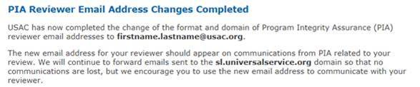

Based on our experience, USAC’s transition to the new domain addresses is not yet complete. As a result, not all emails to PIA reviewers using “sl.universalservice.org” are being forwarded to the proper “usac.org” addresses. In such cases, emails to PIA reviewers are bouncing. In particular, watch out for:
- Portal-generated PIA reminders using the old format and, as of last Friday, still being used by many reviewers. A “Reply” to these messages, if not corrected, will use the reviewers’ old email addresses.
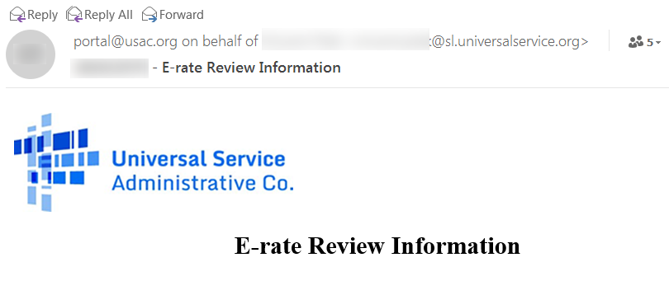
- Some of the reviewers, even if they’re using their new email addresses, have not yet updated the contact information in their “Signature.”
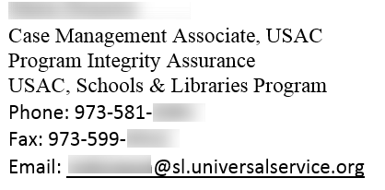

Reminder: Applicants responding via email to PIA reviewers should be careful to use the new “firstname.lastname@usac.org” format.
E-Rate Updates and Reminders

Upcoming 2018 E-Rate Dates:

May 7 FY 2017 Form 486 deadline for funding committed in Wave 33. Other upcoming Form 486 deadlines include:

Wave 34 05/14/2018

Wave 35 05/18/2018

Wave 36 05/21/2018

Wave 37 05/29/2018

Applicants missing these (or earlier) deadlines should watch carefully for “Form 486 Urgent Reminder Letters” in EPC. The Reminders will afford applicants with 15-day extensions to submit their Form 486s without penalty.

The first Form 486 deadline for FY 2018 is not until October 29, 2018.

May 23 USAC webinar on Filing FCC Form 486.

June 1 Deadline for submitting comments to the FCC re. the NPRM on Protecting Against National Security Threats to the Communications Supply Chain Through FCC Programs (see our newsletter of April 2nd). Reply comments are due by July 2nd.

June 20 USAC webinar on Understanding Post-Commitment Actions.

Updated USAC Reference Material:

Many sections in USAC’s online Reference Area are being updated on an ongoing basis. Recent updates are largely clarifying in nature, but are worth a review. The most recent sections updated include:
- BEAR Form Filing
- Category Two Budget — including budget factors for FY 2018
- Children’s Internet Protection Act (“CIPA”)
- Commitment Adjustment (“COMAD”) — notification via EPC News Feed as of FY 2016
- Disposal or Trade-in of Equipment
- Equipment Transfers
- FCC Form 473 (“SPAC”) Filing — Service Provider Annual Certification
- FCC Form 474 (“SPI”) Filing — Service Provider Invoice
- Invoicing Extensions
- Invoicing – Applicants
- Service Delivery Extensions
- SPIN Changes — Service provider changes

FCC Decision Watch:

The FCC issued its monthly set of “streamlined,” precedent-based decisions (DA 18-416). Applicants facing similar problems as addressed in these decisions may garner useful information by carefully reading the additional FCC explanations found in the footnotes. The original appeal and waiver requests can be found online in the FCC’s Search for Filings.

The most important aspect of the April streamlined decision is confirmation that the FCC will again, upon request, waive the Form 471 window for applications submitted within two weeks of the deadline. Last week’s grants included almost 200 waivers for over 235 applications. At the same time, the FCC denied out-of-window waivers for applications filed more than two weeks late (not covered by “extraordinary circumstances”).

In other decisions, the FCC:

- Dismissed:
  - Three Requests for Review and/or Waiver deemed moot because the invoicing records indicated that the applicants had been fully compensated or a Form 486 had already been accepted by USAC.
  - Three Requests not meeting the FCC’s basic filing requirements.
  - Two Petitions for Reconsideration for failing to provide any arguments not already fully considered by the FCC.
- Granted:
  - Four Requests for Waiver for Ministerial and/or Clerical (“M&C”) errors involving incorrect BEN, contract expiration date, or category of service.
  - One Request for Review involving competitive bidding for a brand-named supplier.
  - Three Requests for Review based on clarifications of bid evaluation, service delivery, or invoice deadline.
  - One Request for Waiver (for one FRN, but not another) for which the applicant had not considered price as the primary factor, but did choose the lowest-cost supplier.
- Denied:
  - One Request for Waiver for voice services not supported by the applicant’s discount rate.
  - Four Requests for Waiver for invoice deadline extensions.
  - One Request for Review involving a Form 470 which did not seek bids on the types of E-rate services later requested.
  - Four Requests for Waiver or Review submitted beyond the 60-day appeal deadline.

USAC News Brief Dated May 4 – Selective Review Details

USAC’s Schools and Libraries News Brief of May 4, 2018, continues a discussion on the selective review process focusing on the more detailed documents requested in this type of review, namely:
- Contracts and/or other agreements
- Request for proposals (“RFPs”) and/or related material
- Bid responses
- Vendor selection documentation including bid evaluation matrices
- Consultant agreements, if applicable
- All correspondence between the applicants, service providers, and consultants
- Any other documents demonstrating compliance with the E-rate competitive bidding requirements

---------------------------------------------------------------------------------------------------------------------Newsletter information and disclaimer: This newsletter may contain unofficial information on prospective E-rate developments and/or may reflect E-Rate Central’s own interpretations of E-rate practices and regulations. Such information is provided for planning and guidance purposes only. It is not meant, in any way, to supplant official announcements and instructions provided by the SLD, FCC, or state education departments.

For further information on E-rate, follow E-rate Central on Twitter, Facebook, and LinkedIn.

