- Funding Status – FY 2018 and FY 2017
- Updates on USAC’s E-Rate Productivity Center and Legacy System
  - Multi-User Access to PIA Inquiries
- E-Rate Updates and Reminders
- Upcoming 2018 E-Rate Dates
- USAC Annual Report for 2017
  - Update on USAC E-Rate Support Contracts
  - USDOE’s Homework Gap Study
- USAC News Brief Dated April 6 – Responding to PIA Inquiries

Funding Status – FY 2018 and FY 2017

FY 2018:

The FY 2018 Form 471 Application Window closed Thursday, March 22, 2018.

Based on data in USAC’s FRN Status Tool, the total demand for FY 2018 is approximately $2.77 billion. PIA application review is well underway. The first funding wave for FY 2018 is expected later this month.

FY 2017:

Wave 50 for FY 2017 was released Friday, April 6th, for a total of $2.97 million. Cumulative national funding through Wave 50 is $2.26 billion. Wave 51 is expected to be released Friday, April 13th.

Updates on USAC’s E-Rate Productivity Center and Legacy System

Multi-User Access to PIA Inquiries:

USAC’s News Brief for March 30th contains the following warning:

This is an important change for any applicant who have may have more than one user (employee, consultant, and/or state coordinator) authorized to respond to, or even just read, PIA inquiries in EPC. It means that only one user at a time can look at or work on a specific inquiry.

A second user, trying to access the same inquiry, will see the following message:

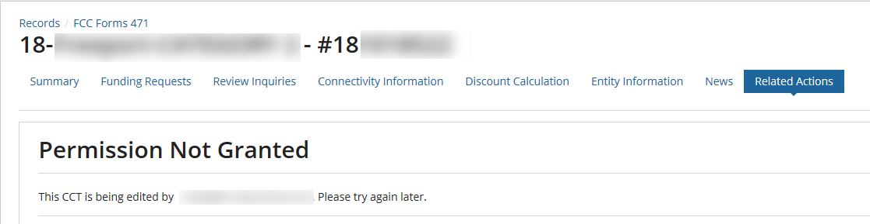
Note: “CCT” is USAC’s acronym for a “Customer Contact Template,” better known among applicants as a PIA inquiry.

To change the user reviewing a specific inquiry, the current user must close out of the inquiry. Note that it is not enough for that user to simply move to a different task within EPC. The current user must proactively close EPC’s inquiry window by clicking the “Save & Close” button.

E-Rate Updates and Reminders

Upcoming 2018 E-Rate Dates:

April 9 FY 2017 Form 486 deadline for funding committed in Wave 28. Other upcoming Form 486 deadlines include:

Wave 29 04/13/2018

Wave 30 04/23/2018

Wave 31 04/30/2018

Wave 32 05/04/2018

Wave 33 05/07/2018

Applicants missing these (or earlier) deadlines should watch carefully for “Form 486 Urgent Reminder Letters” in EPC. The Reminders will afford applicants with 15-day extensions to submit their Form 486s without penalty.

USAC Annual Report for 2017:

USAC released its 2017 Annual Report summarizing the year and highlighting all four Universal Service Fund (“USF”) programs. For E-rate, USAC focused on:
- Issuing funding decisions faster — FCDLs for 98% of “viable” E-rate applications by the end of 2017 (vs. 88% in the comparable period last year).
- Helping those in need — a second application window to implement the FCC’s Hurricane Relief orders.
- Engaging users to improve systems — user testing of new EPC features.

For E-rate readers, three other points of clarification should be mentioned:
- The table on “Authorized Support by Year” shows an increase for 2017. Note that the amounts shown are for authorized disbursements (not commitments), and that the columns are for calendar years (not funding years).
- The table on “2017 Expenses, Receipts, and Payments” shows E-rate disbursements exceeding E-rate receipts. Note that “Receipts from Operations” are based on USF contributions during the year and do not include FCC-authorized roll-over funding from previous years.
- The two largest vendors in the “2017 USAC Contractors” table are both providing E-rate support. USAC currently has an RFP outstanding for “Business Process Outsource (BPO) Services” targeted for 2019 (see following article).

Update on USAC E-Rate Support Contracts:

USAC is currently in the middle of a six-month transition for the call center operation of the Client Service Bureau (“CSB”). The previous provider, now being phased out, is General Dynamics Information Technology. The new CSB contractor is Sutherland Government Solutions, a subsidiary of Sutherland Global Solutions. The transition appears to be proceeding smoothly and is scheduled for completion by the end of June.

Bids have been received on an IT Development and Technical Services contract to provide continued support for the USAC Appian-based EPC system. The current contract holder, Incentive Technology Group, has been funded through June 30th.

Most importantly, the current Solix Inc. contract providing PIA and other program administrative support is expiring at the end of this year. An RFP for the associated Business Processing Outsourcing (“BPO”) services was issued last month; bids are due May 25th.

Applicants looking to the program support RFP as a model for their own procurement process should exercise caution. USAC’s bid evaluation section includes the following “down-select process” that would raise a red flag in an E-rate environment:

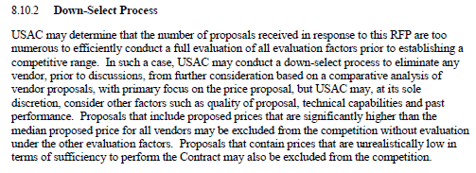
In line with the E-rate rules, the process does indicate a primary focus on price, but does a poor job of laying out the relative importance of other factors. More disturbing from an E-rate perspective is the seemingly arbitrary process of eliminating certain bidders from consideration if the number of bids received are “too numerous.” As a reminder, E-rate rules permit applicants to:
- Disqualify bids that do not meet specific requirements if the disqualification reasons are clearly identified in the Form 470 and/or RFP.
- Narrow the number of bids for final consideration by using a multi-stage evaluation process if the price of eligible goods and services remains the primary factor at each stage.

USDOE’s Homework Gap Study:

The U.S. Department of Education released a detailed report entitled “Student Access to Digital Learning Resources Outside of the Classroom,” less formally referred to as the “Homework Gap Study.” The report was commissioned under the Every Student Succeeds Act (“ESSA”) to help evaluate uneven access to electronic devices and Internet services at home to support digital learning nationwide. Key elements of the report include:
- Student use of digital learning resources (“DLRs”) outside of the classroom (finding that just 61% of students aged 3-18 use the Internet at home)
- Barriers to student access
- Educational challenges faced by students lacking access
- Impact of access on the instructional practices of educators
- Interventions at state and local levels

The report briefly references the role of E-rate in making Internet access and telecommunications more accessible and affordable to schools and libraries. To date, however, the only visible FCC proponent for extending E-rate support for DLRs at home is Commissioner Jessica Rosenworcel who has ofttimes stressed the educational challenges of the “homework gap.” Perhaps this study will raise the possibility of E-rate support for out-of-school Internet services.

USAC News Brief Dated April 6 – Responding to PIA Inquiries

USAC’s Schools and Libraries News Brief of April 6, 2018, addresses the PIA inquiry/response process, focusing on the following topics:

- How you will be notified of a pending PIA inquiry
- How to access PIA questions
- How to respond to PIA questions (see article above if more than one user will be involved)
- How to request an extension of time to answer PIA questions
- How to submit modifications to a Form 471

---------------------------------------------------------------------------------------------------------------------Newsletter information and disclaimer: This newsletter may contain unofficial information on prospective E-rate developments and/or may reflect E-Rate Central’s own interpretations of E-rate practices and regulations. Such information is provided for planning and guidance purposes only. It is not meant, in any way, to supplant official announcements and instructions provided by the SLD, FCC, or state education departments.

For further information on E-rate, follow E-rate Central on Twitter, Facebook, and LinkedIn.

