- Funding Status – FY 2018 and FY 2017
- Updates on USAC’s E-Rate Productivity Center and Legacy System
  - New PDF Versions of FCDL and RFCDL for FY 2018
  - Form 486 for FY 2018
- E-Rate Updates and Reminders
  - Upcoming 2018 E-Rate Dates
  - USAC PIA Review Webinar
  - FCC Universal Service Monitoring Report
- USAC News Brief Dated April 20 – New Format for FCDLs and RFCDLs

Funding Status – FY 2018 and FY 2017

FY 2018:

The first funding wave for FY 2018 was released Friday, April 20th for $237 million. Wave 2 was released the next day, April 21st, for $266 million. The beginning of funding was more than a month earlier than the start last year for FY 2017.

Earlier last week, USAC released a preliminary estimate of demand for FY 2018 confirming total requests of $2.77 billion as we had initially reported just after the window closed. Note that this preliminary number is based on the actual applications received during the window. The final demand numbers, eliminating duplicate applications and ineligible requests, but perhaps adding funding requested in out-of-window applications approved for waiver by the FCC, are expected to be less. The following table provides a comparison of preliminary demand for FY 2018 with FY 2017.

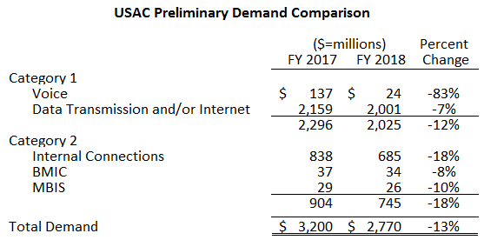

FY 2017:

No funding wave for FY 2017 was released last week, perhaps to avoid any conflicts with the release of Wave 1 for FY 2018. Cumulative national funding currently stands at $2.26 billion.

Updates on USAC’s E-Rate Productivity Center and Legacy System

New PDF Versions of FCDL and RFCDL for FY 2018:

With the first wave of FY 2018 funding, USAC unveiled a new and much improved PDF version of the Funding Commitment Decision Letter (“FCDL”). A similar version of the Revised Funding Commitment Decision Letter (“RFCDL”) will be available to handle post-commitment decisions.

Previously, funding decisions as displayed in the EPC News feed consisted of boilerplate text, a funding summary, and a downloadable spreadsheet. The new PDF version is well-formatted and includes an introductory page showing the total application commitment.
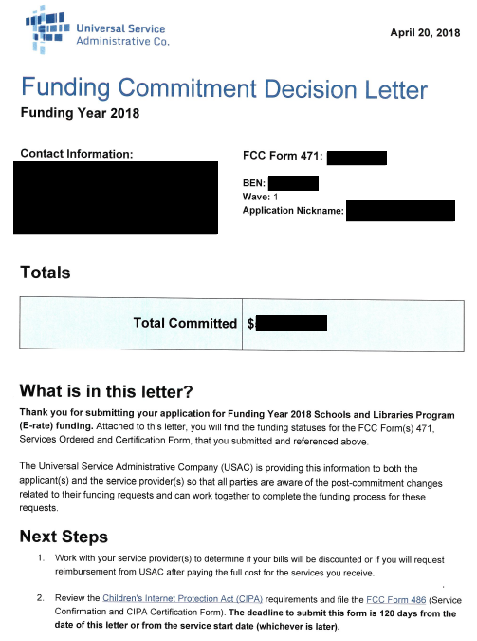

Details of the initial funding decisions are shown on a subsequent page.

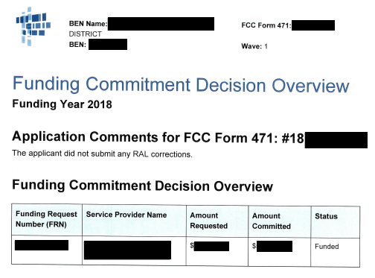
The RFCDL format will be similar, but with an additional detail column to show the type of request.
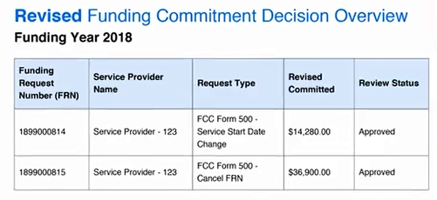

One important point to note concerning the new FCDL is that a notice and copy of the PDF will be emailed only to the person who certified the associated Form 471 application. In many cases, the certifier is not the person most responsible for the day-to-day E-rate work. Although every authorized EPC user will have access to the new FCDL through the EPC News feed, key E-rate personnel may not be made aware of funding approval. Because appeal and Form 486 deadlines are determined by the FCDL date, delayed recognition of funding approval could be problematic.

This is not the first time that USAC has chosen to notify certifiers, not E-rate contacts, of important decisions — and it may not be the last. As a safeguard, applicants designating separate people for form certifications may want to establish message forwarding rules in their email systems to automatically send copies of emails from usac.org to the appropriate E-rate contacts.

Form 486 for FY 2018:

Coincident with the first funding wave, USAC updated EPC to permit the filing and certification of Form 486s for approved applications. Note that the general timing rule for filing Form 486s is that they should not be filed until services have started. However, there is an exception — and a special certification — for applications approved before the start of the funding year. The first certification permits applicants to file early Form 486s if services will begin on or after July 1st, but at least by July 31st. Early filing of Form 486s for approved applications is advantageous particularly for applicants seeking discounted bills on recurring services because it gives their vendors time to set up their invoicing systems in time to provide discounts on July’s bills.

In previous years, applicants filing early Form 486s had to be careful to not mistakenly enter Service Start Dates (“SSDs”) before July 1st of the upcoming funding year. Pre-July SSDs on Form 486s — allowed within EPC, but not under E-rate rules — would flag those Form 486s for review. Early SSDs were correctable errors, but required PIA review and typically delayed Form 486 approvals. For FY 2018, USAC has smartly modified EPC to only accept SSDs of July 1st or later.

In addition to enabling the Form 486 for FY 2018, and fixing the filing process to avoid SSD errors, USAC is already approving many submitted Form 486s and issuing approval notification letters such as the following:

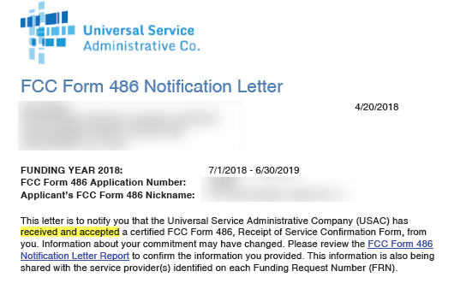

E-Rate Updates and Reminders

Upcoming 2018 E-Rate Dates:

April 23 FY 2017 Form 486 deadline for funding committed in Wave 30. Other upcoming Form 486 deadlines include:

Wave 31 04/30/2018

Wave 32 05/04/2018

Wave 33 05/07/2018

Applicants missing these (or earlier) deadlines should watch carefully for “Form 486 Urgent Reminder Letters” in EPC. The Reminders will afford applicants with 15-day extensions to submit their Form 486s without penalty.

May 23 USAC webinar on Filing FCC Form 486.

June 20 USAC webinar on Understanding Post-Commitment Actions.

USAC PIA Review Webinar:

A live webinar on “Understanding PIA Review” was conducted by USAC last week and is now available online. The webinar included a discussion of the new versions of the FCDL and RFCDL discussed above. Copies of the webinar slides are also available including “Things You Should Know” such as:
- How to include a new contact person not listed on the Form 471.
- How to address identical questions for an entity across multiple applications.
- How to explain taxes and surcharges.
- How to answer questions on entity and discount validations.
- Changes PIA reviewers may make to your application.
- How to recognize changes in application status.
- How to understand “wave ready” status.

FCC Universal Service Monitoring Report:

The FCC released its annual Universal Service Monitoring Report providing detailed data on the Universal Service Fund (“USF”) through September 2017. Pages 39-41 provide an overview of the Schools and Libraries (“E-rate”) program showing commitments and disbursements since the program’s inception in 1998. A breakdown by state and applicant type is also provided.

USAC News Brief Dated April 20 – New Format for FCDLs and RFCDLs

USAC’s Schools and Libraries News Brief of April 20, 2018, reviews the new format changes to Funding Commitment Decision Letters (“FCDLs”) and Revised Funding Commitment Decision Letter (“RFCDLs”). Examples of the new formats are shown in the article above.

FCDLs issued for Wave 1 of FY 2018 used the new format as will future waves for FY 2017. The newly formatted RFCDLs will be used going forward for FY 2016, FY 2017, and FY 2018.

Last Friday’s News Brief also indicated that USAC has completed the transition of PIA reviewer email addresses to the new format and domain firstname.lastname@usac.org.

---------------------------------------------------------------------------------------------------------------------Newsletter information and disclaimer: This newsletter may contain unofficial information on prospective E-rate developments and/or may reflect E-Rate Central’s own interpretations of E-rate practices and regulations. Such information is provided for planning and guidance purposes only. It is not meant, in any way, to supplant official announcements and instructions provided by the SLD, FCC, or state education departments.

For further information on E-rate, follow E-rate Central on Twitter, Facebook, and LinkedIn.

Cumulative funding through Wave 51 for FY 2017, for example, is 29% below the preliminary demand.

