- Funding Status – FY 2018 and FY 2017
- Updates on USAC’s E-Rate Productivity Center and Legacy System
  - FCDL and RFCDL Notices to Applicant Contacts
- E-Rate Updates and Reminders
  - Upcoming 2018 E-Rate Dates
  - Education-Related FCC NPRM Initiatives
  - FFL’s Annual E-Rate Survey
- USAC News Brief Dated April 27 – USF Transfer to U.S. Treasury

Funding Status – FY 2018 and FY 2017

FY 2018:

Wave 3 for FY 2018 was released Friday, April 27th. Cumulative funding as of Wave 3 is $637 million. Wave 4 is scheduled for release on Friday, May 4th.

FY 2017:

National funding for FY 2017 is currently $2.26 billion. Wave 52 is scheduled for release on Tuesday, May 1st.

Updates on USAC’s E-Rate Productivity Center and Legacy System

FCDL and RFCDL Notices to Applicant Contacts:

Our newsletter of April 23rd and USAC’s News Brief of April 20th both discussed USAC’s updated format for Funding Commitment Decision Letters (“FCDLs”) and Revised Funding Commitment Decision Letters (“RFCDLs”). Although the new PDF format is great, email notifications of new funding decisions were being sent only to the Form 471 application certifiers. This raised concerns that key applicant E-rate contacts, who were often not the certifiers, would not see important, time-sensitive decisions otherwise available only in their cluttered News feeds.

Late last Friday, in response to this concern, USAC began sending separate emails to applicant contacts alerting them of recently released FCDLs and RFCDLs. An example of such an email received by a contact representing multiple applicants is shown below. The red arrows in this example reflect a slight formatting error offsetting the application information from the entity information in the two columns, but this is a small price to pay for the timeliness of the fix. As indicated in the body of the email, USAC is working to incorporate system-generated contact emails within EPC. We commend USAC for its rapid response to applicant concerns.

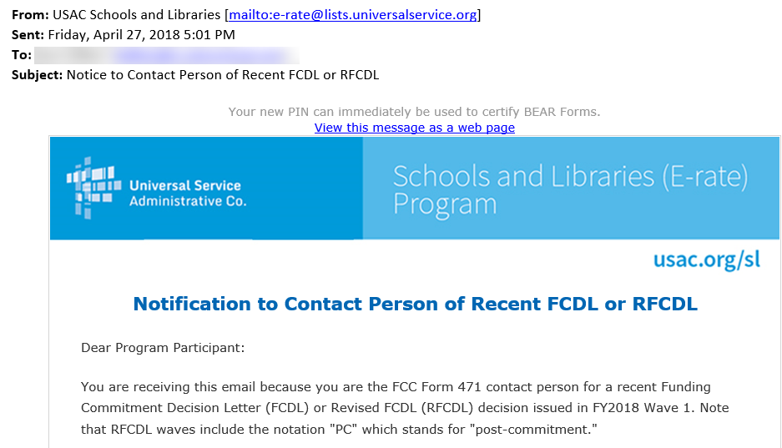

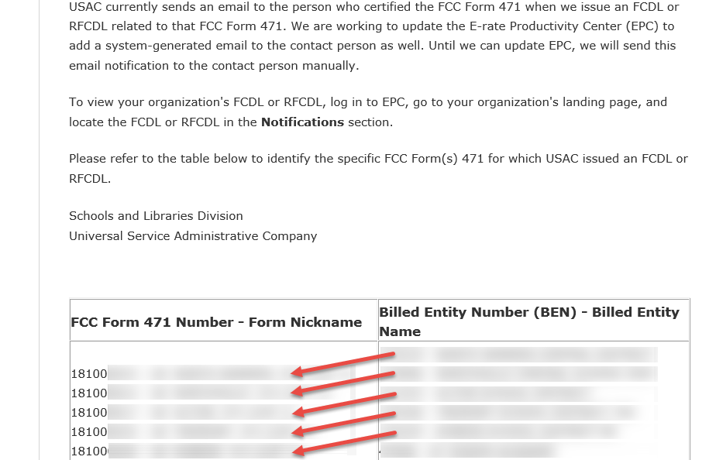

E-Rate Updates and Reminders

Upcoming 2018 E-Rate Dates:

April 30 FY 2017 Form 486 deadline for funding committed in Wave 31. Other upcoming Form 486 deadlines include:

Wave 32 05/04/2018

Wave 33 05/07/2018

Wave 34 05/14/2018

Wave 35 05/18/2018

Applicants missing these (or earlier) deadlines should watch carefully for “Form 486 Urgent Reminder Letters” in EPC. The Reminders will afford applicants with 15-day extensions to submit their Form 486s without penalty.

The first Form 486 deadline for FY 2018 is not until October 29, 2018.

May 23 USAC webinar on Filing FCC Form 486.

June 20 USAC webinar on Understanding Post-Commitment Actions.

Education-Related FCC NPRM Initiatives:

The FCC has released, or is about to release, two Notice of Proposed Rulemakings (“NPRMs”) of interest to E-rate applicants and/or schools in general.

National Security Rulemaking:

On April 18th, the FCC issued an NPRM, designated FCC 18-42, entitled “Protecting Against National Security Threats to the Communications Supply Chain Through FCC Programs” — particularly those programs, including E-rate, funded through the Universal Service Fund (“USF”).

As discussed in our newsletter of April 2nd, following the release of a draft of the NPRM, the proposed rules would prohibit USF payments to any communications equipment and/or service provider deemed to be posing a national security risk. Although the primary goal of the NPRM is to prevent unauthorized foreign access into our national telecom networks, most directly impacting carriers receiving payments from the High Cost fund, the NPRM seeks numerous comments on how national security restrictions should or could affect E-rate applicants.

Comments on this NPRM will be due 30 days after publication in the Federal Register. Reply comments will be due another 30 days thereafter.

Education Broadband Service Rulemaking:

The FCC also circulated a preliminary copy of an NPRM, scheduled for adoption at the FCC’s next open meeting on May 10th, to revise the rules on valuable radio spectrum in the 2.5 GHz band designated as Educational Broadcast Services (“EBS”). The EBS spectrum is currently set aside for educational organizations (partially available for lease to others). If adopted, the NPRM includes proposals to:

- Modernize and rationalize EBS spectrum to allow more flexible use.
- Establish up to three local priority filing windows to apply for EBS spectrum (largely unused throughout most of the country).
- Thereafter, to make any remaining spectrum available for commercial use.

EBS rules will not directly affect E-rate, but schools may wish to explore how this spectrum might be used to address the much-discussed “Homework Gap” by providing wireless Internet access to students wherever they are.

As a preliminary matter, pending formal adoption of the NPRM next week, schools might want to review the list of current EBS license holders within their states. To do so, go to http://wireless2.fcc.gov/UlsApp/UlsSearch/searchAdvanced.jsp, and search by “ED” services and state.

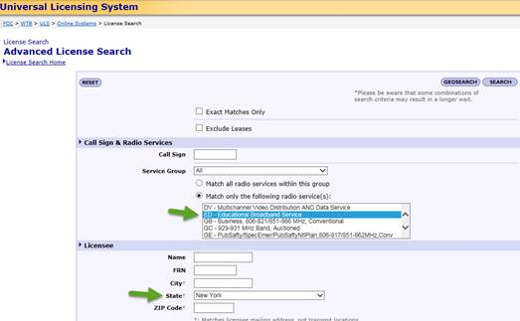

FFL’s Annual E-Rate Survey:

For a number of years, Funds For Learning (“FFL”) — an E-rate consultant (and colleague) — has been conducting a broad nationwide survey of E-rate applicants. The survey has traditionally yielded information on E-rate that, when published (see 2017 results), can have a meaningful and positive impact on public policy.

This year, with the FCC considering changes to Category 2 funding and with new leadership at the FCC and USAC, we believe that it is critically important for the E-rate community to be proactive. We encourage all E-rate applicants to visit FFL’s 2018 survey site and participate.

USAC News Brief Dated April 27 – USF Transfer to U.S. Treasury

USAC’s Schools and Libraries News Brief of April 27, 2018, discusses the May schedule for Universal Service Fund (“USF”) disbursements on BEAR and SPI invoices. As discussed in our newsletter of April 16th, all USF collections and disbursements will henceforth be handled through the U.S. Treasury rather than through commercial banks. As a practical matter, the transfer should have little effect on E-rate applicants, although some applicants may have to update their permitted “originator” codes at their own banks to accept BEAR payments from the Treasury. An Overview of the USF Funds Transfer is available online.

Last Friday’s News Brief also notes that Category 2 budgets have been reset for “Directly Impacted Applicants” covered by the FCC’s emergency relief Order FCC 17-139. USAC’s legacy Category 2 Budget Tool has been jury-rigged to show:
- The reset budget and Category 2 funding granted under the special emergency filing window for FY 2017. To view this information, set the Tool’s funding year to 2017. In most cases, the displayed budget information will include the following note:
- For historical purposes, the original budget information can be viewed by setting the Tool’s funding year to 2016. At this setting, the Tool will show any Category 2 funding awarded prior to the reset including funding from FY 2015, FY 2016, and the regular window for FY 2017.

---------------------------------------------------------------------------------------------------------------------Newsletter information and disclaimer: This newsletter may contain unofficial information on prospective E-rate developments and/or may reflect E-Rate Central’s own interpretations of E-rate practices and regulations. Such information is provided for planning and guidance purposes only. It is not meant, in any way, to supplant official announcements and instructions provided by the SLD, FCC, or state education departments.

For further information on E-rate, follow E-rate Central on Twitter, Facebook, and LinkedIn.

