- Funding Status – FY 2018 and FY 2017
- Universal Service and National Security Threats
- Updates on USAC’s E-Rate Productivity Center and Legacy System
  - Late-Filed Form 471 Applications for FY 2018
  - Unlocking of EPC Entity Profiles
- E-Rate Updates and Reminders
- Upcoming 2018 E-Rate Dates
  - FCC Decision Watch
- USAC News Brief Dated March 30 – Overview of the PIA Review Process

Funding Status – FY 2018 and FY 2017

FY 2018:

The FY 2018 Form 471 Application Window closed Thursday, March 22, 2018.

Based on data in USAC’s FRN Status Tool, the total demand for FY 2018 is approximately $2.77 billion — well below next year’s $4 billion funding cap. Many FY 2018 applications have already been reviewed and are currently shown in a “Wave Ready” status. Our expectation is that the first wave for FY 2018 can be expected as early as mid-April.

FY 2017:

Wave 48 for FY 2017 was released Thursday, March 29th, for a total of $7.45 million. Wave 49 for hurricane relief applicants was issued on Friday, March 30th, for $511 thousand. Cumulative national funding through Wave 49 is $2.25 billion, including $92.7 million for New York. Wave 50 is expected to be released Friday, April 6th.

Universal Service and National Security Threats

FCC Chairman Pai circulated a draft Notice of Proposed Rulemaking (“NPRM”) scheduled for adoption at the FCC’s next open meeting on April 17th. The NPRM seeks comments on rules to restrict Universal Service Fund (“USF”) payments to any equipment and/or service providers deemed to be posing a national security risk to U.S. communications networks or supply chains.

The FCC’s action is in response to ongoing and growing Executive Branch and Congressional concerns over the purchase and use of telecommunications equipment from certain foreign entities. Most recently, Congress passed the National Defense Authorization Act for Fiscal year 2018 (“NDAA”) which includes prohibitions on the use of equipment or services provided by Huawei Technologies Company and ZTE Corporation, two Chinese manufacturers, or by Kaspersky Lab, a company with alleged ties to the Russian government. Presumably both direct and indirect USF payments to these companies would be barred under new FCC rules. Far less certain is how the new rules might affect U.S. companies with products manufactured in China.

Although the primary goal of the NPRM is to prevent unauthorized foreign access into our national telecom networks, most directly impacting carriers receiving payments from the High Cost fund, the proposed rules would affect all USF programs. As shown below, referenced by NPRM paragraph numbers, comments will be sought on the following E-rate issues:
17. “Are there special considerations for schools, libraries, and rural health care facilities, which may not be as well-positioned as a carrier receiving USF support to know whether the services and/or equipment they purchase with USF support are being provided by an entity that pose a supply chain integrity risk?”
24. “…we seek comment on how to ensure that USF recipients (especially smaller USF recipients, including schools, libraries, and rural health care facilities) can learn which companies fall within the scope of our proposed rule.”
27. “We seek comment on which party, in the E-Rate context, is in the best position to anticipate and prevent violations of our proposed rule, and thus, which party should be held liable for the recovery of disbursed funds should such a violation occur. Should providers be held liable for the recovery of disbursed funds in all instances when a violation of our proposed rule has occurred? How can non-provider recipients of USF support, such as school districts or libraries, determine whether their service provider has purchased prohibited services or equipment?”
29. “In instances where an applicant for USF support is not a service provider — such as when eligible schools and libraries receive discounts under the E-Rate program... — should the certification be made by the service provider that has knowledge of and control over its network? Does it matter whether the applicant is seeking to purchase and install equipment itself or whether it is purchasing services from another?”

At this stage in the NPRM process, no specific E-rate rules have been proposed. Indeed, as the FCC begins formulating national security rules, a second-round NPRM may be utilized. New rules, if only new E-rate form certifications, are not expected until late in 2018 at the earliest. In anticipation of such changes, however, applicants beginning their procurement cycles later this summer or fall may wish to include appropriate service provider certification requirements in their FY 2019 RFP documents.

Updates on USAC’s E-Rate Productivity Center and Legacy System

Late-Filed Form 471 Applications for FY 2018:

The deadline for filing Form 471 applications for FY 2018 was March 22, 2018. Applications certified after that date are considered “Out-of-Window” and will not be considered by USAC unless the March 22nd filing deadline is waived by the FCC on an application-by-application basis.

The FCC has routinely approved deadline waiver requests for Form 471 applications submitted within two weeks of the original USAC deadline. For FY 2018, this two-week period ends this Thursday, April 5th. FCC waivers for Form 471 applications filed after this date have occasionally been approved but only for “extraordinary” circumstances involving serious hospitalizations, deaths, or military deployments.

Instructions for “Submitting Window Waiver Requests” are provided in the final section of USAC’s FCC Form 471 Filing guidance as reproduced below.

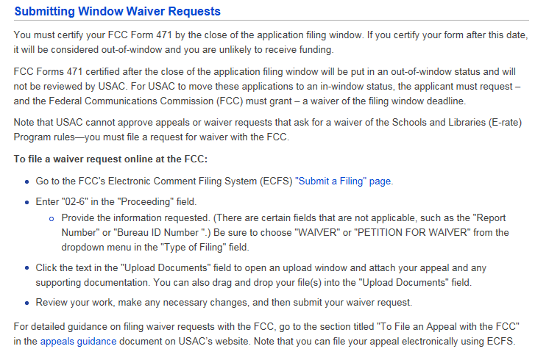
Unlocking of EPC Entity Profiles:

USAC announced that it will unlock entity profiles in EPC early this week. The profiles were locked during the FY 2018 Application Window to freeze school entity data so as not to impact the application work of libraries and consortia.

It is important to note that any changes schools now make in their entity profiles will not carry through to FY 2018 applications. To make entity changes that apply to pending applications, applicants must submit RAL modifications (see last Friday’s USAC News Brief).

E-Rate Updates and Reminders

Upcoming 2018 E-Rate Dates:

April 2 FY 2017 Form 486 deadline for funding committed in Wave 27. Other upcoming Form 486 deadlines include:

Wave 28 04/09/2018

Wave 29 04/16/2018

Wave 30 04/23/2018

Applicants missing these (or earlier) deadlines should watch carefully for “Form 486 Urgent Reminder Letters” in EPC. The Reminders will afford applicants with 15-day extensions to submit their Form 486s without penalty.

April 5 Close of the two-week period for which the FCC has traditionally approved waivers for out-of-window Form 471 applications. Associated Form 470s for applications filed by April 5th must themselves have been filed by March 8th to meet the 28-day posting requirement. For additional information on requesting an FCC late-filed Form 471 waiver, see the EPC update article above.

FCC Decision Watch:

The FCC issued its monthly set of “streamlined,” precedent-based decisions (DA 18-299). Applicants facing similar problems as addressed in these decisions may garner useful information by carefully reading the additional FCC explanations found in the footnotes. The original appeals and waiver requests can be found online in the FCC’s Search for Filings.

In summary, last week’s FCC decisions:

- Dismissed:
  - One Request for Waiver deemed moot because the invoicing records indicated that the applicant had been fully compensated.
  - Four Petitions for Reconsideration for failing to provide any arguments not already fully considered by the FCC.
- Granted:
  - One Request for Waiver granting the application additional time to respond to USAC’s request for information.
  - Three Requests for Waiver for Ministerial and/or Clerical (“M&C”) errors involving incorrect entry of pre-discounted prices.
  - One Request for Waiver involving a late-signed contract.
  - One Request for Review remanding an appeal to USAC which had been erroneously rejected as untimely.
  - One Request for Waiver of a late-filed appeal on an issue deemed to involve an error by USAC.
- Denied:
  - Five Requests for Waiver for invoice deadline extensions.
  - One Request for Review for an M&C error without a demonstrated “good cause.”
  - One Request for Waiver involving a Form 470 that did not seek bids on the types of E-rate services later requested.
  - Two Requests for Waiver for unsubstantiated service delivery deadline extensions.
  - Ten Requests for Waiver or Review submitted beyond the 60-day appeal deadline.

The FCC approved an application by Space Exploration Holdings (d.b.a. “SpaceX”) to provide satellite-based broadband service both nationally and internationally (FCC 18-38). This is the fourth new satellite system — the first by a U.S. company — that the FCC has authorized to provide affordable broadband connectivity, particularly in more remote unserved or underserved areas. Amazingly, the SpaceX system proposes to use a “constellation” of 4,425 low-orbit satellites.

USAC News Brief Dated March 30 – Overview of the PIA Review Process

USAC’s Schools and Libraries News Brief of March 30, 2018, discusses the basic steps in the PIA review process focusing on the Initial Review, the handling of modifications and denials, and Final Review.

To prepare for PIA review, USAC suggests the following:
- Check your Form 471 and your Receipt Acknowledgment Letter (RAL) to make sure all of your entries are correct. If you find a mistake, you can submit a RAL modification in EPC. If your review has already started, you can submit any corrections directly to your reviewer using the reviewer's contact information provided on the PIA email or in EPC.
- Organize all of the documentation related to your application and have it readily available to assist you in answering any questions.
- Monitor your email so that you will know when PIA attempts to contact you.
- Answer all questions promptly and completely.
- Ask for more time to respond if you need it.
- If you are having problems, ask to speak to a manager.

---------------------------------------------------------------------------------------------------------------------Newsletter information and disclaimer: This newsletter may contain unofficial information on prospective E-rate developments and/or may reflect E-Rate Central’s own interpretations of E-rate practices and regulations. Such information is provided for planning and guidance purposes only. It is not meant, in any way, to supplant official announcements and instructions provided by the SLD, FCC, or state education departments.

For further information on E-rate, follow E-rate Central on Twitter, Facebook, and LinkedIn.

