- Funding Status – FY 2018
- Updates on USAC’s E-Rate Productivity Center and Legacy System
  - Updated Form 470 for FY 2019
  - Invoice Payment Recalls
  - Missing Recipients of Service
- E-Rate Updates and Reminders
  - Upcoming 2018 E-Rate Dates
  - FCC Decision Watch
- USAC News Brief Dated June 29 – Form 470 Available for FY 2019

Funding Status – FY 2018

FY 2018:

After skipping a week, USAC issued two funding waves for FY 2018 last week, Wave 11 on Tuesday, June 26th, and Wave 12 on Friday, June 29th. Cumulative funding as of Wave 12 is $1.28 billion.

Updates on USAC’s E-Rate Productivity Center and Legacy System

Updated Form 470 for FY 2019:

The FY 2019 version of the Form 470 was activated in EPC on Sunday, July 1st. “Minor” changes are reviewed in last Friday’s USAC News Brief referenced below. The opening screen of the “Create FCC Form 470” is

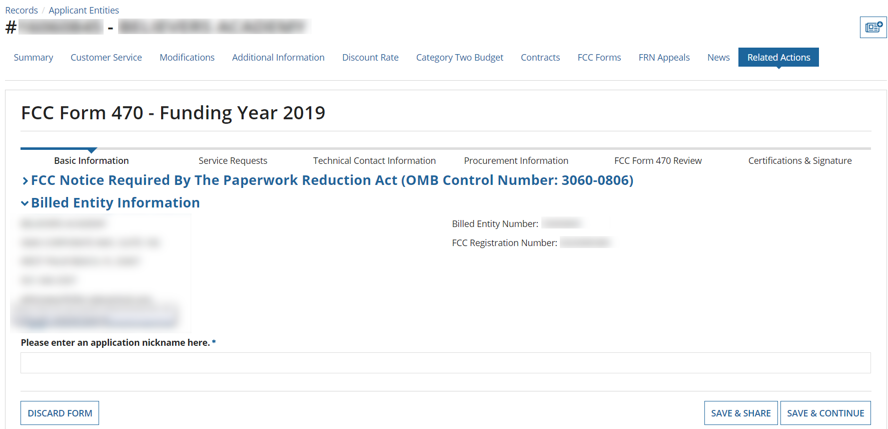

Disappointingly, USAC’s efforts to clarify and simplify the Category 1 drop-down menu options, as instructed by the FCC, fall short of expectations. Although USAC added short parenthetical comments to some of the transmission and Internet options, and included a separate sentence on when to select each option (see below), the basic menu options remain. USAC’s additions do nothing to restore what used to be an intuitive process. As a result, last year’s confusion is likely to persist. Most problematically, applicants unsure as to whether desired services will or will not include fiber (as opposed to copper wire, coaxial cable, wireless, or any other transmission media) will need to select multiple fiber and non-fiber options.

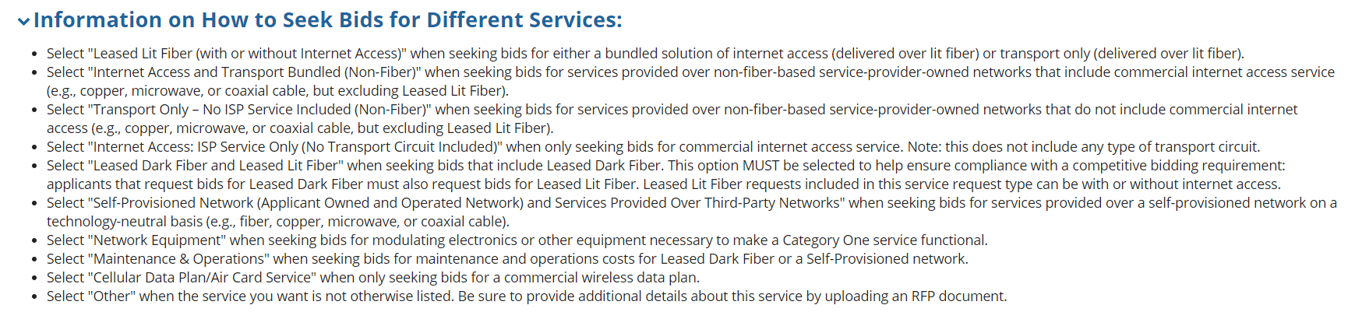

We will continue to discuss the proper use of the Form 470 drop-downs in future newsletters. Hopefully, more guidance will be provided by USAC as well. In the interim, our advice is to:
- If unsure of the transmission media of services to be requested, include all fiber, non-fiber, and Internet options.
- Include a clear textual description of the services you are seeking in the “Narrative.”
- Consider creating a Customer Service Case, including your “Narrative” text, seeking specific USAC guidance on the proper Form 470 option choices. Adherence to such USAC advice, if provided in writing, may be useful in any future appeal proceeding.

Invoice Payment Recalls:

Over the past two weeks, we have found a small, but significant, number of applicants receiving “Recovery of Improperly Disbursed Funds” letters (all apparently dated June 18, 2018) indicating USAC’s intention to recapture payments on invoices now deemed to have been submitted after the associated invoice deadlines. The only explanation given for these actions is “FCC Directive.”

Unlike more traditional Commitment Adjustment (“COMAD”) actions, by which USAC rescinds committed funds, these new invoice payment recalls to not actually reduce commitments. As a result, these invoicing actions do not show up in any DRT or FST databases and are, therefore, difficult to track.

The underlying problem appears to trace back to USAC and applicant invoicing problems for earlier funding years, as far back as FY 2013. (so far as we’ve seen). In May 2017, the FCC issued its Jefferson-Madison decision (DA 17-526) directing USAC to accept resubmitted invoices from certain applicants who had missed invoice deadlines as the result of delayed service provider certifications. At the same time, the FCC instructed USAC to accept resubmitted invoices from other “similarly-situated” applicants. In August 2017, after investigating such similar cases, USAC reached out to applicants it so identified, invited them to resubmit invoices for specific FRNs, and gave them new invoice deadlines. Many applicants did refile invoices within those new deadlines.

However, USAC has now apparently reexamined its own review process and determined that it had improperly identified some applicants qualifying as “similarly-situated” and should not have provided new invoice deadlines. By “FCC directive,” USAC is now proposing to recover payments on invoices which USAC itself had specifically — but “improperly” — allowed. Note that this is not a case of improperly committed funds. It is only a somewhat esoteric case of invoice deadlines — a crazy, and indeed much broader, problem of USAC’s and the FCC’s own making.

Applicants receiving these June “Recovery of Improperly Disbursed Funds Letters” should immediately appeal to USAC including, if that be the case, copies of their August 2017 USAC letters extending their invoice deadlines. Unless USAC can correct these problems, subsequent appeals to the FCC may be required.

Missing Recipients of Service:

A small but growing number of applicants are also reporting that the “current” (i.e. approved) version of their FY 2017 Category 2 applications, at least for some FRNs, do not include the recipients of service (provided, still shown, and subsequently approved, in their original applications).

Uncorrected recipient of service situations do not appear to prevent invoice submission, but may create issues in invoice review. Equally important, funding not correctly associated with recipients of service is not reflected in USAC’s Category 2 budget tools and may affect applicant planning for FY 2019.

USAC has apparently found a number of these cases, and has itself initiated and processed “appeals” on applicant’s own behalf to correct these problems. Applicants finding similar problems, not already corrected by USAC, should advise USAC via Customer Service Cases.

E-Rate Updates and Reminders

Upcoming 2018 E-Rate Dates:

July 2 FY 2017 Form 486 deadline for funding committed in Wave 44. Other upcoming Form 486 deadlines include:

Wave 45 07/06/2018

Wave 46 07/13/2018

Wave 47 07/12/2018

Wave 48 07/27/2018

Wave 49 07/30/2018 (hurricane relief wave)

Applicants missing these (or earlier) deadlines should watch carefully for “Form 486 Urgent Reminder Letters” in EPC. The Reminders will afford applicants with 15-day extensions to submit their Form 486s without penalty.

The first Form 486 deadline for FY 2018 is not until October 29, 2018.

July 2 Reply comment deadline on the FCC’s Notice of Proposed Rulemaking (“NPRM”) on Protecting Against National Security Threats to the Communications Supply Chain Through FCC Programs (see FCC 18-42).

July 23 Deadline for submitting Form 470/471 comments (see Federal Register notice).

FCC Decision Watch:

The FCC issued another set of “streamlined,” precedent-based decisions (DA 18-672). Applicants facing similar problems as addressed in these decisions may garner useful information by carefully reading the additional FCC explanations found in the footnotes. The original appeal and waiver requests can be found online in the FCC’s Search for Filings.

In last week’s decisions, the FCC:

- Dismissed:
  - Two Requests for Review or Waiver deemed moot for which the applicant withdrew the applicable funding requests or was fully funded and compensated.
  - One Request for Waiver not meeting the FCC’s basic filing requirements.
  - One Petition for Reconsideration already fully considered and rejected by the Wireline Competition Bureau.
- Granted:
  - Four Requests for Waiver involving late FY 2018 Form 471s filed within two weeks of the window deadline. The FCC also approved one other Request for Waiver for a late-file application due to “delays beyond its control.”
  - Two Requests for Waiver for ministerial and/or clerical errors.
  - Two Requests for Waiver of the appeal filing deadline, remanding the underlying appeals to USAC for review.
- Denied:
  - Twenty-two Requests for Waiver for applications filed more than two weeks after the close of the FY 2018 window.
  - One Request for Waiver seeking support for services not covered by the applicant’s Form 470.
  - Nine Requests for Waiver or Review (involving three applicants) submitted beyond the 60-day appeal deadline.

USAC News Brief Dated June 29 – Form 470 Available for FY 2019

USAC’s Schools and Libraries News Brief of June 29, 2018, announces the availability of the new Form 470 for FY 2019 within EPC, and reviews the following “minor” changes in the FY 2019 version:
- Revised Category 1 drop-down options, now reading (with additions in red):
Leased Lit Fiber (with or without Internet Access)
Internet Access and Transport Bundled (Non-Fiber)
Transport Only – No ISP Service Included (Non-Fiber)
Internet Access: ISP Service Only (No Transport Circuit Included)
Leased dark Fiber and Leased Lit Fiber
Self-Provisioned Network (Applicant Owned and Operated Network) and Services Provided Over Third-Party Networks
Network Equipment
Maintenance & Operations
Cellular Data Plan/Air Card Service
Other
Note: Voice service discounts have been phased out for all applicants as of FY 2019, so the “Voice Service” and “Cellular Voice” options have been eliminated.

- The “Installment Payment Plan” option appears only for special construction charges.

- PDF generation of a draft Form 470 will be posted in the “Tasks” menu.

An updated FY 2019 video series on the Form 470 includes the following topics:
- Starting Your FCC Form 470
- Service Requests: Category One
- Service Requests: Category Two
- FCC Form 470 Technical Contact, Procurement Information, and Certification
- Post an Additional RFP Document
- How to Search for FCC Form 470s

---------------------------------------------------------------------------------------------------------------------Newsletter information and disclaimer: This newsletter may contain unofficial information on prospective E-rate developments and/or may reflect E-Rate Central’s own interpretations of E-rate practices and regulations. Such information is provided for planning and guidance purposes only. It is not meant, in any way, to supplant official announcements and instructions provided by the SLD, FCC, or state education departments.

For further information on E-rate, follow E-rate Central on Twitter, Facebook, and LinkedIn.

