- Funding Status – FY 2018
- Updates on USAC’s E-Rate Productivity Center and Legacy System
  - USAC Seeks IT Enhancement Feedback
- E-Rate Updates and Reminders
  - Upcoming 2018 E-Rate Dates
  - Reply Comments re. National Security Threats NPRM
- USAC News Brief Dated July 3 – “Submit a Question” Discontinued

Funding Status – FY 2018

FY 2018:

USAC issued Wave 13 for FY 2018 on Friday, July 6th. Cumulative funding as of Wave 13 is $1.32 billion.

Updates on USAC’s E-Rate Productivity Center and Legacy System

USAC Seeks IT Enhancement Feedback:

USAC’s latest News Brief (referenced below) encourages E-rate participants to submit their ideas and feedback on Schools and Libraries information systems via the USAC web page “Share Your E-rate Technical System Ideas.” The site can also be used to volunteer to help test new IT features.

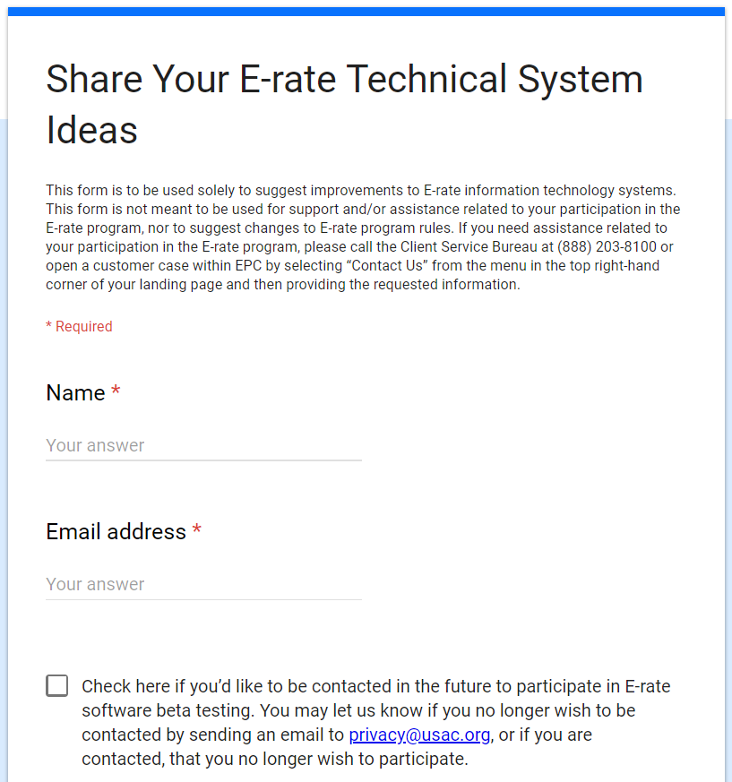

E-Rate Updates and Reminders

Upcoming 2018 E-Rate Dates:

July 13 FY 2017 Form 486 deadline for funding committed in Wave 46. Other upcoming Form 486 deadlines include:

Wave 47 07/12/2018

Wave 48 07/27/2018

Wave 49 07/30/2018 (hurricane relief wave)

Applicants missing these (or earlier) deadlines should watch carefully for “Form 486 Urgent Reminder Letters” in EPC. The Reminders will afford applicants with 15-day extensions to submit their Form 486s without penalty.

The first Form 486 deadline for FY 2018 is not until October 29, 2018.

July 23 Deadline for submitting Form 470/471 comments (see Federal Register notice).

Reply Comments re. National Security Threats NPRM:

Last week was the deadline for submitting reply comments on the FCC’s Notice of Proposed Rulemaking (“NPRM”) on Protecting Against National Security Threats to the Communications Supply Chain Through FCC Programs (see FCC 18-42 and our newsletter of April 2nd). Initial comments filed by the State E-Rate Coordinators’ Alliance (“SECA”) and the American Library Association (“ALA”) both urged the FCC to base compliance with any resulting E-rate rules on service provider assurances and certifications.. Additional support for this position was provided in the reply comments filed by Kellogg & Sovereign Consulting (“KSLLC”).

Most of the other reply comments — none taking issue with the SECA/ALA position — were filed by national or regional telecommunications associations concerned primarily with FCC authority and with the preeminence of Congressional and other federal agencies (e.g., the Departments of Commerce, Homeland Security, or Defense and the National Security Agency). Several rural broadband and wireless associations warned the FCC about the detrimental impact of banning affordable equipment currently being provided by Chinese companies. Copies of all reply comments are available in the FCC’s Electronic Comment Filing System under the proceeding designated “18-89.”

USAC News Brief Dated July 3 – “Submit a Question” Discontinued

USAC’s Schools and Libraries News Brief of July 3, 2018, indicates that the much beloved “Submit a Question” feature, long a staple of the “Resources & Tools” list on USAC’s E-rate site will be retired as of Friday, July 13th.
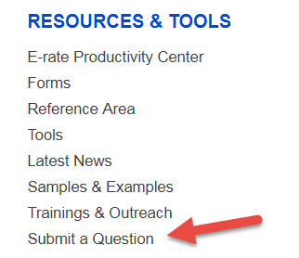
The News Brief reminds users of the newer ways to handle the following questions and requests, including:
- General questions
- Appeals, service substitution requests, and SPIN change requests
- Invoice deadline extensions requests
- Submissions of attachments to customer service cases or other requests

For “Submit a Question” cases pending as of June 1st, USAC is creating new customer service case numbers, linked through EPC.

---------------------------------------------------------------------------------------------------------------------Newsletter information and disclaimer: This newsletter may contain unofficial information on prospective E-rate developments and/or may reflect E-Rate Central’s own interpretations of E-rate practices and regulations. Such information is provided for planning and guidance purposes only. It is not meant, in any way, to supplant official announcements and instructions provided by the SLD, FCC, or state education departments.

For further information on E-rate, follow E-rate Central on Twitter, Facebook, and LinkedIn.

