- Funding Status – FY 2018
- Updates on USAC’s E-Rate Productivity Center and Legacy System
  - Correcting Form 498 and FCCRN Errors
  - Update on Invoice RIDFs Actions
- E-Rate Updates and Reminders
  - Upcoming 2018 E-Rate Dates
  - Updated Guidance on Product Demonstration “Loans”
- USAC News Brief Dated July 13 – Form 470 Information Resources

Funding Status – FY 2018

USAC issued Wave 14 for FY 2018 on Friday, July 13th for $66.5 million. Cumulative funding as of Wave 14 is $1.39 billion.

Updates on USAC’s E-Rate Productivity Center and Legacy System

Correcting Form 498 and FCCRN Errors:

A few applicants have recently encountered problems in receiving BEAR payments as a result of inaccuracies in their on-file banking or tax records. It could be that the U.S. Treasury, now the source of E-rate invoice payments, is being a little more exacting in their procedures.

In one case, generating the somewhat ominous “PAYMENT WITHHELD DUE TO INVALID BANKING INFORMATION” email shown below, the problem was a missing leading zero in the bank routing number provided in the applicant’s Form 498. Once the problem was identified, this was easily fixed by updating the Form 498.

In another case, there was a mismatch between the applicant’s Federal Tax ID (“EIN”) and its listing in the applicant’s FCC Registration Number (“FCCRN”) database (due to a transposition of two digits). Similarly, this was easily fixed, once identified, by correcting the FCCRN data.

The trick, obviously, is to identify the problem causing the withholding of a payment. For specific help, we recommend calling the special USAC “Customer Operations” helpline (shown in the notice): 888-641-8722.

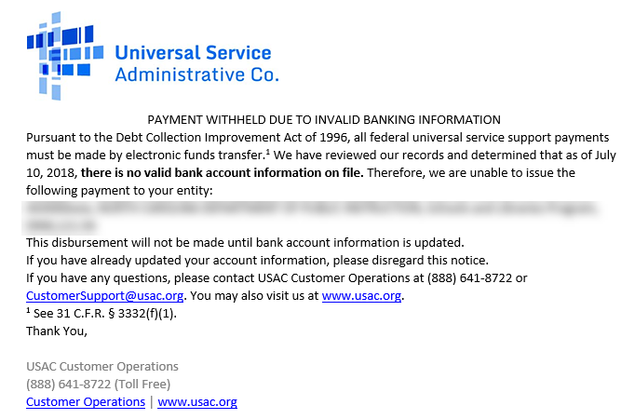

Update on Invoice RIDFs Actions:

Our newsletter of July 2nd reported on a few instances of applicants receiving Recovery of Improperly Distributed Funds Letters (“RIDFs”) indicating USAC’s intention of seeking the return of disbursed BEAR payments. We have now identified 40 affected applicants — and there are likely more.

The BEARs in question had been filed under explicit invoice extensions generated by USAC based on the FCC’s 2017 Jefferson-Madison decision (DA 17-526). Although the RIDFs state only that repayment is required as the result of an “FCC Directive,” it has become clear that USAC now believes it mistakenly identified some applicants qualifying for invoice deadline extension relief under the FCC order’s “similarly situated” language. Because of these errors — the exact nature of which USAC is loath to explain — USAC is now seeking a return of the funds.

Based on our analysis of the FRN invoicing history associated with the RIDFs we have reviewed, there have been several different “mistakes,” as now interpreted by USAC. The common point of contention is whether an applicant had originally filed a BEAR prior to July 1, 2016 (or by an earlier invoice deadline), but the BEAR was rejected because the associated service provider had not acknowledged it. Under the Jefferson-Madison decision, the FCC provided applicant relief only for timely-submitted, but unacknowledged, BEARs. USAC’s apparent contention is that it mistakenly extended relief to other applicants, not covered by the Jefferson-Madison decision, and that it must now rescind any related payments.

Applicants faced with these RIDFs should appeal, first to USAC and then, if necessary, to the FCC. We suggest that USAC appeals focus on the invoicing histories of the BEARs and on the problems encountered with obtaining service provider acknowledgments.

Should appeals ultimately need to be made to the FCC, an additional point to be made is that recovery of funds, properly committed, but paid under an erroneously applied invoice extension, “…may not be appropriate for violation of procedural rules codified to enhance operation of the e-rate program” (see FCC 04-190, ¶19).

E-Rate Updates and Reminders

Upcoming 2018 E-Rate Dates:

July 18 USAC webinar “E-rate Program 101” designed for beginners new to E-rate.

July 21 FY 2017 Form 486 deadline for funding committed in Wave 47. Other upcoming Form 486 deadlines include:

Wave 48 07/27/2018

Wave 49 07/30/2018 (hurricane relief wave)

Applicants missing these (or earlier) deadlines should watch carefully for “Form 486 Urgent Reminder Letters” in EPC. The Reminders will afford applicants with 15-day extensions to submit their Form 486s without penalty.

The first Form 486 deadline for FY 2018 is not until October 29, 2018.

July 23 Deadline for submitting Form 470/471 comments (see Federal Register notice).

Updated Guidance on Product Demonstration “Loans”:

USAC is continually updating the guidance it provides in various sections of its website, often without highlighting what could be significant to some applicants and service providers. An example, brought to our attention last week, was a May 2018 update to USAC’s Free Service Advisory governing service provider provision of on-site demo products.

Earlier guidance had referenced, but had not defined, “loan” in the context of free services. The new guidance, effectively prohibiting equipment loans for demonstration purposes, now reads:

Applicants may not accept gifts with a retail value greater than $20, which include but are not limited to gifts for attending seminars; marketing calls; loans of products, including those characterized as on-site product demonstrations; service or equipment; or training.

This change is particularly concerning because many applicants seek to trial new products as a “proof of concept” before committing to large capital investments. Additionally, it is unclear if this new provision prohibits product demonstrations that are offered from the manufacturer or only from value added resellers (“VARs”). In most cases, subsequent purchases will be from the VARs, not the manufacturers.

USAC News Brief Dated July 13 – Form 470 Information Resources

USAC’s Schools and Libraries News Brief of July 13, 2018, reviews a number of informational resources that USAC provides to assist applicants in preparing, and service providers in reviewing, Form 470s for FY 2019. Given the continued confusion with Form 470 pulldown menu options, this is particularly important information. The resources include:
- The FCC Form 470 Video Series
- The FCC Form 470 User Guide
- The Category One Services Drop-down Menu Reference Table
- The FCC Form 470 Search User Guide
- The View an FCC Form 470 (FY2016 and later) tool

The following website documents have been updated with information on filing Form 470s for FY 2019:
- Competitive Bidding
- FCC Form 470 Filing
- FAQs: Eligible Fiber Services

---------------------------------------------------------------------------------------------------------------------Newsletter information and disclaimer: This newsletter may contain unofficial information on prospective E-rate developments and/or may reflect E-Rate Central’s own interpretations of E-rate practices and regulations. Such information is provided for planning and guidance purposes only. It is not meant, in any way, to supplant official announcements and instructions provided by the SLD, FCC, or state education departments.

For further information on E-rate, follow E-rate Central on Twitter, Facebook, and LinkedIn.

