- Funding Status – FY 2018
- Updates on USAC’s E-Rate Productivity Center and Legacy System
  - BEARs and Unfiled SPACs
  - Correcting Form 498 and FCCRN Errors, cont.
- E-Rate Updates and Reminders
  - Upcoming 2018 E-Rate Dates
- USAC News Brief Dated July 20 – FY 2018 SPAC Reminder

Funding Status – FY 2018

USAC issued Wave 15 for FY 2018 on Friday, July 20th for $41.3 million. Cumulative funding as of Wave 15 is $1.43 billion.

Updates on USAC’s E-Rate Productivity Center and Legacy System

BEARs and Unfiled SPACs:

Applicants working to file BEAR reimbursement invoices for FY 2017 services, particularly those associated with smaller service providers not doing much E-rate work, should check to make sure that their service providers have filed their Service Provider Annual Certifications (Form 473s or “SPACs”) for FY 2017. Although BEAR payments are now paid directly to applicants — without the need for formal supplier acknowledgment as was required before July 1, 2016 — USAC will not approve BEARs for payment unless the associated vendors have SPACs on file for the funding year(s) in which services are delivered.

Applicants expecting discounted services for FY 2018 — based on the Service Provider Invoice (“SPI”) process — may also want to check that their suppliers have current FY 2018 SPACs on file. Appropriately, last Friday’s USAC News Brief (referenced below) reminds service providers to file their SPACs for the current year.

As of last week, we counted over 740 service providers without FY 2017 SPACs. This represented about 16% of the active E-rate vendors responsible for about 1% of the total committed funding.

The easiest way to check whether or not a supplier has a current SPAC on file — short of trying to file a BEAR and having it rejected — is to check USAC’s SPIN Search Tool. The last column in the search results table indicates the supplier’s SPAC history. As an example, the display for AT&T, which has been active in E-rate since the program’s start, shows that it has already filed SPACs for FY 2017 and FY 2018. SPAC status on an FRN-by-FRN basis is also shown in USAC’s FRN Status Tool.

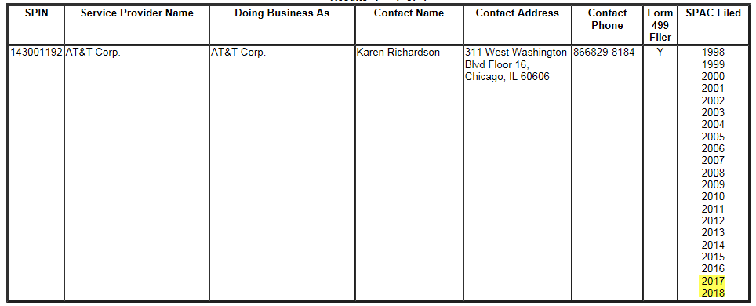

If your service provider has not yet filed its SPAC, the best first step is to call the E-rate contact listed in the same SPIN search result. If this effort is unproductive, USAC’s suggestion — made in response to a question on last week’s E-rate Program 101 webinar— is to file a customer service request via EPC and ask USAC to reach out to the service provider.

Correcting Form 498 and FCCRN Errors, cont.:

Last week’s newsletter discussed the occasional need for applicants to fix incorrect bank routing or account numbers in their existing Form 498s, typically because of missing leading zeros or transposed digits. Until such errors are fixed, the U.S. Treasury cannot process BEAR payments. Once the errors are fixed, applicants should receive the following confirmation (note the useful helpline numbers):

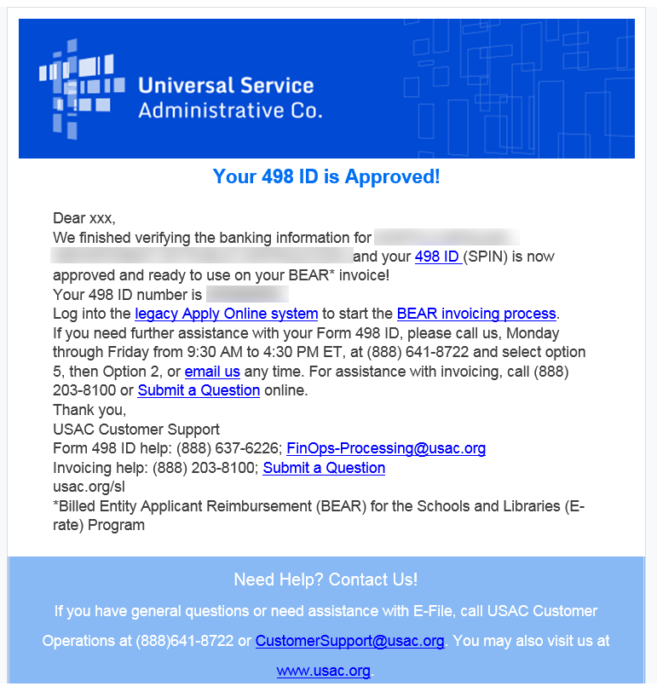
E-Rate Updates and Reminders

Upcoming 2018 E-Rate Dates:

July 23 Deadline for submitting Form 470/471 comments (see Federal Register notice).

July 27 FY 2017 Form 486 deadline for funding committed in Wave 48. Other upcoming Form 486 deadlines include:

Wave 49 07/30/2018 (hurricane relief wave)

Wave 50 08/06/2018

Wave 51 08/13/2018

Wave 52 08/29/2018

Applicants missing these (or earlier) deadlines should watch carefully for “Form 486 Urgent Reminder Letters” in EPC. The Reminders will afford applicants with 15-day extensions to submit their Form 486s without penalty.

The first Form 486 deadline for FY 2018 is not until October 29, 2018.

USAC News Brief Dated July 20 – FY 2018 SPAC Reminder

USAC’s Schools and Libraries News Brief of July 20, 2018, reminds service providers to file their Service Provider Annual Certifications (“SPACs”) for FY 2018, and provides an overview to the SPAC filing process.

Newsletter information and disclaimer: This newsletter may contain unofficial information on prospective E-rate developments and/or may reflect E-Rate Central’s own interpretations of E-rate practices and regulations. Such information is provided for planning and guidance purposes only. It is not meant, in any way, to supplant official announcements and instructions provided by the SLD, FCC, or state education departments.

For further information on E-rate, follow E-rate Central on Twitter, Facebook, and LinkedIn.

