- Funding Status – FY 2018
- Updates on USAC’s E-Rate Productivity Center and Legacy System
  - FCC Form 470 and Form 471 Comments
  - Overbudget Category 2 Denials
- E-Rate Updates and Reminders
  - Upcoming 2018 E-Rate Dates
- USAC News Brief Dated July 27 – Form 486 Reminders

Funding Status – FY 2018

USAC issued Wave 16 for FY 2018 on Friday, July 27th for $40.85 million. Cumulative funding as of Wave 16 is $1.47 billion.

Updates on USAC’s E-Rate Productivity Center and Legacy System

FCC Form 470 and Form 471 Comments:

Last week was the deadline for filing comments with the FCC regarding revisions to the Form 470 and Form 471 (see Federal Register notice). Important comments were filed by:

- The Schools, Health & Libraries Broadband (“SHLB”) Coalition and the State E-Rate Coordinators’ Alliance (“SECA”)
- The Ohio Information Technology Centers (“Ohio ITCs”)

Both sets of comments, with varying degrees of subtlety, take USAC and the FCC to task for implementing changes to the Form 470 and Form 471 within EPC without proper documentation (including form instructions) and without a public notice and comment period. The joint SHLB/SECA comments point to the need to:

- Revise the Form 470 drop-down menus to accurately describe:
  - Category 1 Internet access service options
  - Category 1 transmission bandwidth/speed requirements
  - Category 1 network equipment and maintenance
  - Category 2 service types, particularly to eliminate the confusion between Basic Maintenance of Internal Connections (“BMIC”) and Managed Internal Broadband Services (“MIBS”)
- Update the Form 470 instructions and/or procedures on competitive bidding regarding:
  - Uploading of amended bidding documents
  - Alignment of the 28-day bidding period re. “cardinal changes” with state law
  - Explicit instructions for listing disqualification factors
- Revise the EPC version of the Form 471 to:
  - Clarify the instructions
  - Eliminate duplicate requests for Category 2 funding
  - Incorporate Category 2 budget information
  - Provide full PDF versions of approved applications
  - Improve the “Managed Contracts” module
- Subject both Form 470 and Form 471 changes to public comment in time to obtain OMB approval and to implement the revised forms for FY 2020 (i.e., in the case of the Form 470, by July 1, 2019)

We remain concerned with the confusing drop-down menus currently incorporated in the FY 2019 Form 470 and urge applicants to carefully review the available guidance — see our newsletter of July 3rd and USAC’s News Brief of June 29th. Additional information may become available when the FCC issues — already a month behind its expected release date — the draft FY 2019 Eligible Services List (“ESL”) for public comment.

Overbudget Category 2 Denials:

We’ve noticed a high percentage of FCDLs for Category 2 applications denied in full include status memos for every FRN reading:

Your total requested Category Two pre-discount funding amount for BEN NNNNNN exceeds this entity’s Category Two Budget by: $X,XXX.XX. This funding request is being denied because you have not authorized sufficient modifications to the Category Two funding requests to bring this BEN within its allowable Category Two budget.

Usually these denials are the result of:
- A finding by PIA that an applicant’s request(s) is overbudget for one or more of an applicant’s entities;
- A PIA request to the applicant to reduce one or more of the application’s FRNs; and
- The lack of a timely and/or adequate response by the applicant to the PIA inquiry.

Admittedly, managing Category 2 budgets is one of the more difficult aspects of the E-rate process. It becomes increasingly complex as:
- Budgets, commitments, and disbursements are tracked over multiple funding years;
- Budgets change each year due to fluctuating student counts and inflationary increases; and
- Individual FRNs involve different recipients of service and line items for multiple equipment types.

Successfully responding to PIA, and avoiding the denial of all requested funding, is a two-step process.

Step 1: Determine the current Category 2 (“C2”) budget situation of each entity. To do this, use USAC’s Category 2 Budget Lookup Tool (as per the example below), clicking on the little “+” sign next to each entity to display the current C2 budget, the amount committed to date, and the remaining balance.

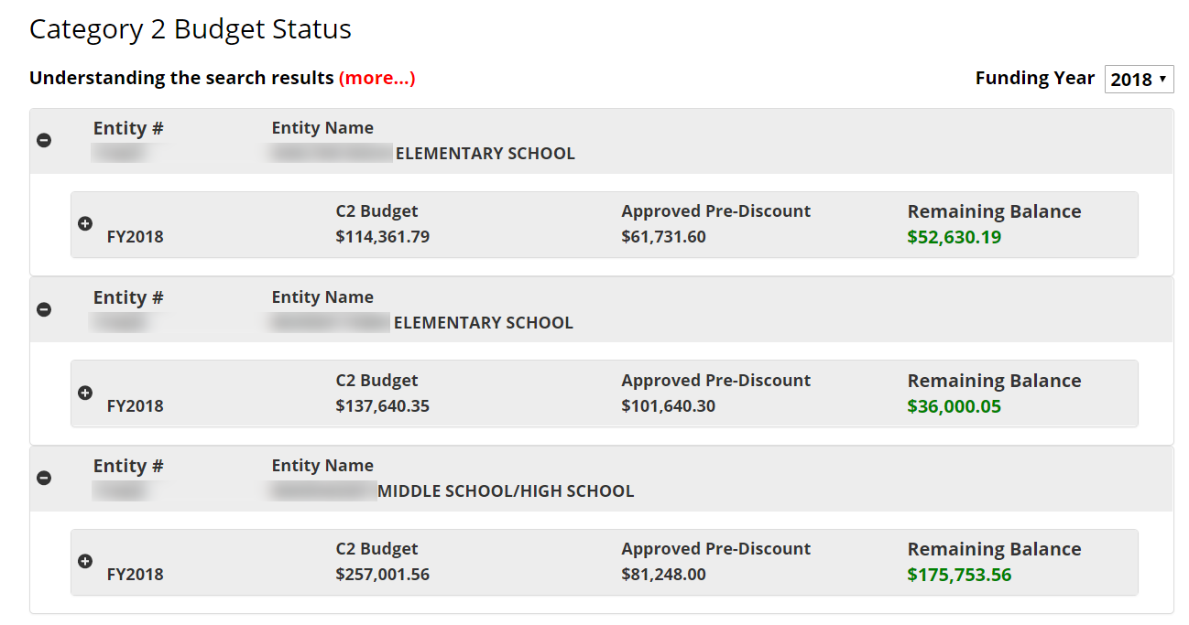
Note four important points about USAC’s budget status tool.
- The budget numbers shown are pre-discount amounts.
- The Remaining Balances include pending FY 2018 requests. If an entity is overbudget, the balance will be negative.
- Details on previous or pending funding for each entity can be shown by expanding (again using the “+” sign) at the entity budget line.

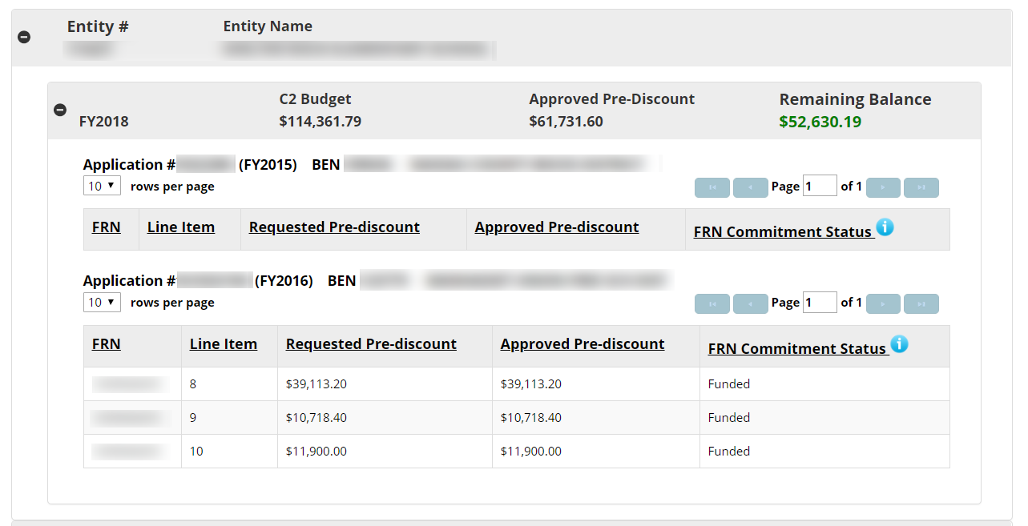

- Prior year funding is based on currently committed amounts, not disbursements. If some of this funding is not going to be used, applicants can and should file Form 500s to reduce and/or cancel the associated FRNs. This will free up Category 2 budgets for addition use.

Step 2: Reduce the funding requests associated with every overbudget entity to bring them within budget. This can be done in several ways.
- Proportionally reduce the prediscount costs of selected products or services (recognizing that such reductions will ultimately be reflected in the associated invoices).
- Eliminate funding requests for selected products or services at the line item and/or recipient of service level.
- In a multi-FRN application, eliminate entire FRNs.

At each stage or step of the process, make sure that you and your PIA reviewer agree on the budget amounts and on which entity(ies) need to be fixed. This is often a painful and iterative process, but it is critical to application approval. The alternative — to await a denial, then appeal — is unlikely to yield additional funding and will take longer.

E-Rate Updates and Reminders

Upcoming 2018 E-Rate Dates:

July 30 FY 2017 Form 486 deadline for funding committed in Wave 49 (a hurricane relief wave). Other upcoming Form 486 deadlines include:

Wave 50 08/06/2018

Wave 51 08/13/2018

Wave 52 08/29/2018

Applicants missing these (or earlier) deadlines should watch carefully for “Form 486 Urgent Reminder Letters” in EPC. The Reminders will afford applicants with 15-day extensions to submit their Form 486s without penalty.

The first Form 486 deadline for FY 2018 is not until October 29, 2018.

August 20 USAC webinar on Understanding Competitive Bidding.

September 10 Deadline to submit comments on the Department of Agriculture’s Rural Utilities Service proposal for the implementation of its pilot broadband program (e-Connectivity Pilot).

USAC News Brief Dated July 27 – Form 486 Reminders

USAC’s Schools and Libraries News Brief of July 27, 2018, provides several reminders on filing Form 486s including the following:
- Form 486s for FY 2016 and later are filed in EPC. Form 486s for earlier funding years (perhaps necessary because of delayed funding) can still be completed via the Forms section of the USAC website.
- Read the text next to each checkbox carefully. The most common mistakes are made in checking the “Early Filing” and “CIPA Waiver” boxes reserved for special situations.
- Choose the Funding Request Numbers (“FRNs”) for which services have started.
- Check the correct CIPA certification(s).
- Review the form before submission.

Newsletter information and disclaimer: This newsletter may contain unofficial information on prospective E-rate developments and/or may reflect E-Rate Central’s own interpretations of E-rate practices and regulations. Such information is provided for planning and guidance purposes only. It is not meant, in any way, to supplant official announcements and instructions provided by the SLD, FCC, or state education departments.

For further information on E-rate, follow E-rate Central on Twitter, Facebook, and LinkedIn.

