- Funding Status – FY 2018
- Updates on USAC’s E-Rate Productivity Center and Legacy System
  - USAC Plans E-Rate Cycle Dates
  - Form 486 “Early Filing” Warning
  - SPAC Status Search Tools
  - FCC Decision on a FY 2016 EPC Problem
- E-Rate Updates and Reminders
  - Upcoming 2018 E-Rate Dates
  - Most Common Application Denial Reasons
- USAC News Brief Dated August 10 – Form 470 FAQs

Funding Status – FY 2018

USAC issued Wave 18 for FY 2018 on Friday, August 10th for $54.1 million. Cumulative funding as of Wave 18 is $1.57 billion.

Updates on USAC’s E-Rate Productivity Center and Legacy System

USAC Plans E-Rate Cycle Dates:

During last month’s Schools & Libraries Committee meeting, USAC indicated that it would set specific E-rate cycle dates that applicants could rely on for advanced planning purposes. We expect USAC to publicly announce the following key E-rate dates shortly for implementation this year.

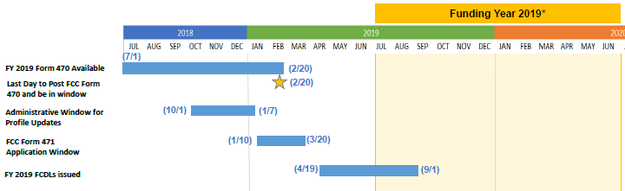

Specifically:

July 1 Form 470 available for next funding year. EPC was updated this year on July 1st (as had been done last year).
October 1 Opening of the “Administrative Window,” the period in which applicants may update their EPC entity profile data.
January 7 Closing of the applicant “Administrative Window.” At this point, entity profiles will be locked for the duration of the application window.
January 10 Opening of the Form 471 application window.
February 20 Last day to file a Form 470 and have it posted for the required 28 days before the close of the application window (presumably February 21 during a Leap Year).
March 20 Form 471 application window deadline.
April 19 Target date for the release of Wave 1 FCDLs.
September 1 Target PIA review completion date for all “workable” applications.

It will be important to remember that USAC intends these to be fixed dates, unaffected by weekends (i.e., not rolling over to the following business day). The first time this will become critical is in 2021 when March 20th falls on a Saturday.

Form 486 “Early Filing” Warning:

Now that it’s August, applicants filing Form 486s for FY 2018 funding should carefully avoid checking the first — deceptively prominent — certification reading:

This certification has a very specific purpose but is no longer applicable at this stage of the E-rate cycle. Checking the box after July is likely to delay the processing and approval of Form 486s.

Background: As a general rule, Form 486s should not be filed until (a) funding has been approved, and (b) service has been started. As a special exception, applicants funded early and seeking discounted billing for July can file Form 486s before services begin for that funding year if, and only if, they can certify that services will start by July 31st. That is the sole purpose of the “Early Filing” certification. Checking this certification box in August will be treated as an error in EPC.

SPAC Status Search Tools:

As discussed in our newsletter of July 23rd, USAC will process BEAR (and/or SPI) invoices for FY 2017 or FY 2018 only if the associated service provider has filed a Form 473 (“Service Provider Annual Certification” or “SPAC”) for that funding year. SPAC status information is available in two USAC databases, the SPIN Search Tool and the FRN Status Tool.

For the most accurate and current data, use the SPIN Search Tool (or the alternative legacy Service Provider Download Tool). SPAC information in the FRN Status Tool does not always reflect the most recently filed SPACs. As of last week, for example, the FY 2018 SPAC filing information had not been updated in the FRN Status Tool for about 50 SPINs.

FCC Decision on a FY 2016 EPC Problem:

The FCC issued a favorable decision (FCC 18-118) for Pribilof School District to waive the application deadline for the district’s FY 2016 Form 471. In parallel, the FCC instructed USAC to identify and afford “similarly situated” applicants the same benefit. The facts of the Pribilof case may limit the applicability of the waiver to others, but the decision provides a clear FCC view as to early and, in some cases, lingering EPC problems. In this instance:
- Partially as the result of EPC filing problems, Pribilof did not file its FY 2016 application until July 25th, four days after the close of the second and final window.
- Immediately after filing, EPC displayed a message confirming the filing, but incorrectly advising Pribilof that funding for late-filed requests would be prioritized based on their post-window filing dates. Based on this message, Pribilof assumed that its application would eventually be funded.
- On July 26th, EPC generated a news feed message correctly noting that Pribilof’s late-filed application would not be funded. Pribilof did not see this message; continued to believe its application would be funded; and, most importantly, did not file an FCC waiver of the FY 2016 application window.
- On November 18th, well after the 60-day deadline for submitting a waiver, Pribilof learned that its late-filed application would not be funded. The district then submitted a late FCC waiver request. That was denied. Pribilof next filed an FCC Petition for Reconsideration. That was dismissed. At this point, if not before, most applicants would have given up. Instead, Pribilof filed an Application for Review with the full Commission. The Commissioners agreed that Pribilof had been misled by an erroneous EPC message. Pribilof’s waiver was granted.

It is not immediately clear how many other FY 2016 applicants might also be able to seek relief under this decision. To be successful, “similarly situated” applicants must: (1) “demonstrate that their requests for waiver of the deadline to appeal a USAC decision were late-filed because of the same EPC notice issue faced by Pribilof; and (2) meet Commission-established waiver criteria for filing applications beyond the close of the applicable filing window (e.g., within 14 days after the window closes).”

What is clear is that the Commission recognizes EPC’s shortcomings. A separate statement by Commissioner Michael O’Rielly reads in part:

The EPC system’s technical problems are well-documented, and I understand that the Chairman and staff are working with USAC to address them, so I will not belabor them here. Rather, my specific concern has been the misguided position that information provided by USAC on the EPC news feed constitutes notice to an applicant of a funding decision and sets the deadline to appeal the decision.

Under past precedent and practice, USAC provides notice of a funding decision directly to an applicant in a funding commitment decision letter (FCDL) mailed or emailed to the applicant’s designated contact(s). In contrast, the EPC news feed essentially broadcasts to all users any action taken in the system. Notice by news feed is lazy, inadequate, and wrongly shifts responsibility for some of the failings of the EPC system on to the shoulders of unsuspecting applicants. Given the number of users and actions within the program, the content posted on EPC has been described as voluminous, cluttered, and almost always irrelevant to specific schools or libraries. It is unreasonable to expect applicants – often school and library staff with a primary educational mission to accomplish – to devote resources to continuously monitor a general-purpose news feed in lieu of receiving an FCDL directly from USAC, especially when they were never told they needed to check it.

E-Rate Updates and Reminders

Upcoming 2018 E-Rate Dates:

August 13 FY 2017 Form 486 deadline for funding committed in Wave 51. Other upcoming Form 486 deadlines include:

Wave 52 08/29/2018

Wave 53 (NA – wave canceled)

Wave 54 09/10/2018

Wave 55 09/12/2018

Applicants missing these (or earlier) deadlines should watch carefully for “Form 486 Urgent Reminder Letters” in EPC. The Reminders will afford applicants with 15-day extensions to submit their Form 486s without penalty.

The first Form 486 deadline for FY 2018 is not until October 29, 2018.

August 17 60-day deadline for a USAC appeal of Recovery of Improperly Disbursed Funds (“RIDFs”) Letters, most issued June 18, 2018, seeking repayment of invoices correctly filed last summer under extensions granted as a result of the FCC’s Jefferson-Madison decision (see our newsletter of July 16th). We suggest that these appeals reference the invoicing authority conveyed in USAC’s 2017 invoice extension letters and seek clarification of the only “FCC Directive” explanation included in the RIDF letters.

August 22 USAC webinar on Understanding Competitive Bidding.

August 29 Deadline to submit comments on the FCC’s Proposed Eligible Services List for FY 2019 (DA 18-789). Reply comments are due September 13th.

September 7 Last day of the PIA summer deferral period. Application reviews placed on hold during this period will be reactivated.

September 10 Deadline to submit comments on the Department of Agriculture’s Rural Utilities Service proposal for the implementation of its $600 million pilot broadband program (e-Connectivity Pilot). Coincidentally, this is the same deadline for the submission of comments on the FCC’s $100 million pilot broadband telehealth program (FCC 18-112). Neither pilot program is directly related to E-rate, but both are designed to promote broadband in rural areas.

Most Common Application Denial Reasons:

USAC recently summarized the top six reasons for funding denials over the past two years, namely:
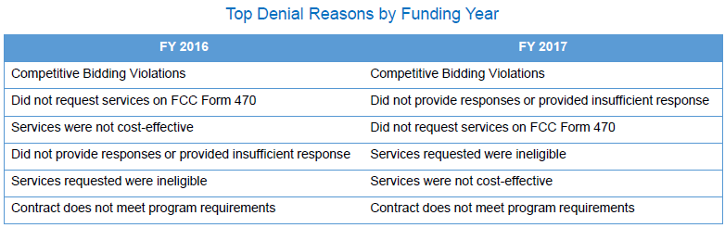

Although mostly self-explanatory, a few notes are in order.
- Competitive bidding: The #1 requirement for all E-rate funding is to conduct a “fair and open” competitive bidding process. This means treating all potential bidders equally in terms of service requirements and bid evaluations — and being able to document that this was done. Form 470s and associated RFPs (broadly defined) must be made available online for a minimum of 28 days. The denial problems we see most often stem from differential treatment of potential bidders or from 28-day posting violations (often a failure to restart the 28-day clock after making “cardinal changes” to the bid specifications).
- Form 470 requests: It is clear that E-rate funding for all products and services is dependent upon having first listed such items in a valid Form 470. Most frequently, the problem is not a failure to list a product or service at all, but the failure to list it in the appropriate category. Two areas requiring the most care involve the distinction between:
  - Fiber-based vs. non-fiber-based transmission and Internet access services in Category 1; and
  - Basic Maintenance of Internal Connections (“BMIC”) vs. Managed Internal Broadband Service (“MIBS”) in Category 2.
When in doubt, select two (or more) pull-down menu options and fully describe the service needed in the Narrative section.
- Insufficient or no PIA response: Not responding to initial or follow-on PIA inquiries is a sure road to denial. If additional time is needed to respond, over and above the initial two-week or one-week extension period, we have found that most PIA reviewers (or their managers, if necessary) will work with applicants if they know that they are not being ignored. Applicants wishing not to respond to inquiries on specific FRNs should request FRN cancellations rather than simply waiting for the inevitable denials.

USAC also provided the following denial statistics on special construction funding requests and, as a subset, on self-provisioned funding requests. The data indicates that the denial rate on these types of applications, while still high, was down dramatically from FY 2016 to FY 2017, reflecting, we believe, a better applicant understanding of the approval requirements for these types of applications. The lack of data for FY 2018 indicates USAC process delays — hopefully soon to be resolved — for special construction applications.
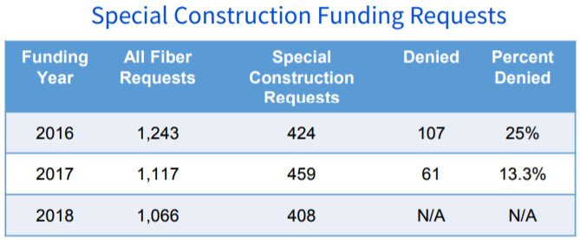

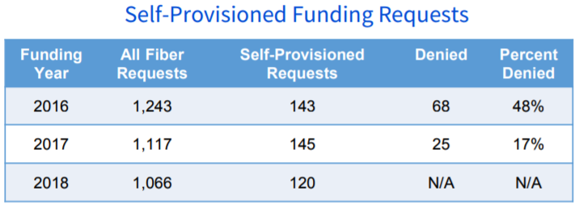

USAC News Brief Dated August 10 – Form 470 FAQs

USAC’s Schools and Libraries News Brief of August 10, 2018, provides answers to the following Form 470 questions commonly posed to the Client Service Bureau:
- When can I file a Form 470 for FY 2019? Short answer: Now!
- What is an RFP and is one required?
- What changes can I make to a certified Form 470?
- How do I make corrections to a certified Form 470?
- My Form 470 does not show the correct number of entities. What do I need to do? Belated hint: Update your EPC entity profile before starting your Form 470.
- What service/function should I list as the service/product on the Form 470?
- What should I do if I certified a Form 470 but left off some services? Best option: File a new Form 470.

Newsletter information and disclaimer: This newsletter may contain unofficial information on prospective E-rate developments and/or may reflect E-Rate Central’s own interpretations of E-rate practices and regulations. Such information is provided for planning and guidance purposes only. It is not meant, in any way, to supplant official announcements and instructions provided by the SLD, FCC, or state education departments.

For further information on E-rate, follow E-rate Central on Twitter, Facebook, and LinkedIn.

A copy of the Briefing Book for the Schools & Libraries Committee Meeting on July 23, 2018 is publicly available at https://www.usac.org/_res/documents/about/pdf/bod/materials/2018/2018-07-23-SL-Briefing-Book.pdf.

