- Funding Status – FY 2018
- E-Rate Updates and Reminders
  - Upcoming 2018 E-Rate Dates
- USAC News Brief Dated August 17 – Federal Debt and Returning Funds
  - How Debt to the Federal Government Affects E-Rate Participants
  - Reminders on Returning Funds to USAC

Funding Status – FY 2018

USAC issued Wave 19 for FY 2018 on Friday, August 17th for $36.8 million. Cumulative funding as of Wave 19 is $1.61 billion.

E-Rate Updates and Reminders

Upcoming 2018 E-Rate Dates:

August 29 FY 2017 Form 486 deadline for funding committed in Wave 52. Other upcoming Form 486 deadlines include:

Wave 53 (NA – wave canceled)

Wave 54 09/10/2018

Wave 55 09/12/2018

Applicants missing these (or earlier) deadlines should watch carefully for “Form 486 Urgent Reminder Letters” in EPC. The Reminders will afford applicants with 15-day extensions to submit their Form 486s without penalty.

The first Form 486 deadline for FY 2018 is not until October 29, 2018.

August 22 USAC webinar on Understanding Competitive Bidding.

August 29 Deadline to submit comments on the FCC’s Proposed Eligible Services List for FY 2019 (DA 18-789). Reply comments are due September 13th.

September 7 Last day of the PIA summer deferral period. Application reviews placed on hold during this period will be reactivated.

September 10 Deadline to submit comments on the Department of Agriculture’s Rural Utilities Service proposal for the implementation of its $600 million pilot broadband program (e-Connectivity Pilot). Coincidentally, this is the same deadline for the submission of comments on the FCC’s $100 million pilot broadband telehealth program (FCC 18-112). Neither pilot program is directly related to E-rate, but both are designed to promote broadband in rural areas.

USAC News Brief Dated August 17 – Federal Debt and Returning Funds

USAC’s Schools and Libraries News Brief of August 17, 2018, discusses two funding process topics, both partially related to the change made earlier this year to process E-rate payments through the U.S. Treasury rather than through commercial banks. Both situations addressed in the News Brief are fortunately not common but are important to understand if they do occur.

How Debt to the Federal Government Affects E-Rate Participants:

E-rate applicants and service providers owing money to the federal government may find that their E-rate invoices will be affected. How this occurs depends upon the nature of the federal debt. In particular:

- Generally, if an applicant or service provider is delinquent on an E-rate debt, perhaps as a result of a Recovery of Improperly Disbursed Funds (“RIDF”), or is in Red Light status, USAC will simply withhold any disbursements until the debt is settled.
- In the special case of E-rate service providers who are also USF contributors, but are delinquent on those USF payments, USAC will net out any delinquent payments against pending invoices.
- Invoices approved by USAC are paid by the U.S. Treasury. If any outstanding debt is owed to other federal governmental agencies, however, the U.S. Treasury will withhold such debt from the payment. Should this occur, E-rate applicants may get conflicting signals — notices of successful payments from USAC, followed by notices of offsetting debt payments from the U.S. Treasury.

Most E-rate applicants are familiar with USAC payment letters, but few — fortunately — have seen the “What Happened to My Payment?” letters from the U.S. Treasury. If only for curiosity sake, a redacted example of such a letter follows this article.

Reminders on Returning Funds to USAC:

If funds need to be returned to USAC, payments must be made electronically to the U.S. Treasury. As examples of common situations in which a return of funds are required, the News Brief cites funds received in error or — in somewhat unfamiliar language — “a discrepancy between your projected support amount and the actual support disbursed.” As best we can determine, this language comes from the return of funds instructions for other Universal Service Fund (“USF”) programs. For E-rate purposes, better examples are contained in the Returning Funds to USAC section of USAC’s Schools & Libraries website.

To actually make a return of funds payment, go to the Payments section, choose the right USF program (see below), and follow the instructions.

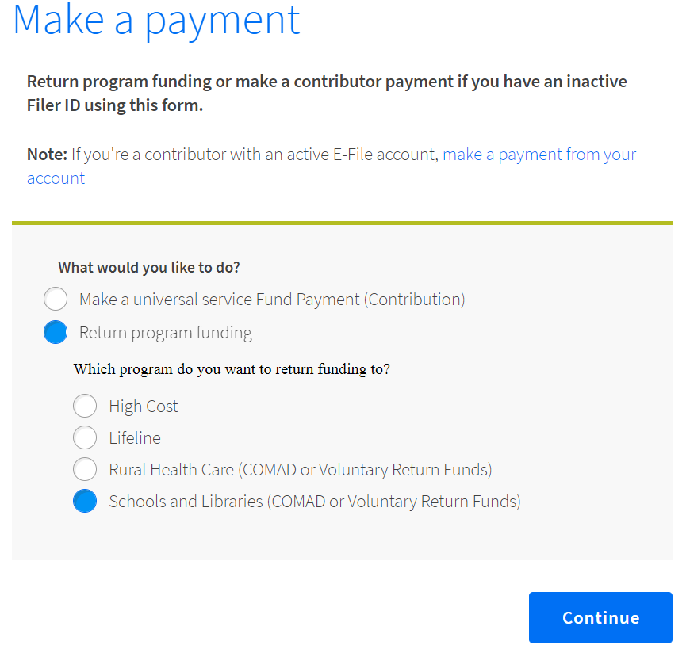
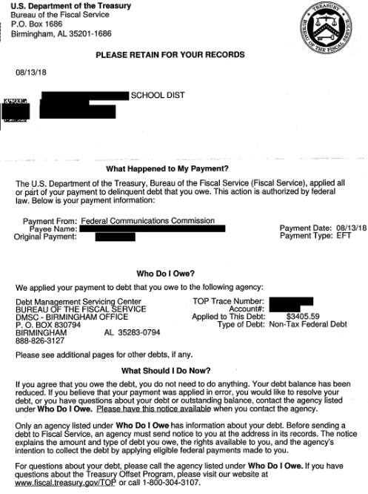

Newsletter information and disclaimer: This newsletter may contain unofficial information on prospective E-rate developments and/or may reflect E-Rate Central’s own interpretations of E-rate practices and regulations. Such information is provided for planning and guidance purposes only. It is not meant, in any way, to supplant official announcements and instructions provided by the SLD, FCC, or state education departments.

For further information on E-rate, follow E-rate Central on Twitter, Facebook, and LinkedIn.

