- Funding Status – FY 2018
- Updates on USAC’s E-Rate Productivity Center and Legacy System
  - More Unexplained USAC Funding Decisions
- E-Rate Updates and Reminders
  - Upcoming 2018 E-Rate Dates
  - Additional USAC Guidance on Product Demos
  - FCC Formalizes $1.2 Billion Roll-Over for FY 2018
- USAC News Brief Dated August 24 – USAC Hiring

Funding Status – FY 2018

USAC issued Wave 20 on Friday, August 24th, for $73.1 million. Cumulative funding as of Wave 20 is $1.68 billion.

USAC is well on its way to meeting the FCC target of issuing current year funding decisions on all “workable” applications by September 1st (see FCC 14-99, para. 59). USAC passed the 90% point as of Wave 18 on August 10th. Excluding unworkable applications, including those on administrative hold (unlikely to be funded) or still on summer deferment (ending the Friday after Labor Day), we expect USAC to hit about 95% by month’s end. That’s the good news.

Unfortunately, there is offsetting bad news.
- The high percentage completion rate is calculated by application count, not by dollar level of application requests. There are still almost $1 billion in pending applications, roughly 35% of total demand.
- The pending application category includes almost $300 million in special construction requests, none of which have been funded. These applications are currently deemed unworkable awaiting additional FCC guidance.
- Reports are beginning to surface of FY 2018 invoice denials for issues that should have been caught, and hopefully corrected, during PIA review. This suggests that there was a rush to judgement in application approvals which is being offset by tighter invoice review procedures.

Updates on USAC’s E-Rate Productivity Center and Legacy System

More Unexplained USAC Funding Decisions:

Last June, USAC issued a series of Recovery of Improperly Disbursed Funds (“RIDFs”) indicating its intention to recapture funds form invoices paid during extended invoice deadlines previously approved by USAC. In all cases, the only explanation for these RIDFs was “FCC Directive” (see our newsletters of July 2nd and July 16th).

USAC has apparently struck again, this time from a slightly different direction. We have recently seen Revised Funding Commitment Decision Letters (RFCDLs”) retroactively reducing applicants’ FY 2017 discount rates, again without explanation. Compounding the problem this time is persistently conflicting data in USAC funding databases.

As an illustration of the problems faced by affected applicants, consider an RFCDL for a consortium applicant issued last June and recently brought to our attention by another state coordinator. Here are the issues we’ve found so far:
- The RFCDL shows a new consortium discount rate of 62%, down from the original 78%, and a commitment amount revised downwards by 20.5%. The only rationale for the reduction is a sentence reading “Your post-commitment request for Funding Year 2017 Schools and Libraries Program (E-rate) funding commitment has been revised to reflect the current commitment amount.” The RFCDL even thanks the applicant for submitting a post-commitment request, which the applicant did not do. (This was a USAC initiated “appeal.”)
- USAC’s FRN Status Tool (“FST”) shows the revised discount rate and lower committed amount, but has only blank fields in the columns for “PC [post commitment] Wave Number” (it should be Wave 21), “Revised FCDL Date” (it should be 06/23/2018), and “Post Commitment Rationale” (unknown). Interestingly, for an application containing two FRNs, the FST shows the reduced discount rate for only one FRN — the only FRN for which the applicant received an RFCDL.
- The FRN view on USAC’s Form 471 download tool, on the other hand, shows a 62% discount rate on both FRNs, but surprisingly doesn’t recalculate and lower the committed amount on one FRN — perhaps the reason that the applicant received only one RFCDL.
- The current EPC data for this application is equally inconsistent. Overall, EPC shows the reduced Category 1 discount on the entire application.

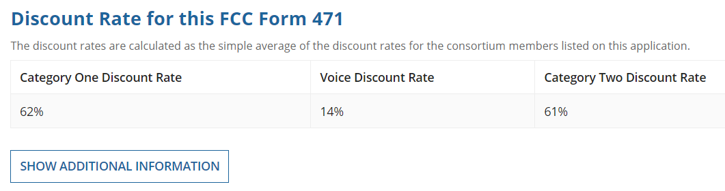
But if you click on the Additional Information button, then average the discount rates on all 20 of the consortium’s members, the overall discount calculated is the original 78%.

With conflicting data in USAC’s database, it is impossible for the applicant to determine how USAC arrived at the revised 62% discount rate for one FRN. Fortunately, the applicant has appealed the reduction. Hopefully, USAC will be able to explain its rationale — or admit that the RFCDL, and others like it, was issued in error.

E-Rate Updates and Reminders

Upcoming 2018 E-Rate Dates:

August 29 Deadline to submit comments on the FCC’s Proposed Eligible Services List for FY 2019 (DA 18-789). Reply comments are due September 13th.

September 7 Last day of the PIA summer deferral period. Application reviews placed on hold during this period will be reactivated.

September 10 FY 2017 Form 486 deadline for funding committed in Wave 54. Other upcoming Form 486 deadlines include:

Wave 55 09/12/2018

Wave 56 10/26/2018

Wave 57 11/26/2018

Applicants missing these (or earlier) deadlines should watch carefully for “Form 486 Urgent Reminder Letters” in EPC. The Reminders will afford applicants with 15-day extensions to submit their Form 486s without penalty.

The first Form 486 deadline for FY 2018 is not until October 29, 2018.

September 10 Deadline to submit comments on the Department of Agriculture’s Rural Utilities Service proposal for the implementation of its $600 million pilot broadband program (e-Connectivity Pilot). Coincidentally, this is the same deadline for the submission of comments on the FCC’s $100 million pilot broadband telehealth program (FCC 18-112). Neither pilot program is directly related to E-rate, but both are designed to promote broadband in rural areas.

Additional USAC Guidance on Product Demos:

Earlier this summer, USAC revised a portion of its website Reference section to indicate that onsite product demonstration “loans” would be considered prohibited “gifts.” This change, made with no public announcement, replaced longstanding guidance that product demos were fine if equipment was made available only on a temporary basis. As discussed in our newsletter of July 16th, the strict new prohibition appeared to be an overly restrictive approach to avoid making a subjective distinction between a short-term product demo and a longer-term product loan.

In last week’s webinar on competitive bidding (available online), USAC modified its demo guidance — slightly. USAC indicated that demos were OK if conducted prior to — and completed by — the filing of the applicant’s Form 470 for the coming year.

This pre-470 guidance is counter-intuitive. It means that as long as an applicant is not yet seeking bids for equipment, vendors can demonstrate their products. But once the applicant decides it needs equipment, goes out for bids, and is faced with evaluating bid responses, actual product demos are forbidden. To us, giving selected suppliers pre-470 access to applicants would seem to be the antithesis of the FCC’s competitive bidding rules. We hope that USAC will rethink its new guidance on product demos.

FCC Formalizes $1.2 Billion Roll-Over for FY 2018:

The FCC’s Wireline Competition Bureau (“WCB”) released a public notice (DA 18-861) formally acknowledging sufficient funding to fully fund all valid FY 2018 Category 1 and Category 2 request. As previously reflected in USAC’s Fourth Quarter USF Size Projections, $1.2 billion was available in unused E-rate funds from previous years to carry forward (or “roll-over”) into FY 2018. With the total demand currently estimated at $2.715 billion, partially funded with the $1.2 billion roll-over, only $1.515 billion of new funding will be required this year — well below the $4.06 billion funding cap.

USAC News Brief Dated August 24 – USAC Hiring

USAC’s Schools and Libraries News Brief of August 24, 2018, touches on several topics including last weekend’s system maintenance and the August 29th deadline for submitting comments on the FCC’s FY 2019 Eligible Services List. It also publicized a number of open positions for which USAC is currently hiring (see USAC Careers Portal).

Newsletter information and disclaimer: This newsletter may contain unofficial information on prospective E-rate developments and/or may reflect E-Rate Central’s own interpretations of E-rate practices and regulations. Such information is provided for planning and guidance purposes only. It is not meant, in any way, to supplant official announcements and instructions provided by the SLD, FCC, or state education departments.

For further information on E-rate, follow E-rate Central on Twitter, Facebook, and LinkedIn.

