- Funding Status – FY 2018
- Updates on USAC’s E-Rate Productivity Center and Legacy System
  - Improving Postal Addresses for USAC Letters
- E-Rate Updates and Reminders
  - Upcoming 2018 E-Rate Dates
  - Updated USAC Training Sessions
  - 4Q18 Proposed Contribution Factor
- USAC News Brief Dated September 14 – Invoicing Reminders

Funding Status – FY 2018

USAC issued Wave 23 on Friday, September 14th, for $39.1 million. Cumulative funding as of Wave 23 is $1.75 billion.

Updates on USAC’s E-Rate Productivity Center and Legacy System

Improving Postal Addresses for USAC Letters:

Most USAC correspondence with applicants and service providers is now delivered electronically via email and/or EPC. Exceptions include BEAR Notification Letters — and importantly letters from the U.S. Treasury in the fortunately rare cases in which an applicant’s BEAR payment is reduced to satisfy an outstanding government debt — which are printed and physically mailed.

Applicant letters are generally addressed to the applicant’s general contact in the following format:

APPLICANT NAME (often truncated)
Contact street address
Contact city, state, ZIP

Normally, this is fine if the contact is an applicant employee. However, if the general contact is not an applicant employee, but is a third party (e.g., the applicant’s E-rate consultant) there is a reasonable likelihood that the mailing may go astray.

To avoid potential postal mailing errors when a non-applicant contact is used, we recommend that the contact’s organization name be added as a separate address line in EPC and, whether system-populated or not, in all E-rate forms. Fortunately, most E-rate contact forms include 2-3 address line fields, one of which can be used for a “c/o” the firm name. As illustrated below, USAC letters may still highlight the applicant’s name, but will at least include the contact’s firm name in the full address.

APPLICANT NAME
c/o Contact organization name
Contact street address
Contact city, state, ZIP

E-Rate Updates and Reminders

Upcoming 2018 E-Rate Dates:

September 19 USAC webinar entitled Navigating the E-rate Invoicing Process.

September 30 Service Delivery Deadline (“SDD”) for FY 2017 non-recurring FRNs. This is also the deadline for requesting a one-year SDD extension.

October 8 Deadline for submitting nominations to the FCC for the USAC Board of Directors (DA 18-921).

October 26 FY 2017 Form 486 deadline for funding committed in Wave 56.

October 29 FY 2018 Form 486 deadline for funding committed in Waves 1–12 (all issued before July 1st).

Note: Applicants missing any Form 486 deadline should watch carefully for “Form 486 Urgent Reminder Letters” in EPC. The Reminders will afford applicants with 15-day extensions to submit their Form 486s without penalty.

October 29 Invoice deadline for FY 2017 recurring services. Note: For applicants and service providers unable to submit invoices by this date, October 29th is also the deadline for filing 120-day Invoice Deadline Extension Requests (“IDERs”).

Updated USAC Training Sessions:

USAC announced the addition of Atlanta as a new applicant training site to this year’s schedule. Registration to all trainings is online.

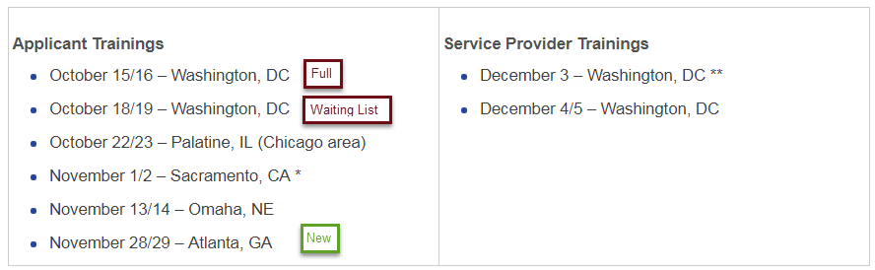

4Q18 Proposed Contribution Factor:

The FCC announced (DA 18-944) the proposed Universal Service Fund (“USF”) contribution percentage for the fourth quarter of calendar 2018 — corresponding to the second funding quarter of E-rate’s FY 2018. Overall, the contribution factor increased from 17.9% in 3Q18 to 20.1% breaking the potentially politically-sensitive 20% level. Fortunately, the increase was largely attributed to an additional $90 million required to fund the coming quarter’s share of the $171 million increase in the USF’s Rural Health Care Program that the Administration-led FCC approved last June.

USAC News Brief Dated September 14 – Invoicing Reminders

USAC’s Schools and Libraries News Brief of September 14, 2018, reminds applicants and service providers that October 29th is the deadline for filing invoices for recurring FY 2017 services or alternatively for filing 120-day Invoice Deadline Extension Requests (“IDERs”).

The News Brief also indicates that USAC will be adding a new IDER tool to EPC within the next few weeks. When available, the new IDER tool must be used for FY 2016 (or later) FRNs. The existing IDER function within the BEAR legacy system will still be used for FY 2015 (or earlier) FRNs.

Newsletter information and disclaimer: This newsletter may contain unofficial information on prospective E-rate developments and/or may reflect E-Rate Central’s own interpretations of E-rate practices and regulations. Such information is provided for planning and guidance purposes only. It is not meant, in any way, to supplant official announcements and instructions provided by the SLD, FCC, or state education departments.

For further information on E-rate, follow E-rate Central on Twitter, Facebook, and LinkedIn.

