* Funding Status – FY 2018
* Updates on USAC’s E-Rate Productivity Center and Legacy System
  + New IDER Tool in Operation
  + Uploading Multiple RFP Documents into a Form 470
  + USAC Tools with Legacy URLs
* E-RateUpdates and Reminders
  + Upcoming E-Rate Dates
  + FCC Decision on Special Construction State Match Funding
* USAC News Brief Dated October 5 – Three October 29 Deadlines

**Funding Status – FY 2018 and FY 2019**

*FY 2018:*

USAC issued Wave 26 on Friday, October 5th. Cumulative funding as of Wave 26 was $1.82 billion.

*FY 2019:*

The administrative window opened October 1st. As explained in [USAC’s Schools and Libraries News Brief of September 28th](https://e-ratecentral.com/Portals/0/DocFiles/files/sld-news-briefs/857.pdf), this three-month window gives applicants an opportunity to update their EPC entity profiles (including NSLP information for schools and school districts) in preparation for FY 2019 applications. The administrative window will remain open until roughly January 7th at which point EPC entity profiles will be locked during the Form 471 application window (estimated to be January 10th – March 20th).

**Updates on USAC’s E-Rate Productivity Center and Legacy System**

*Using the New IDER Tool:*

USAC’s new Invoice Deadline Extension Request (“IDER”) tool is now available in EPC. The tool permits applicants and service providers to request automatic 120-day invoice deadline extensions for FRNs from FY 2016 forward. Invoice extensions for earlier funding years may be requested, as before, through the legacy BEAR system. Please remember that IDERs must be filed on or before the original invoice deadlines. The next key invoice deadline is October 29th for FY 2017 recurring service FRNs.

The IDER tool is accessed from the applicant page using the pull-down menu in the upper righthand corner.

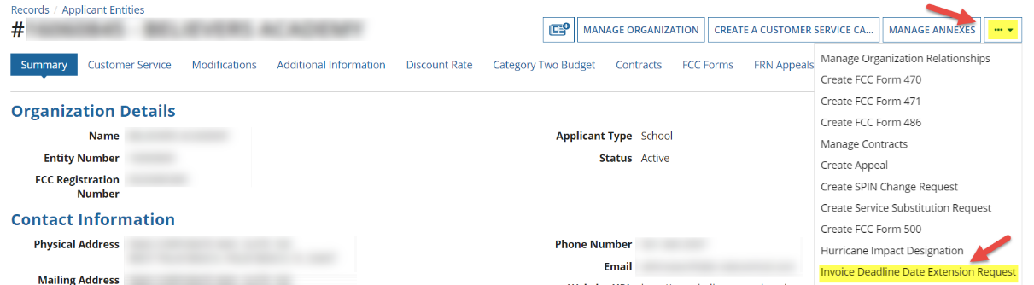

Extensions may be requested for a list of FRNs, each separated by a comma. Pre-submission, click the “CHECK ELIGIBILITY” button.

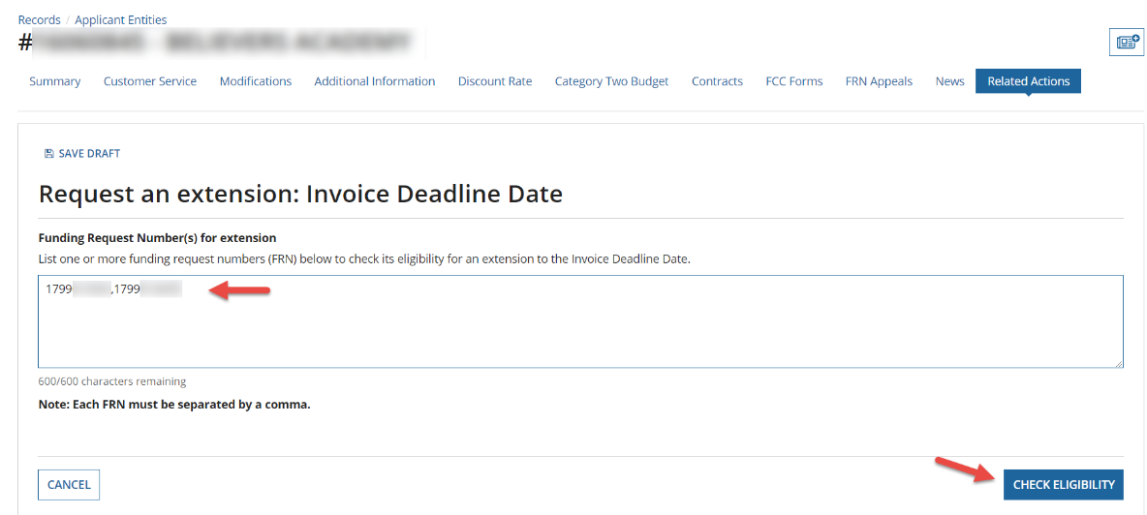

Review the results to make sure that extensions are eligible for those FRNs, then “SUBMIT” the request.

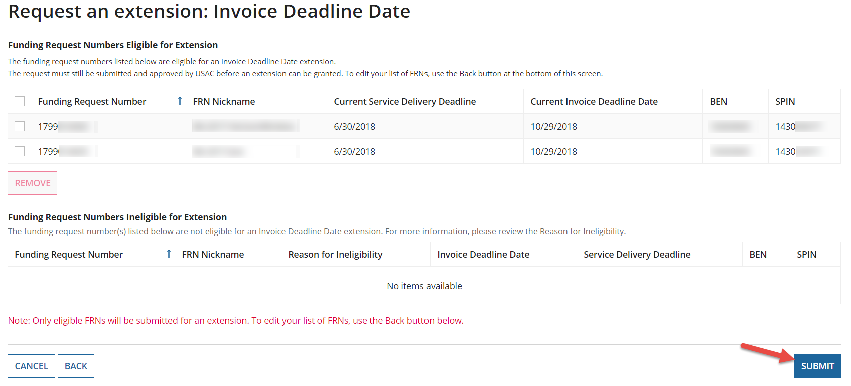

Please note one potentially confusing aspect on extended invoice deadlines. If the new IDER tool is used to extend the Current Invoice Deadline Date of 10/29/2019, the Extended Invoice Deadline Date will be 2/**26**/2019. Applicants who had previously requested IDERs using the legacy BEAR system may instead see extended deadline dates of 2/**25**/2019. These day earlier deadlines are still being displayed in the [FRN Extension Table](http://www.sl.universalservice.org/utilities/FRN_CurFundExt.asp). We expect USAC to correct this discrepancy and have been assured that the 26th is the correct deadline extension date for all related FRNs — not that applicants should be pushing the boundary of any E-rate deadline.

*Uploading Multiple RFP Documents into a Form 470:*

Competitive bidding rules require applicants to upload all RFP-related documents (including supplementary information) into their associated Form 470s. Failure to do so may result in funding denials. Attempts to upload multiple documents during the same EPC session, however, may generate an error message such as:

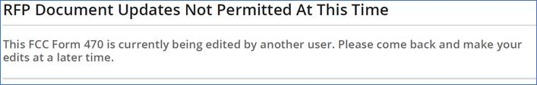

There are several approaches to solving this problem, including:

* Combine multiple documents into a single ZIP file requiring only one upload.
* Start a new EPC session by logging out and logging back in. This approach normally works but becomes tedious if more than a couple of documents are involved.
* Try uploading the document the next day (if time permits).
* When nothing else seems to work, call CSB or initiate a customer service request within EPC.

*USAC Tools with Legacy URLs:*

Most of the webpages on USAC’s E-rate site now have URLs beginning “usac.org/sl/,” an update from URLs beginning “sl.universalservice.org.” A few of USAC’s links, however, have not been updated and are still using the original URLs. Most of the time the older URL formats work, but sometimes clicking on a link generates the following error message:

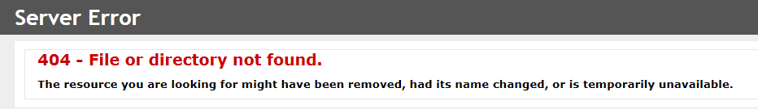

Occasional errors are being reported on the following “sl.universalservice.org” sites:

[SPIN Search](http://www.sl.universalservice.org/Forms/SPIN_Contact_Search.asp): http://www.sl.universalservice.org/Forms/SPIN_Contact_Search.asp

Alternative: [Service Provider Download Tool](https://data.usac.org/publicreports/SpinDownload/Spin/Download)

[FRN Extension](http://www.sl.universalservice.org/utilities/FRN_CurFundExt.asp): http://www.sl.universalservice.org/utilities/FRN_CurFundExt.asp

Alternative: [FRN Status Tool](https://data.usac.org/publicreports/FRN/Status/FundYear) (FY 2016 and forward)

[Apply Online](http://www.sl.universalservice.org/menu.asp): http://www.sl.universalservice.org/menu.asp

Individual alternatives available for Forms 470, 471, 486 and Utilities

Our best advice to users encountering 404 errors is to try a different browser or computer, or to simply wait awhile. Be careful when using the alternative sites indicated to check either SPAC filings by service providers or invoice deadline extensions on FRNs; the data on the FRN Status Tool is not always consistent.

**E-Rate Updates and Reminders**

*Upcoming E-Rate Dates:*

October 8 Deadline for submitting nominations to the FCC for the USAC Board of Directors ([DA 18-921](https://docs.fcc.gov/public/attachments/DA-18-921A1.pdf)).

October 26 FY 2017 Form 486 deadline for funding committed in Wave 56.

October 29 FY 2018 Form 486 deadline for funding committed in Waves 1–12 (all issued before July 1st).

Note: Applicants missing any Form 486 deadline should watch carefully for “Form 486 Urgent Reminder Letters” in EPC. These Reminder Letters afford applicants 15-day extensions to submit their Form 486s without penalty.

October 29 Invoice deadline for FY 2017 recurring services. Note: For applicants and service providers unable to submit invoices by this date, October 29th is also the deadline for filing 120-day Invoice Deadline Extension Requests (“IDERs”).

*FCC Decision on Special Construction State Match Funding:*

The FCC issued an appeal order ([DA 18-1000](https://docs.fcc.gov/public/attachments/DA-18-1000A1.pdf)) overturning USAC’s denial of special construction funding for Farmington Municipal Schools in New Mexico. The decision is significant in part because it deals with the potential impact of state match funding on special construction bid evaluations.

In 2016, Farmington filed a Form 470 and issued an RFP seeking bids on leased lit fiber, leased dark fiber, and a self-provisioned network. The district received bids from several service providers, including one for a self-provisioned network and one for a leased dark fiber network, both with special construction charges. Farmington evaluated the bids, properly assigning price of the total cost of ownership of eligible services over a 20-year period as the primary factor. Other factors considered included (a) ability to adhere to the rollout timeframe, (b) supporting requirements in the RFP, (c) proposed contract terms, (d) service reliability, (e) offering a turn-key solution, (f) scalability, and (g) references. The higher total cost of the winning bid was offset by the other factors.

During PIA review, Farmington responded to inquiries regarding the total cost calculations and the weighting of all the evaluation factors. In its response, the district also mentioned that it had calculated and compared total post-discount costs under both proposals. Traditionally, when comparing pre- and post-discount costs of eligible services, the cost ratio of competing bids would be the same. In New Mexico (and 21 other approved states), however, applicants are eligible for additional discounts on special construction if matched by state funding. Everything else being equal, this means that the larger the percentage of total costs attributed to special construction, rather than monthly recurring charges, the lower the net cost to the applicant.

Here’s an example assuming two bids, both for the same total costs over the life of the project, but with different proportions of special construction costs and recurring costs. The example assumes that the applicant has a normal E-rate discount of 50% and will receive an additional 10% discount and matching state funds for its special construction charges. Note that Bid B, with the higher special construction charge, results in a lower net cost to the district.

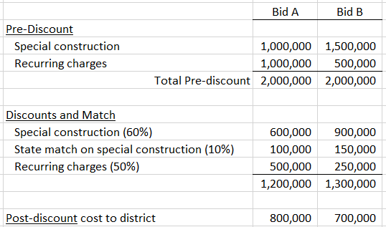

Although Farmington did not use a net cost comparison in its bid evaluation process, USAC denied the application on the basis “that the applicant impermissibly considered the availability of state match funding in its cost-effectiveness analysis, which USAC interpreted as indicating that the district evaluated the bids based on costs to the district.”

The FCC reversed the USAC denial finding that Farmington had properly used total costs, not net district costs, in its evaluation. This was a positive decision for Farmington but should serve as a cautionary warning for all applicants considering state matching funds. E-rate rules require price comparisons of total eligible costs, not an applicant’s net costs after discounts.

**USAC News Brief Dated October 5 – Three October 29 Deadlines**

[USAC’s Schools and Libraries News Brief of October 5, 2018](https://e-ratecentral.com/Portals/0/DocFiles/files/sld-news-briefs/858.pdf), reviews and discusses three critical filing deadlines occurring on October 29th (all noted above), namely:

* BEAR and SPI submission deadlines for FY 2017 recurring services
* Deadline for requesting 120-day invoice extensions of these FY 2017 BEAR and SPI deadlines (see discussion of the new EPC IDER tool above)
* Form 486 deadline for FRNs approved in the early FY 2018 funding waves

The News Brief also reminds all program participants to “[Share Your E-rate Technical System Ideas](https://docs.google.com/forms/d/e/1FAIpQLSdYTg3Qa1RGjR1gD5E5ofdSfcw6F9d1Mus8L8xDjCwLd1iiLw/viewform).”

--------------------------------------------------------------------------------------------------------------------- *Newsletter information and disclaimer: This newsletter may contain unofficial information on prospective E-rate developments and/or may reflect E-Rate Central’s own interpretations of E‑rate practices and regulations. Such information is provided for planning and guidance purposes only. It is not meant, in any way, to supplant official announcements and instructions provided by the SLD, FCC, or state education departments.*

*For further information on E-rate, follow E-rate Central on Twitter, Facebook, and LinkedIn.*

