* Funding Status – FY 2018 and FY 2019
* Updates on USAC’s E-Rate Productivity Center and Legacy System
  + New Dataset for E-rate Recipient Details and Commitments
* E-RateUpdates and Reminders
  + Upcoming E-Rate Dates
* USAC News Brief Dated November 9 – USAC’s Open Data Platform

**Funding Status – FY 2018 and FY 2019**

*FY 2018:*

USAC issued Wave 31 on Friday, November 9th. Cumulative funding as of Wave 31 is $1.90 billion.

*FY 2019:*

The FY 2019 administrative window (permitting applicants to update their EPC entity profiles) is open and will remain open until roughly January 7th. Thereafter, EPC entity profiles will be locked for the duration of the Form 471 application window (estimated to be January 10th – March 20th).

**Updates on USAC’s E-Rate Productivity Center and Legacy System**

*New Dataset for E-rate Recipient Details and Commitments:*

As first previewed in the [advanced “Data” presentation](https://www.usac.org/_res/documents/sl/training/2018/Applicant-Data.pptx) at USAC’s applicant training workshops this fall, USAC has developed a new database in its set of [Open Data](https://opendata.usac.org/browse?category=E-rate&limitTo=datasets) tools. The new dataset, labeled “E-rate Recipient Details and Commitments,” is broadly described as:

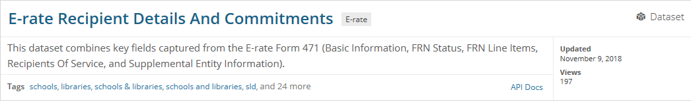

The dataset is designed to answer questions such as:

* Who are all the recipients in the E-rate program?
* What type of service is a recipient getting?
* How much is a recipient paying for a service?
* Who is the service provider for a recipient?
* How are Category 2 costs allocated among recipients?
* Is the recipient a Tribal School/Library, Public School/Library, Charter School, etc.?

Note that “recipient,” in this case, refers to individual entities, not simply to applicants. As such, this is a very large file. The database includes FRN-by-FRN, recipient-by-recipient, funding and services data from all FY 2016-2018 applications — over 5.4 million rows in spreadsheet format. Viewed online, only 50 rows are visible per page, each accessed by “<Previous Next>” tabs. Downloaded, the file currently includes over 3 gigabits of data — primarily for large E-rate data mining purposes.

For more focused inquiries, the new dataset and others in USAC’s Open Data platform can be searched and/or filtered in a customized manner as described in USAC’s most recent News Brief discussed and referenced below.

**E-Rate Updates and Reminders**

*Upcoming E-Rate Dates:*

November 12 Form 486 deadline for FY 2018 funding committed in Wave 14. More generally, the Form 486 deadline is 120 days from the FCDL date or the service start date (typically July 1st), whichever is later. Upcoming FY 2018 Form 486 deadlines in November are:

Wave 15 11/19/2018

Wave 16 11/26/2018

Note: Applicants missing any Form 486 deadline should watch carefully for “Form 486 Urgent Reminder Letters” in their EPC News Feed. These Reminder Letters afford applicants 15-day extensions to submit their Form 486s without penalty (see last week’s USAC News Brief references below).

November 13 [USAC E-rate Tribal training](https://www.usac.org/sl/about/outreach/tribal.aspx) workshop in Omaha, NE. Tribal registrants for this half-day session will have the option of attending the regular USAC training beginning that afternoon (see below). Full-day Tribal workshops will also be held November 28th in Spokane, WA, and November 30th in Farmington, NM.

November 13-14 Next in the [series of two-day USAC annual fall training](https://www.usac.org/sl/about/outreach/2018-training.aspx) workshops in Omaha, NE.

November 20 USAC webinar on [Updating Applicant Profiles](https://register.gotowebinar.com/register/8977769021055901185?source=SL+News+Brief_Website) in EPC.

**USAC News Brief Dated November 9 – USAC’s Open Data Platform**

[USAC’s Schools and Libraries News Brief of November 9, 2018](https://e-ratecentral.com/Portals/0/DocFiles/files/sld-news-briefs/863.pdf), provides a brief overview of USAC’s [Open Data](https://opendata.usac.org/browse?category=E-rate&limitTo=datasets) platform, a collection of datasets, updated daily, providing detailed data derived from applicant Form 470s, Form 471s, and other EPC information. The entire platform can be accessed via USAC’s [Tools](https://www.usac.org/sl/tools/default.aspx) page

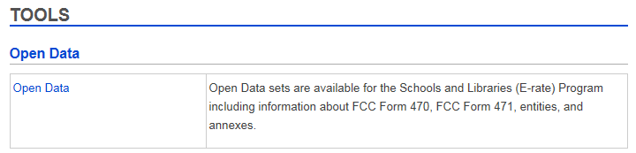

In addition to the new “E-rate Recipient Details and Commitments” dataset referenced above, the Open Data platform contains databases breaking out and/or integrating data from multiple USAC data sources from FY 2016 forward (including early Form 470 data for FY 2019). The datasets include:

* Competitive bidding data including:
  + Basic Form 470 information
  + Consortium entity information
  + Form 470 consultant information
* Funding request data including:
  + Basic Form 471 information
  + The new “E-rate Recipient Details and Commitments” dataset
  + Form 471 consultant information
  + Discount rate data
  + Requested services by line item
  + FRN status
  + Recipients of service
* Supplemental EPC information on:
  + Entities
  + Annexes

As the News Brief notes, the Open Data platform gives users the ability to view, search, filter, manipulate, and extract program data in a variety of formats (including API). By setting up accounts within Open Data, users can save customized searches to view automatically updated information in one action instead of having to download and reformat data from multiple datasets.

[Open Data video guides](https://opendata.usac.org/videos) are available to help users:

* Sort a dataset
* Search within a dataset
* Comment on a dataset
* Use basic filters
* Create a map
* Use data “lens”
* Aggregate data

USAC’s News Brief also provides an update on November’s upcoming training sessions.

---------------------------------------------------------------------------------------------------------------------*Newsletter information and disclaimer: This newsletter may contain unofficial information on prospective E-rate developments and/or may reflect E-Rate Central’s own interpretations of E‑rate practices and regulations. Such information is provided for planning and guidance purposes only. It is not meant, in any way, to supplant official announcements and instructions provided by the SLD, FCC, or state education departments.*

*For further information on E-rate, follow E-rate Central on Twitter, Facebook, and LinkedIn.*

