- Funding Status – FY 2018 and FY 2019
- Updates on USAC’s E-Rate Productivity Center and Legacy System
  - EPC After Dark
- E-Rate Updates and Reminders
  - Upcoming E-Rate Dates
  - FCC Decision Watch
- USAC News Brief Dated November 30 – Form 471 Bulk Upload Templates

Funding Status – FY 2018 and FY 2019

FY 2018:

USAC issued Wave 34 on Friday, November 30th. Cumulative funding as of Wave 34 is $1.94 billion.

FY 2019:

The FY 2019 administrative window is open and will remain open until at least January 7th. EPC entity profiles will be locked for the duration of the Form 471 application window (expected to open mid-January).

Updates on USAC’s E-Rate Productivity Center and Legacy System

EPC After Dark:

Midnight, and the few minutes before and after midnight, is a magical time for E-rate. Sometimes things are not always what they appear to be.

The minute before midnight on the East Coast is a critical time for applicants rushing to submit forms in EPC on the last day of any of the many E-rate deadlines. The holiest of these deadlines for most applicants is the close of the Form 471 application window. For FY 2019 applications, this is expected to be at 11:59 p.m. EDT no earlier than March 20, 2019. The one minute before midnight is a well known deadline for most experienced applicants.

Less well known is what happens in the first few minutes after midnight. Recently this has been the time at which USAC commonly posts funding decision letters to EPC. The question, most important to applicants needing to challenge funding decisions within the 60-day appeal window, is: What is the date of the funding decision being released?
The answer in the case of an initial Funding Commitment Decision Letter (“FCDL”) is simple. The date of an FCDL is the date it was released in EPC.

The answer in the case of a Revised Funding Commitment Decision Letter (“RFCDL”) is not as clear cut. The date of an RFCDL is either the date it was released in EPC or the day before. As an illustration of the problem, here is an example of one RFCDL dated November 13th:

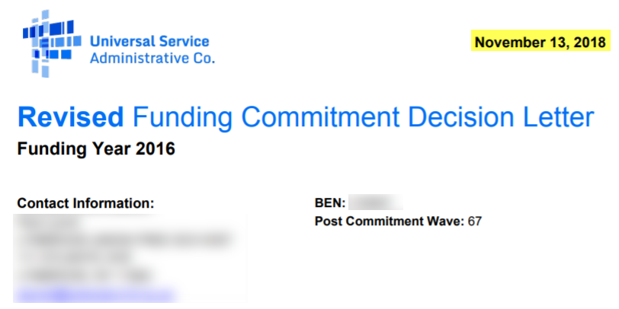

As shown on the applicant’s EPC Landing Page, however, this RFCDL was “issued” on 11/14/2018, having been “generated” one minute after midnight.

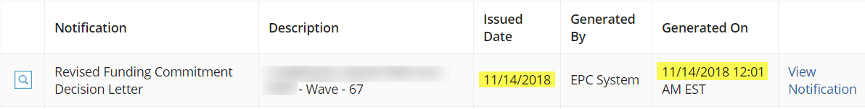

The “View Notification” link goes to the EPC News page and discusses the RFCDL in general, linking in turn to the letter itself and to a small Excel file with the post-commitment change, and a summary of the key data indicating an RFCDL date of 11/14/2018 — the same day it was generated in EPC.

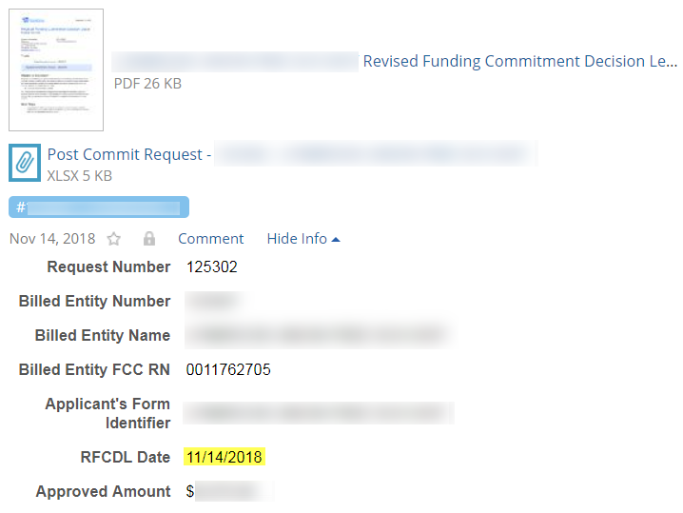
USAC’s FRN Status Tool, which includes the most detailed information available on individual FRNs, also shows November 14th as the date of the most recent RFCDL, namely:

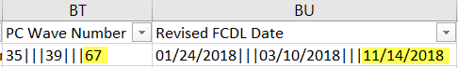

Resolving the November 13th/November 14th discrepancy only becomes important when determining the deadline to file an appeal. In one case, having asked the Client Service Bureau about the two dates, an applicant was advised: “The date for Appealing the decision should likely [emphasis added] be based on the Issued Date, not the date within the document.” While the later date probably sets the deadline in USAC’s systems, as a safety measure we would encourage use of the earlier letter date.

E-Rate Updates and Reminders

Upcoming E-Rate Dates:

December 3 Form 486 deadline for FY 2018 funding committed in Wave 17. More generally, the Form 486 deadline is 120 days from the FCDL date or the service start date (typically July 1st), whichever is later. Other FY 2018 Form 486 deadlines this year are:

Wave 18 12/10/2018

Wave 19 12/17/2018

Wave 20 12/24/2018

Wave 21 12/31/2018

Note: Applicants missing any Form 486 deadline should watch carefully for “Form 486 Urgent Reminder Letters” in their EPC News Feed. These Reminder Letters afford applicants 15-day extensions to submit their Form 486s without penalty (see last week’s USAC News Brief references below).

December 3-5 USAC fall service provider workshops in Washington, DC.

December 12 USAC webinar on Preparing for the FY 2019 Application Window.

FCC Decision Watch:

The FCC issued another set of “streamlined,” precedent-based decisions (DA 18-1209). Applicants facing similar problems as addressed in these decisions may garner useful information by carefully reading the additional FCC explanations found in the footnotes. The original appeal and waiver requests can be found online in the FCC’s Search for Filings.

In last week’s decisions, the FCC:

- Dismissed:
  - One Request for Review and/or Waiver deemed an appeal that should have been first submitted to USAC.
  - Three Requests for Review deemed moot for which USAC had already taken the actions requested or for which the applicants had already been fully compensated.
  - One Request for Review failing to comply with the FCC’s basic filing requirements.
  - Two Petitions for Reconsideration, generally for failure to identify reasons warranting review.
  - Two Petitions for Reconsideration not filed within the 30-day window required for petitions for reconsideration (in contrast to the 60-day appeal window).
- Granted:
  - Four Requests for Review and/or Waiver of service delivery extensions, two of the non-recurring September 30th deadline and two of the June 30th special construction deadline.
  - One Request for Review granting the applicant additional time to respond to USAC’s request for information.
  - Three Grants on Reconsideration to resolve USAC system problems with respect to invoice or Form 471 filings.
  - One Request for Review on behalf of two districts to correct Form 486 service start dates.
  - Eight Requests for Review and/or Waiver to extend invoice deadlines for a variety of special situations.
  - Two Requests for Review of invoices incorrectly reduced by USAC.
  - Seven Requests for Review and/or Waiver for ministerial and/or clerical errors on Form 471 applications or Form 500 service substitutions.
  - Four Requests for Review and/or Waiver of the rule requiring price of eligible services to be the primary factor in competitive bid evaluations. There were three requests where the lowest-cost provider was ultimately selected and one request where the ineligible cost resulted in no impact on the vendor being selected.
  - Five Requests for Review and/or Waiver of the 60-day appeal- or waiver-filing deadline, filed “only a few days late.”
- Partially granted:
  - One application in a Request for Review and/or Waiver involving a late-filed Form 486 submitted before the FCC established strict Form 486 filing standards in January 2017.
- Denied:
  - Two Requests for Review by one applicant for failing to seek competitive bids.
  - One Request for Review and/or Waiver involving a Form 470 with “inadequate specificity” including the failure to indicate the availability of an RFP.
  - One Request for Review seeking to reverse intentionally cancelled funding.
  - Four Requests for Waiver of invoice deadline extensions.
  - One Request for Waiver for an application filed more than two weeks late and failing to provide “special circumstances” justifying a waiver.
  - Two Requests for Review and/or Waiver of applications relying on Form 470s which did not seek bids on the E-rate services later requested.
  - Six Requests for Review and/or Waiver for untimely-filed waivers or appeals.

USAC News Brief Dated November 30 – Form 471 Bulk Upload Templates

USAC’s Schools and Libraries News Brief of November 30, 2018, reminds applicants planning to file extensive Form 471s that USAC will again be providing templates for uploading Category 1 and Category 2 information to their applications. The templates can be prepared, reviewed, and edited offline and then uploaded to online applications. The following templates are available:
- Category One - Data Transmission and/or Internet Access (v17.0)
- Category Two - Internal Connections (v19.0)
- Category Two - Managed Internal Broadband Services (MIBS) (v18.0)
- Category Two - Basic Maintenance of Internal Connections (v18.0)

The Category 2 templates have been updated to include the dropdown menu options used in the FY 2019 version of the Form 471. The Category 1 templates are unchanged fom FY 2018. Additional assistance on preparing and using these templates may be found in the FCC Form 471 Bulk Upload User Guide.

---------------------------------------------------------------------------------------------------------------------Newsletter information and disclaimer: This newsletter may contain unofficial information on prospective E-rate developments and/or may reflect E-Rate Central’s own interpretations of E-rate practices and regulations. Such information is provided for planning and guidance purposes only. It is not meant, in any way, to supplant official announcements and instructions provided by the SLD, FCC, or state education departments.

For further information on E-rate, follow E-rate Central on Twitter, Facebook, and LinkedIn.

Note: This article is dedicated to Jacqueline Friends, the mother of Kimberly Friends, CSM, who first discovered these RFCDL date discrepancies.

