- Funding Status – FY 2018 and FY 2019
- Updates on USAC’s E-Rate Productivity Center and Legacy System
  - USAC Focus on Participant Experience
- E-Rate Updates and Reminders
  - Upcoming E-Rate Dates
  - E-rate Invoice Payments to Continue During a Government Shutdown
  - SHLB Seeks Clarification on Product Demos
  - 1Q19 Proposed USF Contribution Factor
  - NDAA, USF, and E-Rate
- USAC News Brief Dated December 14 – Early 2019 Invoicing Reminders

Funding Status – FY 2018 and FY 2019

FY 2018:

USAC issued Wave 36 on Friday, December 14th, for $6.03 million. Cumulative funding as of Wave 36 is $2.00 billion.

FY 2019:

The FY 2019 administrative window is open and will remain open until at least January 7th. EPC entity profiles will be locked for the duration of the Form 471 application window (expected to open in mid-January).

Updates on USAC’s E-Rate Productivity Center and Legacy System

USAC Focus on Participant Experience:

Last week, USAC posted a brief notice of its goals for 2019 and the few remaining weeks of 2018 (shown below). Friday’s USAC News Brief, referenced below, provides slightly more information for participants with pending applications and requests.

The subtle mention of a “transition” is a reference to the January 1st transfer of the Business Process Outsourcing (“BPO”) contract from Solix to Maximus, the “new vendor,” as discussed in our newsletter of December 10th — a development we view as anything but routine.

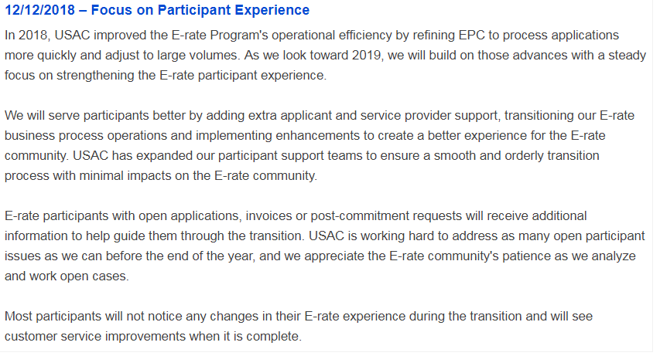

E-Rate Updates and Reminders

Upcoming E-Rate Dates:

December 17 Form 486 deadline for FY 2018 funding committed in Wave 19. More generally, the Form 486 deadline is 120 days from the FCDL date or the service start date (typically July 1st), whichever is later. Other upcoming Form 486 deadlines are:

Wave 20 12/24/2018

Wave 21 12/31/2018

Wave 22 01/07/2019

Note: Applicants missing any Form 486 deadline should watch carefully for “Form 486 Urgent Reminder Letters” in their EPC News Feed. These Reminder Letters afford applicants 15-day extensions to submit their Form 486s without penalty.

January 7 Initially announced deadline for the close of the administrative window permitting applicants to update their EPC entity profiles. A final deadline is likely to be set a few days before the opening of the FY 2019 Form 471 application window later in January.

E-Rate Invoice Payments to Continue During a Government Shutdown:

The threat of an impending U.S. Government shutdown has raised concerns that E-rate invoice payments, now being made through the U.S. Treasury, might be disrupted. Based on a recent meeting with a legal advisor to FCC Chairman Pai, the Schools, Health & Libraries Broadband Coalition (“SHLB”) has been advised that procedures are in place to continue USF funds disbursal even if major segments of the government are temporarily furloughed during a shutdown.

SHLB Seeks Clarification on Product Demos:

As discussed in our newsletter of December 10th, one of the outstanding issues currently unresolved is the legitimacy of service provider product demonstrations. Although USAC has recently loosened its guidance verbally in training sessions, the Gift Rules in its Reference section still indicate that onsite product demonstration “loans” would be considered prohibited “gifts.” Giving applicants the ability to field test the compatibility or “equivalance” of proposed equipment is critical in certain competitive bidding situations.

In an attempt to help resolve this issue, SHLB (along with CoSN and SECA) filed a detailed letter with the FCC last week formally seeking clarification that product demos are not gifts. The SHLB letter asks the FCC to direct USAC to remove the product demo prohibition language from its website.

1Q19 Proposed USF Contribution Factor:

The FCC announced (DA 18-1249) the proposed Universal Service Fund (“USF”) contribution percentage for the first quarter of calendar 2019 (corresponding to the third funding quarter of E-rate’s FY 2018). Overall, the contribution factor dropped only slightly from 20.1% in 4Q18 to 20.0% thus remaining at the potentially politically-sensitive 20% level. The higher level is largely attributed to an additional $90 million required to fund the coming quarter’s share of the $171 million increase in the USF’s Rural Health Care Program that the Administration-led FCC approved last June.

It should be noted that new USF funding required to meet the E-rate demand for FY 2018 is only $1.52 billion. This reflects USAC’s initial demand estimate of $2.77 billion, less the $1.2 billion roll-over funding approved for the year. New funding for FY 2018 is well below the $4 billion funding cap. Higher demand for FY 2019, perhaps fueled by more Category 2 funding, combined with the prospects for lower roll-over funding, could put added pressure on the USF contribution factor in the near future.

NDAA, USF, and E-Rate:

In April, the FCC adopted a Notice of Proposed Rulemaking (“NPRM”) entitled Protecting Against National Security Threats to the Communications Supply Chain (FCC 18-42). As discussed in our newsletter of April 2nd, the proposed rules would prohibit any direct or indirect USF payments — including E-rate payments — to communications equipment and/or service providers deemed to be posing national security risks. The FCC’s action was part of broader federal concerns by the Departments of Defense, Homeland Security, and others leading to the August enactment of the John S. McCain National Defense Authorization Act for Fiscal Year 2019 (“NDAA”).

In October, the FCC issued a Public Notice (DA 18-1099) seeking comment on the applicability of the NDAA legislation to the FCC’s own proposed rules. Comments and reply comments under this docket, due December 7th, were received from trade associations representing different segments of the telecommunications industry and from certain equipment manufacturers. The comments:
- Generally supported the need to address national security risks by promoting a coordinated approach among all agencies.
- Raised concerns regarding the impact of increased equipment costs on rural broadband services including the potential need for greater USF High Cost support for product line replacements.
- Revolved around somewhat arcane legal distinctions between “grants and loans” and “subsidies” referenced in different NDAA subsections.

For E-rate applicants, already expressing concern with increasing tariffs on Chinese-sourced equipment and components, the outright ban of products from specific Chinese manufacturers — even if two years off — becomes another factor to be considered in bidding and contracting.

USAC News Brief Dated December 14 – Early 2019 Invoicing Reminders

USAC’s Schools and Libraries News Brief of December 14, 2018, reminds applicants and service providers of two important invoicing deadlines for FY 2017 services, namely:

January 28, 2019 For non-recurring service FRNs
February 26, 2019 For recurring service FRNs whose deadlines have been extended

The News Brief also includes a somewhat expanded version of the “Focus on Participant Experience” discussed above.

---------------------------------------------------------------------------------------------------------------------Newsletter information and disclaimer: This newsletter may contain unofficial information on prospective E-rate developments and/or may reflect E-Rate Central’s own interpretations of E-rate practices and regulations. Such information is provided for planning and guidance purposes only. It is not meant, in any way, to supplant official announcements and instructions provided by the SLD, FCC, or state education departments.

For further information on E-rate, follow E-rate Central on Twitter, Facebook, and LinkedIn.

