- Funding Status – FY 2018 and FY 2019
  - FY 2019 Application Window Announced
- Updates on USAC’s E-Rate Productivity Center and Legacy System
  - Cleaning Up USAC’s E-Rate Homepage
- E-Rate Updates and Reminders
  - Upcoming E-Rate Dates
  - FCC Releases Government Shutdown Plan
  - New USAC Board Members
  - FCC Decision Watch
- USAC News Briefs Dated December 21 & 22 – FY 2019 Application Window & Training

Funding Status – FY 2018 and FY 2019

FY 2018:

USAC issued Wave 37 on Thursday, December 20th, for $10.3 million. Cumulative funding as of Wave 37 is $2.01 billion.

FY 2019:

The Form 471 application window will open at noon EST on Wednesday, January 16th, and will close at 11:59 p.m. EDT on Wednesday, March 27th.

The FY 2019 administrative window, which is currently open, will close at 11:59 p.m. EDT on Tuesday, January 15th. At that point EPC entity profiles will be locked for the duration of the Form 471 application window.

Updates on USAC’s E-Rate Productivity Center and Legacy System

Cleaning Up USAC’s E-Rate Homepage:

A number of users, regardless of computer or browser used, have been reporting “funky” formatting on USAC’s Schools and Libraries homepage. Sometimes it’s only a few words running together.

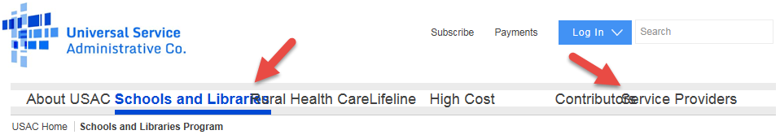
Other times, new words appear by the Login and the header tabs are spread out beyond the regular page boundaries.

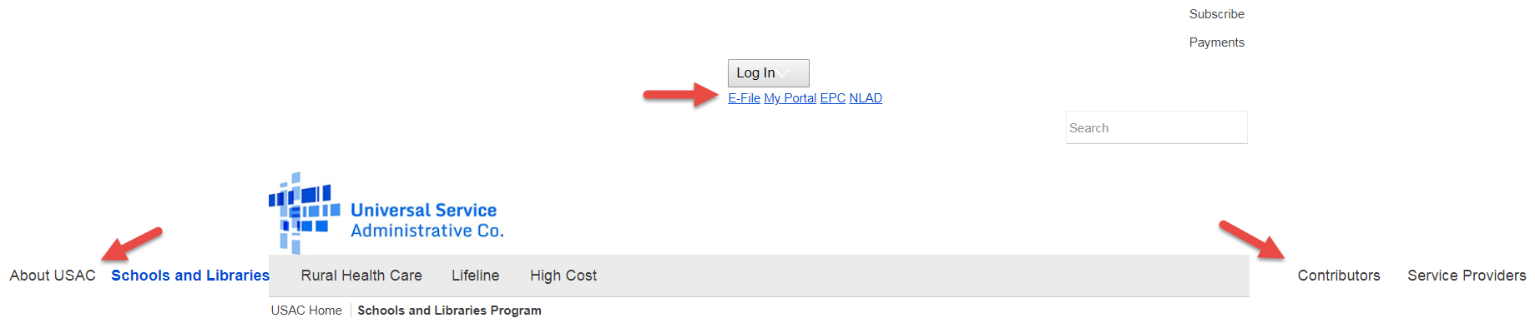

And all formatting in the footer is lost.

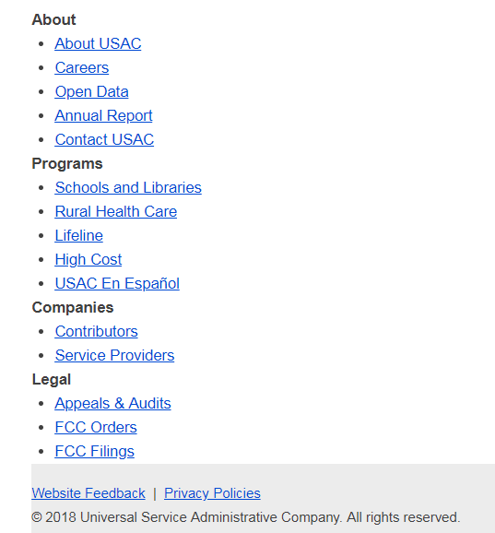

The solution to these appearance problems is to clear your cache using the keyboard shortcut Ctrl + F5. As if by magic, the proper header and footer will reappear.

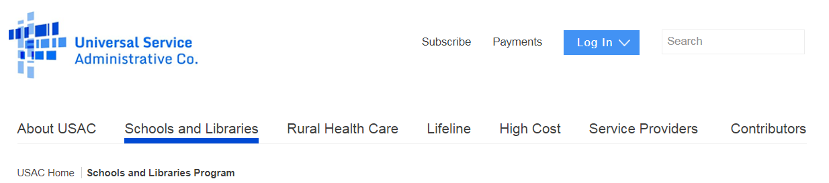

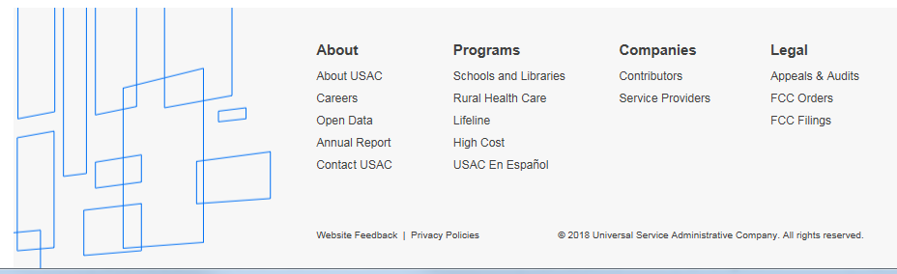
E-Rate Updates and Reminders

Upcoming E-Rate Dates:

December 24 Form 486 deadline for FY 2018 funding committed in Wave 20. More generally, the Form 486 deadline is 120 days from the FCDL date or the service start date (typically July 1st), whichever is later. Other upcoming Form 486 deadlines are:

Wave 21 12/31/2018

Wave 22 01/07/2019

Wave 23 01/14/2019

Wave 24 01/22/2019

Note: Applicants missing any Form 486 deadline should watch carefully for “Form 486 Urgent Reminder Letters” in their EPC News Feed. These Reminder Letters afford applicants 15-day extensions to submit their Form 486s without penalty.

Holidays USAC’s Client Service Bureau (“CSB”) will be closed December 24-25 and January 1. No USAC News Brief will be published on Friday, December 28.

January 15 Close of the administrative window permitting applicants to update their EPC entity profiles.

January 16 Opening of the FY 2019 Form 471 application window.

January 28 Invoice deadline — or deadline for requesting a 120-day extension — for FY 2017 non-recurring services.

February 26 Extended invoice deadline for FY 2017 recurring services.

FCC Releases Government Shutdown Plan:

Prior to the U.S. Government shutdown, the FCC released an updated Plan for Orderly Shutdown Due to Lapse of Congressional Appropriations report. The good news is that E-rate funding comes out of the Universal Service Fund (“USF”) that is not dependent upon federal appropriations. Most importantly, as noted last week, procedures are in place to permit USF disbursements now coming from the U.S. Treasury during the shutdown. The FCC plan specifically indicates that “Two (2) employees will be retained, working as needed, to certify Universal Service Fund (USF) disbursements.”

What will be disconcerting about the shutdown is the furloughing of other FCC E-rate employees. This will delay action on critical program issues such as extending the suspension of the requirement to amortize non-recurring Category 1 WAN expenses at or above $500,000 which is currently slated to take effect again as of FY 2019.

New USAC Board Members:

FCC Chairman Pai appointed (DA 18-1281) six members of the USAC Board of Directors to three-year terms beginning January 1st. Five of the individuals are reappointments of current Board members. The sixth appointment — the most important from an E-rate perspective — is Julie Tritt Schell, the State E-rate Coordinator for the Pennsylvania Department of Education, whose role on the Board will be to represent the interests of all eligible schools. Julie, an active and extremely effective member of the State E-Rate Coordinators’ Alliance (“SECA”) returns to the Board after a three-year hiatus replacing Dr. Miguel Hernandez whose term expires at the end of this year.

FCC Decision Watch:

The FCC released two district-specific E-rate decisions last week. It also released a Rural Health Care (“RHC”) decision that, although not involving E-rate, tracks many previous E-rate decisions on missed invoice deadlines.

The FCC rejected Petitions for Reconsideration by Mansfield ISD (DA 18-1282) involving USAC denials of district applications for funding years 2011–2013. In all cases, the district relied on Form 470s listing approximately 60 types of Priority 1 services to be provided “District Wide.” and “5 schools” for Priority 2 services. The Form 470 did not specify numbers of lines or bandwidth requirements and did not reference an RFP would could have provided more information. Having received zero bids, the district then selected service providers from a Texas state master contract. Following a special compliance review in 2014, USAC rescinded the applications for all three years and sought recovery of funds. USAC determined — and the FCC upheld on appeal and on reconsideration — that the district had filed “encyclopedic” Form 470s which did not constitute “bona fide requests for services.”

In a better result for a district, the FCC approved a one-time waiver of the red light rule for Metropolitan Nashville Schools (DA 18-1283). In 2016, Nashville had overlooked the need to make a $1,519 payment for an earlier application error and had been placed on red light status. In line with E-rate rules prohibiting payments to delinquent debtors, USAC dismissed Nashville’s FY 2016 application with requests totaling $3,640,923. Recognizing its error, Nashville quickly repaid its small debt. The FCC granted Nashville’s request for a waiver and remanded its FY 2016 application to USAC for processing.

Consistent with many E-rate decisions on late invoices — albeit inconsistent with the flexibility provided for late applications — the FCC denied six of seven RHC requests for invoice deadline relief for Indiana Telehealth Network et al (DA 18-1284). The one approved request involved a USAC technical system error. The rejected requests reflected applicant-specific issues such as funding cap increase delays, confusion over the invoice deadline, personnel changes, and service provider response problems, etc. — all considered applicant responsibilities. What we deem inconsistent with this policy of strict invoice deadline enforcement is the countervailing flexibility exhibited by the FCC and USAC on late filed Form 471s and Form 486s. Effectively, the FCC is making the program more forgiving in approving funding upfront, before services are delivered, but making the actual funding of those commitments more difficult on the backend. If anything, most applicants would accept less flexibility in the approval of E-rate commitments for assurances that E-rate funds for services once delivered will be paid.
USAC News Briefs Dated December 21 & 22 – FY 2019 Application Window & Training

USAC’s Schools and Libraries Special Edition News Brief of December 21, 2018, announced the opening of the Form 471 application window that will run from January 16th through March 27th. The News Brief summarizes the following steps that applicants can take to begin preparing for a successful filing:
- Install browser updates.
- Establish EPC accounts, if necessary, and set user rights.
- Update EPC profiles.
- Proceed with competitive bidding.

The Special Edition News Brief also reviews several ways USAC has worked to improve the E-rate experience.

USAC’s Schools and Libraries News Brief of December 22, 2018, highlighted the new suite of 14 applicant training videos designed to “mirror” the content from USAC’s fall training workshops. The videos are available online in the 2018 Applicant Training Series.

Saturday’s News Brief also reiterated the information provided in the previous week’s edition regarding the status of currently pending applications and post-commitment requests as USAC transitions to a new reviewer outsource contract effective January 1st. USAC advises:

…if you have a form or open request that is currently under review and will not be resolved by the end of this year, USAC will be reaching out to you. If you do not have a form or open request under review, you do not need to take any action. If you have a future request, create a case in EPC and your request will be assigned to a member of the new team.

As has traditionally been the case at the end of the year, USAC will not be issuing a News Brief next Friday, December 28th.

---------------------------------------------------------------------------------------------------------------------Newsletter information and disclaimer: This newsletter may contain unofficial information on prospective E-rate developments and/or may reflect E-Rate Central’s own interpretations of E-rate practices and regulations. Such information is provided for planning and guidance purposes only. It is not meant, in any way, to supplant official announcements and instructions provided by the SLD, FCC, or state education departments.

For further information on E-rate, follow E-rate Central on Twitter, Facebook, and LinkedIn.

