- Funding Status – FY 2018 and FY 2019
- 2018 Review – 2019 Preview
  - Key E-Rate Milestones in 2018
  - Anticipated E-Rate Developments in 2019
- E-Rate Updates and Reminders
  - Upcoming E-Rate Dates
  - FCC Commissioner O'Rielly's Blog
- USAC News Brief – None for the Pre-New Year’s Week

Funding Status – FY 2018 and FY 2019

FY 2018:

USAC issued Wave 37 on Thursday, December 20th, for $2.6 million. Cumulative funding as of Wave 37 is $2.01 billion.

FY 2019:

The Form 471 application window will open at noon on Wednesday, January 16th, and will close at 11:59 p.m. EDT on Wednesday, March 27th.

The FY 2019 administrative window, which is currently open, will close at 11:59 p.m. EST on Tuesday, January 15th. At that point EPC entity profiles will be locked for the duration of the Form 471 application window.

2018 Review – 2019 Preview

At the New Year, it is worthwhile to look back on the past year and to plan for the new one. Here’s our E-rate review of 2018 and a preview of 2019. Additional details on 2018 developments can be found in our E-Rate Weekly News Archive.

Key E-Rate Milestones in 2018:

January | - The FY 2018 application window opened (and closed) five days earlier than this year’s announced application window for FY 2019.  - E-Rate Central launched its newly designed website with direct links from the homepage to the State Information pages and Funding History Search tools.  - USAC began using Revised Funding Commitment Decision Letters (“RFCDLs”) to communicate post-commitment funding decision changes on appeals, Form 500s, SPIN Changes and service substitutions.  - USAC introduced a new Category Two Budget Tool providing committed funding per entity from FY 2015. As such, the new tool is an improvement over the EPC version that shows funding only since FY 2016. USAC also established a new online mechanism — Share Your E-rate Technical System Ideas — to solicit ideas and feedback on IT enhancements.  - A new contract to staff USAC’s Client Service Bureau (“CSB”), previously held by General Dynamics Information Technology, was awarded to Sutherland Government Solutions. A three-month transition was planned.
February | - USAC created over 200 self-initiated “appeals” to correct “small computational errors” in Funding Commitment Decision Letters (“FCDLs”). Affected applicants were notified in somewhat perplexing emails entitled “ROS Allocation Mismatch” — “ROS” standing for “Recipient of Service.”  - The FCC issued a special order (DA 18-188) providing applicants (and service providers) with additional invoicing deadline extensions for FY 2016 recurring service FRNs. The FCC initiated this action on its own motion in recognition of the many USAC delays in (a) approving Form 486s, or (b) processing and approving post commitment changes (e.g., SPIN changes and service substitutions). These delays prevented invoices from being filed by the original deadline of October 30, 2017, or the extended deadline of February 27, 2018. Unfortunately, this action appears to have constrained further flexibility on similar invoicing issues subsequently encountered.
March | - EducationSuperHighway (“ESH”) created a special website focusing on all the E-rate applications for special construction fiber projects being delayed or denied. As of last week, the site lists 61 fiber projects which it deems “unfairly” denied, and 38 projects still awaiting funding decisions from last year. In explaining the funding problems, ESH points to excessive scrutiny, inconsistency in the application of rules, and the lack of clarity on process changes.
April | - At the behest of the General Accounting Office (“GAO”) and the Office of Management & Budget (“OMB”), USAC transferred all funds associated with the Universal Service Fund (“USF”) programs, including E-rate, from the commercial bank it was using to the U.S. Treasury. The FCC has been careful to state that the entity holding USF funds has no effect on the Fund’s status as a “permanent, indefinite appropriation” and that, as such, the Fund is not subject to the annual Congressional appropriations process.  - The first funding wave for FY 2018 was released on April 20th, more than a month earlier than in the previous year. With the release of Wave 1, USAC introduced a new and much improved PDF version of its Funding Commitment Decision Letters (“FCDLs”) for FY 2018.  - The FCC issued a Notice of Proposed Rulemaking (“NPRM”) (FCC 18-42) entitled “Protecting Against National Security Threats to the Communications Supply Chain Through FCC Programs” — particularly those programs, including E-rate, funded through the Universal Service Fund (“USF”). If adopted, the proposed rules would bar the purchase of certain Chinese- and Russian-manufactured communications equipment.
May | - The FCC sent a letter to USAC attempting to resolve the confusing Form 470 Category 1 drop-down menu. The FCC letter directed USAC:  - Not “to deny an FY 2018 application solely because the applicant chose the ‘Internet Access and Transport Bundled’ or ‘Transport Only - No ISP Service’ option on its FCC Form 470 and subsequently selected a fiber service on its FCC Form 471;” and  - To revise the dropdown menu on the FY 2019 Form 470 — normally available July 1st — to clearly specify those options that include only “non-fiber services” and those that include “fiber services,” and “to take whatever measures necessary to ensure that applicants fully understand those options” — a directive that has proved only partially successful.
June | - A small, but significant, number of applicants began receiving “Recovery of Improperly Disbursed Funds” (“RIDFs”) letters indicating USAC’s intention to recapture payments on invoices, initially approved for filing under an FCC order for extended deadlines, but now deemed to have been incorrectly accepted by USAC. The only explanation given for these actions was “FCC Directive.”
July  August | - USAC retired its “Submit a Question” feature in favor of the customer service case mechanism within EPC.  - USAC proposed establishing the following fixed E-rate cycle dates that applicants could rely upon each year. To date, the FCC has not endorsed the process; FY 2019 is not quite a week behind this schedule.  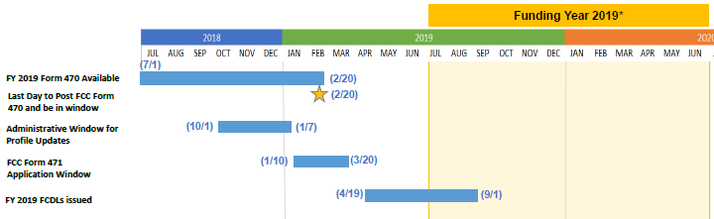
September | - On an application percentage basis, USAC largely met its FCC directed target of having issued FCDLs on all workable FY 2018 applications by September 1st. The actual percentage was about 98%. Performance on a dollar amount basis was less impressive. The 2% of the applications still pending represented approximately one-third of the requested funding, much of which was still outstanding at yearend.  - The U.S. Attorney’s Office for the Southern District of New York, together with the FBI and the District Attorney of Rockland County (NY) announced indictments of seven individuals, subsequently arrested, for E-rate fraud. The defendants included four vendors, two consultants, and one parochial school administrator. All are alleged to have taken part in a scheme to defraud the E-rate program, in one instance purportedly draining $14 million in funds from the program between 2010 and 2016. The enforcement action was apparently linked to hundreds of E-rate applications over the past few years, 60-65% for New York parochial schools, that have been denied or are still pending.  - Despite E-rate funding requirements for FY 2018 well under the annual cap, other Universal Service Fund (“USF”) program requirements pushed the overall contribution factor for 4Q18 to just over 20%.  - USAC announced a new tool for submitting Invoice Deadline Extension Requests (“IDERs”) for FY 2016 or later from within EPC.  - Applicants and service providers began realizing that new or proposed tariffs on telecommunications and networking equipment (and components) from China could raise prices from 10-25%.
October | - EducationSuperHighway (“ESH”) released its 2018 State of the States report showing each state’s progress towards reaching the national Internet broadband goal of 100 Kbps/student. Nationwide, the percentage of school districts having access to broadband services has risen dramatically over the past five years.  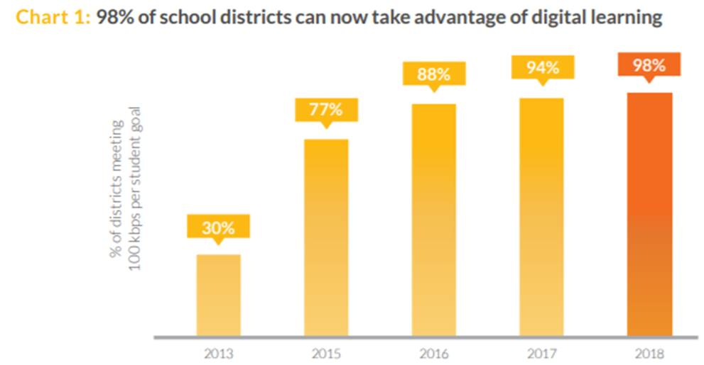  - USAC released a Semi-Annual Audit Recovery Report reviewing the process for recovering funds based on previous audit findings and summarizing the status of outstanding audit findings, some— almost unbelievably — involving funding disbursed well over ten years ago.  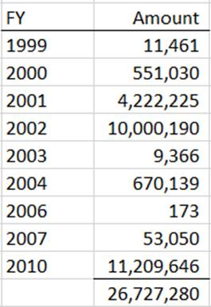  - USAC announced a major change in the staffing of PIA application review, post-commitment changes, and invoice processing with the expiration of the Business Processing Outsourcing (“BPO”) contract with Solix Inc. set to expire at yearend. As of January 1, BPO functions will be assumed by Maximus Federal Systems. USAC is working hard to minimize the disruptions likely to be caused by the BPO contractor change.
November | - State E-rate Coordinators began noticing and reaching out to applicants still confused with Form 470 dropdown menu choices for Internet services. The most common error was selecting “Internet Access. ISP Service Only (No Transport Circuit Included)” in situations where the applicant clearly needed a circuit to deliver the Internet service. It is not yet clear if the FCC will again direct USAC to “hold harmless” applicants misled by Form 470 options.
December | - The Schools, Health & Libraries Broadband Coalition (“SHLB”), together with CoSN and SECA, filed a detailed letter with the FCC last week formally seeking clarification that product demos are not gifts. The SHLB letter asks the FCC to direct USAC to remove the product demo prohibition language from its website.  - Julie Tritt Schell, the State E-rate Coordinator for the Pennsylvania Department of Education, was appointed as one of the school representatives on the USAC Board.  - 2018 ended as it had started, and is expected carryover into 2019, with a government shutdown. The FCC announced that it had available funding to remain fully open through the close of business on Wednesday, January 2, 2019.

Anticipated E-Rate Developments in 2019:

2019 could be a difficult year for USAC, applicants, and service providers alike. The major concern is the time and effort that will be required to fully staff and train Maximus Federal Systems as the BPO contract replacement for Solix. To facilitate this process, USAC has created a Program Management Office, partially staffed by a small Deloitte transition consulting team. It has also established a PIA Incubator Team of SLD staffers to handle some of the larger and more complicated applications. Still, the transition is likely to be disruptive — particularly in the beginning. USAC, however, remains optimistic and is hoping to again have all or most FY 2019 applications completed by September 1st.

The first order of business will be to transition pending applications, post-commitment changes, and invoices over to the new team. Last week, applicants with pending requests were sent the following email:

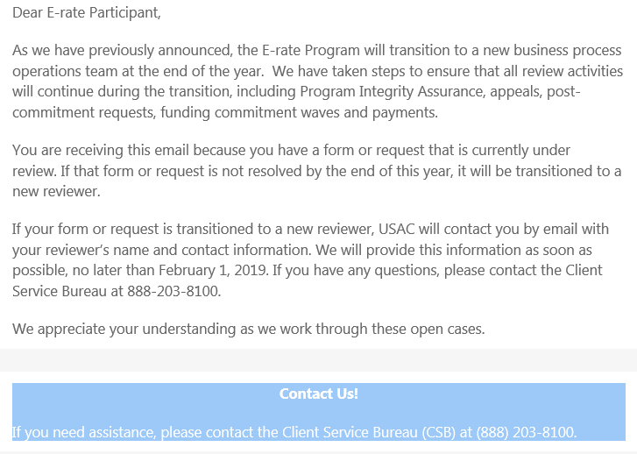

Conspicuously missing was any definitive reference to the pending request at issue — presumably information that the Client Service Bureau (“CSB”) will be able to provide. We would also suggest contacting CSB or initiating a customer service inquiry if you believe you have a pending request and did not receive this email.

While USAC is navigating its BPO contractor transition, several key issues are pending before the FCC.
- Most immediately, for FY 2019, the FCC must decide whether it should continue to extend the suspension of the pre-2015 amortization requirement of Category 1 installation charges of $500,000 or more. If not, the FCC must decide how to handle, if at all, the amortization of state matching funds.
- Most importantly, as of FY 2020, the FCC must decide on a plan to fund Category 2 products and services currently being provided on a 5-year trial basis ending with FY 2019. In particular:
  - A new plan is clearly needed for (a) applicants who began using their 5-year budgets in FY 2015 and will be reaching their fifth year in FY 2019, and (b) applicants who have not used any Category 2 funding during the 5-year trial.
  - Arguably, applicants who began using Category 2 in FY 2016 or later will have one or more years left in their 5-year budgets beyond FY 2019, but neither USAC nor the FCC has clarified this aspect of the trial budget plan.
  - Supposedly, if the FCC does not act, Category 2 funding will revert to the previous 2-in-5 rule. But even this default position may require clarification to deal with subsequent changes with discount calculations, now at the district level, or to decide if any of Category 2 funding in the later years of an initial 5-year budget counted as a part of the 2-in-5.
- In part because current FCC Chairman Pai and Commissioner O’Rielly had voted against increased E-rate funding when the E-rate Modernization Orders were adopted in 2014, rumors persist that the FCC might move to roll-back portions of the program. We have taken a wait-and-see position on program changes at the moment, but we are carefully watching the USF contribution factor that is currently hoovering at the 20% level.

We wish you all the best for the New Year and a successful FY 2019. It certainly promises to be interesting.

E-Rate Updates and Reminders

Upcoming E-Rate Dates:

December 31 Form 486 deadline for FY 2018 funding committed in Wave 21. More generally, the Form 486 deadline is 120 days from the FCDL date or the service start date (typically July 1st), whichever is later. Other upcoming Form 486 deadlines are:

Wave 22 01/07/2019

Wave 23 01/14/2018

Wave 24 01/22/2018

Note: Applicants missing any Form 486 deadline should watch carefully for “Form 486 Urgent Reminder Letters” in their EPC News Feed. These Reminder Letters afford applicants 15-day extensions to submit their Form 486s without penalty.

January 15 Close of the administrative window permitting applicants to update their EPC entity profiles.

January 16 Form 471 application window for FY 2019 opens at noon EST.

January 28 Invoice deadline — or deadline for requesting a 120-day extension — for FY 2017 non-recurring services.

February 26 Extended invoice deadline for FY 2017 recurring services.

March 27 Close of the Form 471 application window for FY 2019 at 11:59 p.m. EDT.

FCC Commissioner O'Rielly's Blog:

A few days before Christmas, FCC Commissioner Michael O’Rielly blogged an extensive list of 61 proposals for reforming and improving FCC procedures. The following is a subset of that list dealing with USAC and the Universal Service Fund (“USF”), all of which, if adopted, would affect E-rate — largely for greater transparency.

26. | Put USAC contract out for public bid; allow USAC to function as a private company.
27. | Limit USAC recoupment for administrative errors to seven years.
28. | Prioritize USAC audits & reviews of administrative errors to those instances when costs would not exceed potential recoupment.
29. | Require any money recouped for fraudulent use of USF by applicants go back into USF program.
30. | Reform USAC board to reduce size and eliminate conflicts of interests.
31. | Outline specific bright line rules for policy calls to be made by Commission and execution decisions to be made by USAC.
32. | Require that any changes to a USF form or form instructions, including online forms, must be preceded by sufficient notice of not less than 60 days.
33. | Require publication of information regarding the size, accruals, and disbursements of any reserved funding for any USF program.
35. | Prevent USAC from using webcrawls or newsfeeds to inform applicants of case decisions.
36. | Strike automatic USF rate increases & require Commission to affirmatively vote any increase on consumers.
54. | Track Fed[eral] Reg[iste]r process, publication and status publicly, including comment/effective dates.
55. | Track PRA [Paperwork Reduction Act] process, publication and status publicly, including effective dates.

USAC News Brief – None for the Pre-New Year’s Week

USAC did not issue a Schools and Libraries Program News Brief on Friday, December 28th.

---------------------------------------------------------------------------------------------------------------------Newsletter information and disclaimer: This newsletter may contain unofficial information on prospective E-rate developments and/or may reflect E-Rate Central’s own interpretations of E-rate practices and regulations. Such information is provided for planning and guidance purposes only. It is not meant, in any way, to supplant official announcements and instructions provided by the SLD, FCC, or state education departments.

For further information on E-rate, follow E-rate Central on Twitter, Facebook, and LinkedIn.

