- Funding Status – FY 2018 and FY 2019
- Update on the Solix-to-Maximus Contractor Transition
- E-Rate Updates and Reminders
  - Upcoming E-Rate Dates
  - CoSN Reports Gains in Wi-Fi and Broadband Connectivity
  - New CORES System for FCC RNs
  - No One Eats Alone
- USAC News Brief Dated January 11 – Preparing for the FY 2019 Application Window

Funding Status – FY 2018 and FY 2019

FY 2018:

USAC issued Wave 40 on Friday, January 11th, for $65.8 million and included funding decisions on a number of long-pending fiber applications. Cumulative funding as of Wave 40 is $2.09 billion.

FY 2019:

The FY 2019 administrative window will close at 11:59 p.m. EST on Tuesday, January 15th. At that point EPC entity profiles will be locked for the duration of the Form 471 application window.

The Form 471 application window will open at noon EST on Wednesday, January 16th, and will close at 11:59 p.m. EDT on Wednesday, March 27th.

Update on the Solix-to-Maximus Contractor Transition

This will be the third week since the expiration of USAC’s longstanding Business Process Outsourcing (“BPO”) contract with Solix on December 31st, and Maximus Federal Systems, USAC’s new contractor, assuming responsibility for application, post-commitment, and invoice review processing.

Just before the end of 2018, USAC sent emails to many applicants advising them that those with pending forms and requests not resolved by the end of the year would be reassigned to new reviewers no later than February 1st. Last week, USAC reiterated the February 1st reassignment goal and indicated that applicants so affected would then receive more detailed information identifying the new reviewers.

In the interim, application inquiries are being sent to applicants with reviewer names and email addresses, but without telephone numbers (not yet permanently assigned). Applicants wishing to speak directly to their new reviewers should request call-backs via the reviewers’ email addresses.

Those fondly remembering days dealing with Solix reviewers may be interested in knowing that many reviewers plan to remain in the E-rate world. We understand that 25-30 ex-Solix employees have been retained on a temporary or permanent basis with Maximus in similar roles, but that Solix is proposing its own transition — a challenging process involving a different skillset — from reviewing forms for USAC to offering E-rate consulting services to applicants (see PRNewswire Release).

E-Rate Updates and Reminders

Upcoming E-Rate Dates:

January 14 Form 486 deadline for FY 2018 funding committed in Wave 23. More generally, the Form 486 deadline is 120 days from the FCDL date or the service start date (typically July 1st), whichever is later. Other upcoming Form 486 deadlines are:

Wave 24 01/22/2019

Wave 25 01/28/2019

Wave 26 02/04/2019

Wave 27 02/11/2019

Note: Applicants missing any Form 486 deadline should watch carefully for “Form 486 Urgent Reminder Letters” in their EPC News Feed. These Reminder Letters afford applicants 15-day extensions to submit their Form 486s without penalty.

January 15 Close of the administrative window which permits applicants to update their EPC entity profiles.

January 16 Opening of the FY 2019 Form 471 application window.

January 28 Invoice deadline — or deadline for requesting a 120-day extension — for FY 2017 non-recurring services.

February 26 Extended invoice deadline for FY 2017 recurring services.

March 27 Close of the FY 2019 Form 471 application window.

CoSN Reports Gains in Wi-Fi and Broadband Connectivity:

The Consortium for School Networking (“CoSN”) issued its 2018 Annual Infrastructure Report indicating that most school districts (92%) are meeting the FCC’s short-term goal on broadband connectivity to provide 100 Mbps per 1,000 students. Further, more than a third (36%) of the districts are meeting the longer-term goal of providing 1 Gbps per 1,000 students — more than double the level from last year. That’s all great news and a good indication of E-rate’s impact.

The report also focuses on the infrastructure challenges remaining including:
- Lack of affordable broadband access in rural areas
- Limited student access to non-shared Internet devices at home — the “homework gap”
- Growing costs of cybersecurity

New CORES System for FCC RNs:

Anyone doing business with the FCC, including E-rate applicants and service providers, must obtain an FCC Registration Number (“FCC RN”) through the FCC’s COmmission REgistration System (“CORES”). The current online version of the CORES system, to be retired on March 1st, is being replaced by a newer version (already available). The function of the two versions is similar, but the look, feel, and web addresses will be different. Specifically:

Current CORES Version:

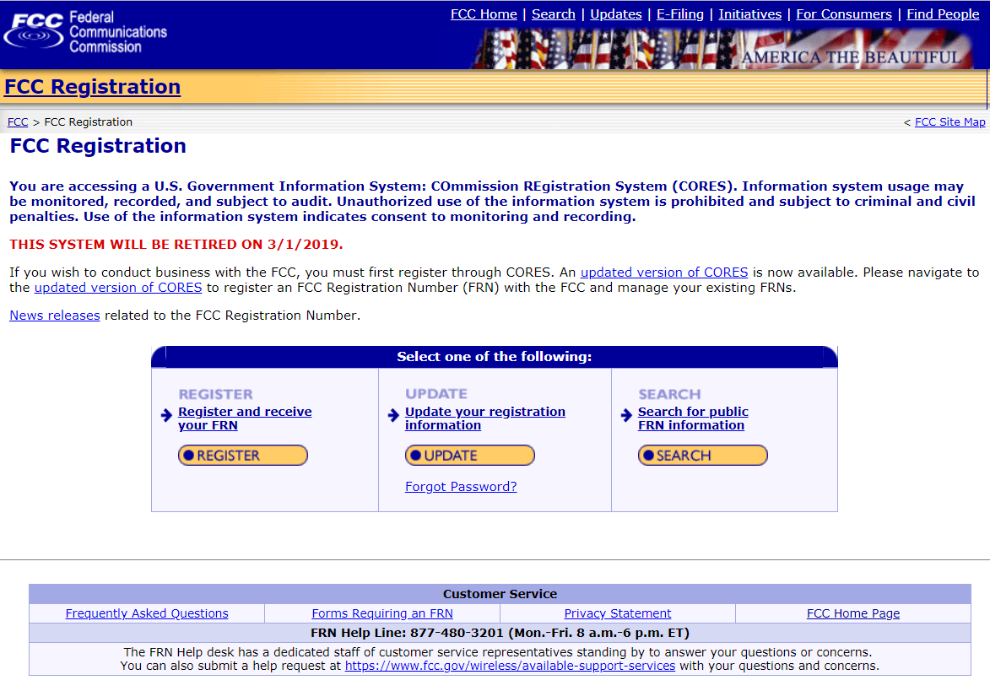

Updated CORES Version:

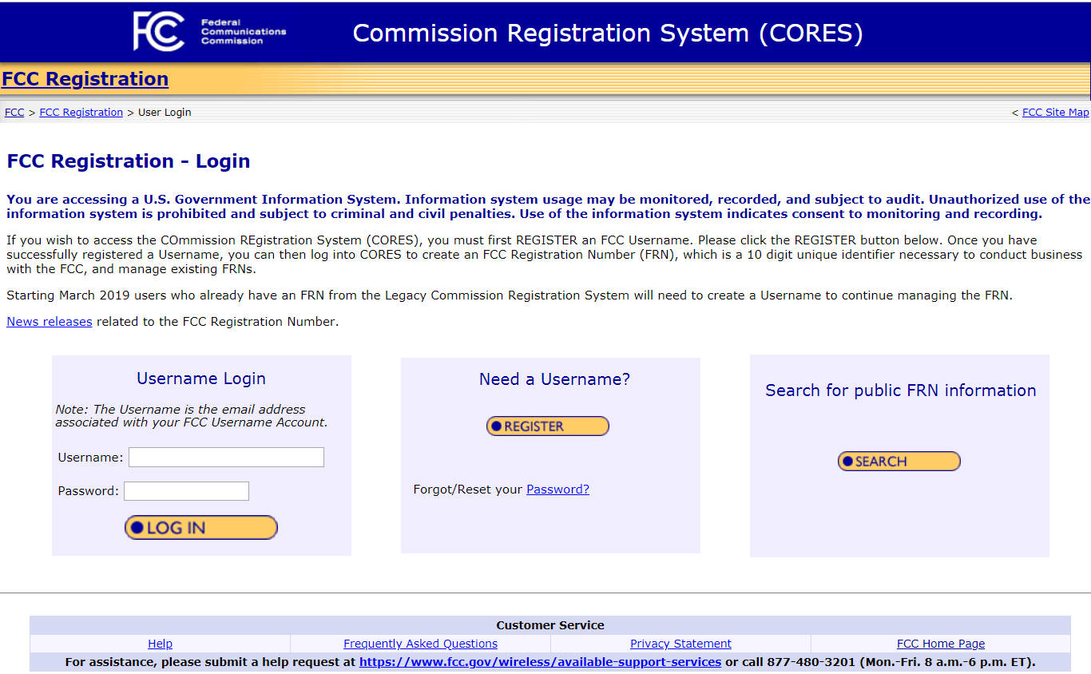

Requesting an FCC RN is a straight-forward process that can be accomplished without contacting the FCC. New E-rate applicants needing help in obtaining an FCC RN — a requirement for filing a Form 471 — can use the special helpline number (877-480-3201) but should recognize that this number will not likely be staffed during the government shutdown.

No One Eats Alone:

It may be a stretch to tie this to E-rate, except perhaps through the National School Lunch Program, but it seems remiss not to mention the upcoming “No One Eats Alone Day” scheduled for February 15th. No One Eats Alone is one of three national programs organized by Beyond Differences designed to work with middle and high school students to promote social inclusivity within schools. Organizational partners include the New York City schools and the Sandy Hook Promise.

USAC News Brief Dated January 11 – Preparing for the FY 2019 Application Window

USAC’s Schools and Libraries News Brief of January 11, 2019, reviews several key steps applicants should undertake to prepare for the FY 2019 Form 471 application window, including:
- Timely filing of necessary Form 470s no later than — and preferably well before — February 27th.
- Updating EPC entity profiles before the administrative window closes at 11:59 p.m. this Tuesday, January 15th. (Note: It appears that CSB has a backlog in processing new entity numbers.)
- Entering new contract records for FY 2019.
- Collecting connectivity data for the Form 471 applications. (Note: This data was previously required in a separate portion of the EPC entity profile.)

The News Brief reminds applicants that USAC is open during the U.S. Government shutdown, and that all USAC deadlines remain in effect.

---------------------------------------------------------------------------------------------------------------------Newsletter information and disclaimer: This newsletter may contain unofficial information on prospective E-rate developments and/or may reflect E-Rate Central’s own interpretations of E-rate practices and regulations. Such information is provided for planning and guidance purposes only. It is not meant, in any way, to supplant official announcements and instructions provided by the SLD, FCC, or state education departments.

For further information on E-rate, follow E-rate Central on Twitter, Facebook, and LinkedIn.

