- Funding Status – FY 2019 and FY 2018
- Update on the Solix-to-Maximus Contractor Transition
- FCC Relief on Special Construction Cost Amortization
- E-Rate Updates and Reminders
  - Upcoming E-Rate Dates
  - Fiber Cables and the Polar Vortex
  - FCC Decision Watch
- USAC News Brief Dated February 1 – Competitive Bidding Reminders

Funding Status – FY 2019 and FY 2018

FY 2019:

The Form 471 application window is open. It will close at 11:59 p.m. EDT on Wednesday, March 27th. As a positive sign of funding waves to begin this spring, we’re already seeing certified applications being listed in a “Wave Ready” state.

FY 2018:

USAC issued Wave 43 for FY 2018 on Friday, January 31st, for $18.9 million. Cumulative funding as of Wave 43 is $2.13 billion.

Update on the Solix-to-Maximus Contractor Transition

In December, as Maximus Federal Systems was preparing to assume its role in reviewing applications, invoices, and various post-commitment requests, USAC began notifying applicants that those with pending forms and requests not resolved by year-end would be assigned new reviewers no later than February 1st. Last week, as promised, Maximus reviewers began reaching out to affected applicants to introduce themselves and provide contact information (including that of their supervisors). The following is an example of a typical introductory message:

Dear ANADARKO SCHOOL
I am writing to let you know that I have been assigned as the new reviewer to your pending Invoice 2825754 for ANADARKO SCHOOL DISTRICT, and I have received the correspondence and other records related to this invoice. You can contact me using the information below.
Tonya Day
Tonya.day @usac.org
410 907-2525

If we need additional information regarding your invoice, I will contact you directly. If you have any questions about your review, you can contact me using the information above.
If you need additional support regarding your invoice, you can reach out to my supervisor:
Tennielle Merritt
Operations Supervisor,
410 907-2533
Tennielle.Merritt@usac.org

For all other questions about the E-rate program, please contact USAC’s Client Service Bureau at 888-203-8100.
We are committed to resolving your invoice and appreciate your patience and cooperation as we work to improve the E-rate program.

Although we have received a few reports of applicants and consultants receiving these “Erate Transition” emails in error, the outreach is a welcome development. We commend USAC for its efforts to make the Solix-to-Maximus review handoff more transparent.

FCC Relief on Special Construction Cost Amortization

As discussed in the “Race for Certainty” article in our last newsletter, one of the important decisions we had been awaiting from the FCC following the government shutdown was resolution of a requirement to amortize special construction charges of $500,000 or more over a period of at least 3 years. This requirement had been suspended for FY 2015 – FY 2018 but, without Commission-level FCC action, was scheduled to kick back in for FY 2019. Amortization, if required, would make large network construction more expensive, complicate the E-rate application process, and disrupt matching funding programs in many states.

The good news last week was the FCC’s release of a Notice of Proposed Rulemaking (“NPRM”) and Order (FCC 19-5) further suspending the amortization requirement for FY 2019 (and for the duration of the rulemaking) and proposing to permanently eliminate the requirement thereafter. Additionally, because this action comes in the midst of the FY 2019 bidding and funding cycle, the FCC Order directs USAC to identify any applicants who had already filed Form 471s for the coming year based on amortized funding and to give them the opportunity to amend their applications to request non-amortized funding. At this time, it is unclear how USAC will identify the impacted applicants and for that reason we recommend applicants affected by this decision proactively reach out to USAC.

Comments on the proposal to permanently eliminate the amortization requirements will be due 30 days after the Order is published in the Federal Register.

E-Rate Updates and Reminders

Upcoming E-Rate Dates:

February 4 Form 486 deadline for FY 2018 funding committed in Wave 26. More generally, the Form 486 deadline is 120 days from the FCDL date or the service start date (typically July 1st), whichever is later. Other upcoming Form 486 deadlines are:

Wave 27 02/11/2019

Wave 28 02/18/2019

Wave 29 02/22/2019

Note: Applicants missing any Form 486 deadline should watch carefully for “Form 486 Urgent Reminder Letters” in their EPC News Feed. These Reminder Letters afford applicants 15-day extensions to submit their Form 486s without penalty.

February 5-6 Four “After Hours” USAC webinars — beginner sessions on eligible services, FY 2019, and competitive bidding; and an advanced session on eligible services.

February 8 Revised deadline for many FCC filings affected by the U.S. government shutdown that would otherwise have been required to be filed between January 8th and February 7th (see DA 19-26).

February 26 Extended invoice deadline for FY 2017 recurring services.

February 27 Last day to file a Form 470 to meet the minimum 28-day posting requirement prior to the close of the Form 471 application window.

March 27 Close of the FY 2019 Form 471 application window.

FCC Decision Watch:

The FCC issued a shutdown-shortened set of “streamlined” precedent-based decisions (DA 19-30). Applicants facing similar problems as addressed in these decisions may garner useful information by carefully reading the additional FCC explanations found in the footnotes. The original appeal and waiver requests can be found online in the FCC’s Search for Filings.

In last week’s decisions, the FCC:

- Granted:
  - Four Requests for Review and/or Waiver of the 60-day appeal- or waiver-filing deadline, filed “only a few days late.”
  - One Request for Waiver of late-filed Form 471 applications that the FCC deemed “timely” because they had been created at USAC’s request to allow for the effective processing of funding requests initially included on another application.
  - Five Requests for Review and/or Waiver for ministerial and/or clerical errors on Form 471 applications.
  - One Request for Review finding that a vendor’s invoice properly reflected services provided during the funding year.
  - One Request for Review finding that “the reduction of entities from the consortium did not materially reduce the overall demand for bandwidth and, therefore, no cost reduction is warranted.”
- Partially granted:
  - One application in a Request for Review and/or Waiver providing relief from a technical provision of state bidding requirements but rejecting support for unapproved services.
- Denied:
  - One Request for Waiver to treat the failure to provide documentation of a vendor selection date as a clerical and/or ministerial error.
  - One Request for Waiver for a late-filed appeal or waiver.

Fiber Cables and the Polar Vortex:

With much of the Midwest in a deep freeze, it’s worth warning both applicants and service providers to be careful, not only of their own persons, but of their fiber systems as well. The photo below is of a frozen fiber splicing box recently pulled from a Wisconsin manhole 8’ underground. Network technicians note that even the routine handling of fiber cables at very low temperatures (e.g., below -20°) can cause serious damage to the fibers. Spring will be coming — eventually!

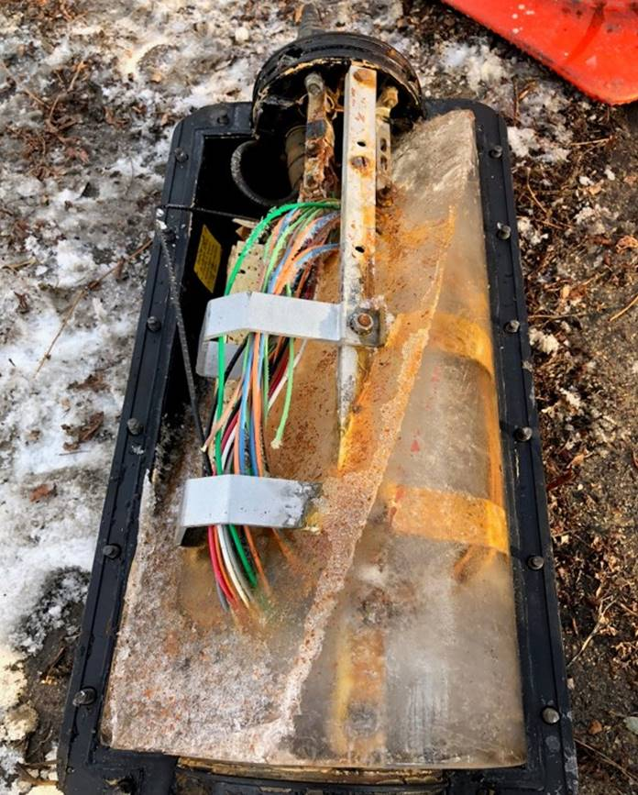
Photo courtesy of the Metropolitan Unified Fiber Network, Madison, WI

USAC News Brief Dated February 1 – Competitive Bidding Reminders

USAC’s Schools and Libraries News Brief of February 1, 2019, includes the following reminders on the competitive bidding process and the associated Form 470:

- The competitive bidding process must be open and fair.
- All Requests for Proposals (“RFPs”) and RFP documents must be uploaded to the Form 470.
- Applicants must wait at least 28 days after the Form 470 is certified to select their service providers.
- February 27th is the last day to certify a Form 470 for FY 2019.
- Some changes in the scope of a competitive bid may require the posting a new Form 470.

Last week’s News Brief also discusses the FCC’s new NPRM and Order (discussed above) on the waiving of the special construction amortization requirement.

---------------------------------------------------------------------------------------------------------------------Newsletter information and disclaimer: This newsletter may contain unofficial information on prospective E-rate developments and/or may reflect E-Rate Central’s own interpretations of E-rate practices and regulations. Such information is provided for planning and guidance purposes only. It is not meant, in any way, to supplant official announcements and instructions provided by the SLD, FCC, or state education departments.

For further information on E-rate, follow E-rate Central on Twitter, Facebook, and LinkedIn.

USAC’s longstanding Business Process Outsourcing (“BPO”) long-standing contract with Solix expired December 31, 2018. The new contractor, effective January 1, 2019, is Maximus Federal Systems.

