- Funding Status – FY 2019 and FY 2018
- Update on the BPO Contractor Transition
- E-Rate Updates and Reminders
  - Upcoming E-Rate Dates
  - Category 2 Filings with FCC
- USAC News Brief Dated February 22 – Special Characters in EPC Narrative Fields

Funding Status – FY 2019 and FY 2018

FY 2019:

The Form 471 application window is open. It will close at 11:59 p.m. EDT on Wednesday, March 27th. February 27th is the last possible date to post a Form 470 for FY 2019 that will meet the 28-day posting requirement by the last day of the application window.

FY 2018:

USAC issued Wave 46 for FY 2018 on Thursday, February 21st, for $241 thousand. Cumulative funding as of Wave 46 is $2.17 billion.

Update on the BPO Contractor Transition

Effective January 1st, Maximus Federal Systems assumed responsibility for most reviews of applications, invoices, and post-commitment change requests under a new USAC Business Process Outsourcing “(BPO”) contract. The previous BPO contract had been held for many years by Solix. The transition from Solix to Maximus is complicated but is proceeding well.

As discussed in our newsletter of February 4th, USAC was assigning Maximus reviewers to all pending forms and requests, and indicated that those reviewers would be emailing all affected applicants by February to provide contact information. At this point, it appears that all or most of the outstanding cases have been reassigned. Applicants who have not been contacted should reach out to USAC’s Client Service Bureau (“CSB”) at 888-203-8100.

The reviewers themselves — not always easily reached by phone — are actively involved (but still on a bit of a learning curve). We’re beginning to see progress on long-stalled invoices. More broadly, PIA review of FY 2019 applications is in full swing. As of last Friday, EPC showed over 3,600 applications as “Wave Ready” (more than 40% of the applications filed), an informal indication that initial reviews have been completed on these applications.

For applications still under review, applicant contacts will initially be notified of PIA inquiries via emails in the following format. Note that for ease of reference, an initial inquiry includes the application number in the email subject line.

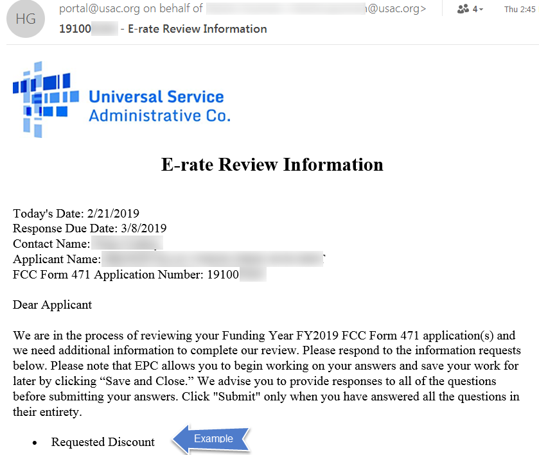

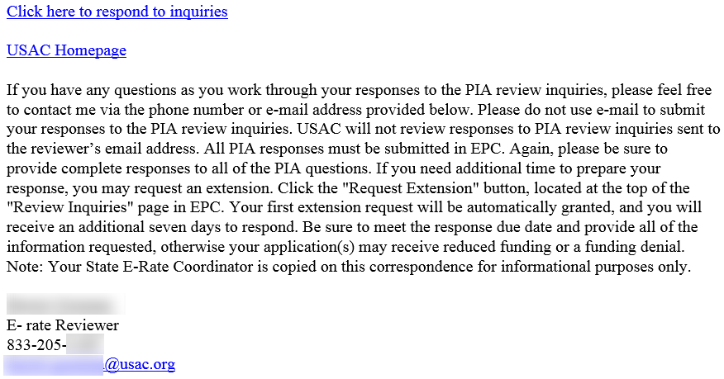

If the applicant has not responded to an inquiry within about a week — the initial request for information usually carries a 15-day due date — a reminder email is sent. Note that the format for the reminder, shown below, is a bit stark in nature including only a link into EPC. For applicants responsible for multiple applications, inclusion of the application number would be helpful.

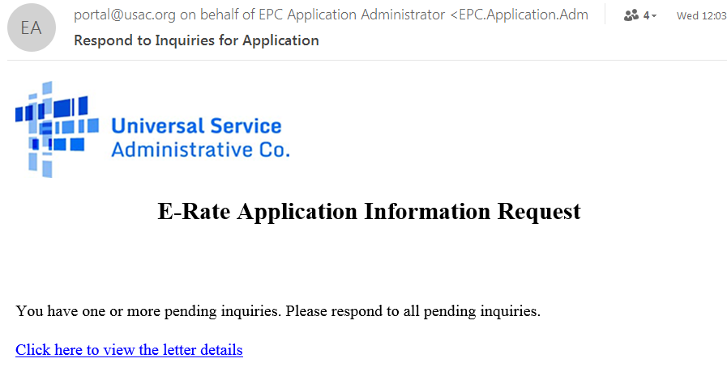

E-Rate Updates and Reminders

Upcoming E-Rate Dates:

February 26 Extended invoice deadline for FY 2017 recurring services.

February 27 Last day to file a Form 470 and meet the minimum 28-day posting requirement prior to the close of the Form 471 application window.

March 3 Form 486 deadline for FY 2018 funding committed in Wave 30. More generally, the Form 486 deadline is 120 days from the FCDL date or the service start date (typically July 1st), whichever is later. Other upcoming Form 486 deadlines are:

Wave 31 03/11/2019

Wave 32 03/18/2019

Note: Applicants missing any Form 486 deadline should watch carefully for “Form 486 Urgent Reminder Letters” in their EPC News Feed. These Reminder Letters afford applicants 15-day extensions to submit their Form 486s without penalty.

March 5 USAC webinar discussing common audit findings.

March 18 Deadline for submitting comments to the FCC’s NPRM (FCC 19-5) to permanently eliminate the amortization requirement on special construction charges (see our newsletter of February 4th). Reply comments are due by April 1st.

March 27 Close of the FY 2019 Form 471 application window.

Category 2 Filings with FCC:

Following the recent release of the Category 2 analysis report (DA 19-71) by the Wireline Competition Bureau (“WCB”) (see our newsletter of February 18th), two national organizations, the State E-Rate Coordinators’ Alliance (“SECA”) and the Schools, Health & Libraries Broadband (“SHLB”) Coalition, submitted ex parte letters to the FCC urging expedited release of a Notice of Public Rulemaking (“NPRM”) to address Category 2 budget rules for FY 2020 and beyond. Both organizations stressed the importance of having forward-looking Category 2 rules in place by the time the competitive bidding cycle begins, and the FY 2020 Form 470 is made available, on July 1, 2019.

The SHLB letter also sought immediate clarification of the existing Category 2 rules with regard to the status of applicant budgets begun as of or after FY 2016. Although the FCC’s First E-rate Modernization Order (FCC 14-99, ¶ 107) and the WCB’s recent report (footnote 36) both indicate that FY 2016-2019 budgets all extend a full five years through FY 2020-2023, respectively, USAC has been reluctant to confirm that the existing rules specify rolling five-year budgets.

The SECA letter, while focusing on the need for an NPRM, also includes several footnotes suggesting revisions to the Category 2 rules, including:
- Re-setting the Category 2 budgets for all entities in FY 2020.
- Allocating Category 2 budgets on a school districtwide or library systemwide basis.
- Anticipating future inflation and setting prospective budget multipliers at levels that can be held fixed for all five years.

USAC News Brief Dated February 22 – Special Characters in EPC Narrative Fields

USAC’s Schools and Libraries News Brief of February 22, 2019, explains that text containing special characters (e.g., !#$%^&*-=+?<>/\) cannot always be copied and pasted from Word or other word-processing files into EPC narrative fields. Attempting to do so will generate error messages. The reason is that word-processing programs often utilize specialized formatting for such characters which cannot be handled by EPC. We have seen similar problems arise when using specialized characters in filenames for files to be uploaded into EPC.

The News Brief describes a process for removing the specialized formatting from these characters, but it is generally easier to simply avoid use of the characters altogether or to type them into EPC directly (rather than copying and pasting them from a word processing program).

Last week’s News Brief also highlights the March 5th auditing webinar noted above, and lists the following online videos for last-minute Form 470 filers:
- Starting Your FCC Form 470
- Service Requests: Category One and Category Two
- Technical Contact and Procurement Information
- FCC Form 470 Review and Certification
- Post an Additional RFP Document
- How to Search for FCC Forms 470

--------------------------------------------------------------------------------------------------------------------- Newsletter information and disclaimer: This newsletter may contain unofficial information on prospective E-rate developments and/or may reflect E-Rate Central’s own interpretations of E-rate practices and regulations. Such information is provided for planning and guidance purposes only. It is not meant, in any way, to supplant official announcements and instructions provided by the SLD, FCC, or state education departments.

For further information on E-rate, follow us on Twitter, Facebook, and LinkedIn.

