- Funding Status – FY 2019 and FY 2018
- Updates on USAC’s E-Rate Productivity Center and Legacy System
  - Official Inflation Adjustments for FY 2019
  - PIA Reviewer Telephone Numbers
- E-Rate Updates and Reminders
  - Upcoming E-Rate Dates
  - USAC Audits for 2019
  - FCC Commissioner O’Reilly’s Concerns on Overbuilding
- USAC News Brief Dated March 8 – Multiple Topics

Funding Status – FY 2019 and FY 2018

FY 2019:

The Form 471 application window is open. It will close at 11:59 p.m. EDT on Wednesday, March 27th.

FY 2018:

USAC issued Wave 48 for FY 2018 on Friday, March 8th, for only $31 thousand. Cumulative funding as of Wave 48 is $2.17 billion.

Updates on USAC’s E-Rate Productivity Center and Legacy System

Official Inflation Adjustments for FY 2019:

On Friday, the FCC announced (DA 19-170) a 2.2% inflation-adjusted increase in the FY 2019 funding cap to $4,151,395,402. USAC’s News Brief for the week, referenced below, announced the new inflation-adjusted Category 2 budget factors as shown in the table below. Please note that although this table includes an extra column for budget factors rounded to the nearest penny, as commonly used by many applicants, the official multipliers are the unrounded numbers. For FY 2019, the unrounded budget factors range from 9-12 decimal points. Both EPC and USAC’s public Category 2 Budget Lookup Tool, when updated, will use the official unrounded figures.

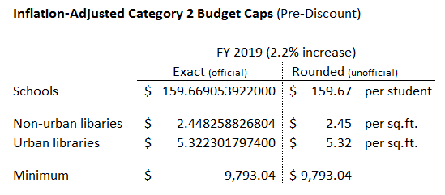

Applicants are reminded that EPC’s Category 2 budget calculations do not reflect commitments from FY 2015. Also note that, as of last weekend, EPC and the Category 2 Budget Lookup Tool have not yet been updated to reflect the new FY 2019 budget factors.

PIA Reviewer Telephone Numbers:

Initial email inquiries from PIA reviewers should include all pertinent reviewer contact information in the form:
[Reviewer Name]
E-rate Reviewer
833-205-1185 EXT [5-digits]
[first name.last name]@usac.org

The system template used to generate these emails, however, does not appear to enforce consistent contact information. Most importantly for applicants seeking to contact their PIA reviewers by phone, about a third of the emails we’ve seen do not include the reviewers’ critical 5-digit extensions. Without an extension, the 833-205-1185 telephone number is virtually worthless. The Maximus phone system requires an extension to complete a call and does not provide an automated directory. Entering “0” (or any combination of digits) in an attempt to reach an operator does not work.

As a last resort, here’s one trick that might work:
- When first prompted for an extension, enter any digit(s) or even “*.” The system will tell you that’s an invalid extension and prompt you to try again.
- Repeat the process.
- Repeat the process.
- Repeat the process.

After 4-5 repetitions, you’ll eventually get a message stating: “We cannot locate the extension you entered” and you’ll be invited to leave a voice message with the promise of a return call. We have not yet tested the veracity of the promised return call. A better approach may be to email the reviewer asking for their 5-digit extension.

E-Rate Updates and Reminders

Upcoming E-Rate Dates:

March 11 Form 486 deadline for FY 2018 funding committed in Wave 31. More generally, the Form 486 deadline is 120 days from the FCDL date or the service start date (typically July 1st), whichever is later. Other upcoming Form 486 deadlines are:

Wave 32 03/18/2019

Wave 33 03/21/2019

Wave 34 04/01/2019

Note: Applicants missing any Form 486 deadline should watch carefully for “Form 486 Urgent Reminder Letters” in their EPC News Feed. These Reminder Letters afford applicants 15-day extensions to submit their Form 486s without penalty.

March 18 Deadline for submitting comments to the FCC’s NPRM (FCC 19-5) to permanently eliminate the amortization requirement on special construction charges (see our newsletter of February 4th). Reply comments are due by April 1st.

March 27 Close of the FY 2019 Form 471 application window.

USAC Audits for 2019:

A webinar on Universal Service Fund (“USF”) issues sponsored by the Schools, Health & Libraries Broadband Coalition (“SHLB”) featured a presentation by the law firm Kelley Drye. The presentation included the following two slides showing USAC’s beneficiary (“BCAP”) and payment quality assessment (“PQA”) audits for 2017 and2018 as well as planned audits for 2019 for all four USF programs.

On the E-rate front, USAC is planning 50% more of the detailed, full funding year, beneficiary audits — roughly at the same level as in 2017 — but less of the more numerous invoice-specific PQA audits. Overall, this will represent a 13% reduction in the number of audits faced by E-rate applicants (or suppliers).

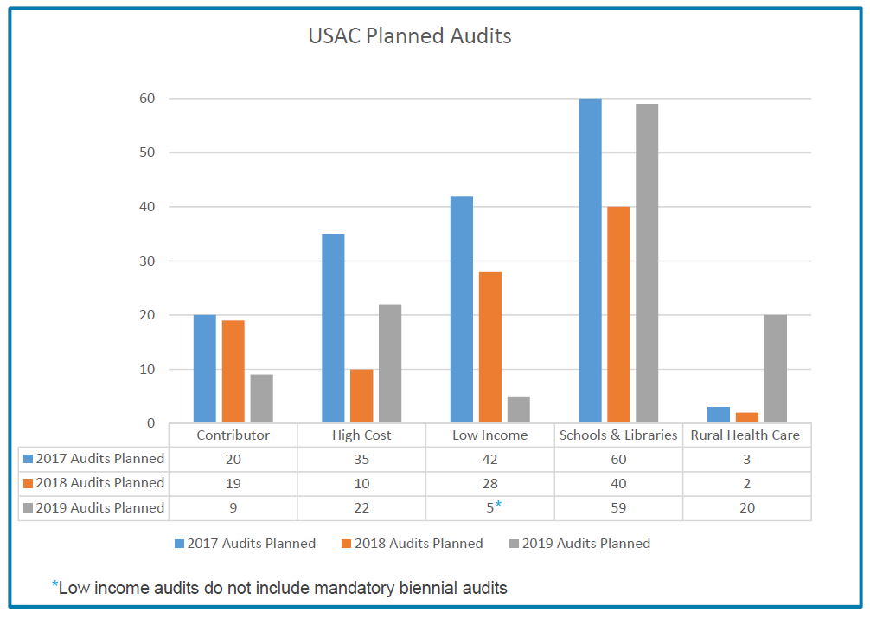

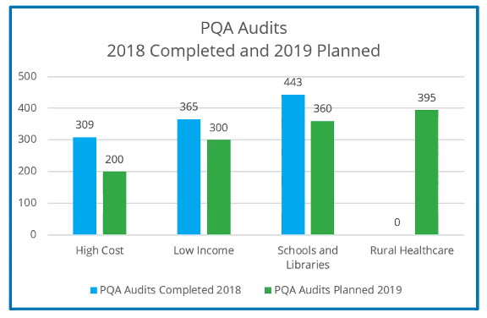

FCC Commissioner O’Rielly’s Concerns on Overbuilding:

FCC Commissioner Michael O’Rielly sent a letter last week to USAC’s CEO Radha Sekar reiterating his longstanding concerns over the use of USF funds, and particularly E-rate funds, to overbuild existing carrier networks. The letter asks USAC for data on consortium-wide WAN applications that would result in the overbuilding of other fiber provider networks funded in part by other USF High Cost or Rural Health Care programs. Commissioner O’Rielly’s current concern appears to have been triggered by complaints raised by several telephone cooperatives in Texas who may have lost E-rate bids by Educational Service Centers (“ESCs”) in their areas.

USAC, which has a history of painstakingly reviewing dark fiber and self-provisioned applications for cost-effectiveness, will hopefully be able to show the Commissioner that a more appropriate set of questions might be posed to incumbent carriers with existing fiber plant who appear to be unable to provide better network pricing on their own pre-existing networks than new providers constructing networks from scratch. In many cases we’ve seen, new fiber builds can provide dramatically improved economics over surprisingly short time horizons. Perhaps some existing carriers — fortunately clearly not all — need to reexamine their own business models.

USAC News Brief Dated March 8 – Multiple Topics

USAC’s Schools and Libraries News Brief of March 8, 2019, includes discussions of the following topics:
- Multipliers for FY 2019 Category 2 Budget Calculations (see more detailed article above).
- Reminder of USAC website resources available for use during the filing window.
- Alert concerning USAC’s own audit that entails FRN balance confirmations being emailed to randomly-selected applicants and service providers.
- Status of two system problems affecting service providers including:
  - File size limits on SPI forms submitted electronically; and
  - Delayed issuance of Receipt Acknowledgment Letters (“RALs”).

--------------------------------------------------------------------------------------------------------------------- Newsletter information and disclaimer: This newsletter may contain unofficial information on prospective E-rate developments and/or may reflect E-Rate Central’s own interpretations of E-rate practices and regulations. Such information is provided for planning and guidance purposes only. It is not meant, in any way, to supplant official announcements and instructions provided by the SLD, FCC, or state education departments.

For further information on E-rate, follow us on Twitter, Facebook, and LinkedIn.

