- Funding Status – FY 2019 and FY 2018
- Updates on USAC’s E-Rate Productivity Center and Legacy System
  - EPC Password Reset Errors
- Non-Amortization of Special Construction Charges
- E-Rate Updates and Reminders
  - Upcoming E-Rate Dates
- USAC News Brief Dated March 22 – Reminders for Form 471 Filers

Funding Status – FY 2019 and FY 2018

FY 2019:

The Form 471 application window is open, but not for long. It will close at 11:59 p.m. EDT on Wednesday, March 27th. To help resolve applicant issues during the final days of the application window, USAC’s Client Service Bureau (“CSB”) will be open for longer hours the last three days — from 8:00 a.m. EDT until 10:00 p.m. EDT on Monday and Tuesday, and from 8:00 a.m. EDT on Wednesday until 12:30 a.m. EDT on Thursday (after the close of the window).

Applicants expecting to be filing last-minute applications should first confirm that their EPC passwords are up-to-date. Applicants encountering password reset problems should review the article below before calling CSB.

FY 2018:

USAC issued Wave 50 for FY 2018 on Friday, March 22nd, for $1.48 million. Cumulative funding as of Wave 50 is $2.18 billion.

Updates on USAC’s E-Rate Productivity Center and Legacy System

EPC Password Reset Errors:

An applicant forgetting their password can generate a reset message by clicking the “Forgot your password?” link on the sign-in screen.

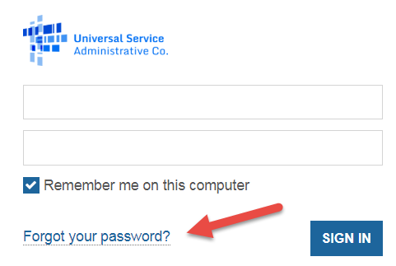
This will generate a return email that includes a hyperlink to an EPC reset website. Depending upon what browser is being used, however, simply clicking on that link may not work. In some cases, it will result in a “401 error – unauthorized user” message. Should this occur, right-click on the link to “Copy Hyperlink,” right-click on the address field of a browser, “Paste” that address into the field, then push the “Enter” key to get to the reset password screen.

Important reminder: The EPC password reset link remains active for only 15 minutes. Once the time expires a new link will have to be requested.

Non-Amortization of Special Construction Charges

Last month the FCC released a Notice of Proposed Rulemaking (“NPRM”) and Order (FCC 19-5) extending the suspension of an earlier rule requiring a three-year amortization of special construction charges of $500,000 or more. That requirement had been suspended as of FY 2015, but only for four years. Without FCC action, amortization would have resumed in FY 2019. In addition to suspending the amortization requirement for the coming year, the NPRM called for comments on a proposal to permanently eliminate amortization.

Comments, due last Monday, were received from the seven organizations listed below — all supporting the permanent elimination of amortization. Reply comments are due April 1st.

- American Library Association (“ALA”)
- Central Texas Telephone/Peoples Telephone/Totelcom
- Illinois Department of Innovation and Technology
- New Mexico Public School Facilities Authority (“NM PSFA”)
- NTCA–The Rural Broadband Association
- Schools, Health & Libraries Broadband Coalition (“SHLB”)
- State E-Rate Coordinators’ Alliance (“SECA”)

Based on the strength of the FCC’s NPRM proposal, and the broad supporting comments, we fully expect the FCC’s final decision to permanently eliminate the amortization requirement. In the interim, USAC has already begun reaching out to applicants who might have already filed special construction applications for FY 2019 before the FCC suspended amortization. These applicants should have received emails with the following instructions:

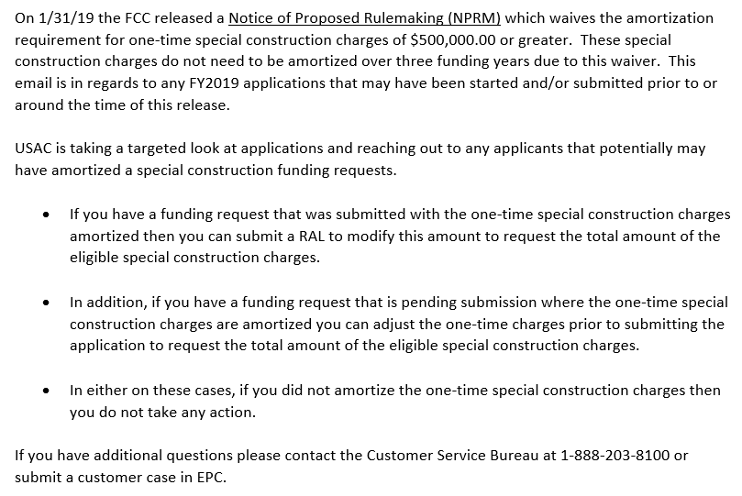

E-Rate Updates and Reminders

Upcoming E-Rate Dates:

April 1 Form 486 deadline for FY 2018 funding committed in Wave 34. More generally, the Form 486 deadline is 120 days from the FCDL date or the service start date (typically July 1st), whichever is later. Other upcoming Form 486 deadlines are:

Wave 35 04/08/2019

Wave 36 04/15/2019

Wave 37 04/19/2019

Wave 38 04/26/2019

Note: Applicants missing any Form 486 deadline should watch carefully for “Form 486 Urgent Reminder Letters” in their EPC News Feed. These Reminder Letters afford applicants 15-day extensions to submit their Form 486s without penalty.

April 1 Deadline for submitting reply comments to the FCC’s NPRM (FCC 19-5) to permanently eliminate the amortization requirement on special construction charges (see article above).

USAC News Brief Dated March 22 – Reminders for Form 471 Filers

USAC’s Schools and Libraries News Brief of March 22, 2019, provides the following final reminders for this year’s Form 471 filers:

- Service types featured on the Form 470 and Form 471 must be consistent.
- Ask CSB to help with entity profile updates not completed during the administrative window.
- Use the RAL modification process after the Form 471 has been filed to make entity changes that CSB cannot correct.
- Libraries must indicate their main branch.
- Store the program documentation you must retain.

--------------------------------------------------------------------------------------------------------------------- Newsletter information and disclaimer: This newsletter may contain unofficial information on prospective E-rate developments and/or may reflect E-Rate Central’s own interpretations of E-rate practices and regulations. Such information is provided for planning and guidance purposes only. It is not meant, in any way, to supplant official announcements and instructions provided by the SLD, FCC, or state education departments.

For further information on E-rate, follow us on Twitter, Facebook, and LinkedIn.

The two service provider filings, while strongly supporting a permanent end to E-rate amortization of special construction, urged the FCC to better coordinate all USF program rules to reduce incentives for overbuilding of existing facilities.

